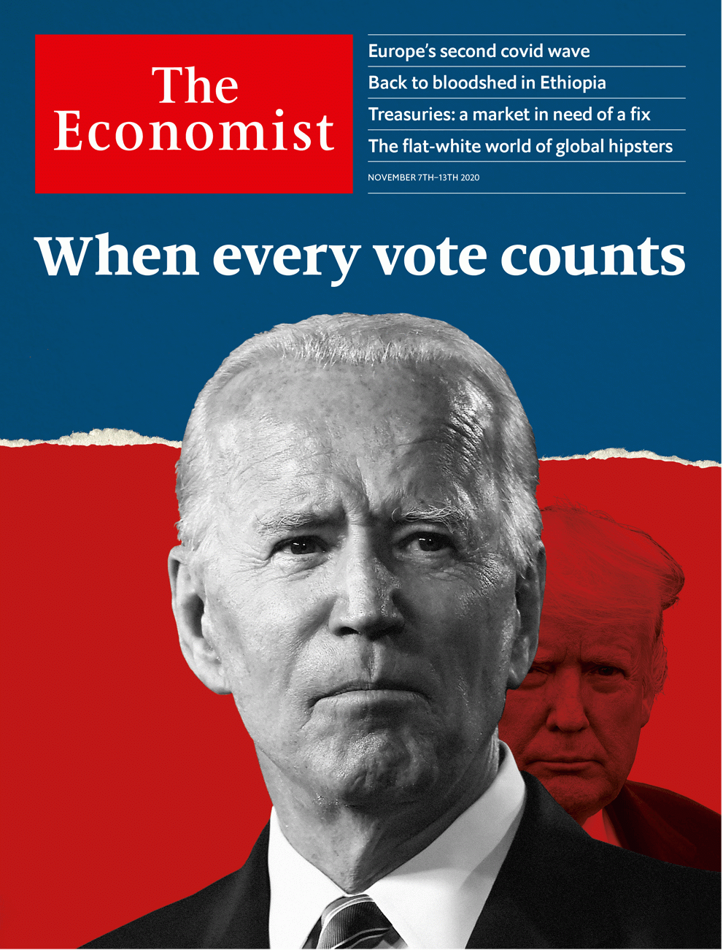

# Table of Contents

The world this week

Politics this week

Business this week

KAL’s cartoon

Leaders

America’s election: When every vote counts

War in the Horn: Ethiopia is poised to unravel

Financial markets: Fixing the plumbing

Secularism and Islam: Voltaire’s heirs

Alternative 5G technology: Open sesame

Letters

Letters to the editor: On nature, the Arctic, John Kennedy, Covid-19, Taiwan, culture, capitalists, Berlin, Albanians

Briefing

Covid-19 in Europe: The relapse

United States

The presidential race: Hello, 46

Congress: Spell unbroken

Polling error redux: Whiffing twice

Election lawsuits: Courting the presidency

Governorships and ballot initiatives: The covid races

Lexington: Trump and Trumpism

The Americas

Canada: Northern light

Brazil: Bundles in the jungle

Bello: It’s hard to do good

Asia

Elections in Myanmar: False start

Music in South Korea: Hot for trot

Banyan: Islands of liberality

China

Economic policy: Circling back

Chaguan: How China sees America

Middle East & Africa

Conflict in Ethiopia: Abiy’s call to arms

Bobi Wine: Sing it loud

Tanzania and Ivory Coast: Setting a bad example

Debt in the Middle East: Not flattening the curve

Robert Fisk: Rage on the page

Europe

Russia: Putin’s new model army

Terrorism in Europe: Oh Vienna

Belarus: Staying put

Spain: Us Gallegos

Alcohol in Sweden: The state’s grip on grape and grain

Charlemagne: Baldrick’s Europe

Britain

Populism: Look who’s back

Remembrance Day: Over the top

Scotland and defence: Should auld acquaintance be forgot

The economy: The fright before Christmas

Education: New tricks

Bagehot: Captain Foresight

International

Global hipsters: Flat-white world

Business

The outlook for corporate America: Still ailing

Xiaomi: Mi time

The turkey glut: Gobble, gobble?

Video games: The games are only just beginning

Bartleby: Questionable behaviour

Schumpeter: Mickey v Masa

Finance & economics

Treasuries: The bonds that bind

Buttonwood: Our currency, your problem

Regulators v Ant Group: Ant agonises

The world economy: Winter is here

Lebanon’s financial mess: The final unravelling

Free exchange: Turning inward

Science & technology

Superbatteries: What do you get when you cross a hare with a tortoise?

Covid-19: Teed up

Manipulating magnetism: Out of left field

Think again: Female stone-age hunters

Books & arts

Colour in art: Paint it black

Renaissance art: Take me to church

China and the second world war: Lest they forget

The Western mind: Value judgments

Martin Amis’s new book: In my life

Economic & financial indicators

Economic data, commodities and markets

Graphic detail

Covid-19 super-spreading: Power of inequality

Obituary

Sean Connery: Screen Scot



### Friday, November 6, 2020

|  |  |
| --- | --- |
| The world this week | 3 |
| Leaders | 5 |
| Letters | 1 |
| Briefing | 1 |
| United States | 6 |
| The Americas | 3 |
| Asia | 3 |
| China | 2 |
| Middle East & Africa | 5 |
| Europe | 6 |
| Britain | 6 |
| International | 1 |
| Business | 6 |
| Finance & economics | 6 |
| Science & technology | 4 |
| Books & arts | 5 |
| Economic & financial indicators | 1 |
| Graphic detail | 1 |
| Obituary | 1 |

加迪迪QQ1562739651问外刊群群号

|  |  |  |
| --- | --- | --- |
|  | Sections | Leaders |

The world this week

Politics this week

.

Business this week

.

KAL’s cartoon

.

|  |  |  |
| --- | --- | --- |
|  | Sections | Leaders |

|  |  |  |  |
| --- | --- | --- | --- |
|  | Articles | Sections | Next |

# Politics this week

Nov 7th 2020 |

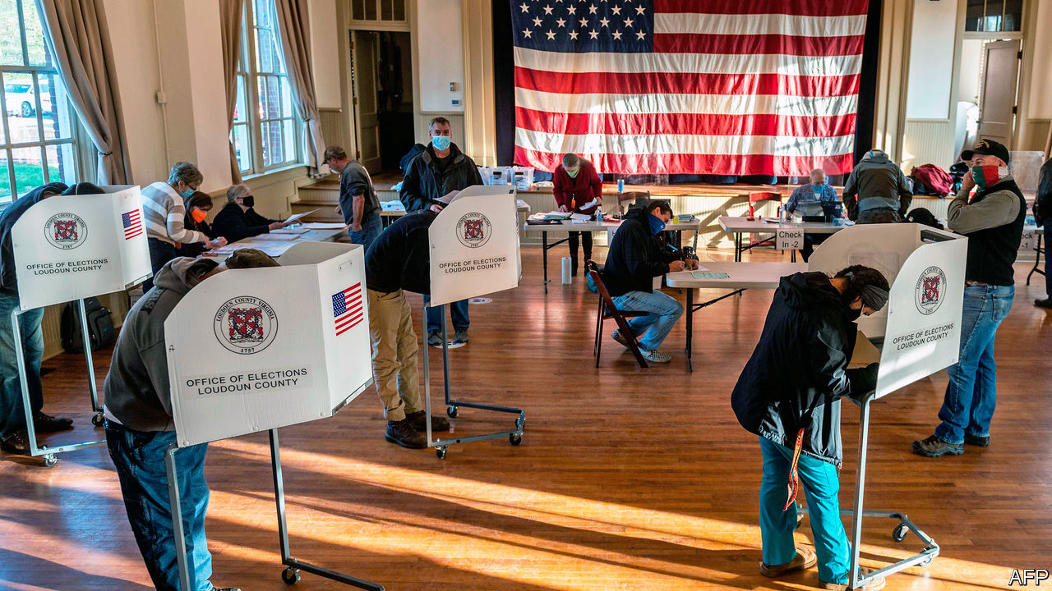

America’s presidential election was closer than the polls had suggested. In the electoral college Joe Biden won Michigan and Wisconsin, two states that helped hand victory to Donald Trump in 2016; Mr Trump took the key state of Florida, and by a bigger margin than in 2016. Mr Biden had the edge in the vote-count, which the Trump campaign challenged in court. When the final results are tallied the Democrat will have won the nationwide popular vote by perhaps five percentage points. See here and [here](https://www.economist.com/united-states/2020/11/05/america-changes-course-while-remaining-very-much-the-same).

Early results suggested that the Republicans would retain the Senate. The Democrats gained two seats, but a Republican took one back in Alabama, defeating a Democrat who had won a special election in 2017 after his rival was embroiled in a sex scandal. Republicans picked up several seats in the House of Representatives, but the Democrats kept a firm grip on the chamber. Montana was the only state to flip parties in the 11 governors’ races, switching to the Republicans. See article.

Among the state ballot initiatives that took place, voters in Oregon approved laws that will decriminalise the possession for personal use of cocaine, heroin and other drugs, and legalise magic mushrooms for mental-health treatment. A new state flag was approved in Mississippi to replace the old one, which featured the Confederate emblem. The new flag portrays a magnolia flower. See article.

Abiy Ahmed, the prime minister of Ethiopia, ordered the army to take action against the northern region of Tigray, whose leaders he accused of attacking an army base. Tensions have been building between the central government and Tigray in recent months and observers worry that a civil war is brewing. See article.

While the world’s eyes were firmly on America’s election, governments in several African countries arrested prominent adversaries. Police in Uganda detained Bobi Wine, a pop-star politician, after he registered as a candidate for the presidency. In Tanzania the police arrested Tundu Lissu, the main opposition leader. And in Zimbabwe Hopewell Chin’ono, a journalist who has exposed corruption linked to the ruling party, was seized. See article.

Officials in Ivory Coast said that Alassane Ouattara had won a third term in a presidential election with 94% of the vote, even though many Ivorians boycotted it. The constitution limits presidents to two terms. His opponents refused to recognise the result. See article.

Algerians approved changes to the constitution that would impose term limits on their president and restrict his choice of prime minister. But the “Hirak” protest movement dismissed the revisions as a “façade” of change. Turnout was low.

A gunman with links to Islamic State went on a rampage in Vienna, killing four people and wounding 23 before he was shot dead by police. The atrocity, which took place in the centre of the Austrian capital, follows a spate of other incidents, including the beheading of a French teacher near Paris and the murder of three people in a church in Nice.

With covid-19 soaring in some areas, England went back into a national lockdown. Non-essential shops, pubs, restaurants, gyms and other public places will close until December 2nd, but schools and building sites remain open. A government scheme that pays 80% of wages for furloughed staff was extended for another month. Covid-19 restrictions were also tightened in Belgium. Family visits are banned, and all non-essential shops closed.

Denmark decided to cull 17m mink, fearing that a mutation of the coronavirus that has been found in the animals could weaken the effectiveness of a vaccine. Denmark is the world’s largest producer of mink skins.

An earthquake in Turkey near the coastal city of Izmir killed at least 110 people. Scores of residents are still missing.

Prosecutors in Rio de Janeiro charged Flávio Bolsonaro, the eldest son of Brazil’s president, Jair Bolsonaro, with corruption and money-laundering. He is accused of taking some of the salaries paid to aides when he was a legislator in the state, a practice known as rachadinha. He is now a federal senator.

Brazil’s space-research institute said that the number of wildfires in the Pantanal, which contains the world’s largest tropical wetland area, reached a record high in October. The area is renowned for its abundance of animal life.

Typhoon Goni slammed into the Philippine islands of Catanduanes and Luzon with winds of 225kph, among the most ferocious landfalls ever recorded; 20 people died and 25,000 homes were destroyed.

Terrorists from the Afghan affiliate of Islamic State attacked Kabul University, killing 22 students before being shot by security forces.

The government of New Zealand announced the results of two referendums. Voters opted to legalise assisted dying but not marijuana. See article.

Police in Hong Kong arrested a local journalist, Choy Yuk-ling, who helped to make a documentary about alleged police misconduct. Ms Choy was accused of using a false pretext to obtain details of car-owners from an official database.

## Coronavirus briefs

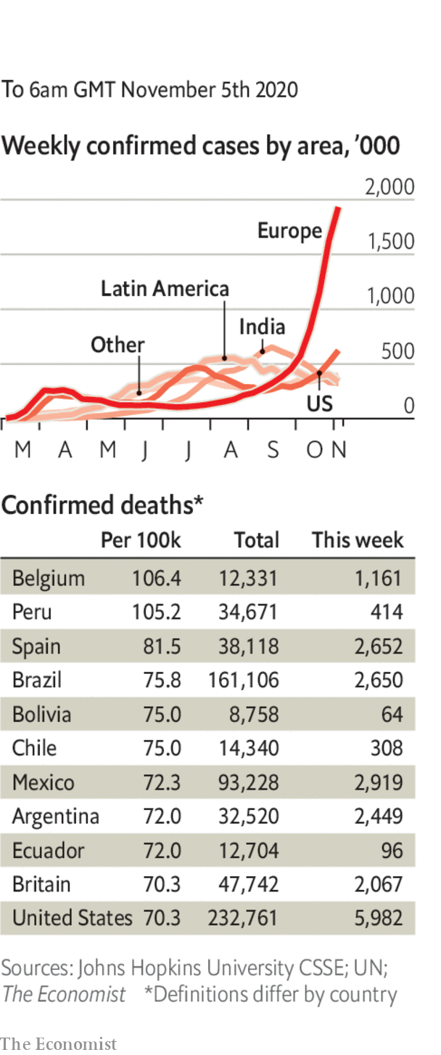

America recorded 100,000 new cases in a day.

The number ofdaily deaths in Italy hit its highest level since early May. Hospitals in Germany were urged to postpone non-urgent operations to make beds available. See [briefing](https://www.economist.com/briefing/2020/11/05/the-second-wave-of-covid-19-has-sent-much-of-europe-back-into-lockdown).

The French health minister said that in Paris one person was becoming infected every 30 seconds, and hospitals were admitting someone with the disease every 15 minutes.

Saudi Arabia allowed foreign pilgrims back into Mecca. They must self-isolate for three days and submit to frequent testing.

Machu Picchu reopened to tourists after eight months of shutdown. The majestic Inca site is restricting visitor numbers; Peru has a high death rate from the disease. An ancient ritual marked the reopening, along with prayers to the gods. With luck they are listening.

This article was downloaded by calibre from <https://www.economist.com/the-world-this-week/2020/11/07/politics-this-week>

|  |  |  |  |
| --- | --- | --- | --- |
|  | Articles | Sections | Next |

|  |  |  |  |
| --- | --- | --- | --- |
| Previous | Articles | Sections | Next |

# Business this week

Nov 7th 2020 |

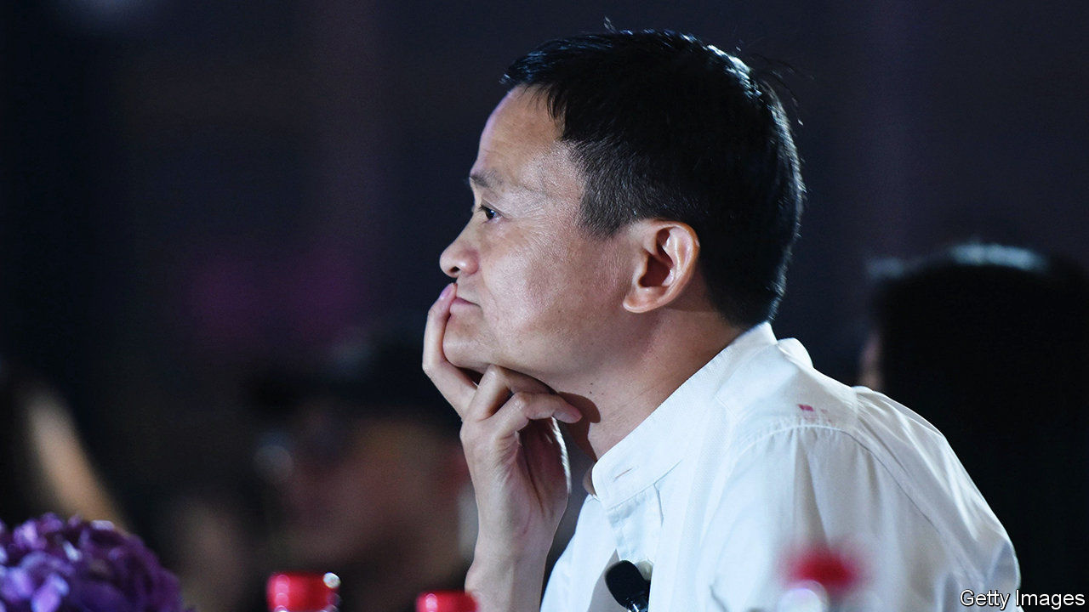

In a stunning turn of events, Chinese regulators suspended the initial public offering in Shanghai of Ant Group, just days before the fintech firm was due to float its shares in a dual listing both there and in Hong Kong. It was expected to be the world’s most valuable IPO ever, potentially raising $34bn. Ant had been given the green light for the sale, but China’s foreign ministry said the decision had been taken “to better safeguard capital market stability and protect investor rights”. Ant’s online-lending business was said to be a concern; new rules were published forcing such lenders to back their loans with more of their own capital. The shelving of Ant’s IPO is a blow to Jack Ma, its founder. See article.

## Using their initiative

Uber, Lyft and other companies that work in the gig economy won a big victory in California when voters approved a measure that will allow them to avoid reclassifying their drivers as employees. The companies will not now have to comply with a state law compelling them to provide benefits like sick pay to drivers, although some have pledged to offer more protections. Uber and its allies spent $200m supporting the measure, the most expensive-ever campaign for a ballot initiative in the state.

BMW had a bumper third quarter, driven by a surge in sales in China, which were up by 31% year on year. Sales in Europe also rose, but the carmaker warned that its business remains volatile because of covid-19. Its global deliveries were still 12.5% lower in the first nine months than in the same period last year.

The euro area’s GDP expanded by 12.7% in the third quarter by comparison with the previous three months, bouncing back from recession. Year on year, however, the currency bloc’s economy shrank by 4.3%. America’s economy also pulled out of recession, growing by 7.4% in the third quarter, though year on year it was down by 2.9%.

Turkey’s annual inflation rate ticked up to 11.9% in October. The lira, which has lost around a third of its value against the dollar this year, fell to another new low.

The mayor of London reached a financial agreement with the British government that will keep the city’s transport system running for at least another six months. The revenue stream from London’s Tube and buses has dwindled during the pandemic. The government had threatened to take direct control of the network. The mayor has agreed to some cost savings, but he will not have to extend the size of the capital’s congestion-charging zone outside the centre.

More oil companies reported their earnings, spotlighting the impact that falling oil prices and reduced demand are having on the industry’s bottom line. ExxonMobil posted its third consecutive quarterly net loss, this time of $680m. It plans to cut 15% of its global workforce next year. Saudi Aramco, the world’s biggest oil company, made a net profit of $11.8bn, but that was 45% less than in the same three months last year. It still intends to pay out dividends totalling $18.8bn. Most of that will go to the Saudi government, which owns the vast bulk of Aramco’s shares.

## Dorsey’s hairy moment

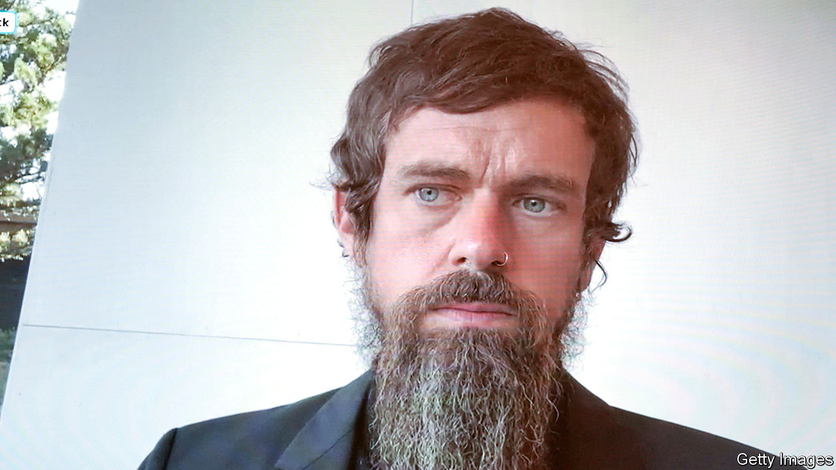

A committee of the board at Twitter that reviewed the company’s management structure “expressed its confidence” in the current arrangements, confirming that Jack Dorsey will remain chief executive. The committee was created after Elliott, an activist hedge fund, questioned Mr Dorsey’s commitment to his job. Twitter’s share price has risen sharply this year, rewarding Elliott and other investors, though it was dented recently by weak daily-user numbers.

Both Lufthansa and Air France-KLM reported another heavy quarterly loss. The German and French-Dutch airlines have received huge state bail-outs during the pandemic. Lufthansa said it would restructure its business further; Air France-KLM is to curtail its flight schedule for the rest of the year. Ryanair also made a loss as passenger numbers plummeted. Michael O’Leary, its combative boss, blamed the first lockdowns in Europe earlier this year, which he said had “achieved nothing”, and lambasted the second lockdowns, many in force this week, which he thinks will achieve “even less”.

Berlin Brandenburg Airport at last opened to passengers after a decade of delays, six missed openings and huge cost overruns. The airport’s inaugural arrival flights were operated by easyJet and Lufthansa. Even the opening had a hitch. Bad weather stopped a planned parallel landing by the aircraft.

There was a sliver of hope for the human race this week, with the reported news that Walmart has scrapped plans to use robots to check stock levels, prices and misplaced items. The retailer will instead retain flesh-and-blood workers, who have been found to be just as adept at those tasks during the pandemic.

This article was downloaded by calibre from <https://www.economist.com/the-world-this-week/2020/11/07/business-this-week>

|  |  |  |  |
| --- | --- | --- | --- |
| Previous | Articles | Sections | Next |

|  |  |  |  |
| --- | --- | --- | --- |
| Previous | Articles | Sections | Next |

# KAL’s cartoon

Nov 5th 2020 |

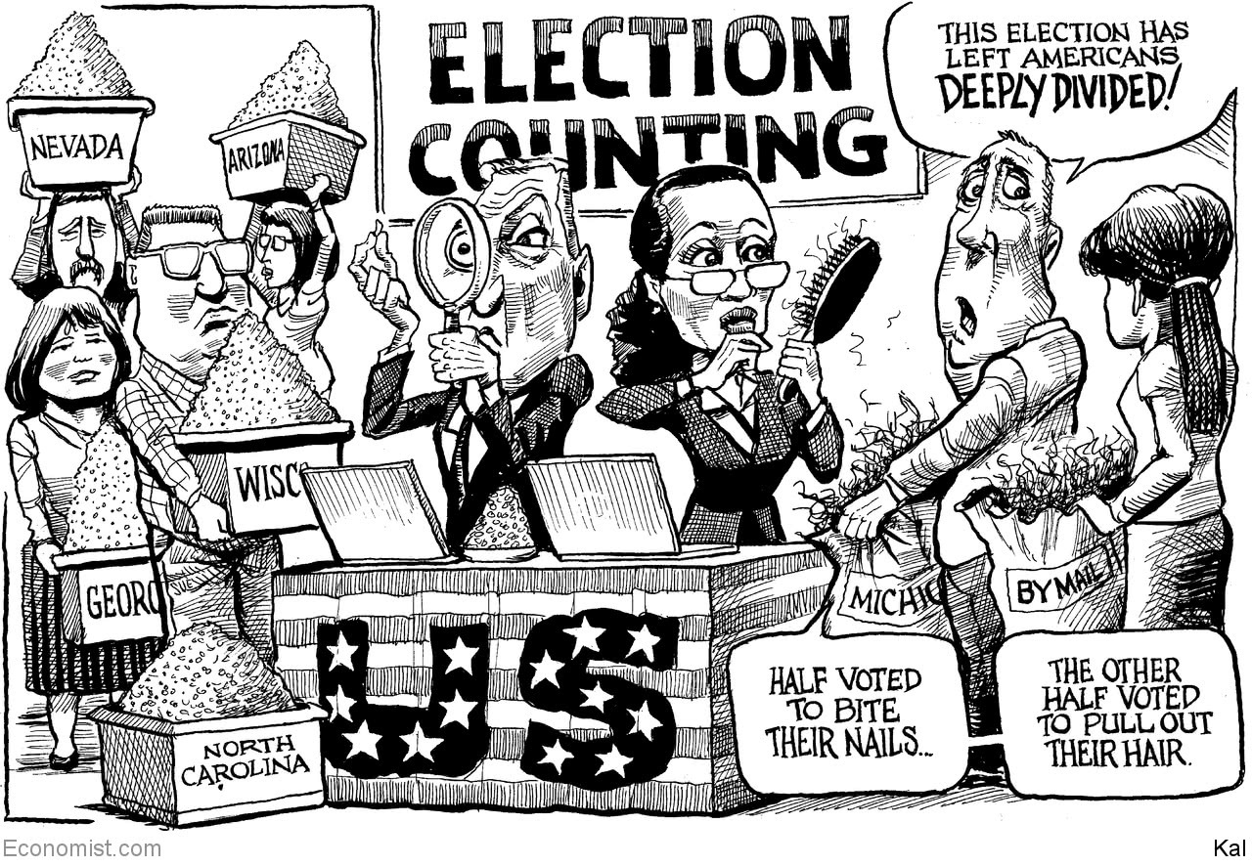

This article was downloaded by calibre from <https://www.economist.com/the-world-this-week/2020/11/05/kals-cartoon>

|  |  |  |  |
| --- | --- | --- | --- |
| Previous | Articles | Sections | Next |

|  |  |  |
| --- | --- | --- |
| The world this week | Sections | Letters |

Leaders

America’s election: When every vote counts

.

War in the Horn: Ethiopia is poised to unravel

.

Financial markets: Fixing the plumbing

.

Secularism and Islam: Voltaire’s heirs

.

Alternative 5G technology: Open sesame

.

|  |  |  |
| --- | --- | --- |
| The world this week | Sections | Letters |

|  |  |  |  |
| --- | --- | --- | --- |
|  | Articles | Sections | Next |

#### When every vote counts

# What the 2020 results say about America’s future

Joe Biden looks set to govern over a deeply divided country

Nov 5th 2020 |

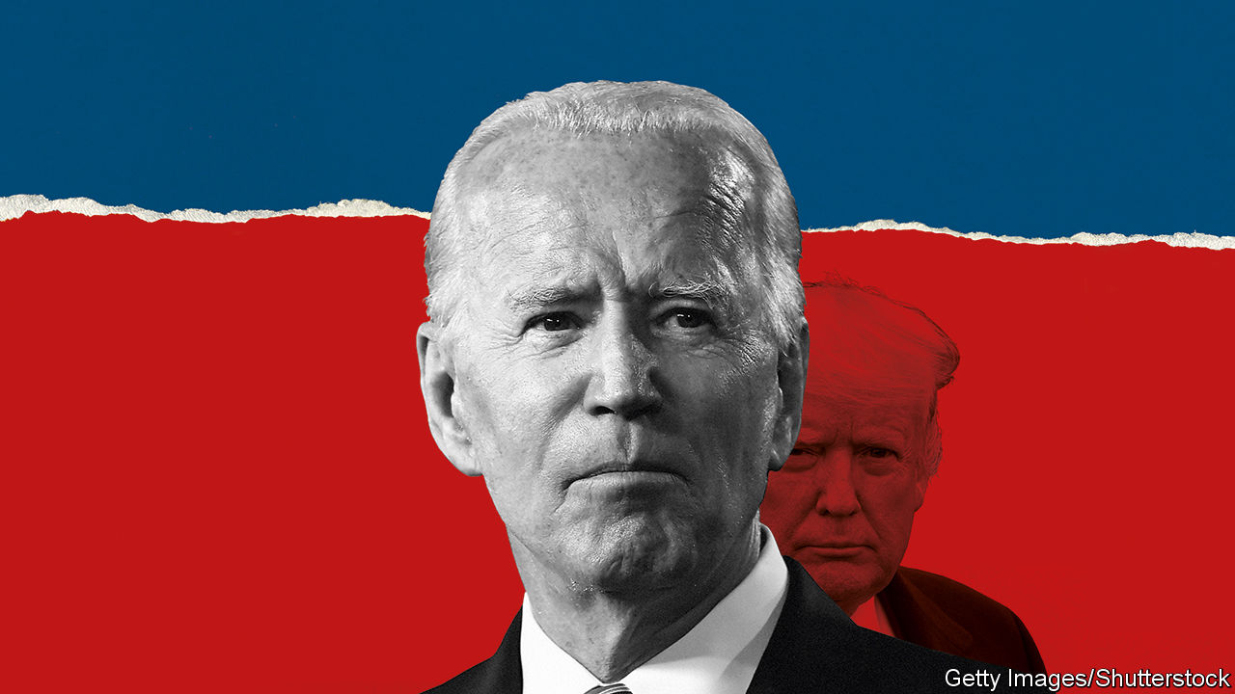

MONTHS OF FRANTIC electioneering, $13.9bn of campaign spending, a raging pandemic and mass protests over race: in spite of all the sweat and tears, America was still determining as we went to press if its next president really would be Joe Biden or whether Donald Trump might somehow wrangle a second term. Congress is likely to be split between a Democratic House and a Republican Senate—though even that result may remain in doubt until a run-off in January.

In the coming days politicians should take their cue from voters, who turned out in greater force than in any year since 1900 and who made their choice without violence. Vote-counting must run its course and disputes between the two campaigns be settled within the spirit of the law. The biggest threat to that comes from Mr Trump, who used his election-night party to claim falsely that he had already won, and to fire up his supporters by warning that victory was being stolen from him. Coming from a man sworn to safeguard America’s constitution, such incitement was a reminder why many, including this newspaper, had called for voters to repudiate Mr Trump wholesale.

With Mr Biden’s victory they would take a crucial first step in that direction. Only once in the past 40 years has a president been denied a second term. Mr Trump will lose the popular vote by, we reckon, 52% to 47%—only the electoral college’s bias towards rural voters saved him from a crushing defeat. That is a repudiation of sorts.

A Biden White House would also set a wholly new tone. The all-caps tweets and the constant needling of partisan divisions would go. So would the self-dealing, the habitual lying and the use of government departments to pursue personal vendettas. Mr Biden is a decent man who, after the polls closed, vowed to govern as a unifier. His victory would change American policy in areas from climate to immigration. That is a form of repudiation, too.

And yet the unexpected closeness of the vote also means populism will live on in America. With this election it has become clear that Mr Trump’s astonishing victory in 2016 was not an aberration but the start of a profound ideological shift in his party (see Lexington). Defying expectations and covid-19, he has won millions more votes in the huge turnout of 2020 than he did in 2016’s moderate one. Far from being swept away in a blue wave, Republicans have gained seats in the House and seem set to keep control of the Senate. The Republican Party, which fell under Mr Trump’s spell while he was in office, is not about to shake itself out of the trance now. It is even conceivable that Mr Trump, or a member of his family, could run for the White House in 2024.

The outside world, which has been watching this contest with rapt attention, will draw two conclusions from America’s failure to reject Trumpism more decisively. The first will be among populist nationalists who look to Mr Trump for inspiration and who will now reckon that their brand of politics has a brighter future outside America, too. An abject defeat for Mr Trump may have spelled trouble for politicians like Jair Bolsonaro in Brazil and Marine Le Pen in France. Instead Nigel Farage, formerly the leader of the Brexit Party, is busy planning his comeback (see article). The persistence of Mr Trump’s support suggests that the rejection of immigration, urban elites and globalisation, which gathered pace after the financial crisis of 2008-09, still has further to run.

The second conclusion is to be wary of relying on America. Mr Trump has been a disruptive, transactional force in foreign affairs, contemptuous of alliances and multilateralism. Mr Biden, by contrast, is steeped in the traditional values of American diplomacy from his time in the Senate. He would doubtless seek to restore close ties with allies and to strengthen global governance, by for instance, remaining in the World Health Organisation and rejoining the Paris agreement on climate change. But after this election result, everyone will know that it could all revert again in 2024.

At home the picture is more complicated, but it contains lessons for both parties—and for their stewardship of America. The hardest message is for the Democrats. Their failure to take the Senate means that Mr Biden will struggle to pass bills or appoint judges. An infrastructure bill, health-care reform and environmental laws could all be blocked by Congress.

That failure partly reflects the Democrats’ inability to attract white, non-college-educated voters, especially in rural America. They also fared less well than expected among young African-American men and Hispanic voters in Florida and Texas. These losses undermine the Democrats’ assumption that, just because America is becoming less white and more suburban, they are destined to win elections. Rather, they will need to earn support by countering Republican claims that they are against free enterprise and that fringe obsessions with identity politics are becoming an oppressive Democratic orthodoxy.

Republicans face lessons, too. Trumpism has its limits. If they block all legislation in the Senate so as to discredit Mr Biden, it will mark yet another electoral cycle in which the gridlock and the zero-sum logic of partisanship prevent America from grappling with its problems. Republicans will tell themselves that discrediting the Washington machine helps the party that claims to stand for limited government—however swampy the Trump administration proved. That view is as short-sighted as it is cynical.

## Red-lesson day

Those black and Hispanic voters who came over to their side this week suggest that Republicans can win minority support and that ethnic groups are not monoliths. Republicans are seduced by a dangerous identity politics of their own, which stirs up white fears of a multiracial country. How much better if they made a positive case for their party, seeking to expand their base by earning their share of the credit for, say, bills to reform criminal justice or upgrade America’s creaking infrastructure.

This election has once again shown that America is a divided nation. Many of its politicians set out to feed the divisions, and none has divided more than Mr Trump. We hope that his defeat will stand as a lesson that it doesn’t always work. ■

This article was downloaded by calibre from <https://www.economist.com/leaders/2020/11/05/what-the-2020-results-say-about-americas-future>

|  |  |  |  |
| --- | --- | --- | --- |
|  | Articles | Sections | Next |

|  |  |  |  |
| --- | --- | --- | --- |
| Previous | Articles | Sections | Next |

#### Back to blood

# Ethiopia’s prime minister may be starting a civil war

Abiy Ahmed should pursue talks instead

Nov 7th 2020 |

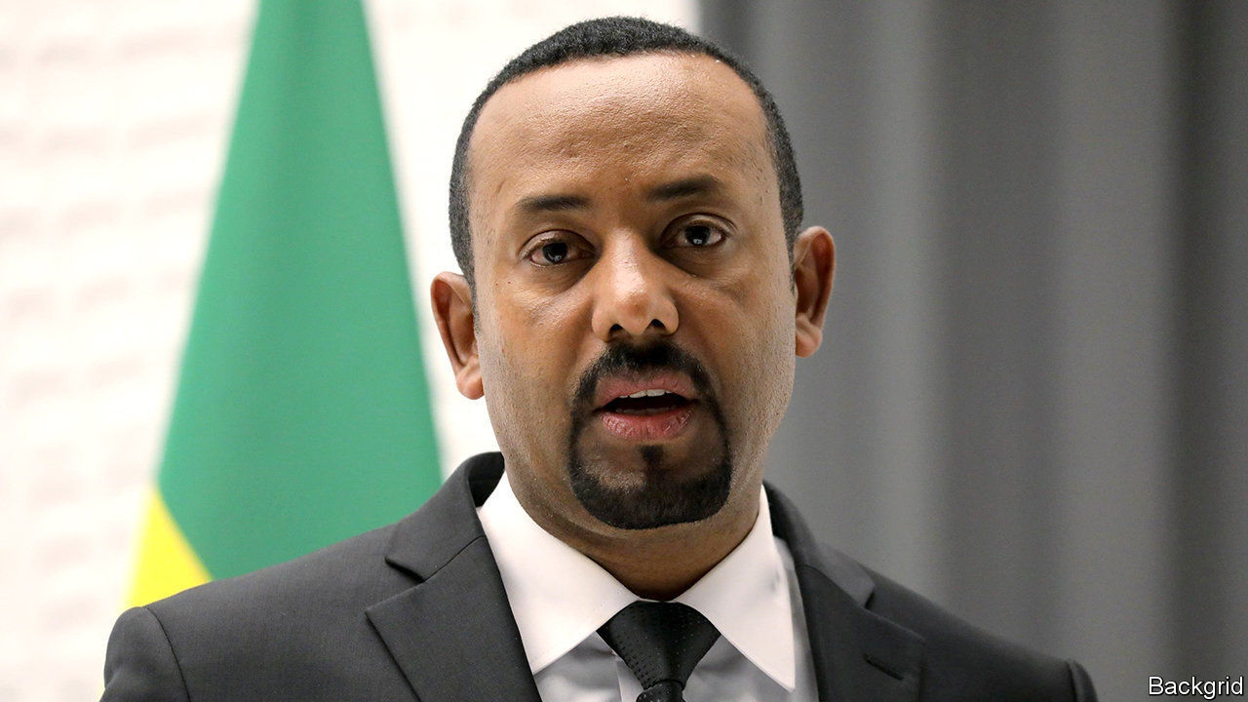

IT STARTED AS a border skirmish in 1998, between Ethiopian policemen and Eritrean soldiers in Badme, a small village on a barren mountain. One observer at the time likened it to “two bald men fighting over a comb”. It grew into a two-decade-long war in which two of the world’s poorest countries bled themselves to exhaustion. Waves of young men charged across the no-man’s-land between their trenches, in battles reminiscent of the first world war in Europe. Perhaps 100,000 soldiers died, and half a million civilians were forced from their homes.

Among those who fought in Badme was a young Ethiopian radio operator who briefly left his foxhole to position his antenna. When he came back to it, he found his unit had been wiped out in an artillery strike. “War is the epitome of hell,” said Abiy Ahmed, the radio operator who is now Ethiopia’s prime minister. “I know because I was there.” He ended that pointless conflict in 2018, by promising to withdraw Ethiopian troops from Badme and restoring relations with Eritrea. In 2019 Abiy won the Nobel peace prize.

Yet now the peacemaker has turned martial. Early on November 4th, while the world’s eyes were boggling at America’s elections, Abiy ordered his troops into action against the Tigrayan People’s Liberation Front (TPLF), which runs Tigray, a northern region of Ethiopia (see article). He accuses the TPLF of attacking an army base to steal weapons. “The last red line has been crossed,” he said. “The federal government is therefore forced into a military confrontation.”

Abiy argues that armed action is needed to bring the TPLF to heel and to hold together Ethiopia’s fractious federation of ethnically based states. Yet in resorting to tanks, rather than talks, he risks rolling Ethiopia into another pointless, hellish war. Such a war could lead to the balkanisation of Africa’s second-most-populous country (with 110m people). It could also spread instability into neighbouring countries.

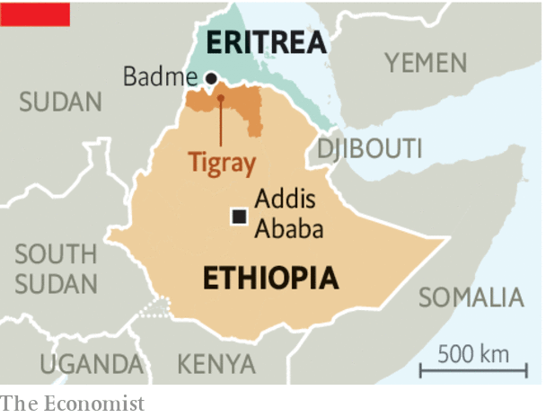

Start with the balance of forces. Because Tigray was on the front line of the war with Eritrea, it has a large militia and paramilitary force manned by veterans. The army’s Northern Command in Tigray contains more than half of the federal army’s fighting men and its best divisions, according to the International Crisis Group, an NGO. Many of the officers and men in the Northern Command are Tigrayan. If ordered into battle against their own region, many might choose to defend it instead.

Fighting in Tigray could draw in neighbouring Amhara, which has long-standing disputes over the border between the two regions. It could also fan ethnic conflagrations elsewhere in Ethiopia. Even though Oromos, another ethnic group, currently dominate the federal government, Oromo activists are demanding more power and autonomy for their region. Their mobs have been killing members of other groups in multi-ethnic towns and cities in Oromia. Amnesty International has reported that on November 1st Oromo gunmen rounded up 54 people, mostly women and children, and killed them in a schoolyard. Smaller ethnic groups, such as the Sidama in the south, are also agitating for greater autonomy and have mounted pogroms against minorities. Conflict could draw in neighbouring countries, such as Eritrea, which has a score to settle with the TPLF dating back to the war it fought with Ethiopia. And it could destabilise Somalia, where Ethiopian troops are battling the jihadists of al-Shabaab.

For almost 150 years since Emperor Menelik II waged the wars of conquest that created the borders of modern Ethiopia, the country’s various governments have used naked power to hold it together against the centrifugal forces of ethnic nationalism. Now, however, violence is more likely to speed up the gyre. To slow it, Abiy and the TPLF need to stand their forces down. That would allow time for Ethiopians to talk about how to mend their country’s many rifts—without shooting. ■

This article was downloaded by calibre from <https://www.economist.com/leaders/2020/11/07/ethiopias-prime-minister-may-be-starting-a-civil-war>

|  |  |  |  |
| --- | --- | --- | --- |
| Previous | Articles | Sections | Next |

|  |  |  |  |
| --- | --- | --- | --- |
| Previous | Articles | Sections | Next |

#### Financial markets

# How to fix the market for Treasury bonds

There is a danger that America’s financial plumbing cannot cope with surging government debt

Nov 7th 2020 |

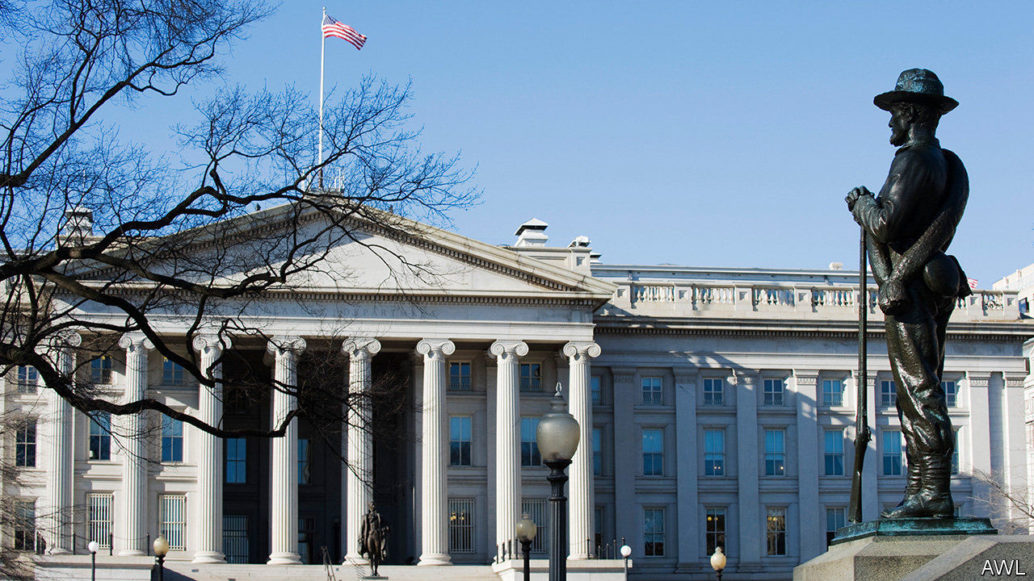

THIS HAS been an extraordinary year for American government debt. The Treasury market is usually the world’s most liquid bond market and a haven in stormy times. But in March it seized up as panic about the pandemic led to fire sales and failed trades. The Fed fixed the problem by buying, in two months, nearly as many Treasuries as it did during five years of quantitative easing after the global financial crisis. The market is now being drenched with new issuance as the federal government spends like mad. Since the start of April it has raised a net $3.3trn to fund its stimulus programmes, expanding the outstanding stock of bonds by 19%. Over the past week bond yields have seesawed as investors have weighed and reweighed the likelihood of more stimulus after the election.

An even more extraordinary decade lies ahead (see article). Regardless of whether a big stimulus is passed in 2021, the budget deficit will probably stay above 8% of GDP. An ageing population will continue to lift health-care spending. And with the Federal Reserve unable to cut rates much more, bigger deficits might be necessary to stimulate the economy during future downturns. A supersized bond market will amplify both the probability of more market stress and its consequences. Randal Quarles, the vice-chairman of the Fed, recently warned that the “sheer volume” of issuance means the market’s plumbing may come under strain. That could disrupt the government’s ability to borrow and cause tremors across the world’s financial system.

There are two fault lines. When Uncle Sam issues debt a group of middlemen known as “primary dealers”—mostly banks—are obliged to buy it up at “reasonably competitive” prices. Primary dealers also act as intermediaries for investors who wish to trade with one another. In a crunch Treasuries can pile up on dealers’ balance-sheets, causing them to swell and pushing the banks closer to breaching the capital requirements set by regulators. That makes it harder for them to act as intermediaries, and investors do not like trading without a big institution sitting in the middle. In the spring, as investors rushed to unwind their bets, primary dealers were overwhelmed.

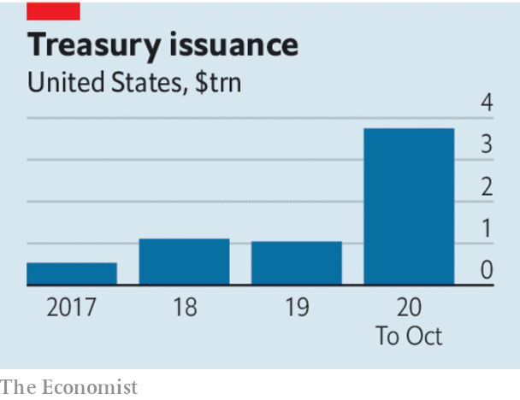

The second vulnerability is that the Treasury market is symbiotically connected with another crucial market: the one for “repo” lending, whereby banks and other financial firms borrow from one another by temporarily exchanging Treasuries for cash. Because primary dealers typically use repo transactions to fund their purchases of Treasuries, the two markets are closely linked. The repo interest rate is important to the economy (more so than the “federal funds” rate that the Fed officially targets) and anchors borrowing rates for businesses and households. But when Treasury issuance or the Fed’s operations suck cash out of the banking system, the repo rate can spike unexpectedly, catching policymakers off-guard. This happened in late 2019.

It would be wise to mend the pipes before the next torrent of issuance gushes down them. Some quick fixes are obvious. A temporary exemption of cash and Treasuries from banks’ leverage ratios should be made permanent. Banks should not have to hold capital against assets which are all but risk-free. And the number of primary dealers could also be expanded, so that it matters less if any one of them gets into trouble.

But it would be better still to implement a deeper overhaul. The primary-dealer system is needlessly complex and would never be designed from scratch today. It should be phased out in favour of a central clearing house for Treasury trades which would let smaller firms deal with each other without an intermediary clogging up the market. More debt issuance could take place without middlemen, too.

The Fed must also get a better grip on rates in the repo market, which influences the entire economy. Currently it puts a floor under repo rates but, in normal times, does not cap them. The answer is a “standing repo facility”, through which it would lend at its target interest rate to any counterparty that can provide short-term Treasuries as collateral. These Fed loans would pose little risk to the taxpayer. And with a firmer grip on rates the Fed would have less need to buy government bonds in a panic, a tactic which over time is destined to cause a political stink because it looks as if the government is being financed by the printing presses.

Dodgy financial plumbing is tricky to fix but it has the capacity to cause an almighty mess. It determines how well policy is being transmitted to the economy as a whole. As the pandemic leads to an epic amount of government borrowing and blurs the boundary between fiscal policy and the Fed, it is time for reforms to make the pipes safer. ■

This article was downloaded by calibre from <https://www.economist.com/leaders/2020/11/07/how-to-fix-the-market-for-treasury-bonds>

|  |  |  |  |
| --- | --- | --- | --- |
| Previous | Articles | Sections | Next |

|  |  |  |  |
| --- | --- | --- | --- |
| Previous | Articles | Sections | Next |

#### Voltaire’s heirs

# France is right to defend free speech

No one has a right not to be offended

Nov 5th 2020 |

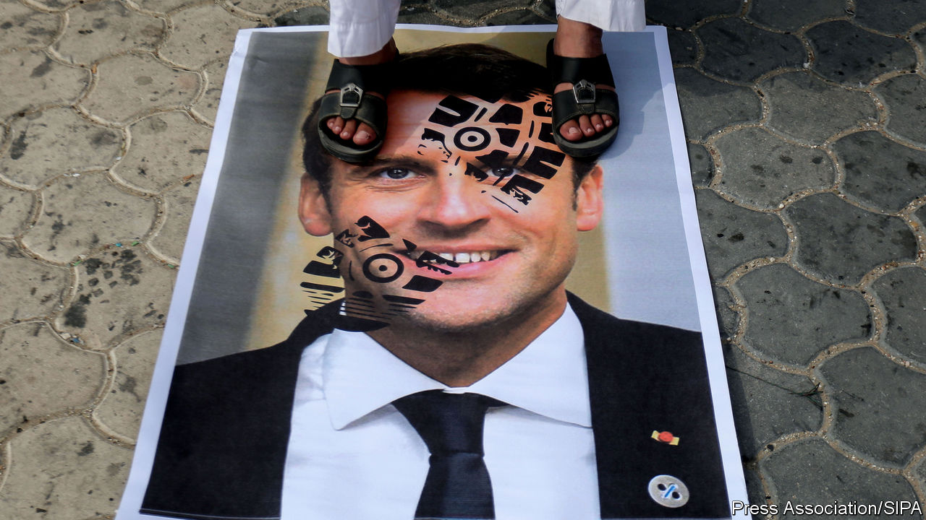

SAMUEL PATY told his pupils to look away if they might be offended. He knew that caricatures of the Prophet Muhammad are deemed blasphemous by Muslims. But since the images in question were published by Charlie Hebdo, a French satirical magazine whose staff were massacred by jihadists in 2015, they were also relevant to a class about free speech. The teacher thought his pupils old enough to decide for themselves. For this, he was beheaded.

In the age of social media, outrage can swiftly go global. The parent who denounced Mr Paty was not in the classroom, and lied when he said his daughter had been. The jihadist who killed the teacher did so after watching a Facebook video posted by that parent. And when Emmanuel Macron, France’s president, decried the murder and defended free speech, the leaders of several Muslim countries accused him of Islamophobia. Among them were Turkey’s president, who locks up thousands of Muslims for belonging to the wrong religious group, and Pakistan’s prime minister, who seems more upset by events in a classroom in France than in next-door China’s million-Muslim gulag.

Unscrupulous politicians have always stirred up racial or sectarian outrage to unite their supporters and distract attention from their own flaws. But some critics seem sincerely to believe that France is the cause, rather than victim, of jihadist attacks on its soil. They often point to its tradition of laïcité, or secularism. This was entrenched by law in 1905, after a long struggle with the Catholic church. It protects the right to believe, or not to believe, and separates religion from public life. No French president could be sworn in on a holy book. No French state school could stage a nativity play. Some feel that such rules discriminate against Muslims. A ban on “conspicuous” religious symbols in state schools includes the crucifix, but some Muslims still resent the fact that they (or their daughters) must remove their headscarves at the school gate. When Mr Macron recently announced a crackdown on signs of “Islamist separatism”, such as home schooling, which he sees as a pretext for radicalised teaching, he was accused of “weaponising” secularism against Muslims.

Most controversial of all for some Muslims, French law protects the right to blaspheme and to insult any religion—although not to discriminate against an individual on the basis of religious belief. Some see this, wrongly, as a French campaign to insult Islam. Boycotts of French goods and anti-Macron protests have taken place from Istanbul to Islamabad.

Discrimination against Muslims is a real problem in France, as Mr Macron implicitly concedes. Employers are more likely to bin their job applications. Mr Macron has vowed to fight racism, and improve opportunities for people in deprived neighbourhoods, “of whatever skin colour, origin, religion”. He will have his work cut out, even without his own ministers undermining him by griping absurdly about the existence of separate shelves for halal food in supermarkets.

Yet it is important not to lose sight of two points of context. First, more than 250 people have been killed in Islamist terrorist attacks in France since 2015. Last year more suspects of jihadist terrorism were arrested in France than in any other EU country. French intelligence services warn that radicals are waging a war for the minds of the young, especially online, to win recruits to violence. France is right to be more concerned than most, and to seek to respond firmly (see article).

Second, France is also right to defend free speech. A religion is a set of ideas, and therefore open to debate and even mockery. Considerate speakers will try not to give gratuitous offence. But governments should not compel them to be inoffensive. If they did, everyone would have to censor themselves, for fear of offending the most easily offended person in the audience. And as Mr Paty discovered, an audience can include anyone on Earth with a phone.

The French state should never give the impression that it endorses blasphemy, but it is right to protect blasphemers, just as it is right to protect those who complain about them, so long as they do not advocate violence. As many thoughtful Muslims in France and elsewhere have pointed out, no matter how offended you feel, the answer to speech is not knives: it is more speech. ■

This article was downloaded by calibre from <https://www.economist.com/leaders/2020/11/05/france-is-right-to-defend-free-speech>

|  |  |  |  |
| --- | --- | --- | --- |
| Previous | Articles | Sections | Next |

|  |  |  |  |
| --- | --- | --- | --- |
| Previous | Articles | Sections | Next |

#### 5G technology

# Is there an alternative to Huawei?

OpenRAN could be it

Nov 7th 2020 |

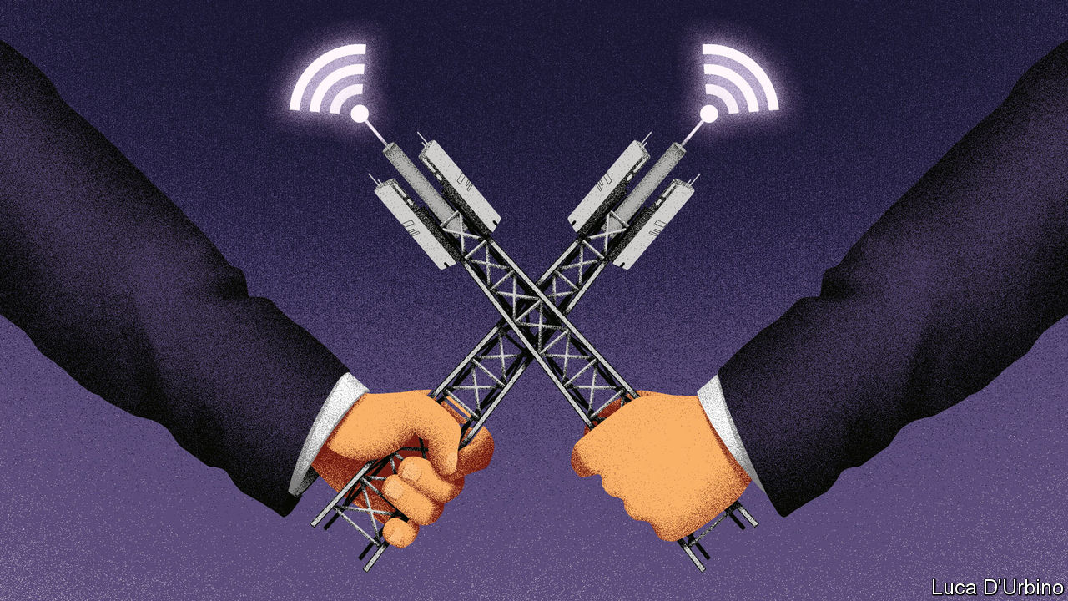

THE SIGNAL was easy to miss amid the noise of new lockdowns and America’s elections. Earlier this week, Vodafone, a mobile operator, announced that in Britain it would use a technology called OpenRAN to replace some gear made by Huawei, a Chinese firm whose products are considered too much of a security risk to be used in the new 5G mobile networks. It is a sign that the much-discussed Huawei dilemma is not as intractable as it may seem—and a reminder that OpenRAN deserves more private-sector and government support.

In recent years America has conducted a campaign against Huawei, which it worries poses a threat to Western interests and which has built a commanding position in 5G systems globally. Australia, Canada and Japan have already in effect banned Huawei from their 5G networks. In July Britain said it would phase out its gear, and on October 20th Sweden said it would impose a ban, too. More countries may follow.

The trouble is that the costs of ditching Huawei are high: you risk becoming reliant on two big Nordic firms, Nokia and Ericsson, the other main suppliers of 5G gear. In the long run a duopoly is bad for competition and innovation. And in the short run neither firm is infallible. Nokia, in particular, is in trouble. On October 29th it announced a drop in sales of 7% year on year, and its shares plunged by almost 20%. Its new boss said that it had been “clearly behind” on 5G.

OpenRAN is an alternative to relying on either Huawei or the Nordic duo. Along with a related technology called network virtualisation, it changes the rules of the game. To understand why, compare an old tethered telephone with a modern smartphone. One is a dedicated piece of hardware made of customised parts, whereas the other is a general-purpose computer controlled by software that can accommodate any type of app, provided it complies with certain technical rules.

Similarly, conventional mobile networks are made out of specialised equipment, whereas the new OpenRAN kind use mostly off-the-shelf hardware, with lots of code defining what it can do. Because all the gear connects up using standard interfaces, carriers can mix and match products from different suppliers—something that they cannot do today. Operators have more insight into what is going on in their networks and can avoid components they do not trust, such as Chinese chips. They could also save a lot of money and become quicker on their feet.

OpenRAN is gaining momentum. Last month Rakuten Mobile launched the world’s first 5G network based on OpenRAN—which helped the Japanese carrier cut investment by 40% (see [Schumpeter](https://www.economist.com/node/21795190)). It can also put together new services within minutes instead of months, as is the case with conventional networks. In September Telefónica, which has 260m mobile subscribers in Europe and Latin America, teamed up with Rakuten to deploy OpenRAN more widely in its networks by 2025. In America Dish has started to build a 5G network based on the technology. With the notable exception of Huawei, even equipment-makers are coming on board. Ericsson has just announced its first related product.

Yet OpenRAN still has problems. The supply chain is untested and may face bottlenecks if demand suddenly surges as more mobile operators sign up. Notwithstanding its roll-out in urban parts of Japan, experts fear that the technology may not yet function well in densely populated cities; most carriers, including Vodafone, want to test it in rural areas first. Integrating the many different products that make up an OpenRAN network is hard. And although the technology lowers the potential security threat from China, it creates new openings for hackers.

All this means that governments still have a role to play. They should help tackle bottlenecks by, for example, encouraging investment in the development of specialist chips that power antennae, as well as laboratories that test integration of a network’s components, as lawmakers in America have proposed. They should also follow Japan by promoting a common set of standards among equipment-makers and network-operators that deals with security and mandates at least some compliance with OpenRAN. The choice between relying on a monolithic Chinese firm that is not fully trusted or on a doddery Western duopoly is a rotten one. It would be a lot better to give a new type of technology a chance to thrive.■

This article was downloaded by calibre from <https://www.economist.com/leaders/2020/11/07/is-there-an-alternative-to-huawei>

|  |  |  |  |
| --- | --- | --- | --- |
| Previous | Articles | Sections | Next |

|  |  |  |
| --- | --- | --- |
| Leaders | Sections | Briefing |

Letters

Letters to the editor: On nature, the Arctic, John Kennedy, Covid-19, Taiwan, culture, capitalists, Berlin, Albanians

.

|  |  |  |
| --- | --- | --- |
| Leaders | Sections | Briefing |

|  |  |  |  |
| --- | --- | --- | --- |
|  | Articles | Sections | Next |

#### On nature, the Arctic, John Kennedy, Covid-19, Taiwan, culture, capitalists, Berlin, Albanians

# Letters to the editor

A selection of correspondence

Nov 7th 2020 |

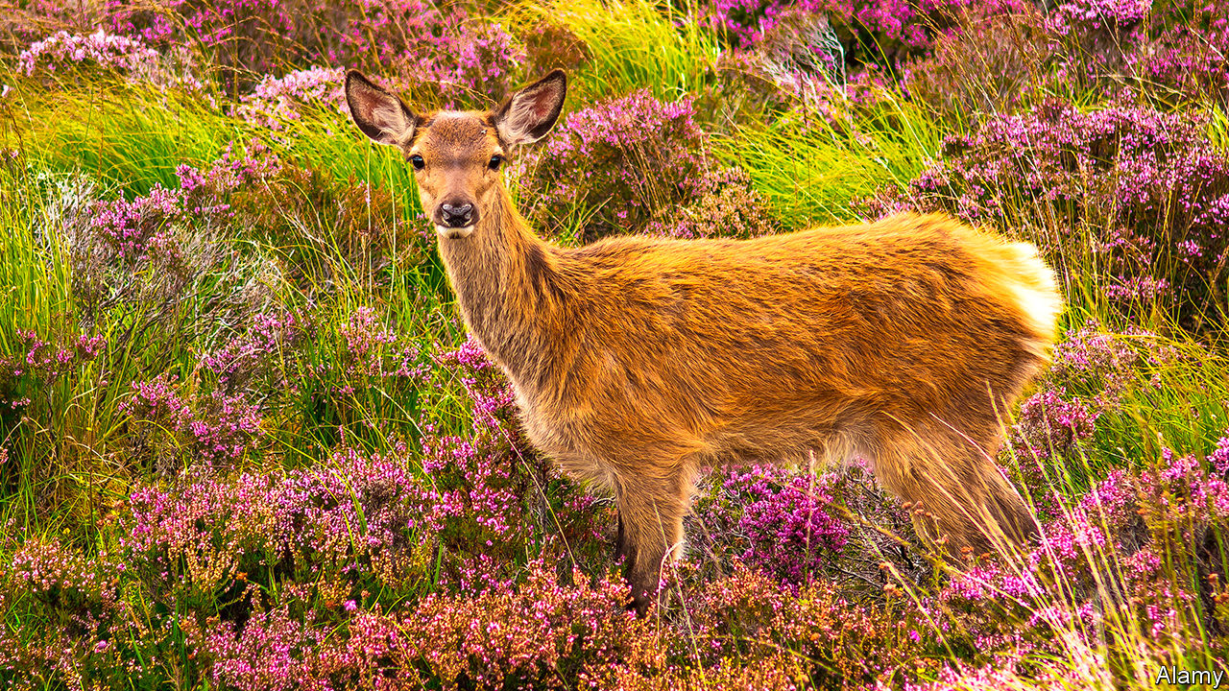

Letters are welcome via e-mail to letters@economist.com

## What is nature?

Your use of quotation marks around “natural” shows the strange turn that word has taken. But your analysis of the rewilding of Scotland missed a deep irony in the effort to create a landscape purified of human influence (“[In their sights](https://www.economist.com/britain/2020/10/03/rewilding-in-the-scottish-highlands)”, October 3rd). This concept of natural excludes humans, but at the same time envisages a highly managed, human-constructed landscape achieved by human processes, undertaken for human goals, and based on the best human guess of what those landscapes used to be like.

The reality is that it is impossible to go back. Whatever natural world existed before humans is lost to us for ever. What is created in the project of rewilding is but a simulacrum of the prehuman ideal.

In addition, this concept of “natural” morally bypasses issues of justice. This is an exercise of the hyper-wealthy, with a contempt for the lives of people, plants and animals whose home this has been for millennia. It could be described as a project in environmental colonialism, where those enlightened, wealthy few civilise the locals or take their land in order to make the world as it should be.

Rewilding is also selective about what is part of “real nature” and should thus be saved or recreated, and what is unnatural and can be disposed of. This project requires the killing of thousands upon thousands of animals, namely deer. One would hope in the very least that these animals will be properly processed and eaten, but even still they remain a waste product in the pursuit of a “natural” Utopia.

None of this is to say that it is inherently wrong for humans to cultivate and shape environments. But let us call rewilding what it is: another attempt to manage our natural environment for specifically human goals. It should thus be morally evaluated and debated like all other human projects and goals, with reference both to the human and environmental impact. It is this, and not some mystical prehuman status, that makes it properly natural.

ROBYN BOERÉ  
Associate lecturer in Christian ethics  
University of St Andrews

NEIL STANGE  
Professional agrologist  
St Andrews, Fife

## Finding north

In my earlier letter ([October 31st](https://www.economist.com/letters/2020/10/31/letters-to-the-editor)) I erroneously identified the northernmost point of contiguous land in the “New World” as Point Barrow, Alaska. That is the northernmost point of the United States. The correct northernmost point of mainland North America is in fact Murchison Promontory, marking the extremity of the Boothia Peninsula in the Bellot Straights, Nunavut.

KEN HEDGES  
Barrie, Canada

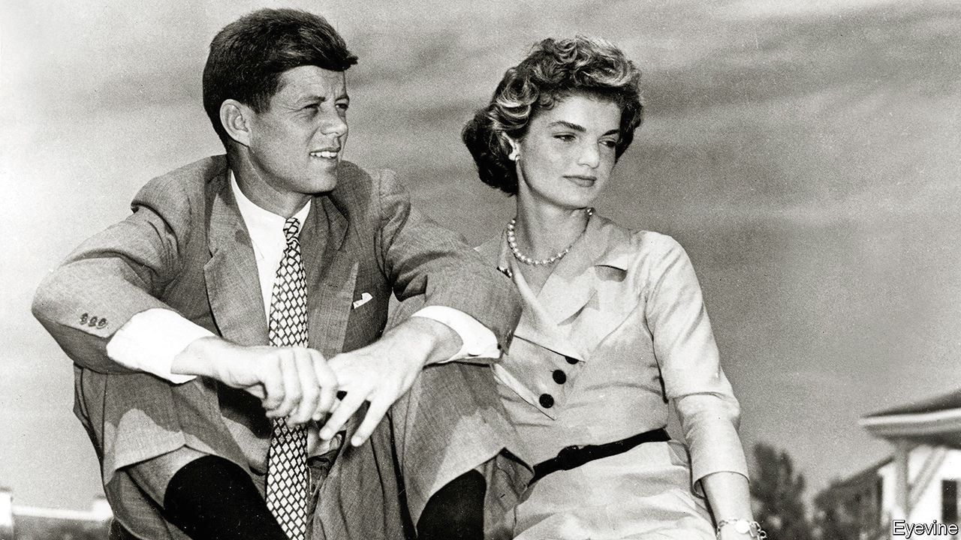

## Born to be president

Your review of Fredrik Logevall’s biography of John Kennedy did not persuade me that it succeeds in deflecting “myths” about the family (“[The road to Camelot](https://www.economist.com/books-and-arts/2020/10/17/a-masterful-biography-of-jfk-is-a-reminder-of-imperilled-ideals)”, October 17th). On Joseph Kennedy, you say “it’s not every multimillionaire father who takes such broad interest in his children” and “instils in them a firm commitment to public service.” It isn’t every millionaire, perhaps, but I’m not sure that grooming your children to become the president of the United States counts as instilling in them a commitment to public service.

John Kennedy himself is “cursed by a sense of entitlement”—poor Jack, what a cross to bear. Can there ever have been a more self-aggrandising book than JFK’s “Profiles in Courage”, which your reviewer regards simply as a reflection on the role of leadership. In reality it was a first step in staking a claim to become leader of the democratic world.

As for the assertion that the Kennedys “had every reason to hate America’s WASP elite”. Hardly. As the review makes clear, they had not just beaten but joined that self-same elite to their own enormous advantage.

ANDREW CLIFFORD  
London

Covid-19 in China  
* [Chaguan](https://www.economist.com/china/2020/10/17/china-calls-its-heroic-handling-of-covid-19-proof-of-its-wisdom) made groundless accusations against China’s handling of covid-19 by once again referring to cover-ups and blaming China for the outbreak (October 17th). The Chinese government and people took swift action to control the disease, making enormous sacrifices. The country managed to contain the rapid spread of the virus in just over a month. In about two months, the daily increase in domestic cases fell to single digits. Meanwhile, a decisive victory was secured in Wuhan, once the hardest-hit Chinese city, in just about three months. Sporadic outbreaks have been contained.  
  
Acting with transparency and responsibility, China has been releasing pandemic-related information in a timely manner. China informed the WHO and the international community of the outbreak, and was the first to release the genome sequence of the virus and the first to share information on control and treatment. Because of our strict prevention and control measures, China prevented hundreds of thousands of infections, containing and slowing down the spread of covid-19.   
  
China supports a review into the outbreak of this new disease led by the WHO at an appropriate time in order to promote international co-operation on health. When such challenges arise again, the world will be better equipped to safeguard life.  
  
 But there was no cover-up. There was no delay. China’s record is clean. It will stand the test of time and history.  
  
ZENG RONG  
Spokesperson of the Chinese embassy  
London

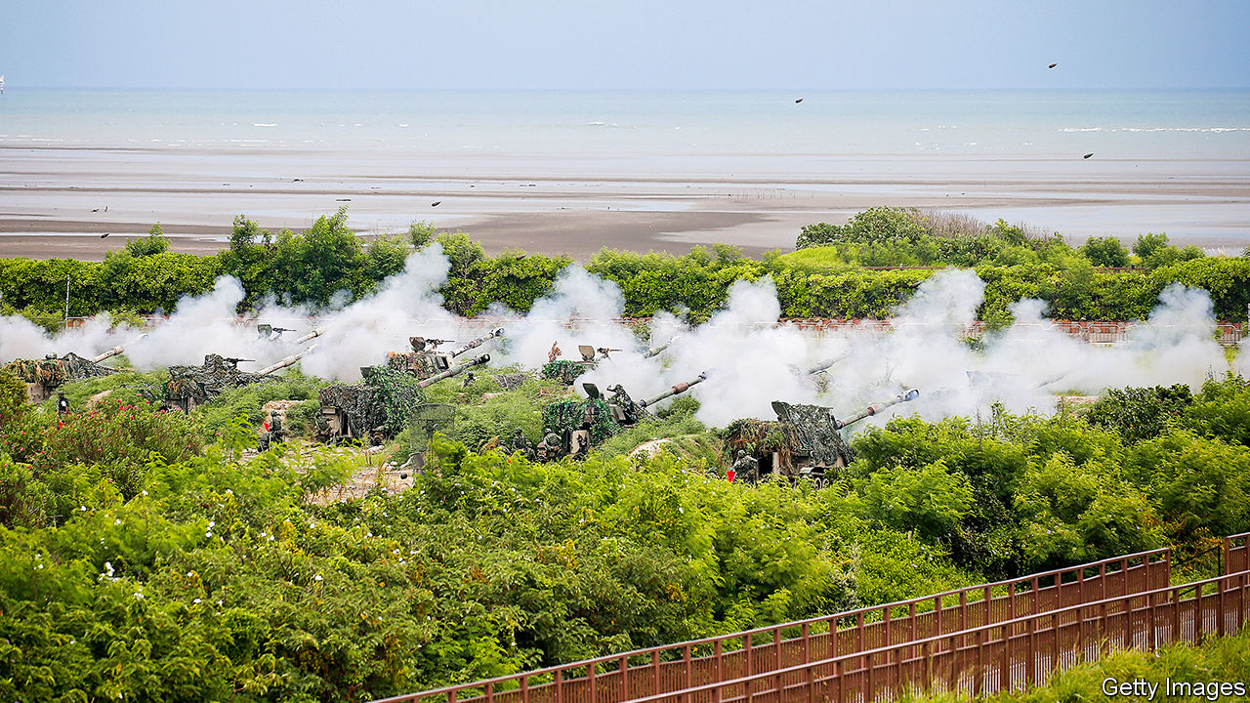

## Protecting chips

Setting aside the fact that the civilised world has an obligation on moral grounds not to sit idly by and watch Taiwan fall into the hands of China (“[Strait shooting](https://www.economist.com/asia/2020/10/10/defending-taiwan-is-growing-costlier-and-deadlier)”, October 10th), it is also a matter of national interest for nearly every country in the world. German cars, French telephony networks, British chipmakers, American smartphones, Japanese robots, and almost every other product we rely on rely in turn on the Taiwan Semiconductor Manufacturing Company. You pointed out its importance in an article last year (“The pivot”, December 21st 2019). The world may run on data, “the new oil”, but data are processed on TSMC’s chips.

HAROLD DEE LEAN  
Hsinchu, Taiwan

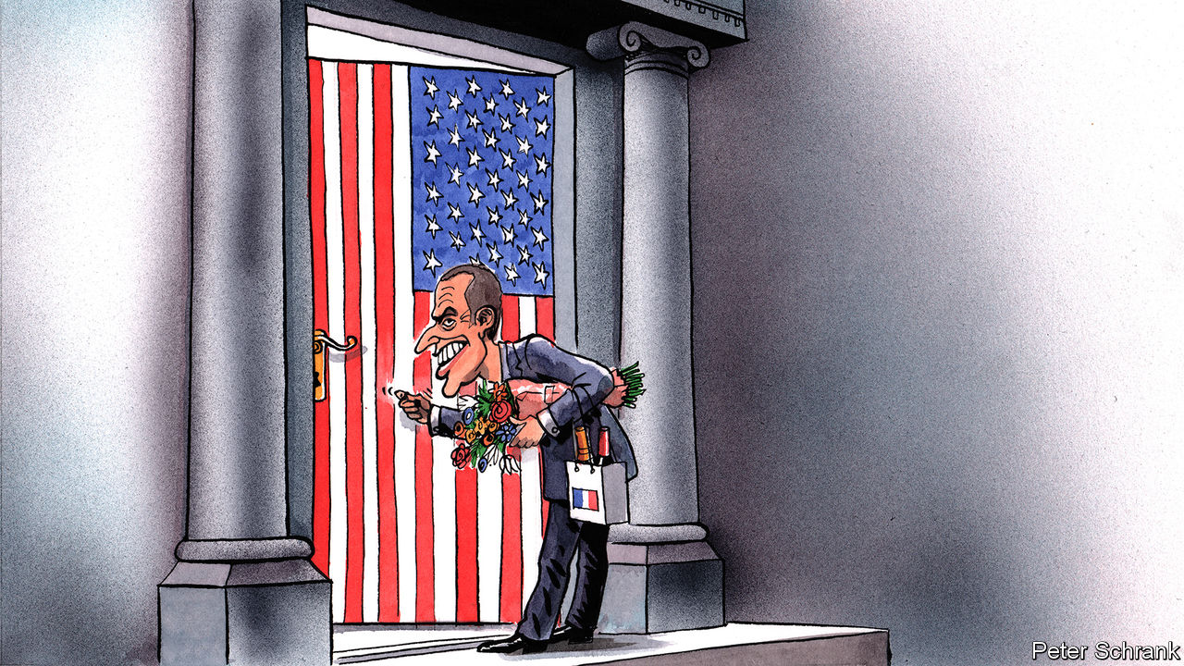

## Ode to joy

“What exactly is European culture?” asks [Charlemagne](https://www.economist.com/europe/2020/10/31/a-biden-presidency-would-offer-emmanuel-macron-a-tempting-opportunity) (October 17th). That there is such a thing as European culture seems undeniable. The inhabitants of Europe have shared Roman occupation, conversion to Christianity, the Renaissance, the Reformation, the Enlightenment, the French Revolution. They may have reacted to some of these in massively different ways, but the depths of consciousness they stirred are very widespread. Indeed, the European Union could one day become, like China, “a civilisation state”. This is not even to mention music, painting, architecture (before and after Bauhaus). There is no need to be self-conscious about this; European culture is at a state of maturity where development simply happens. One does not need to define it, only live it. So says one who must regretfully soon view this process from the outside.

ANTONY BLACK  
Dundee

With regard to the EU’s plans to take up cultural projects, you seem to have forgotten that the organisation has very capably turned Beethoven’s 9th Symphony into Eurokitsch.

J.A. HOULDING  
Nuremberg, Germany

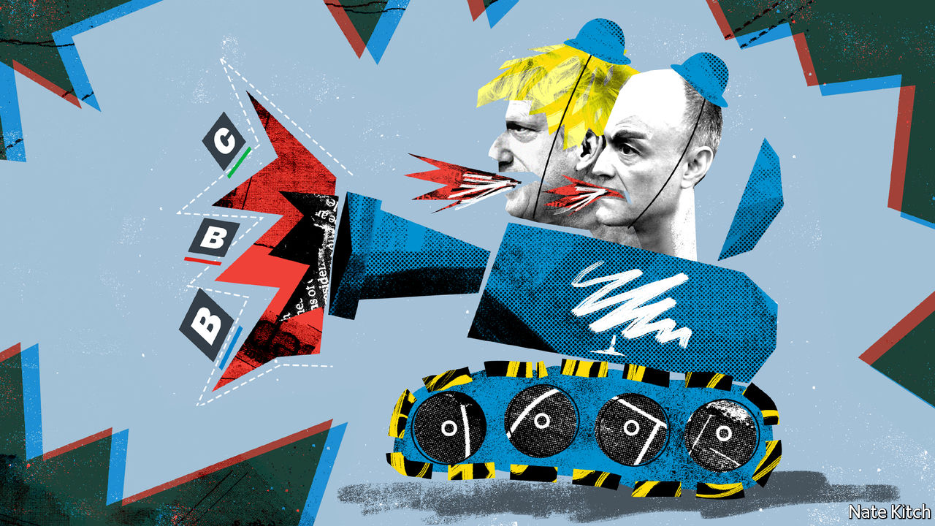

## Capitalist lives matter

I enjoyed [Bagehot’s](https://www.economist.com/britain/2020/10/03/the-tories-launch-a-culture-war) insightful column on the Tories’ new culture war, until he claimed that banning anti-capitalist material in schools is wrong (October 3rd). As a lifelong capitalist I’m keenly aware that there is precious little taught in schools in favour of capitalism these days to level up against the considerable anti-capitalist propaganda that pervades all aspects of Western cultural life. I can only assume you think anti-capitalist literature is okay because we are a much smaller minority than most others. You must educate yourself on the need to protect us as much as any other group.

NICK WALKER  
Burnley, Lancashire

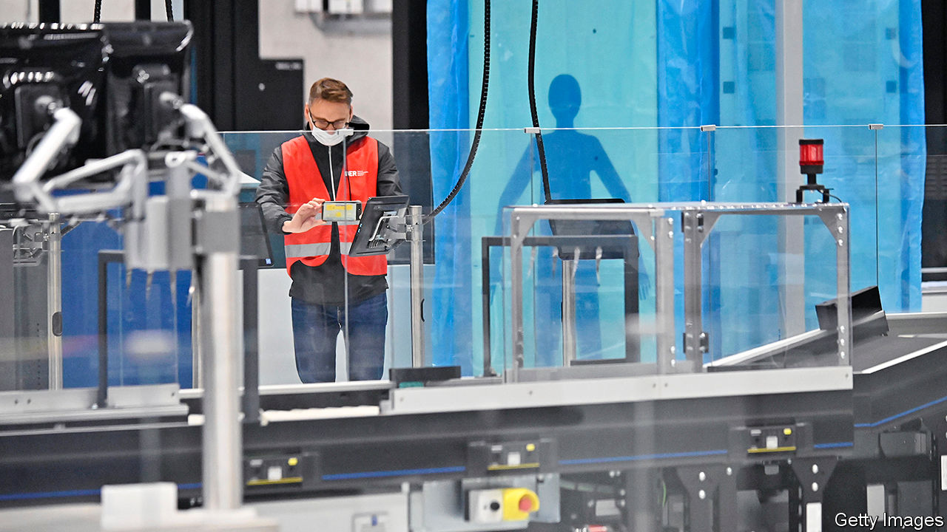

## Now open for business

You noted the many failings of the new Berlin Brandenburg Airport (“[It’s built, but will they fly?](https://www.economist.com/europe/2020/10/17/berlins-long-delayed-airport-is-finally-opening)”, October 17th). I chuckled when I realised that its designated airport code, BER, is also an acronym used in manufacturing to mean Beyond Economical Repair.

PHILIP NAGLE  
Dublin

## Comedy gold

There are more to “[The Albanian all-stars](https://www.economist.com/europe/2020/10/03/what-do-dua-lipa-rita-ora-and-ava-max-have-in-common)” (October 3rd) than Mother Teresa and Enver Hoxha. John Belushi was also of Albanian heritage. So, along with the saint and the sinner you also have the silly samurai.

DAVID GILEFSKI  
Wilmington, Delaware

* Letters appear online only

This article was downloaded by calibre from <https://www.economist.com/letters/2020/11/07/letters-to-the-editor>

|  |  |  |  |
| --- | --- | --- | --- |
|  | Articles | Sections | Next |

|  |  |  |
| --- | --- | --- |
| Letters | Sections | United States |

Briefing

Covid-19 in Europe: The relapse

.

|  |  |  |
| --- | --- | --- |
| Letters | Sections | United States |

|  |  |  |  |
| --- | --- | --- | --- |
|  | Articles | Sections | Next |

#### Once more, with dread

# The second wave of covid-19 has sent much of Europe back into lockdown

When it emerges it will need to do better

Nov 7th 2020 |

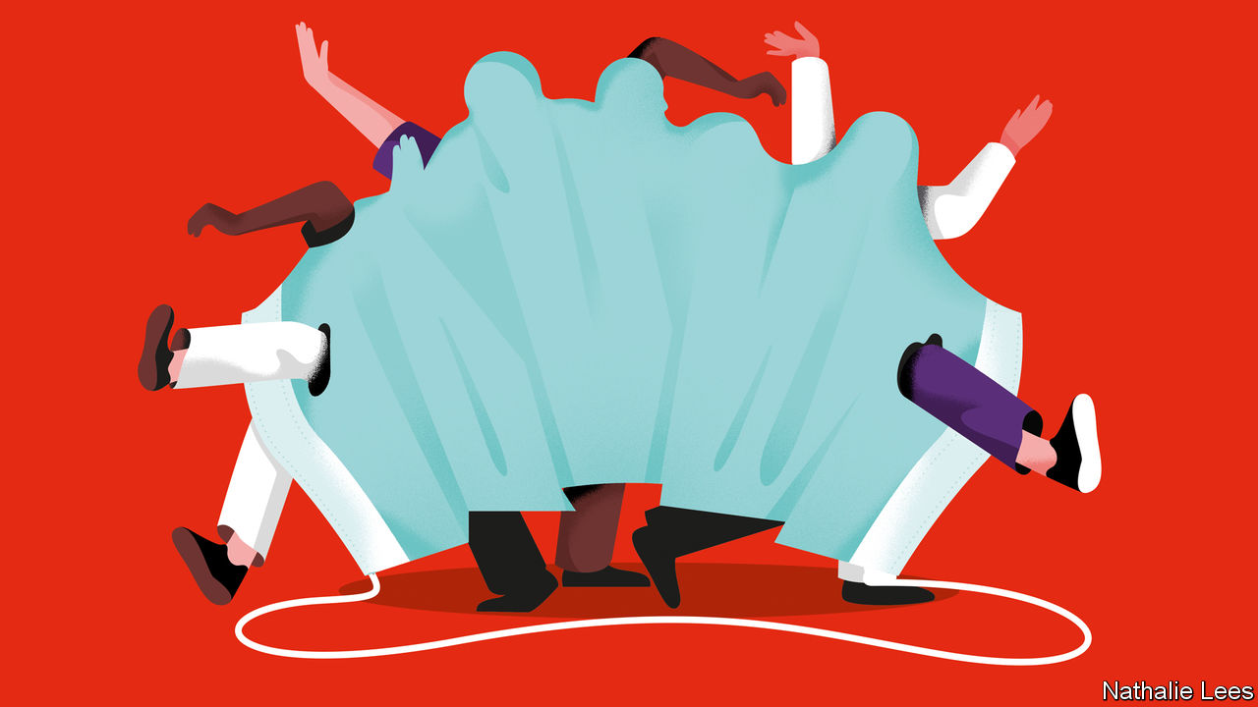

Editor’s note: Some of our covid-19 coverage is free for readers of The Economist Today, our daily [newsletter](https://my.economist.com/user#newsletter). For more stories and our pandemic tracker, see our [hub](https://www.economist.com/news/2020/03/11/the-economists-coverage-of-the-coronavirus)

IN THE EARLY days of the covid-19 pandemic doctors were befuddled by a peculiar phenomenon: some patients ill enough to be admitted to hospital seemed at first to respond well to treatment, recovering almost enough to be discharged, before suddenly deteriorating again. Europe is now recapitulating that sad trajectory on a continental scale.

When the initial onslaught of covid-19 threatened to swamp their intensive-care wards back in spring, many European countries implemented lockdowns that greatly constrained all sorts of activity. Case numbers duly dropped, covid wards began to empty and in time the restrictions were eased. In the summer that followed infections started to inch up without causing a great deal of alarm. Then, in October, the epidemic exploded again (see chart 1). Today cases are doubling across the continent every two weeks—a rate of growth not far short of that seen in March.

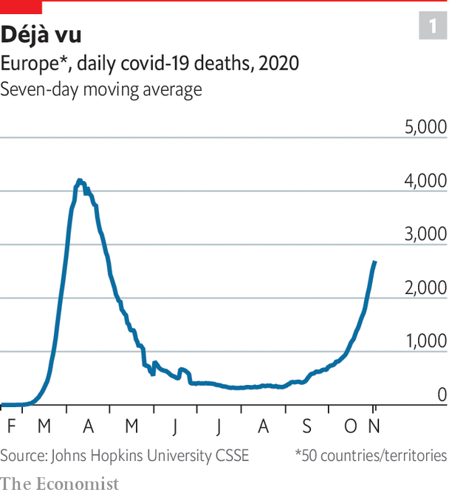

The sudden upturn shows the nightmarish realities of exponential growth at work. At low caseloads you can put up with two-week doublings for a while. But once an outbreak becomes appreciable, a month that sees four-fold growth is like a kick in the teeth—and still leaves you expecting twice as many cases as you have today in a fortnight’s time.

Belgium is learning this the hard way. Its hospitals, which doubled their intensive-care capacity in preparation for a second wave, were nevertheless half full by October 26th; they are expected to run out of beds by November 6th. Before their recently announced lockdowns France and Switzerland looked set to follow by mid-November. Scientists advising the British government showed it modelling suggesting that, in the absence of something like a lockdown, the National Health Service would reach breaking point in December, when the number of covid patients would exceed the “surge capacity” in the field hospitals set up in the spring.

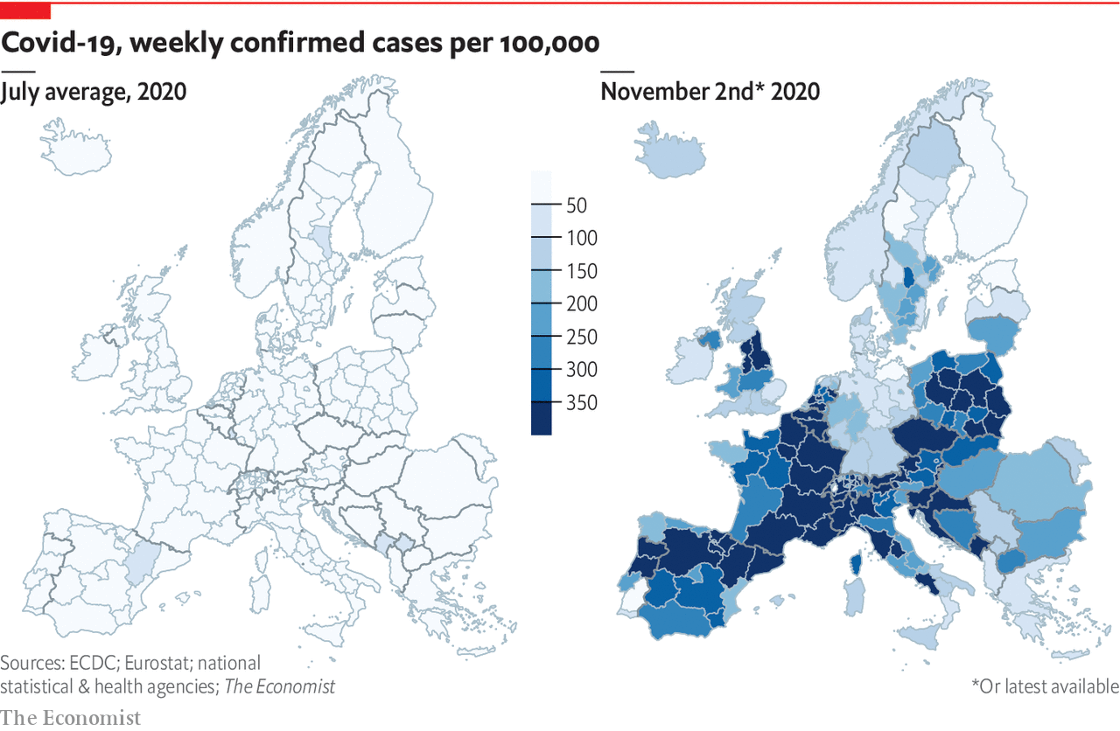

As the scope of the incipient disaster has dawned on them, ashen-faced leaders have told their citizens that they have little choice but to reimpose lockdowns of various sorts. By November 5th, 20 countries had shut gyms, restaurants, museums and other public venues, introduced curfews, banned people from going out for non-essential business or all of the above. France has gone furthest, forbidding all social gatherings and clamping down on sorties outside the home for anything but food, medicine or schooling. But even Sweden, champion of a light-touch approach, called for new curbs on November 3rd, limiting the size of groups in restaurants and discouraging meetings between households.

In general, the most striking difference between these measures and those of the spring is that most schools and universities are staying open. The second most striking is that this time it is winter, not summer, that is coming, with all that means for the inhospitality of outdoors activity and the stir-craziness of being cooped up.

In terms of buying time, these lockdowns are unlikely to be as successful as the first round, during which restrictions were stronger and the people locked down less weary of restrictive precautions. This reinforces the need for governments to make better use of whatever time they do manage to buy.

Asian nations, some democratic, some not, have proved it possible to force infection rates so low as to more or less eradicate the disease. But when they came out of their first lockdown European countries were unwilling to impose the strictures they thought would be necessary for true eradication. Many doubtless thought that their citizens would not put up with them. They chose instead a strategy in which various not-too-onerous modifications in everyday behaviour would keep the level of infection low enough for their health systems to be able to cope.

This strategy of containment has, unfortunately, proved fragile. But it remains the only one that most European nations see as viable. When the current lockdowns run their course, they need to follow it better. New tools may help them do so. Cheaper and quicker tests are already becoming available, and fairly soon there may be antibody and other treatments which, given early, reduce the risk of severe disease, and which might even offer some degree of prophylaxis. There could also be a significant boost to morale if, during the lockdowns, vaccine trials provide good news. Seeing a fairly near-term way out of the bind may make people more willing to submit to constraints in the meantime.

## Clad in black mortality

But not everything can be put right with more effective and appropriate interventions and a dash of hope. Policies that meet the need for containment are vital; and they have to be communicated, and carried forward, in ways that generate public trust, and thereby compliance.

A large part of the reason for the resurgence is that the policies Europe put in place to keep the disease manageable did not take full account of its peculiarities. The number of others to whom an infected person will pass the covid virus varies a lot (see [Graphic detail](https://www.economist.com/node/21795133)). Most will not pass it on to anyone; a few will pass it on to many. It is estimated that just 10-20% of infected people account for about 80% of subsequent infections, with those subsequent infections often occurring in clusters. The biggest clusters are spawned in crowded spaces, especially those where ventilation is poor or people talk loudly to others at close range.

In Japan, this aspect of the disease was appreciated from the outset, in part through studies of the outbreak on Diamond Princess, a cruise liner, says Oshitani Hitoshi, a virologist at Tohoku University who sits on the national covid-19 task force. As early as March the Japanese government began warning its citizens to avoid the “3Cs”: closed spaces, crowded places and close-contact settings. This was on top of a near universal use of face masks, to which the Japanese, like many other Asians, were already well accustomed.

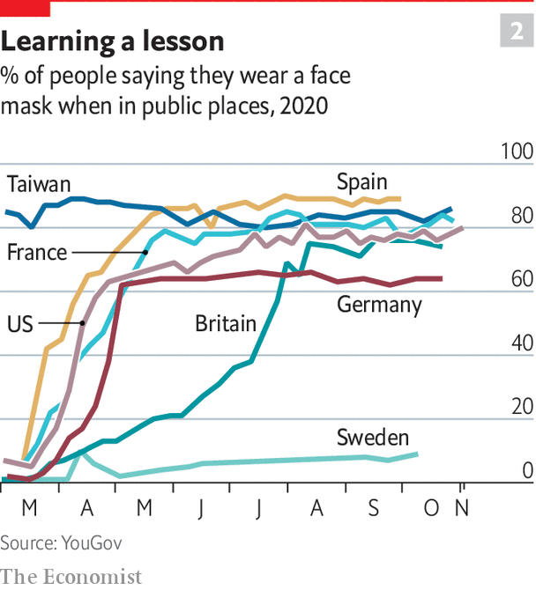

The 3Cs message was far less clear in Europe. Public-health authorities stressed continued mask-wearing, which increased almost everywhere, reaching Asian levels quite early on in Italy and Spain (see chart 2). Yet many countries also allowed bars and nightclubs to re-open with no strings attached. In parts of eastern Europe, where the current outbreak is particularly bad, football fans were filling up stadiums even as cases were on the rise.

Holidays abroad did a lot of damage, too—as they had in the initial outbreak. Many of the European chains of transmission mapped in February and March turned out to have originated in Alpine ski resorts. Studies of viral genomes show that much of the current outbreak can be tracked back to holidaymakers from around the continent mingling in Spain.

European countries tried to limit cross-border contagion by requiring people returning, or arriving, from places deemed high-risk to quarantine themselves. But there were lots of such travellers and enforcement was lax; no one knows how many actually complied. No European country has enforced such measures in the way that Australia, New Zealand and various East Asian countries have, confining incomers to hotels or barracks.

If test-and-trace systems worked across borders this might matter less. But these systems are, for the most part, each limited to a single nation, making it impossible for them to get to grips with international transmission. They are also, for the most part, not terribly good, and as caseloads have grown their shortcomings have been mercilessly exposed. Only 23% of those tested in person in England over the week to October 22nd received results within 24 hours, down from 93% at the end of June. And just 45% of those testing positive received a call from a contact tracer within a day of their diagnosis, down from around 80% over the summer.

Even Germany, which has had one of Europe’s best test-and-trace systems, is now struggling. Its contact tracers have the capacity to do follow up on all cases as long as the number of infections stays below 50 per 100,000 population per week. The national infection rate exceeded that limit on October 21st; it now stands at around 125. Today three-quarters of new infections in Germany can no longer be adequately traced to their source, Angela Merkel, the German chancellor, told her fellow citizens on November 2nd. This, she said, was why the country had to return to lockdown, albeit a “light” one: bars, gyms and entertainment venues are closed and restaurants limited to takeaways; shops, offices, schools and factories remain open.

Mrs Merkel delivered her message with a certain amount of reproach. “There was a lot of negligence”, she said, in Germany’s “carefree summer”. Some younger Germans and other Europeans, aware that the disease poses much less risk to them than it does to older generations, acted as though its spread through their cohort would be without too much consequence. Over time, though, the virus crosses generational boundaries just as it does geographic ones (see chart 3).

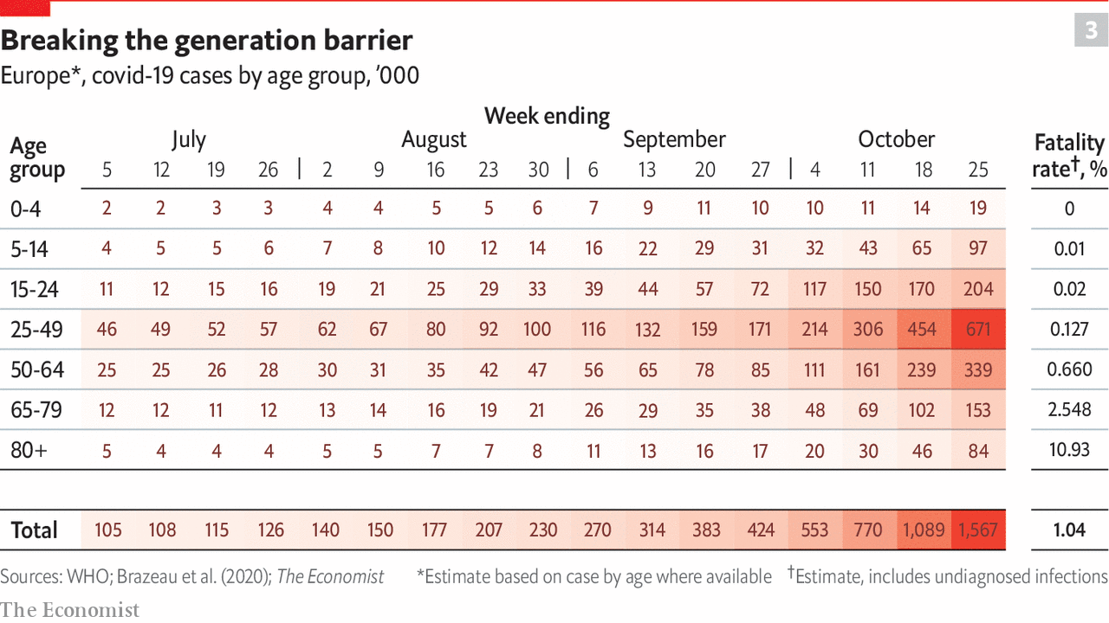

When the new lockdowns come to an end—most are envisioned as lasting for a month or so—many public-health officials plan to make use of a tool not available back in the summer: cheap testing kits which provide results in 15-30 minutes. In principle these offer a wealth of advantages. Using them to ramp up the rate of testing could, by finding new infections wholesale, reduce the burden on contact tracers.

They could also be used to confirm whether someone found through contact tracing is indeed infected. If individuals asked to self isolate could test themselves before deciding to mix again—a development that would require antigen testing to be licensed for home use, as pregnancy tests are—many of them would, and those who tested positive would be likely to act accordingly. This would reduce transmission by people without symptoms. If new drugs become available which, taken early on, reliably improve the prognosis, such self testing would benefit the individual as well as society.

## The rock of reason

Until now, testing in rich countries has relied almost entirely on PCR tests which detect tiny amounts of the RNA on which the covid-19 virus stores its genome. Such tests are the gold standard for diagnosis, but they have to be done in laboratories and typically take hours. Tests which look instead for viral proteins—“antigens”—are quicker and cheaper. They are also less accurate, missing about a quarter of the infections PCR picks up. But the cases they miss are mostly in the early or late stages of infection, when people are thought to be less contagious.

In mid-October Germany’s testing strategy was expanded to include antigen tests which, at €10 ($12) a pop, are around a quarter the price of a PCR test. About 10m such antigen tests are now available every month. They are being used to enable safe visits to hospitals and care homes. America has placed orders for 150m such tests, which are also being sent to care homes and other high-risk places. And for developing countries, a global procurement fund led by the World Health Organisation has cut a deal for 120m tests at a ceiling price of $5 apiece. Many experts expect prices to drop further, perhaps as low as $1—the current price point for rapid malaria tests that use similar technology.

On November 6th, the day after its national lockdown begins, Britain will begin trying out “whole city” testing in Liverpool, where the infection rate is currently particularly high. A combination of PCR and antigen tests sufficient to test the whole population is being laid on, and everyone living or working in the city will be encouraged to avail themselves of the opportunity. The idea is to gain experience of the approach so that after the lockdown is over it can be used to avoid the need for a repeat.

Slovakia, where infections took off in October, is trying something similar to avoid the need for any lockdown at all. On the last weekend of October it undertook a testing drive meant to cover everyone over the age of ten. Soldiers and volunteers were recruited to swab the noses of the 3.6m people (66% of the population) who turned up. The exercise will be repeated over the weekend of November 7th-8th. If the infected self isolate effectively, the procedure could offer much of the benefit of a lockdown with a lot less economic cost.

How well the Liverpool and Slovakia experiments work will go some way to showing whether rapid testing can indeed be a game-changer. To bear out its promise, though, it will need a context in which isolating after a positive test (some of which will be false alarms) is tolerable. Adam Briggs of the Health Foundation, a British think-tank, notes that growing numbers of local-authority contact-tracing teams are now also offering help—be it with shopping, prescriptions or just company—to encourage those who have tested positive to isolate. More countries are now offering some reimbursement for lost wages to such people.

Another route to easier compliance is shortening the quarantine period to fewer than the 14 days recommended by the World Health Organisation. In the vast majority of cases the first week or so is the most infectious period, which is why France and Sweden have already cut the period to one week and other countries are mulling over a reduction to ten days. Rapid testing to show that the infectious period has passed would make such approaches safer.

David Heymann of the London School of Hygiene and Tropical Medicine believes that the best approach is to inform people of the risks and let them decide how to protect others and themselves, rather than imposing blunt lockdowns against which people are likely to rebel. There is some evidence from Britain that he is right. In September, only 19% of 18- to 24-year-olds surveyed in England claimed that they adhered to the rules completely; in October, as transmission picked up again, a third said they were following all the rules.

Many people in Europe are dealing with the pandemic like one 29-year-old Londoner, who characterises the official restrictions on socialising as “suck it up or you’re killing granny”. He has devised his own set of rules, avoiding contact with over-40s—including all of his family—but socialising relatively freely with friends his age. “I’m taking these decisions based on caring about people, not the letter of the rules,” he says. “I have a flat that is well sound-insulated and you can get people in and out discreetly.” Such an attitude might be fine if all those entering and leaving discreetly hold themselves to the same standards. As yet, though, such consistency had not been a hallmark of Europe’s response. ■

This article was downloaded by calibre from <https://www.economist.com/briefing/2020/11/07/the-second-wave-of-covid-19-has-sent-much-of-europe-back-into-lockdown>

|  |  |  |  |
| --- | --- | --- | --- |
|  | Articles | Sections | Next |

|  |  |  |
| --- | --- | --- |
| Briefing | Sections | The Americas |

United States

The presidential race: Hello, 46

.

Congress: Spell unbroken

.

Polling error redux: Whiffing twice

.

Election lawsuits: Courting the presidency

.

Governorships and ballot initiatives: The covid races

.

Lexington: Trump and Trumpism

.

|  |  |  |
| --- | --- | --- |
| Briefing | Sections | The Americas |

|  |  |  |  |
| --- | --- | --- | --- |
|  | Articles | Sections | Next |

#### The presidential election

# America changes course, while remaining very much the same

A familiar election story unfolds

Nov 7th 2020 |

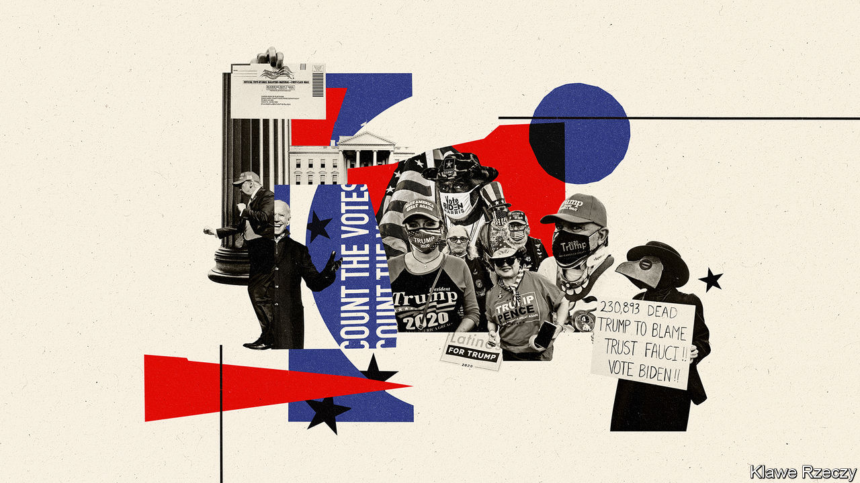

LIU XIAOBO, China’s heroic anti-Communist dissident, was a great admirer of American democracy. “What interests me most”, he once wrote, “is the obvious evidence of how the American democratic system can correct itself…especially in moments of great crisis.” Shortly after he made that observation, Liu was imprisoned for the rest of his life. Yet the point stands. Viewed from sufficient distance, American voters seem to have again acted decisively in a moment of crisis and removed an incumbent president, something that has happened only once in the past 40 years.

Viewed from up close, the conclusions to draw from the results of the elections on November 3rd are less sweeping. Opinion polls, which showed Joe Biden with a vast lead going into election day, conditioned Democratic hopes and Republican fears for what would happen. Those polls turned out to be off—maybe even more so than they were in 2016.

The result is tight enough that even though Mr Biden seems likely to win enough electoral-college votes to make him the next president, there will be legal challenges, and the cathartic moment when one candidate wins and the other concedes still looks far off. If this is a repudiation of the president, the mechanics of the electoral college meant it is a marginal, equivocal one, which shows the grip of partisanship on the country.

Despite the covid-19 epidemic, turnout was the highest it has been since 1900—meaning that Mr Biden won more votes than any other candidate in American history. The states that run federal elections have yet again been unable to count votes as quickly as other big democracies manage to. In its general election last year, India counted 600m votes in a few hours, compared with the days it will have taken to tally about 140m votes in America. Yet so much was uncertain in the administration of this election, including the widespread use of voting by mail for the first time in some states, that such high turnout is still an achievement worth celebrating, even if it was mainly a product of something approaching existential terror on both sides.

High turnout did not, however, deliver the dividend that Democrats, as well as most analysts, were expecting. Since at least 2004, the last time a Republican won the popular vote, Democrats have assumed that high-turnout national elections are necessarily good for their party. And Mr Biden did win the popular vote comfortably, underlining the Democrats’ status as the party consistently favoured by a majority of American voters. This extends the Democratic run in the popular vote to seven of the past eight presidential elections, an achievement that receives no prize beyond the ability to claim that the country is not really as conservative as it seems. But increased turnout did not favour Mr Biden decisively. Instead, a cast of occasional voters who sat out 2016 made their voices heard and, in the end, came close to cancelling each other out.

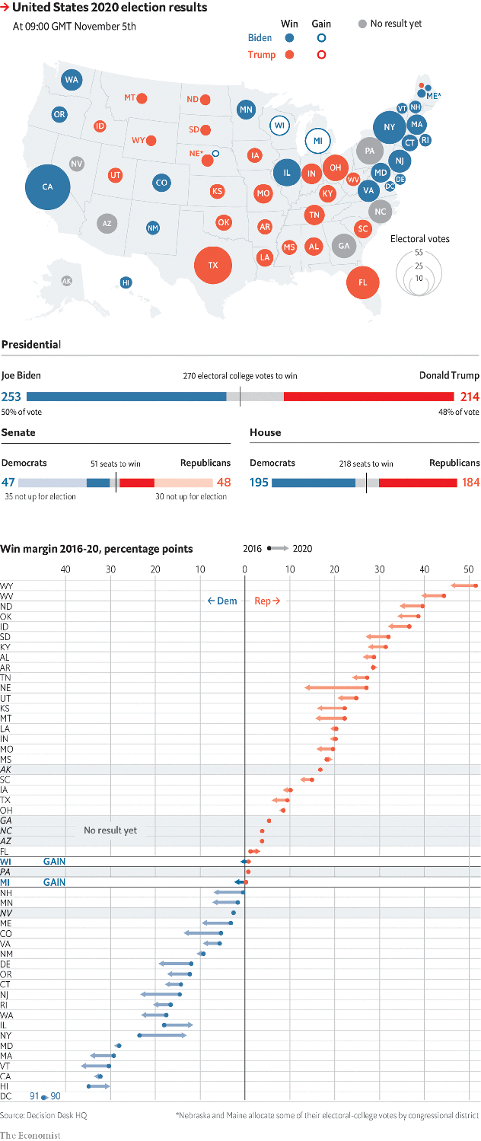

That in turn underlines a second striking feature of the result, which is the degree to which 2020 looks like almost any other recent presidential election. North Carolina and Pennsylvania will not report definitively for a while. But thus far, with a few exceptions—notably Florida and possibly Arizona—the electoral map looks much as it did in 2012, when Barack Obama narrowly beat Mitt Romney. Despite everything that has happened over the past four years, in other words, this race ended up looking very much like what would occur if a generic Republican ran against a generic Democrat in a year when not much of note took place.

This is remarkable when you pause to remember all the things that have failed to break the partisan deadlock in 2020. Over the past year Donald Trump has been impeached by the House of Representatives, making him only the third president in American history to suffer this rebuke. Covid-19 has killed more than 230,000 Americans and caused the economy to oscillate wildly. The country saw well-publicised killings of unarmed African-Americans by police officers, the largest civil-rights protests in American history and episodes of violence in some cities.

California suffered awful wildfires, far-right thugs plotted to kidnap the governor of Michigan and the president had perhaps the worst first-debate performance ever seen. The president also nominated a third Supreme Court judge, securing a conservative majority on the highest court for decades to come. Hunter Biden’s laptop divulged its emails after the president’s lawyer somehow made sure it found its way to a friendly tabloid. At the end of all that, hardly any Americans had changed their mind about who they wanted to be the next president. It is possible to argue that all these things simply cancelled each other out. More likely, they were made irrelevant by the power of partisan bias to shape how voters interpret such events.

American elections used to be able to deliver landslides in moments of great turmoil. They no longer can. Ever since Ronald Reagan beat Walter Mondale by 525 electoral-college votes to 13 in 1984, though, partisan attachment has been growing in strength to the point where voters overwhelmingly vote the way they did last time, irrespective of the candidate, the policies, or what is going on in the country or the world. More than 90% of voters who voted for Mr Trump in 2016 had voted for Mr Romney four years earlier. Despite all the attention on Never-Trumpers, it is a safe bet that more than 90% of those who voted for Mr Trump in 2016 did so again this year. The president’s approval rating has barely budged in the past four years. Both sides dream of delivering a knockout blow that will allow them to govern as they wish; neither can manage more than a few jabs.

## Hispanic lessons

The small number of voters who did switch in key states this time will be the object of fascination and study, as more data become available (hard-core election nerds will base their findings on the American National Election Study, which will be released in January). In 2016 the Obama-Trump voters in Pennsylvania, Michigan and Wisconsin were almost outnumbered by the journalists and sociologists who set forth to study them in their natural habitat. County-level results from 2020 suggest that Hispanic Republican voters may get the same treatment this time.

That group delivered the president both Florida and Texas. The Sunshine State now looks more like a reliably Republican place than a true swing state. In Texas Democrats are once again left arguing that demographic change will hand them the state at some unspecified point in the future—an argument that the party has been making to reassure itself for too long (the best expression of this optimistic thesis, “The Emerging Democratic Majority” by John Judis and Ruy Teixeira, is now almost 20 years old).

Democrats seemingly have to learn the same lesson over and over again: that Hispanic voters are not monolithic and that a more welcoming policy towards immigrants does not automatically translate into more votes from immigrants. In fact, county-level returns suggest the best predictor of a swing towards Mr Trump was the presence of lots of Latino voters.

Conversely, the best predictor of a swing towards Mr Biden was the clustering of college-educated Americans. In demographic terms, the story of the election is therefore a slight lessening of racial polarisation (the phenomenon of minority voters attaching themselves to the Democratic Party) and a slight increase in educational polarisation (the phenomenon of college-educated voters deserting the Republican Party). It is unwise to plot trend lines far into the future, but this looks like good news for the future prospects of Republicans, given how diverse the country is becoming, and given that only 36% of Americans have a bachelor’s degree.

## Telling it how it isn’t

Despite their relatively small number, college graduates have disproportionate cultural sway in America. This tends to distort perceptions of what the country is really like, both from inside America and from outside. A very large share of college-educated Americans believed that Mr Trump was both a disastrous president and also a threat to America’s governing institutions. They also believed he was a racist, whose dog-whistles about immigrants and African-Americans would make him toxic to non-whites. This view is not as widely shared as they assumed it was.

Why might that be so? A survey from the Cato Institute, a libertarian think-tank, earlier this year found that “strong liberals” were the only ideological group in the country who felt free to express their political opinions without causing offence. Everyone else, from regular liberals to “strong conservatives”, felt somewhat muzzled by the political culture in which they sought to express those opinions. If this is accurate, there may be no amount of reweighting that can make polls accurate. A further, possibly related problem for prognosticators is that a lot of voters just do not trust pollsters enough to answer their questions: in 2016 fewer than 1 in 200 calls made by polling firms resulted in an interview with a voter. The same will probably have been true this time.

Mr Biden, then, looks set to become the 46th president, but by a narrow margin. His just-about victory will reignite a long-running argument in the Democratic Party about whether left-wing populism might be a better antidote to right-wing populism, a dispute that Mr Biden’s victory in the primaries seemed to have put to rest. The result looks likely to keep the Republican Party in thrall to Mr Trump and Trumpism for the foreseeable future (see Lexington). And it means that Mr Biden, if he is indeed sworn in come January 20th, will be highly constrained when it comes to domestic policy (see article). Yet if the president it elects is the most visible measure of its values, America really has changed course. ■

This article was downloaded by calibre from <https://www.economist.com/united-states/2020/11/07/america-changes-course-while-remaining-very-much-the-same>

|  |  |  |  |
| --- | --- | --- | --- |
|  | Articles | Sections | Next |

|  |  |  |  |
| --- | --- | --- | --- |
| Previous | Articles | Sections | Next |

#### The House and Senate

# Democrats’ dreams for Congress go up in smoke

Divided and divisive government is here to stay

Nov 5th 2020 | WASHINGTON, DC

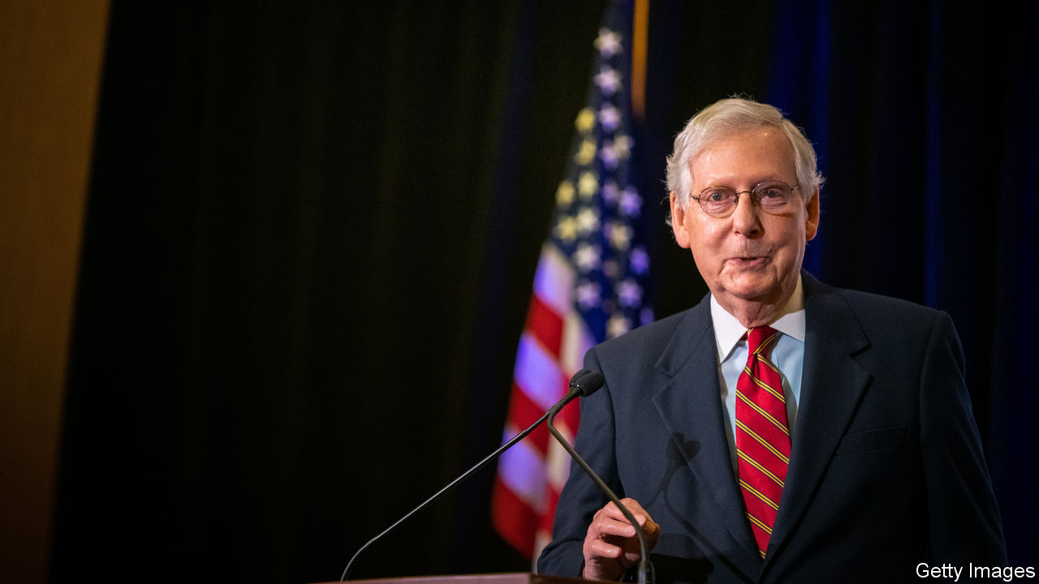

Editor’s note: See our [results page](https://www.economist.com/graphic-detail/2020/11/03/the-us-2020-election-results) for details of the vote.

FORGET NUKING the filibuster, packing the Supreme Court and dismantling the electoral college—the prizes that bold Democrats salivated over after their expected landslide victory. Those dreams are now dead. The pre-existing Democratic majority in the House of Representatives has weakened, though it has still held. The Senate, on the other hand, looks likely to remain in Republican control, even though some results are yet to be finalised. Mitch McConnell, the majority leader who coasted to a seventh term representing Kentucky, was perfectly content to stymie Barack Obama for years. At 78, he would probably remain set in his ways if Joe Biden has indeed won a narrow presidential victory. That promises another four years of gridlock and hyper-partisan dysfunction. Forget, too, the chance of a green-infrastructure plan, a reform of health care—or much serious legislating of any sort.

Opinion polls not only overstated Mr Biden’s national standing, but also the prospects for down-ballot Democrats. In races for the House of Representatives in 2018, Democrats captured a resounding 54% of the votes cast for either major party. Nancy Pelosi, the House speaker, thought she would be surfing another blue wave. But preliminary results suggest that in 2020 that national margin actually shrank by four percentage points to near-parity. Given that Mr Trump is facing a clear loss in the popular vote, that suggests that down-ballot Republicans overperformed relative to the president all over the country.

Two years ago, Democrats were excited by their pickups in moderate, suburban districts in unexpected places like Oklahoma City, Charleston in South Carolina and Cedar Rapids, Iowa. All of those seats have now reverted to Republican control, while Democrats did not really manage to add to their territory elsewhere (excepting a pair of open seats in North Carolina). There will probably be more Republican flips, but election projectors think that the Democratic majority in the chamber will survive, even if it is eroded.

Great expectations for the Senate were similarly dampened once results came in. The two most endangered Republican incumbents—Martha McSally of Arizona and Cory Gardner of Colorado—lost as expected, as did Doug Jones, the improbable Democratic senator from Alabama. That left 47 Democratic seats, four short of a majority (or three if a Democratic vice-president broke ties). Some races are still uncalled, but the maths look likely to work for Republicans. Susan Collins of Maine won a comfortable victory and Thom Tillis of North Carolina looks likely to have got a narrow one. More long-shot opportunities for the Democrats, like capturing seats in Iowa and Montana, were decisively beaten back. And their more improbable map-expansion projects failed miserably.

At least $100m was raised to unseat Lindsey Graham, the Republican senator from South Carolina, who nonetheless won by 14 percentage points. “This is the worst return on investment in the history of American politics,” gloated Mr Graham in his victory speech. Neither did the $88m raised in Kentucky to unseat Mr McConnell look well-spent: he cruised to a 21-point victory. The ultimate composition of the Senate might not be decided until Georgia holds run-off elections in January—though these are probable Republican holds.

Most modern presidents have had unified party control of Congress at the start of their term (before voters usually wrench it back in mid-term elections). Should Mr Biden win, he is unlikely to be afforded that. This means that much of his ambitious agenda—and much of the all-consuming policy debate during the Democratic primary about which shade of health-care reform was best—will in effect become moot. Mr Biden would preside not over a realignment of American politics, but an interregnum between Trumpism and something else. Bipartisan accord might not stretch beyond infrastructure spending, if even that. A resuscitated Republican worry about debts and deficits would probably hamstring any serious spending legislation of a Biden presidency, just as happened with much of the Obama presidency.

With such a narrow result, the hope that America might be able to move beyond its high-stakes, ultra-partisan legislating seems to be extinguished. “Cry more, lib”, was the first public statement of Madison Cawthorn, a 25-year-old newly elected Republican congressman from North Carolina. A vocal supporter of the QAnon conspiracy theory, Marjorie Taylor Greene from Georgia, will soon be seated in Congress. The moderate Democrats who helped secure a large House majority in 2018 were the first to get wiped out.

America’s rickety constitutional design gives big rewards for even razor-thin margins. This encourages partisans to stay in their trenches until the next contest, and to sabotage as much as possible the ambitions of the other side. Nothing has happened this time to change that. Even if the next president is not yet confirmed, you can confidently predict how much will get done in the next Congress: very little. ■

Dig deeper:  
For the latest on the election, see our [results page](https://www.economist.com/graphic-detail/2020/11/03/the-us-2020-election-results), read the [best of our 2020 campaign coverage](https://www.economist.com/us-election-2020) and then sign up for Checks and Balance, our [weekly newsletter](https://www.economist.com/checksandbalance/) and [podcast](https://www.economist.com/checks-and-balance-our-weekly-podcast-on-american-politics) on American politics.

This article was downloaded by calibre from <https://www.economist.com/united-states/2020/11/05/democrats-dreams-for-congress-go-up-in-smoke>

|  |  |  |  |
| --- | --- | --- | --- |
| Previous | Articles | Sections | Next |

|  |  |  |  |
| --- | --- | --- | --- |
| Previous | Articles | Sections | Next |

#### Polling error redux

# Polls—and our forecast model—overestimated support for Joe Biden

The positions of Mr Biden and Hillary Clinton were overestimated in mostly the same states

Nov 5th 2020 |



ON THE MORNING of election day, The Economist’s election-forecasting model gave Joe Biden a 19-in-20 chance of winning the presidency. Once all the votes are tallied, Mr Biden will probably be sitting behind the Resolute Desk next year. But it will be by a much closer margin than we forecast.

As we went to press, Mr Biden had amassed 253 electoral votes. He looks to be holding leads in enough states to bring his margin up to 270—the bare threshold needed to win. He could well pick up another 20 votes in Pennsylvania as mail-in ballots are tallied. That is still quite shy of the 356 we predicted.

Simply put, this is because the president did much better than the dismal showing the opinion polls expected. Mr Biden may win Wisconsin by less than one percentage point, whereas polls suggested he was ahead by eight. The model incorporated similarly large misses in Ohio, Iowa and Florida.

Depending on how the remaining states finish, Mr Biden is expected to win one of 270, 290 or 306 electoral votes. A showing at 270 would be outside our 95% confidence interval for the range of outcomes, meaning that our level of certainty was too high. The other likely outcomes would be at the bottom end—what could be expected in one out of every three or four of simulations we ran.

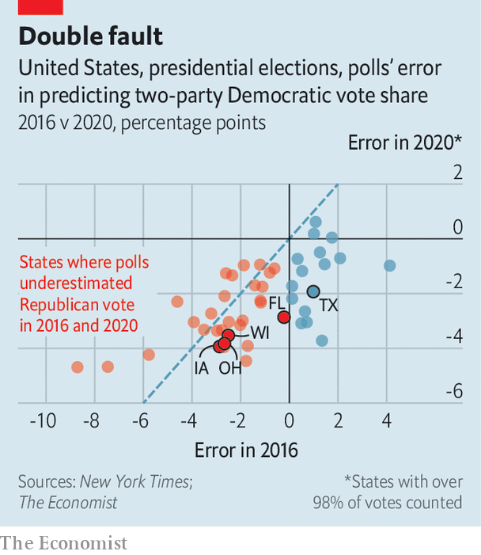

The Economist’s model had found that Mr Biden was comfortably ahead in so many places that it was hard to envisage him losing them all. But he may have come close. Our errors may reflect a general weakness of quantitative models: they try to predict the future by extrapolating from the past. Perhaps this election, held in the midst of a pandemic and a volatile economy, stretched this assumption too far.

Usually polling errors do not follow the last election’s pattern because pollsters try hard to correct their mistakes. Yet the polls still overestimated the positions of Mr Biden and Hillary Clinton in mostly the same states—and often by similar magnitudes.

One worrying possibility is that surveys again did not accurately gauge the share of working-class whites who supported Mr Trump. Before the election, polling showed that they had shifted towards Mr Biden. But preliminary election returns indicate that counties with lots of white working-class voters actually swung further towards Mr Trump. This suggests that Trump-supporting working-class whites were less likely to respond to pollsters in the first place. Should that theory prove true, it would present a very serious problem for the polling industry to solve.

This article was downloaded by calibre from <https://www.economist.com/united-states/2020/11/05/polls-and-our-forecast-model-overestimated-support-for-joe-biden>

|  |  |  |  |
| --- | --- | --- | --- |
| Previous | Articles | Sections | Next |

|  |  |  |  |
| --- | --- | --- | --- |
| Previous | Articles | Sections | Next |

#### Courting the presidency

# Donald Trump goes to court

The incumbent hopes litigation will keep him in the White House

Nov 5th 2020 |

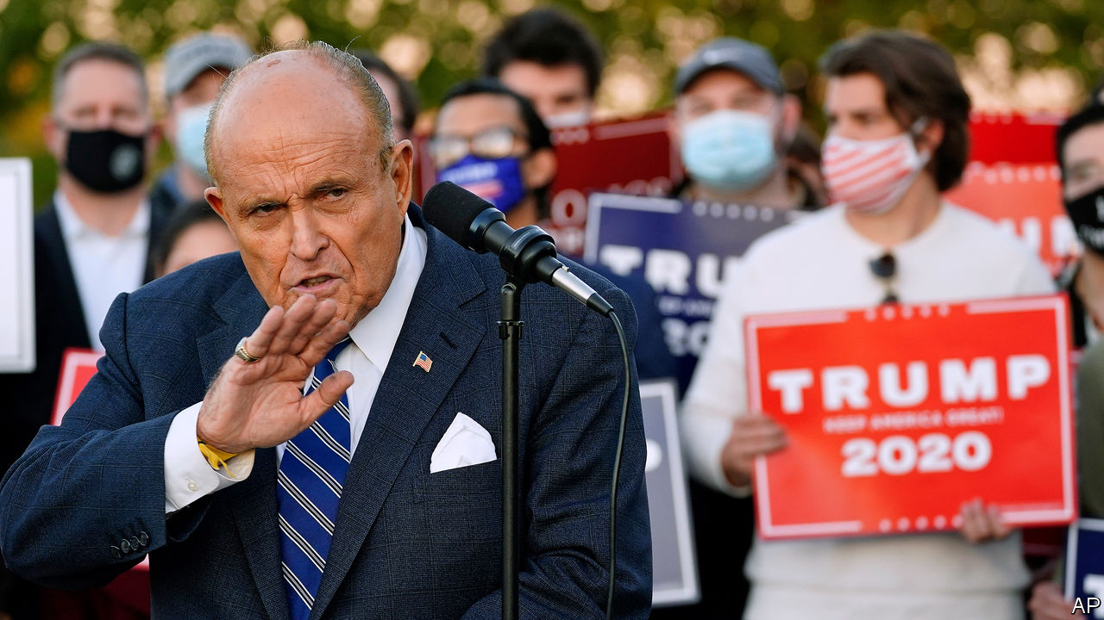

WATCHING HIS re-election odds falter in the Midwest on November 4th, Donald Trump pulled out a backup plan: salvation through litigation. “We’ll be going to the US Supreme Court,” he said in the wee hours after election day, repeating a weeks-long mantra justifying a rush to install Amy Coney Barrett into the late Ruth Bader Ginsburg’s chair. Continuing to count ballots is “a fraud on the American public”, he declared, without explanation. “We want all voting to stop.”

The scattershot legal strategy that emerged hours later carried an air of desperation and included, as promised, a quest to stop counting ballots in states where Mr Trump was in the lead and perhaps in some where he was behind. Mr Trump and his supporters have now filed suits in Georgia, Michigan, Nevada, Pennsylvania and Wisconsin. In Pennsylvania, the Trump campaign claims, rogue officials are opening “a backdoor to victory” for Joe Biden. Further suits may come in Arizona. However, the barrage of litigation is no more likely to change the president’s fortunes than his tweet announcing he would “hereby claim the state of Michigan”, where Mr Biden had already eked out a win.

Mr Trump’s lawyers and allies are particularly busy in Pennsylvania, where the president has also declared victory prematurely. The hoped-for win relies on at least five lawsuits. Four of them are rather small potatoes. The Trump campaign is appealing a judge’s one-paragraph dismissal of its complaint that campaign workers sent to observe vote-canvassing were denied sufficient access. Twin suits in state and federal courts involve mail-in voters seeking to correct errors such as a missing envelope or mismatched ballot signature; the opportunity to “cure” a ballot, according to one filing, entails a “high risk of jeopardising the integrity” of the election. Another suit contends that Pennsylvania ballots that lack proof of identification should be thrown out if not fixed by November 9th.

Such efforts aim to give Mr Trump small advantages. None of them seems destined to alter the president’s electoral prospects or get a hearing in America’s Supreme Court. The Nevada state supreme court rejected a canvassing-observation complaint on November 3rd, finding that observers for the Trump campaign had plenty of access. A judge on November 4th seemed unimpressed with one of the ballot-curing challenges. Didn’t the Pennsylvania legislature, the judge asked, intend to “franchise, not disenfranchise, voters?”

A battle with higher stakes for the Pennsylvania race is Republican Party of Pennsylvania v Boockvar, a case that has seen two visits to the Supreme Court and is now back for a third. The matter involves the Pennsylvania state supreme court’s order in September, amid the pandemic, to allow a three-day extension to the receipt deadline for mail-in ballots. Republican challengers could not persuade five justices that this move was an illegitimate usurpation of the state legislature’s will. They tried and failed again one week later, when the newly minted Justice Barrett chose not to participate in the matter.

But on October 28th, in a separate opinion involving the case’s second trip to the court, three justices told Pennsylvania’s Republican Party that it may have better luck asking a third time. Accepting the invitation, the Trump campaign has joined the suit with the hope of shredding any ballots arriving after election day.

If the presidential election comes down to Pennsylvania, stemming votes trickling in by November 9th—ballots that are helping Mr Biden erase his deficit—might be just what Mr Trump needs to hold on to a slim lead and win 20 critical electoral votes. But it may not come to that if Mr Biden finds his way to 270 votes without the Keystone State. Efforts to halt voting in Michigan, throw out a small stack of mail-in ballots in a single Georgia county or force a recount in Wisconsin, where Mr Biden has a 20,000-vote advantage, all seem quixotic.

Mr Trump won the White House four years ago with a brash, take-no-prisoners campaign. He seems intent on losing it—if the 2020 election comes to that—in much the same posture. ■

This article was downloaded by calibre from <https://www.economist.com/united-states/2020/11/05/donald-trump-goes-to-court>

|  |  |  |  |
| --- | --- | --- | --- |
| Previous | Articles | Sections | Next |

|  |  |  |  |
| --- | --- | --- | --- |
| Previous | Articles | Sections | Next |

#### State houses and local referendums

# Covid coloured races for governor and ballot initiatives

Health and social policy shaped America’s state and local elections

Nov 5th 2020 |

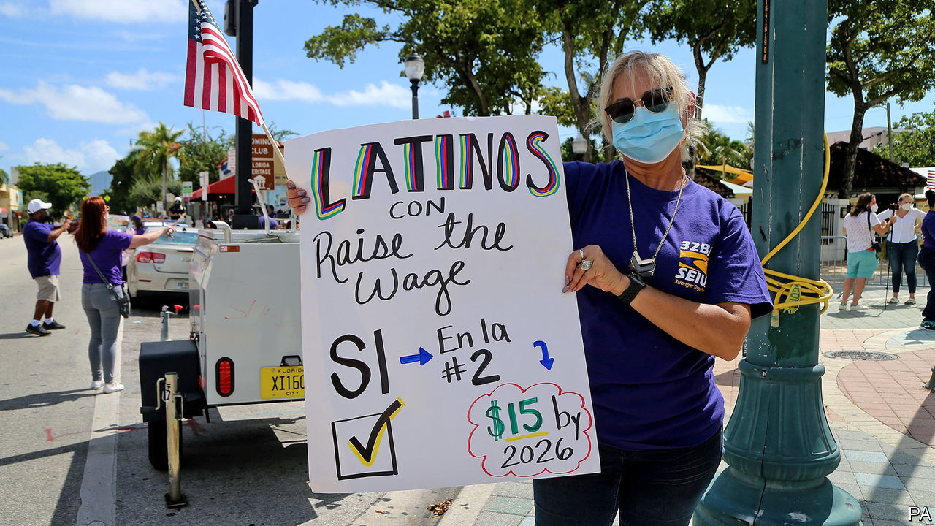

IF YOU WANT to see where the momentous events of 2020 had their biggest impact, look not at the national contest but at the governors’ races and local referendums. Covid-19 and other traumas turned competitive races into walkovers and showed that states could still push through social changes even while the country is counting every last vote.

Governors have been the dominant figures of the pandemic response, choosing when and how to lock areas down. As a result, gubernatorial races often turned into referendums on states’ responses to covid-19. Take the contests in New England, where Democrats might have fancied their chances of unseating one or both Republican governors up for re-election, Chris Sununu of New Hampshire and Phil Scott of Vermont. Mr Biden won both states easily. But on covid-19, the governors were the un-Trumps. When the president told Americans not to be afraid of covid, Mr Sununu shot back, “I’m afraid of covid. I think everyone should be very concerned.” Mr Scott even endorsed Bill Weld, Mr Trump’s rival in the Republican presidential primary. Both earned sky-high approval ratings for handling of pandemic; both won re-election in blue states by over 30 points.

There was a similar story in North Carolina, where the Democratic governor, Roy Cooper, won by four points in a state where the presidential and Senate races were in essence tied. Mr Cooper, an affable centrist, won plaudits for taking the pandemic seriously from the start. His Republican challenger, in contrast, criticised the health restrictions and mask-wearing.

The only governorship which changed hands (out of 11 races) was in a state where covid-19 policy was barely mentioned. This was Montana, where the Democratic incumbent was term-limited and ran for a Senate seat. Neither candidate for governor made the pandemic an issue, though Montana now has the fourth-highest covid caseload, relative to its population, in America. In the absence of debate, the state reverted to its habitual hue, with Republicans winning every statewide office.

Just as only one governorship changed hands, so only four state houses seemed likely to switch party, the fewest since 1946 (a handful were undecided as The Economist went to press). Democratic hopes of winning the Texas and Michigan legislatures came to naught. The 2020s will see a new round of redistricting, to Democrats’ dismay. Republicans will gerrymander five times as many state maps as they will.

The political impact of covid-19—and of that other upheaval of 2020, the Black Lives Matter (BLM) movement—was clearest in the state and local ballot initiatives put to voters. There were fewer than usual, about 120 state ones, because lockdowns made it harder to collect the signatures required to get proposals on the ballot. Of those that got through, many tackled health and racial inequalities. Surprisingly, voters tended to approve socially liberal proposals, while rejecting conservative ones.

Two Californian referendums showed the contrast in criminal-justice policy. A proposition permitting felons on parole to vote passed. One that would have toughened sentencing failed. Six cities asked voters to approve or expand the powers of independent panels to oversee local police forces. All passed, including in Columbus, Ohio, a state Mr Trump won easily.

Amy Liu, who tracks state and local governments for the Brookings Institution, a think-tank, argues that cities and states are still able to make social policy through ballot initiatives, despite paralysis at the federal level. Coloradans approved state-wide paid family leave and repealed a constitutional provision that kept property taxes low. A majority of Floridians backed Mr Trump—and a hike in the hourly minimum wage from $8.56 to $15 by 2026.

Even so, there are limits to state progressivism. In Illinois, a constitutional amendment to change the state’s flat-rate income tax to a graduated one (which would have raised taxes on the wealthy) went down to defeat. The governor, J.B. Pritzker, spent millions of his family fortune backing the idea. His cousin, Jennifer Pritzker, spent hers defeating it. Partisanship may be less hyperbolic in state politics but families are still deeply divided.■

This article was downloaded by calibre from <https://www.economist.com/united-states/2020/11/05/covid-coloured-races-for-governor-and-ballot-initiatives>

|  |  |  |  |
| --- | --- | --- | --- |
| Previous | Articles | Sections | Next |

|  |  |  |  |
| --- | --- | --- | --- |
| Previous | Articles | Sections | Next |

#### Lexington

# Trump and Trumpism

The president has transformed his party. But how enduring his influence will be is unclear

Nov 5th 2020 |

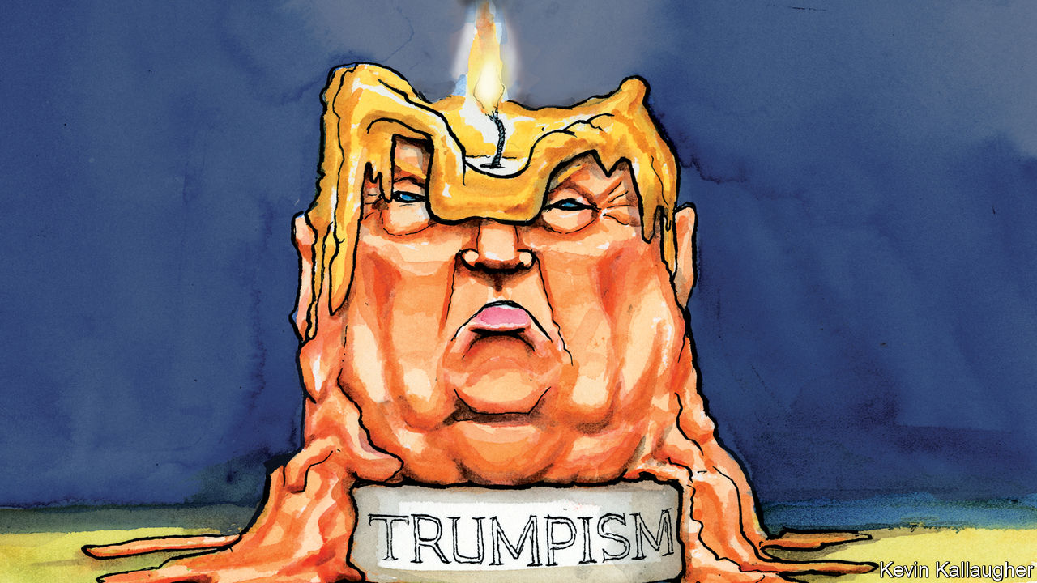

IT HAS BECOME a cliché of liberal editorialising to demand that voters repudiate Donald Trump’s populist platform as well as the president himself. Wherever the final vote tallies land, it will be hard to argue that they have.

At the time of writing, Mr Trump looked on course to lose his re-election bid with the second-highest number of votes ever recorded. He seemed to have achieved that feat mainly by turning out the most characteristic parts of his coalition in force. White working-class men, in particular, cemented the Republicans’ hold on some of the territory he took for them in 2016. Mahoning County in Ohio—which is dominated by hardscrabble Youngstown, whose construction sites your columnist visited on the trail—went Republican for the first time since 1972.

The president’s populist rhetoric—his hounding of elites and foreigners, his race-baiting—also proved to be much less of a turn-off generally than the Democrats had hoped. Bumper support from Cuban-Americans in Florida and Mexican-Americans in southern Texas saw Mr Trump more than double his winning margin in the first state and kill off Democratic dreams of winning the second. Exit polls suggest he increased his share of support from every group except white men. If that is right, Democrats won the election chiefly through their improved turnout effort, not by wooing voters from Mr Trump.

And this, to recap, was after an election campaign that had featured the president at his worst. In the midst of a deadly pandemic, he derided public-health experts and ridiculed his opponent for following their advice. He gave nodding support to a conspiracy theory which holds that Democrats are devil-worshipping paedophiles. He called Kamala Harris—Joe Biden’s black, female, running-mate—a “monster”. It is not hard to see why Mr Trump’s opponents consider the results too close. Yet their hopes of a full-on repudiation, encouraged by a dose of hubris as well as by rotten polls, now appear unrealistic.

Contemporary nationalist populists—such as Andrzej Duda in Poland or Viktor Orban in Hungary—and American presidents alike tend to win re-election. By that measure, merely dislodging Mr Trump would represent an achievement. And Mr Biden’s campaign message, it should be noted, was almost entirely devoted to the vital importance of doing exactly that. If the result was not a crushing rejection of Mr Trump, it seems nevertheless to have been a rejection.

For those who worry about the endurance of Mr Trump’s strain of populism, it should also be noted that it is not altogether clear what it is. After his victory in 2016, Trumpism looked like a rallying-call to the economically distressed. Mr Trump fought this campaign on his claim to have built “the greatest economy in the history of our country”. A mixture of isolationism, cronyism, nativist rhetoric, somewhat performative authoritarianism, corporate tax cuts and personality cult, Trumpism is what the president says it is. No one finds this more frustrating than the small minority of Republicans—including Senators Tom Cotton and Marco Rubio—who have attempted to turn the party into an actual vehicle for the working-class concerns Mr Trump raised. Arguably he has thereby emerged as the main obstacle to the conservative movement he inspired.

His influence may prove to be most enduring if those frustrated adherents take over in his wake. Mr Rubio and the rest appreciate that the pre-Trump party had become detached from its main supporters. And the president has normalised protectionism and other policies that they like. But there is no reason to assume a populist successor to Mr Trump would persist with his race-baiting and thuggery—or, at least, get away with it so easily if he did. Another oddity of the president is how voters who would normally balk at such bad behaviour have given him a pass. Mr Trump, a loud-mouthed celebrity for 40 years, is in that sense a political one-off.

This should be somewhat reassuring to his critics in both parties. Mr Trump has transformed the right—but his influence may be less enduring than these results suggest. In a polarised environment, they probably represent less of an endorsement of him even on the right than it seems. His low approval rating suggests he has again been backed by Republicans who dislike him, but cannot bear to vote for the alternative. The logic of such hyper-partisanship is that, once he is out of office, many Republicans will shift their allegiance to a new leader, and be influenced by him in turn.

Yet there is still plenty in the election verdict to worry Trumpism’s opponents. Above all, the president’s success in broadening his coalition points to their own weaknesses. Democrats will probably take from this that they should have offered Hispanics a better economic message and done more campaigning among them. They say this after most elections. Yet after a campaign almost entirely governed by negative partisanship on both sides, Democrats should think harder about how they may have actively repelled their flagging non-white base.

## Populist polarisation

Cuban-Americans are hostile to socialism, a label the Democratic left proudly wears. Mexican-Americans care less about Mr Trump’s anti-immigrant rhetoric than Democrats—in the face of much evidence to the contrary—persist in believing. A doggedly upwardly mobile community, Hispanics do not generally consider themselves to be the downtrodden minority the left refers to them as. The Democrats will not be a reliable alternative to right-wing populism unless they correct such errors and widen their appeal.

In the current polarised environment, anything less than full control of the government is a recipe for deadlock and disaffection. It was the enabling condition for Mr Trump. That America appears to be headed for another bout of divided government is therefore hard to celebrate.■

This article was downloaded by calibre from <https://www.economist.com/united-states/2020/11/05/trump-and-trumpism>

|  |  |  |  |
| --- | --- | --- | --- |
| Previous | Articles | Sections | Next |

|  |  |  |
| --- | --- | --- |
| United States | Sections | Asia |

The Americas

Canada: Northern light

.

Brazil: Bundles in the jungle

.

Bello: It’s hard to do good

.

|  |  |  |
| --- | --- | --- |
| United States | Sections | Asia |

|  |  |  |  |
| --- | --- | --- | --- |
|  | Articles | Sections | Next |

#### Northern light

# Jobs are coming back in Canada, thanks to subsidies

Will a second wave of covid-19 swamp the recovery?

Nov 5th 2020 | OTTAWA

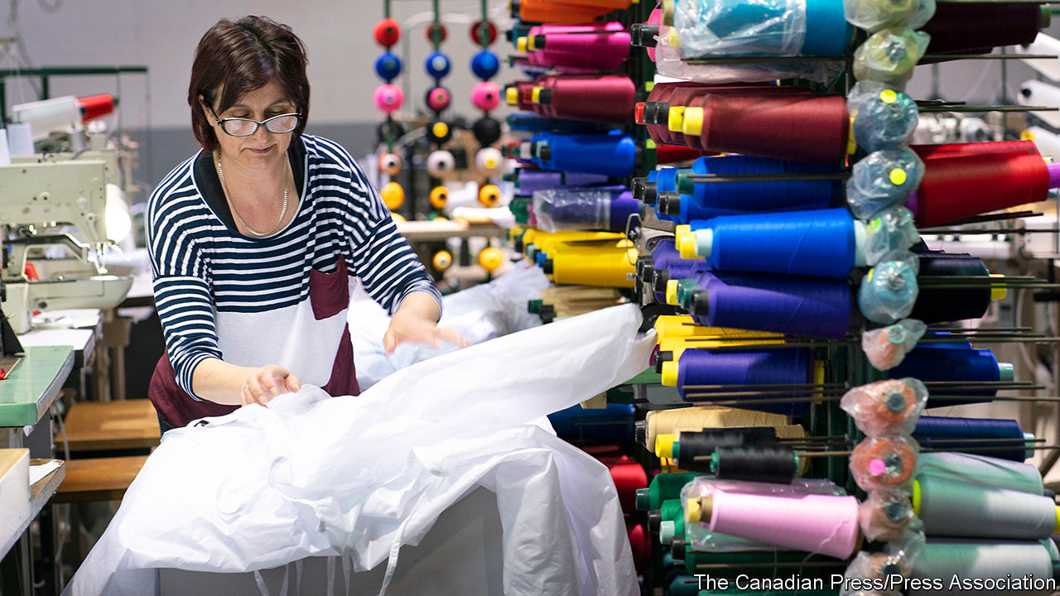

CANADA’S ECONOMY is often subject to unfavourable comparisons with that of the United States, but recently it has been rivalling its neighbour’s. Like the United States it has recently enjoyed a big improvement in economic sentiment. In July the Bank of Canada predicted that at the end of 2020 GDP would be 6.8% smaller than a year earlier; on October 28th it revised that forecast to a 4.3% hit.

By many measures, Canada’s labour market seems to be rebounding even faster than America’s; in September Canadian employment was only 3.7% beneath its pre-pandemic peak, while in the United States jobs remained 7.1% scarcer, calculate economists at TD Bank (see chart). Yet the country has not quite overhauled Uncle Sam in the quest for a V-shaped recovery from the spring slump. That may be because, as in Europe, many of its jobs remain propped up by the government.

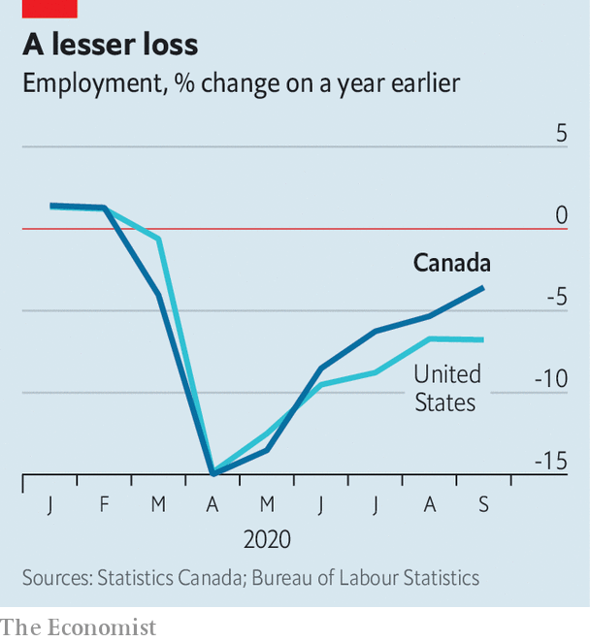

In the spring Canada had a tight lockdown and a big fall in GDP, of over 11% (compared with about 9% south of the border). But in the recovery it has benefited from several advantages. For most of the year it has been relatively successful in controlling the spread of covid-19. Unlike nearly all American states, Canadian provinces can run operating deficits. They have used their borrowing powers to boost hiring of teachers and health-care workers during the pandemic. Provincial deficits are expected to rise to C$96bn ($72bn), 4.5% of Canada’s GDP, this financial year, from C$18bn in 2019. American states, by contrast, are having to slash spending as tax revenues have fallen.

In Washington, disagreement over whether to bail out the states has impeded the passing of a second round of fiscal stimulus. But Canada has reduced for now the usual friction between province and nation. The federal government has given the provinces an extra C$21bn to reopen schools and cover extra health-care costs.

In August Doug Ford, the Conservative who governs Ontario, the most populous province, praised Justin Trudeau for doing “an incredible job as prime minister”. Overall, the 16% of GDP Canada has spent stimulating the economy is even bigger than the United States’ massive package of 14% of GDP. “I don’t like deficits. But the alternatives were much worse,” said Erin O’Toole, the recently elected leader of the opposition Conservatives.

The expansion in Canadian education and health care has helped women, who are most of the workforce in those sectors. Mothers, who were likelier than others to stop work during the pandemic, returned when schools and day-care centres fully reopened in September. Paid holidays are relatively generous. During the pandemic federal and provincial governments, which regulate different sectors, extended the amount of unpaid leave that parents and other workers could take. Many allow them as much time as they want. That stopped their employers from sacking them even when they could not work. Women have still lost more working hours than men in Canada, but the gap is smaller than in the United States, says Beata Caranci, TD Bank’s chief economist.

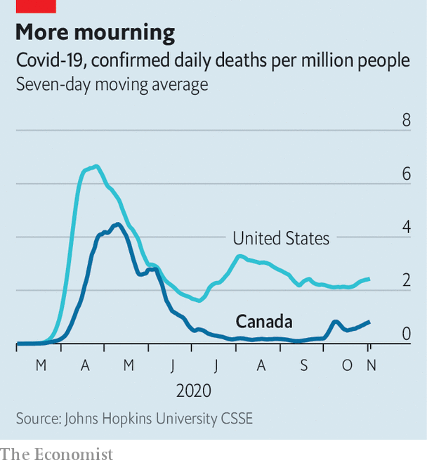

The number of jobs in e-commerce has jumped, as shopping shifts away from the high street. That has also happened in the United States, but Canada started out with fewer such jobs, and so the room for growth is bigger. Although the weak energy market has hurt oil-pumping Alberta, prices of natural resources such as gold, copper and lumber have stayed high. The housing market has been buoyed by buyers who reckon the shift to working from home is permanent and want larger dwellings. In all, “eight of 20 major industrial sectors are now operating above their year-ago levels,” writes Doug Porter, chief economist of BMO, a bank.

Growing confidence may explain why the government felt bold enough to raise its immigration target on October 30th by 17%. Next year it plans to invite more than 400,000 permanent residents, more than 1% of the population. The last time it welcomed that many immigrants was in 1913.

Despite this, most forecasts, including those of the IMF and the Bank of Canada, show that Canada will return to its pre-pandemic level of GDP only after the United States does. The disparity between the labour-market statistics and GDP may reflect the fact that unproductive jobs are being propped up by government subsidies. In September 1.7m employees, or about 8% of Canada’s pre-pandemic labour force, were benefiting from the Canada Emergency Wage Subsidy programme, which contributed an average of more than C$1,000 per employee to firms’ monthly payroll costs. About a fifth of these workers are in the troubled hospitality sector. Although the United States also has a scheme to subsidise payroll costs among small businesses, its reach is narrower and it closed to new applicants in August. Canada’s scheme is being extended, with a smaller payout, until next June. In this respect Canada looks more like Europe, where job-support schemes have obscured labour-market weakness but not falls in output.

And the virus is again on the rise. As provinces and cities reintroduce restrictions they are trying to minimise their economic impact. That may be tricky. Winnipeg, where the highest temperature on an average day in January is -11°C (11°F), is drawing up rules to allow pubs and restaurants to serve outdoors throughout the winter. The uncertain path of the virus could yet dash both economic and epidemiological hopes, as it has elsewhere. But among rich countries Canada has so far performed well on both fronts.■

Editor’s note: Some of our covid-19 coverage is free for readers of The Economist Today, our daily [newsletter](https://my.economist.com/user#newsletter). For more stories and our pandemic tracker, see our [hub](https://www.economist.com/news/2020/03/11/the-economists-coverage-of-the-coronavirus)

This article was downloaded by calibre from <https://www.economist.com/the-americas/2020/11/05/jobs-are-coming-back-in-canada-thanks-to-subsidies>

|  |  |  |  |
| --- | --- | --- | --- |
|  | Articles | Sections | Next |

|  |  |  |  |
| --- | --- | --- | --- |
| Previous | Articles | Sections | Next |

#### Bundles in the jungle

# How e-commerce works in the Amazon rainforest

Amazon isn’t doing it, but Bemol is

Nov 5th 2020 | MANAUS

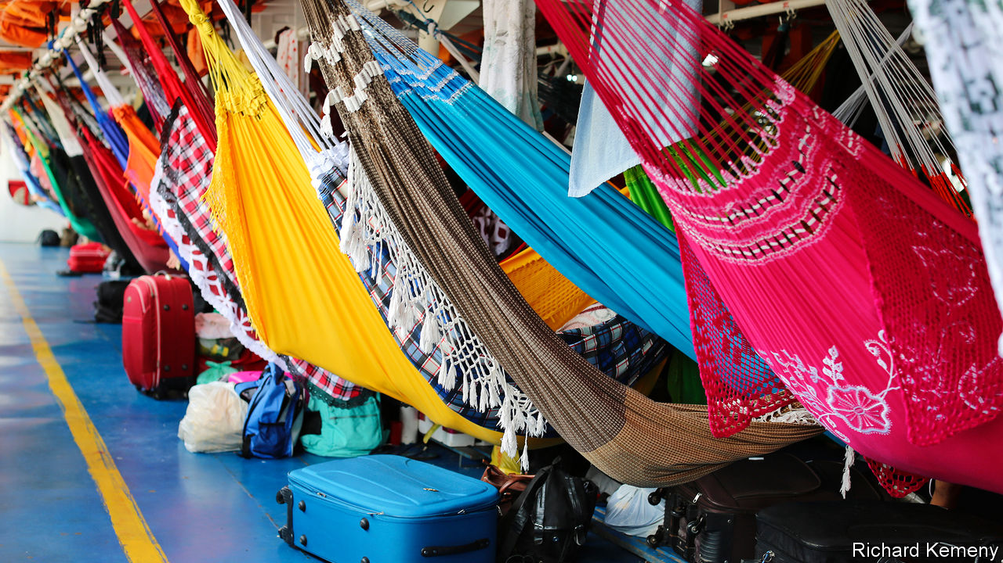

WHEN YOU behold the Lion of Judah you do not think “e-commerce”. Its lower decks have hooks for 467 hammocks where passengers sleep on the three-day voyage up the Amazon river from Manaus, a city of 2m people, to Uarini, a manioc-growing town. Its upper deck has more hammocks, a bar for sinners and a chapel for saints. Its cargo hold stinks of fish. But when the Amazon’s largest department store, Bemol, started delivering to customers in the rainforest, three-decker passenger boats were its chosen means of transport.

Bemol was founded in 1942 by three grandsons of a Moroccan Jewish immigrant who arrived in Brazil in 1887. It sold fridges and televisions in the traditional way from its megastores in Manaus until 2018, when one of the founders’ grandsons, Denis Minev, took over. He suspected there were hundreds of thousands of customers up and down the Amazon and its tributaries that Bemol wasn’t reaching and decided to go to them.

But delivering parcels in the rainforest is difficult and expensive. (Amazon the company barely serves its namesake river.) Consumers in far-flung places either had to pay up to 30% of the product’s price for shipping and wait a month or longer for the postal service to deliver it or spend money and time on shopping trips to Manaus. Mr Minev made what sounded like an impossible promise: to deliver an order placed online within a week for not a centavo more than the “Manaus price”.

Bemol calls its answer to those problems caboclo e-commerce. A term for Brazilians with both indigenous and European ancestry, caboclo has come to mean a mix of tradition and modernity. Mr Minev’s experience at a cooking-gas firm, also owned by his family, showed him how challenging the Amazon’s logistics could be. Rather than buy a fleet of boats, risking collisions, fuel theft and high debt, Mr Minev outsourced delivery to the brightly painted ferries that carry people and provisions around the region.

As the Lion of Judah lay at anchor in the port of Manaus on a recent Tuesday, deckhands stuffed its hold with hundreds of cases of beer, thousands of cartons of eggs, scores of frozen chickens and three squawking ones. Alongside them were near-identical mattresses, supplied by Bemol, to be left in different towns. Contracts with boat owners are verbal, inventory is recorded with pen and paper and mix-ups happen. If merchandise goes missing—smartphones can disappear—Bemol swallows the loss. Just a few boats and their crews serve each route. “If I fight with all of them, there’s no one left to deliver our products,” says Fred Galvão, who runs logistics for Bemol.

To encourage Amazonians to place their first online orders, Bemol installed Wi-Fi in the plaza of every town where it launched caboclo e-commerce. It set its catalogue to pop up on users’ smartphones and grants free minutes to those who place orders. Like Amazon, Bemol sends customers adverts based on the data they provide.

It invented some tactics to suit the region. Amazonians who lack savings or credit cards use zero-interest loans starting at 150 reais ($26) to finance their purchases; a whopping 85% of Bemol’s online sales are paid for this way. Shoppers who are uneasy about using the internet can place orders and lodge complaints with an attendant’s help at chemists and floating petrol stations. Bemol allows returns, but encourages customers to accept vouchers instead. “The traditional e-commerce model without a physical presence doesn’t work in the Amazon,” says Mr Minev.

His caboclo model seems to. Its pilot operation in Autazes, 100km (60 miles) downriver from Manaus, which started in April last year, brought in 113 orders and 73,000 reais in its first month. By February this year Bemol had expanded to dozens of towns. It booked 2.6m reais in sales that month. After the pandemic struck, business boomed. Bemol’s e-commerce revenues in June reached 10.5m reais. “Amazon lost money for years,” Mr Minev says. “We’re already profitable.”

The Lion of Judah has been less lucky. At the start of the pandemic, it stayed in port for two weeks while ambulance boats brought covid-19 patients and the bodies of those who had died on the journey. The Lion resumed sailing in April but with half as many passengers. The captain, Richard Lacet, who inherited the boat from his father, has made up for lost revenue by charging more for cargo, to squawks from merchants sending chickens upriver and farmers dispatching manioc flour down it. But Bemol, which pays a flat rate for its own compartment, “is starting to change the business”, he says. E-commerce could keep the Lion afloat. ■

This article was downloaded by calibre from <https://www.economist.com/the-americas/2020/11/05/how-e-commerce-works-in-the-amazon-rainforest>

|  |  |  |  |
| --- | --- | --- | --- |
| Previous | Articles | Sections | Next |

|  |  |  |  |
| --- | --- | --- | --- |
| Previous | Articles | Sections | Next |

#### Bello

# The difficulty of doing good in Latin America

The region has too little philanthropy

Nov 5th 2020 |

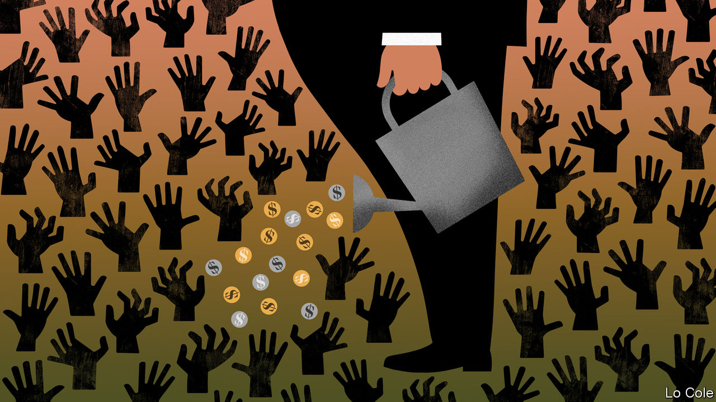

AFTER THE pandemic struck Chile, ten do-gooding organisations formed Fondo Respuesta Comunitaria (the Community Response Fund) to alleviate hunger and poverty. It provides money for some 200 projects, mostly ollas comunes (soup kitchens). In Colombia the Fundación Santo Domingo is giving 100bn pesos ($26m) to pay for groceries and a domestic-abuse hotline, among other things. The Fundación Carlos Slim, backed by Mexico’s richest man, earmarked 1bn pesos ($47m) to treat covid-19 in that country.

The pandemic has given a boost to philanthropy in Latin America, but it is also a threat. Donors have less money to give or are shifting it to public health from other good causes. Almost half of NGOs in Chile may not survive, fears Sylvia Eyzaguirre of the Centro de Estudios Públicos, a think-tank. Prospects are as gloomy in Colombia, where many charities depend on events like galas and bingo nights, which cannot happen in covid times. In too many countries bureaucracy and politics add to the burdens. For the sake of its political and social health, Latin America needs more charitable activity, not less.

Philanthropy is fragile in part because it is less deeply rooted than elsewhere, notably the United States and Europe. In colonial times the Catholic church cured the sick and helped the poor. Centralising states took over such responsibilities, though not as effectively as in the rich world. “Philanthropy and [civil-society] associations were sort of a minor tributary and not part of the main story of development of those nations,” says Michael Layton of the Johnson Centre for Philanthropy at Grand Valley State University in Michigan.

They remain weak. The Latin American countries with the largest philanthropic sectors are Mexico and Colombia, according to a study published in 2018. There foundations’ assets are worth 1% of annual GDP, compared with 4.8% in the United States. Ordinary folk seem less altruistic than in other regions, though the tradition of almsgiving through the church remains strong. In a global giving index put together by the Charities Aid Foundation, the only Latin American country in the top 20 is Haiti.

The region pays a high price for low levels of generosity. The population of non-profit universities, museums, bird-watching clubs and the like is sparse. Unlike in the rich world, governments do not give them much money. Worldwide, non-profits account for 5.7% of employment; in Mexico, Colombia and Peru that is 3% or less, according to Lester Salamon of Johns Hopkins University in Maryland.

Latin America has too few groups that channel citizens’ grievances into proposals that governments might adopt, making conflict more likely. If the rich, who are undertaxed, gave away more money, high levels of inequality might rankle less.

Recently they have become more open-handed. More than half the region’s philanthropic groups have been founded since 2000, according to a study published by the Universidad del Pacífico in Peru. But the law, and increasingly politics, throw up obstacles. In many countries registering a charity is difficult. Chile has some 60 laws governing the tax treatment of donations. Donors can give tax-free money to cultural institutions but not to environmental or human-rights groups.

There is a push to change that in Chile, made more urgent by last year’s violent protests against inequality and poor public services. Left- and right-leaning think-tanks are lobbying together for a law to make giving easier.

Where authoritarians rule, life is getting harder for groups that benefit from philanthropy. Jair Bolsonaro, Brazil’s right-wing president, has made rhetorical war on defenders of the environment. Mexico’s left-wing president, Andrés Manuel López Obrador, has attacked environmental groups that oppose pet infrastructure projects, such as the Maya train across the Yucatán peninsula. This month Mexico’s Senate passed a law to strip tax-exempt status from groups that get most of their income from activities not related to their charitable goals. That would hurt groups like universities that make ends meet by, for example, operating bookshops. The bill is “a profound attack on the independence of non-profits”, says Mr Layton.

Weakening do-gooders may make life more comfortable for high-handed presidents like Messrs Bolsonaro and López Obrador. But a region traumatised by pandemic and rising poverty needs more philanthropy, not less.

This article was downloaded by calibre from <https://www.economist.com/the-americas/2020/11/05/the-difficulty-of-doing-good-in-latin-america>

|  |  |  |  |
| --- | --- | --- | --- |
| Previous | Articles | Sections | Next |

|  |  |  |
| --- | --- | --- |
| The Americas | Sections | China |

Asia

Elections in Myanmar: False start

.

Music in South Korea: Hot for trot

.

Banyan: Islands of liberality

.

|  |  |  |
| --- | --- | --- |
| The Americas | Sections | China |

|  |  |  |  |
| --- | --- | --- | --- |
|  | Articles | Sections | Next |

#### False start

# Aung San Suu Kyi was supposed to set Burmese democracy free

Instead she has clipped its wings

Nov 7th 2020 |

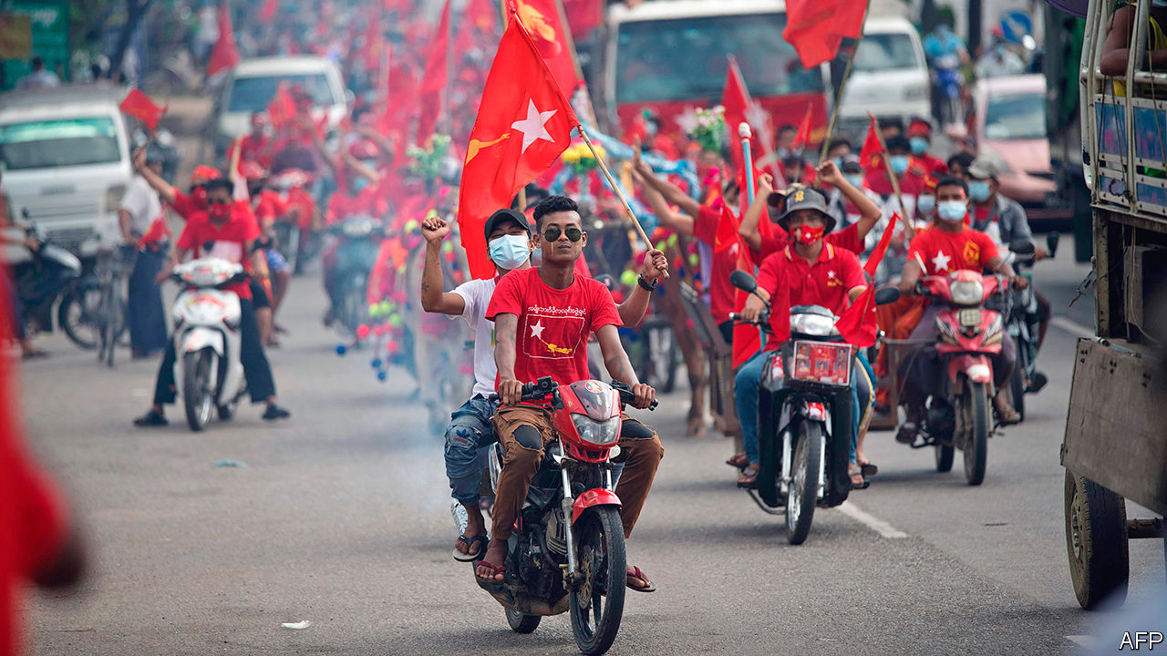

THE MEMORY of Myanmar’s most recent election, in 2015, still cheers Kyaw Zayya. Even if he had not been covering the results as a journalist, he would have gone to the headquarters of the National League for Democracy (NLD), which swept the polls, to celebrate the end of more than 50 years of military rule. Like so many of his fellow citizens, he placed his hopes in Aung San Suu Kyi, the long-persecuted leader of the NLD, who promised to bring peace, prosperity and democracy. “We had been suffering for decades under the military regime, so we were eager to see changes,” he says. “I was very delighted.”

On November 8th Myanmar will vote again. This time Mr Kyaw Zayya will not be taking part. He belongs to a small but growing number of Burmese who have decided to abstain because they are bitterly disappointed with the NLD. He is outraged that the commission administering the election, which is appointed by the government, has cancelled the vote in parts of the country that it says are too dangerous. In fact, not all the areas in question are plagued by violence. And the cancellation disproportionately affects ethnic minorities, many of whom are unlikely to vote for the NLD. Some 1.5m voters have been disenfranchised, out of a voting-age population of roughly 35m, although the commission has reinstated polling in a few spots.

The “no-voters” join a swelling chorus of discontent. It includes activists and journalists hounded by the authorities, ethnic minorities brutalised by decades of violent conflict and workers left behind by rapid but uneven economic growth. Then there are the Rohingyas, a persecuted Muslim minority who have been ghettoised in squalid refugee camps on either side of Myanmar’s border with Bangladesh after a series of pogroms led or cheered on by the army. The majority of Burmese still revere “Mother Suu” and will probably return her to power. But neither she nor the NLD have proved the champions of liberal ideals that many imagined them to be. In the eyes of a growing number of Burmese, Ms Suu Kyi, having kindled the flame of democracy, is now smothering it.

The wild hopes borne aloft by Ms Suu Kyi’s victory were always bound to collide with gunmetal reality. For one thing, Ms Suu Kyi presides over a system designed by the generals towards the end of their half-century in power, which preserves a big and inviolable role for them in government—what they call “discipline-flourishing democracy”. The constitution gives them control over their own affairs, as well as the right to appoint the ministers of defence, the interior and borders. A quarter of the seats in the national and regional parliaments are reserved for members of the Tatmadaw, as the armed forces are known. It also controls a majority of seats on the National Defence and Security Council, which can declare an emergency. Ms Suu Kyi has no control over the Tatmadaw and, in particular, cannot force it to cease hostilities against the various ethnic insurgencies that have long racked the country.

Ms Suu Kyi naturally wants to release her government from these manacles. In March the NLD put forward several constitutional amendments, among them one that would gradually reduce the number of seats in parliament reserved for military appointees. But the generals had foreseen such a move. Constitutional amendments need the support of more than three-quarters of MPs. With a quarter of the seats, the Tatmadaw can block any it does not like—and so it did.

Within these restrictions, Ms Suu Kyi has tried to nibble away at the Tatmadaw’s authority. She has given the previously meek anti-corruption commission some teeth and repealed a few repressive laws. She has refused to convene the security council. She has also taken the power to appoint bureaucrats in the national and local governments away from the Ministry of the Interior.

Nonetheless, the only institution capable of returning the army to the barracks is the army itself, and it will not do so until it is convinced that the civilian government is both capable of governing and committed to protecting the Tatmadaw, writes Andrew Selth of Griffith University in Australia. “Discipline-flourishing democracy is the only game in town,” says Ian Holliday of the University of Hong Kong.

But even in areas where Ms Suu Kyi has unfettered authority, she is no liberal. Take the NLD. She runs it like the Tatmadaw ran the country: with an iron fist. “There is no democracy in the party,” says Thet Thet Khine. She should know: a member of the NLD for seven years, she was sacked from the executive committee in 2018 for publicly criticising government policy. (She later quit the party to form one of her own, which is contesting the election.) Ms Suu Kyi does not delegate and is not cultivating a fresh crop of leaders, even though she is 75 and has no clear successor.

Ms Suu Kyi’s authoritarian streak extends to the government’s relations with civil society. It has repeatedly attempted to muzzle its critics in court. In 2017 two Reuters journalists, investigating violence against the Rohingyas, were sentenced to seven years in jail for breaking a colonial-era national-security law. According to Athan, a local watchdog, the government has filed 251 suits against its critics, twice as many as under the previous army-backed government. The NLD’s spokesman, Monywa Aung Shin, points out that many of these cases were initiated by army-run ministries. Yet the NLD has sued critics of Ms Suu Kyi, and could easily repeal the laws used to silence journalists and activists if it so pleased.

The government’s litigiousness has had a chilling effect. The press is less free now than it was during the final years of military rule, says Zeya Thu, the editor of The Voice Journal. “We are scared,” says Saw Alex Htoo, an activist.

Ms Suu Kyi is also not proving the ally many minorities hoped. She spent years working with political parties that champion assorted ethnic groups as they struggled against their common enemy, the Tatmadaw. She promised to defend their rights and to broker an end to the many small wars that have raged around the periphery of the country, in areas inhabited mainly by ethnic minorities. To that end, she has held several inconclusive peace conferences.

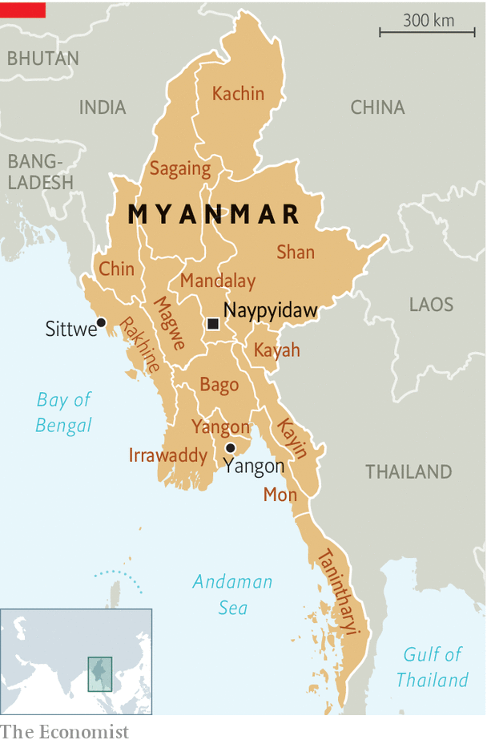

But Ms Suu Kyi does not have “any clear vision” of what a less centralised, federal state might look like, argues Hla Myint of the Arakan League for Democracy (ALD), which advocates for Rakhines, an ethnic group from the state of the same name (see map). During the NLD’s failed attempt to amend the constitution, ethnically based political parties recommended more than 3,000 changes, many of them related to devolution. The NLD did not endorse a single one. And just like the military-backed government that preceded it, the NLD appointed one of its own as the chief minister of Rakhine state, even though the Arakan National Party (ANP), another Rakhine party, won a majority in the state election in 2015. “We don’t see any difference so far between the previous and current government when it comes to their style of governing our Rakhine state,” says Hnin Yu She of the ALD, which split from the ANP in 2017.

Ethnic minorities are also upset because the peace process is flagging. Fighting between the Tatmadaw and the Arakan Army (AA), a Rakhine guerrilla outfit, has escalated dramatically since 2019, to become the most serious conflict in the country in decades. Fighting also smoulders in Kachin and Shan states. Ms Suu Kyi is not primarily responsible, in that she cannot control the army. But she stood mutely by when it ruled out the prospect of negotiations by declaring the AA a terrorist group in March and when it excluded it from its covid-19 ceasefire. She seems not to wish to broaden her dispute with the Tatmadaw by questioning its handling of insurgencies.

In 2013, when she met Ben Rhodes, an adviser to Barack Obama, he underscored the importance of ending the country’s many conflicts and evinced concern about Rohingyas. He says she replied, “We will get to those things. But first must come constitutional reform”—for which she needs the acquiescence of the army. “The NLD’s first priority”, says Mr Saw Alex Htoo, the activist, is “to make peace with the military, not peace with the country”.

Minorities are losing faith not just in Ms Suu Kyi but in the political system itself. Aung Kaung Moe (not his real name) is a Rakhine student activist who was recently jailed for protesting against an internet blackout in the state. Your correspondent asks if he has ever considered going into politics. Yes, he says, often. But sometimes he wonders if he would not be better off throwing in his lot with the Arakan Army. Ethnic parties’ success at the polls does not translate into real political power, he says: just look at how unfairly the NLD treated the ANP. By contrast, ethnic groups like the Wa who seize territory and successfully defend it are able to carve out autonomous enclaves. “In Myanmar, in the reality, [ethnic armed organisations] are more powerful than the ethnic electoral political parties,” says Mr Aung Kaung Moe. The AA, which is wildly popular among Rakhines, governs swathes of northern Rakhine state, he notes. Many young Rakhines have given up on the idea of a federal union. Now they dream of independence.

In the border regions, where most minorities live, Ms Suu Kyi has been knocked off her pedestal. In the heartland, where Bamars, the country’s biggest ethnic group, predominate, support for “Mother Suu” is strong. But even here, cracks have begun to appear. More than twice as many Burmese surveyed by the Asian Barometer Survey (ABS) last year prioritised the economy over democracy. At first glance, there is much for them to be cheerful about. Until covid-19 struck, growth had averaged 6.2% since 2015. The share of the population in poverty fell by half between 2005 and 2017. A middle class is emerging.

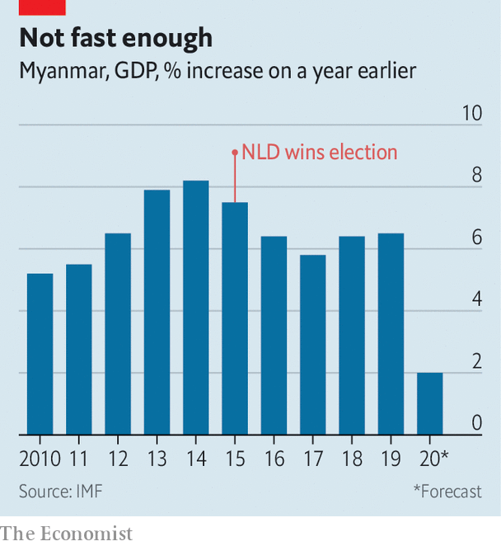

But growth is still slower than in the final days of the military regime (see chart). The IMF reckons that the economy is underperforming by a percentage point or two, owing to weak domestic demand and sagging foreign investment. Many Burmese have yet to see the prosperity that Ms Suu Kyi promised. One in four remained poor in 2017, according to the World Bank. The precariat is growing. Nearly half of those polled by the ABS last year were worried about losing their livelihood, more than twice as many as in 2015. Some 54% said they were unable to access basic services, such as water, public transport and health care, up from 48% five years ago. “Gains from the economic reforms and growth under the NLD government have yet to be widely perceived by ordinary citizens,” the authors of the survey wrote.

Part of the problem is the government’s lack of capacity. When the NLD took up residence in Naypyidaw, the army-built capital, Ms Suu Kyi stuffed the cabinet full of the party faithful—men (and they are all men) whose only qualification was their loyalty to her. Their ineptitude, combined with an inert bureaucracy staffed by ex-soldiers, left the government floundering and unable to achieve anything much.

Matters have improved somewhat as incompetent ministers have been replaced with technocrats. Yet the government still has few tools to help the poor, according to Gerard McCarthy of the National University of Singapore. It “inherited a really skeletal social safety net”, he says, and its capacity to improve matters is limited. Tax revenue has hovered at around 7% of GDP since 2016, less than half the average in South-East Asia. Myanmar’s covid-19 stimulus amounted to a miserly 3.4% of GDP, also far below the regional average.

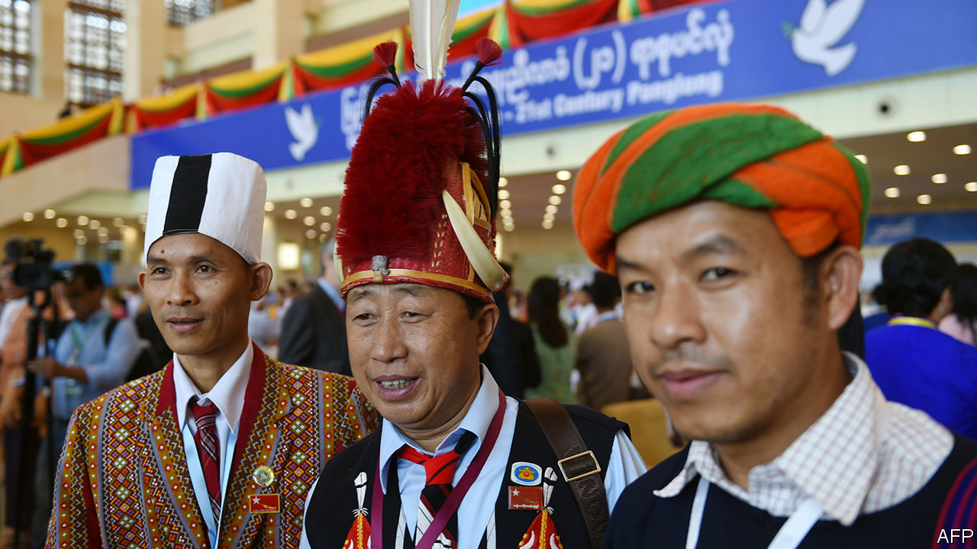

Keeping ethnic minorities in line

The NLD discourages the poor from relying on the state, argues Mr McCarthy. For decades it has cleaved to the idea that people are morally obliged to help themselves and others through acts of charity, an ethic born of both Buddhism and necessity. During the austere years of army rule, political organisations were outlawed and there was no public safety net. People in need could turn only to charities. But this ideology is in growing conflict with the expectations of the public, a majority of whom believe that democracy should lead to better public services, according to the ABS.

Just five years after civilians took power, Burmese have muddled and ambivalent views about their hard-won political freedoms. Although 87% of those surveyed by ABS say that they support democracy, two-thirds believe it does not effectively promote economic growth or maintain order. People also harbour wistful thoughts about military rule. Nearly half support a role for the Tatmadaw in politics—up from 39% in 2015. Confusingly, 56% also back military rule, compared with 48% five years ago.

Younger, rural Bamars who care about the economy and security are more likely to admire the men in uniform. They are less likely “to remember the really bad times,” notes Bridget Welsh, one of the authors of the ABS report. What they do remember is that Thein Sein, an ex-general who began the process of opening up the country, was a better steward of the economy than Ms Suu Kyi. These Burmese believe that Muslims pose an existential threat to the country’s survival, and that the army is necessary to repel them and keep order in a fractious nation, says Mr Holliday. The surveys he conducted with Roman David, of Lingnan University in Hong Kong, suggest that a growing minority of the Burmese population do not see democracy and army rule as antithetical to each other, but as systems of governance that can co-exist. Ms Suu Kyi, in other words, is undermining her own legacy. ■

This article was downloaded by calibre from <https://www.economist.com/asia/2020/11/07/aung-san-suu-kyi-was-supposed-to-set-burmese-democracy-free>

|  |  |  |  |
| --- | --- | --- | --- |
|  | Articles | Sections | Next |

|  |  |  |  |
| --- | --- | --- | --- |
| Previous | Articles | Sections | Next |

#### Hot for trot

# What’s bigger than K-pop?

Among older South Koreans, a fustier, more sentimental musical genre reigns

Nov 5th 2020 | SEOUL



AT A CINEMA in Seoul eight middle-aged women in matching sky-blue hoodies, hair bands and face masks are sharing dried figs and persimmons as they chat and snap selfies. They have travelled from all over the country for the opening weekend of “Mr Trot”, a film based on a South Korean television show that aired earlier this year. In the show, a mix of washed-up and aspiring male crooners chosen from 15,000 applicants dress up in pastel suits and semi-unbuttoned silk shirts and sing old South Korean ballads to compete for the title of “Mr Trot”. The women, whose hoodies read “Lim Young-woong, you are my hero”, are members of an online fan club for the winner. They are not alone in their obsession: more than 30% of South Korean television-viewers tuned into the show’s final episode in March.

Trot, which emerged in the early 20th century when the Korean peninsula was a Japanese colony, blends traditional Korean music with elements of the Japanese and Western popular songs of the era. It has long been ubiquitous in South Korea, but it has been a long time since it was considered cool—if it ever was. The ballads, with their cheesy melodies, melodramatic lyrics and repetitive beats are perennial favourites with drunken revellers in noraebang, or “singing rooms”, the South Korean equivalent of karaoke parlours. Songs about doomed romance, lost hometowns and the general tragedy of life blare from speakers at motorway service stations and from the radios of buses and taxis driven by older men. The more up-tempo numbers are beloved of political parties at election time, when candidates and activists regale voters with clunky dancing set to trot blasting from campaign lorries.

But partly thanks to the popularity of “Mr Trot” and its predecessor “Miss Trot”, a similarly popular programme with female contestants that aired last year, the genre has gone from a sentimental throwback to a potent cultural force. The shows’ stars have become celebrities. In 2019 two of the three most popular music acts in South Korea were trot singers, eclipsed only by BTS, the world’s biggest boy band. Trot singers top the charts for streaming and record sales. Several new trot-themed television shows are trying to emulate the success of their famous predecessors. Companies selling everything from coffee to gas boilers have recruited trot stars to front advertising campaigns.

The trot renaissance owes a lot to South Korea’s other big musical genre, K-pop, as well as to covid-19. At the cinema in Seoul, the blue-hooded women explain that in running their fan club, they have been inspired by devotees of K-pop, who are notable not just for their ardour, but for their organisation. “We co-ordinate on social media to vote for our favourite candidates and stream their songs every day to make sure they make the charts,” says the 50-something woman with long hair and big glasses who has organised the outing and who became a trot fan while bored at home during the early days of the pandemic. Members’ age ranges from 40 to over 80. “If someone older doesn’t know how to do the right thing on their phone, we teach them.” This sort of activism is new for the middle-aged people who tend to listen to trot, says Son Min-jung of Korea National University of Education, who studies the history and cultural significance of the genre. “They used to be passive listeners—trot has always been popular, but now it’s visible,” she says.

And even though trot fans are much older than K-pop groupies, they are no more level-headed or dispassionate. The cinema in Seoul is full of middle-aged women who alternatively whoop and weep as their hero and his fellow contestants sing, dance and change into a dazzling array of costumes for two and a half plodding hours. Their only complaint is that “there could have been more about them hanging out together, just like brothers—because it’s not just about one of them winning, but all of them together.” That remark, too, could have come straight from a hardened BTS fan. ■

This article was downloaded by calibre from <https://www.economist.com/asia/2020/11/05/whats-bigger-than-k-pop>

|  |  |  |  |
| --- | --- | --- | --- |
| Previous | Articles | Sections | Next |

|  |  |  |  |
| --- | --- | --- | --- |
| Previous | Articles | Sections | Next |

#### Banyan

# New Zealand allows assisted dying, among other progressive steps

But it cannot quite stomach legalising cannabis

Nov 5th 2020 |



UNTIL THIS week, Asia’s most famous ministerial tattoo belonged to the Indonesian former fisheries minister, Susi Pudjiastuti. But you had to know where to look—the birdlike form lived on Ms Susi’s shin. In contrast, New Zealand’s new foreign minister, Nanaia Mahuta, sports a Maori tattoo known as a moko kauae on her lips and chin.

Ms Mahuta is part of the most diverse cabinet in New Zealand’s history, appointed by Jacinda Ardern following a thumping re-election for the prime minister and the Labour Party she leads. Ethnically, almost half the 20 members are not pakeha, ie, white, including five indigenous Maori. There are eight women, two of whom are lesbians with young children, and the first openly gay deputy prime minister, Grant Robertson.

Ms Ardern would not, this week, have fared well in Kansas. After a massacre of Muslim worshippers last year, she swiftly implemented a ban on semi-automatic weapons. Climate change and the environment are big priorities. She likes to talk about her “team of 5m”, meaning all Kiwis. Vogue magazine nicknamed her the “anti-Trump”.

Yet the prime minister’s liberal stances are not so much shaping the country’s attitudes as emblematic of them. New Zealand, after all, was the first place in the world to give women the vote. The country is content, even occasionally smug, about being so very progressive. As Andrew Geddis of the University of Otago says of Ms Mahuta’s moko kauae, New Zealand’s public face “says something about how we’re changing as a society and what we’re comfortable with showing the world”.

More notable than the appearance of Ms Ardern’s cabinet is how voters answered one question on their ballot paper: should New Zealand legalise assisted dying for those with a terminal illness? Though the final tally has yet to be announced, around two-thirds of New Zealanders appear to have said “yes”.

Dying with dignity has been the subject of heated debate for years. Voluntary euthanasia has had the support of libertarians, notably David Seymour, who heads the ACT party, as much as of more left-leaning types. In 2015 Lecretia Seales, a lawyer with a terminal brain tumour, sued the government for the right to die. She lost, but after her death her husband redoubled the campaign. A national debate ensued, in which lawmakers looked to see what worked in other countries.

Last year Parliament passed the End of Life Choice Act. It restricts access to assisted dying more than some European legislation. It requires you to be suffering from a terminal illness that is likely to end your life within six months, to be showing a significant decline in physical capability and to be able to make an informed decision. Arguments that the law would result in disabled people, the mentally ill or even children being put to death never gained traction. The law’s enactment was contingent on the referendum, which was binding. New Zealand thus becomes only the seventh country to legalise assisted dying, and the first country in Asia—though the Australian state of Victoria passed a similar law last year.

Yet when it came to another, non-binding, question on their ballots, about whether to legalise cannabis, Kiwis curiously found limits to their open-mindedness: just over half appear to have voted against the proposition. That might seem strange. New Zealand is one of the easiest places in the world to get a toke, and Ms Ardern’s admission of having smoked weed elicited little more than a national shrug. More than half of those aged between 15 and 45 say they’ve done the same.

Still, as Lara Greaves of the University of Auckland, puts it, full legalisation of cannabis, rather than its simple decriminalisation, was “a jump too far”. Some feared that making more available would only further encourage its use, especially among the young. Moreover, said anti-cannabis campaigners, a problem already exists with heavy alcohol consumption, especially among Maori and Pacific-islanders—why add to it? Besides, who is going to get locked up just for smoking a joint?

Such arguments are understandable. But they miss a point that Maori community workers and others make: Maori are far more likely than pakeha to be charged with possession and cultivation of marijuana. And the disproportionate number of Maori banged up for small-fry drug offences feeds into the pathology of Maori gangs that blight indigenous life. Even the most progressive societies have their blind spots.

This article was downloaded by calibre from <https://www.economist.com/asia/2020/11/05/new-zealand-allows-assisted-dying-among-other-progressive-steps>

|  |  |  |  |
| --- | --- | --- | --- |
| Previous | Articles | Sections | Next |

|  |  |  |
| --- | --- | --- |
| Asia | Sections | Middle East & Africa |

China

Economic policy: Circling back

.

Chaguan: How China sees America

.

|  |  |  |
| --- | --- | --- |
| Asia | Sections | Middle East & Africa |

|  |  |  |  |
| --- | --- | --- | --- |
|  | Articles | Sections | Next |

#### Circling back

# China’s “dual-circulation” strategy means relying less on foreigners

Xi Jinping sees the creation of fully domestic supply chains as a matter of national security

Nov 7th 2020 | FENGYANG

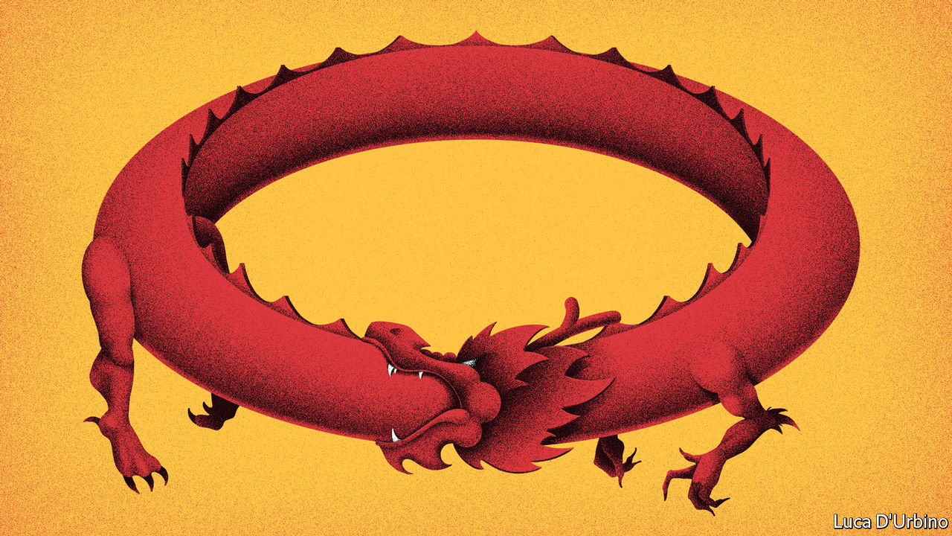

AT THE HEADQUARTERS of Deli, one of China’s biggest makers of glassware, display shelves hold hundreds of drinking glasses of all shapes, sizes and colours. Some are stubby. Others are impossibly thin wine goblets, marketed as having a “feminine body curve”. But it is another curve—the steep upward one that Deli’s mastery of the business has traced—that ought to command more attention. Founded in 1996, the company initially churned out cheap, easily chipped glasses. Little by little it has raised its game, nearly tripling its exports over the past decade. It once had no choice but to import equipment for crafting its finest glassware. Now it can use China-made machinery. “Apart from branding, there’s not much that separates us from the world’s best,” says Cheng Yingling, a senior executive.

Deli’s evolution—which has involved getting better and more Chinese at the same time—is what the government wants for the broader economy. These are not exactly novel ideas. For years officials have declared that China must grow more innovative and more resilient. To a certain extent it has achieved this naturally, as a result of its fast-paced economic development. But these goals have taken on far greater urgency as tensions with America have mounted. American restrictions on exports of critical components, notably semiconductors, have shone a harsh light on the gaps in China’s industrial abilities. Drinking glasses may be much simpler to make—requiring not much more than sand and sodium carbonate plus some relatively basic machinery—but China is not about to stop there. Xi Jinping, China’s leader, has described the creation of fully domestic supply chains as a matter of national security.

The question is how to build them. Chinese officials know that they cannot turn their backs on the world. Exports are still an important source of revenue for many firms such as Deli. And China must attract technology and investment from abroad. Pushing too transparently for “indigenous innovation”, a term once bandied about by the government, only makes foreigners wary. Striking the right balance is tough.

Enter the newest of China’s big economic policies: the “dual-circulation” strategy. At its most basic it refers to keeping China open to the world (the “great international circulation”), while reinforcing its own market (the “great domestic circulation”). If that sounds rather vague, it is: the government has not spelled out the details. Nevertheless, it has fast emerged as the most talked-about economic policy in China, with analysts and businesspeople jostling to put their spin on it. The strategy lies at the heart of the five-year plan for 2021-25, an outline of which was released by the Communist Party on November 3rd. Its implementation—especially how China resolves the tension between the two kinds of circulation—will be critical to the way that China’s economy develops.

The term “international circulation” was coined in 1988 by Wang Jian, a government researcher who argued that China should pursue an export-led growth strategy, plugging its vast pool of cheap labour into global production networks. Well into the early 2000s, this was a guiding principle for China’s economic planners. Yet circumstances have changed. Exports have shrunk as a share of GDP—from 36% in 2006 to 18% last year. The government has repeatedly vowed to make consumption within China a bigger engine of growth. So scholars have been turning their attention more to the domestic kind of circulation.

In May it became evident that this academic debate had reached official ears. At a meeting of the Politburo, Mr Xi described dual circulation as the framework for economic policy. Initially, jaded veterans of Chinese official rhetoric were tempted to dismiss this as just another way of phrasing the long-stated goal of rebalancing towards domestic demand. But it has become clear that something bigger is afoot. More recent comments by Mr Xi on the economy have been less about promoting consumption and more about bolstering China’s defences. China needs “self-developed, controllable” supply chains, with at least one alternative source for vital products, he said in a speech published on October 31st. Even more striking was his inversion of the idea of international circulation. Instead of talking about it in terms of the economic benefits China reaps from globalisation, he emphasised only the strategic purpose of opening China’s doors to foreign firms, ie that making them more dependent on the Chinese market would deter foreign powers from putting pressure on the country.

That combination—the pursuit both of economic self-reliance and of greater economic leverage over foreign countries—now describes much of what China is doing. Mr Xi refers to changes “unseen in a hundred years” sweeping the global order—a way of saying that, while China is rising, America is declining and trying to stop the new power (see [Chaguan](https://www.economist.com/node/21795160)). “Where linkages with the global economy create vulnerabilities, China wants to minimise them,” says Andrew Polk of Trivium China, a research firm. “Where the linkages create benefits, China wants to expand them.”

Chinese officials tailor their remarks on dual circulation to please foreign ears. In a video address on November 4th at the opening of the China International Import Expo, an annual jamboree in Shanghai, Mr Xi said the concept would involve opening China more widely to the rest of the world. “This is not just what China needs for its development, but something that will enrich the people of all countries,” he said. But businesses in China see the concept more as an indication that the government will step up support for favoured industries at home, says Zhu Ning of the Shanghai Advanced Institute of Finance. They are hungry for news of handouts.

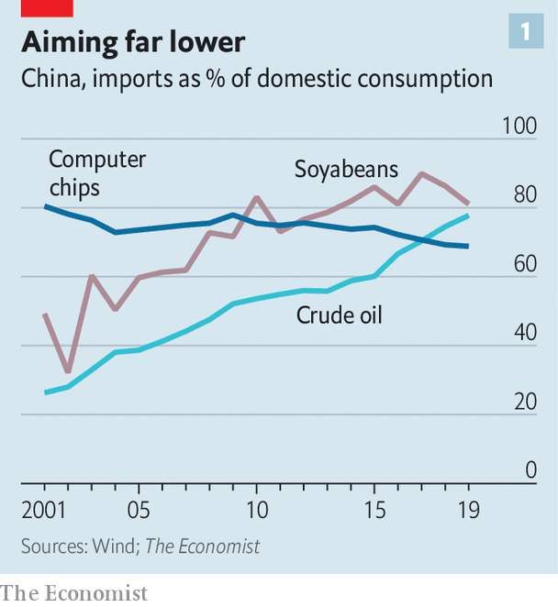

In its outline of the new five-year plan (a fleshed-out final version will be adopted next year at the annual session of China’s parliament, probably in March), the party did not specify industries to be coddled. Instead it referred more generally to a need to develop critical technologies at home. But other policies already in train suggest that China will prop up any high-tech sector threatened by global vicissitudes. In August it announced tax breaks and loan support for semiconductor and software firms. China currently produces about 30% of the chips it consumes (see chart 1). Its goal is to reach 70% by 2025. Another focus is on green technology and renewable energy. That is not just for the sake of the environment (China recently pledged to halt the rise of its carbon emissions by 2030). Investment in such businesses will also limit China’s thirst for imported oil.

In the past, when publishing outlines of five-year plans prior to their adoption by parliament, the party has often announced a goal for average annual GDP growth during the plan period (see chart 2). There was no such figure this time. In separate comments, Mr Xi said it was entirely possible that China could double the size of its economy by 2035. That would require average annual growth of 4.7% over the next 15 years. Such a rate would be readily attainable for the first half of that period, but may become much harder thereafter.

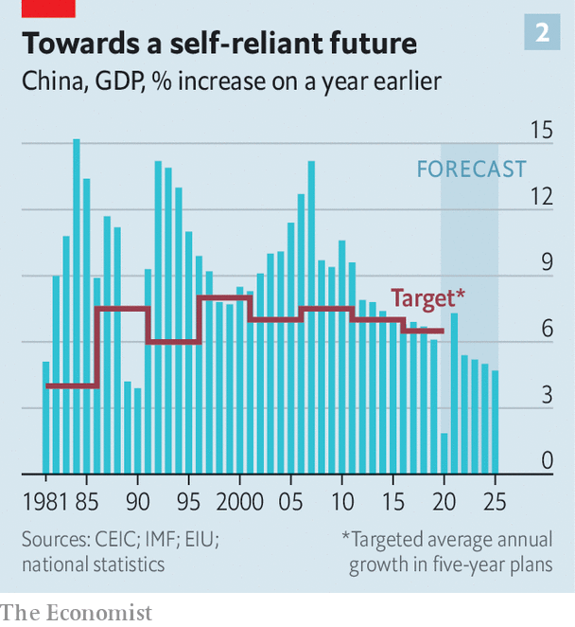

China has good reason to abandon such targets. They lead to an overemphasis on investment in infrastructure and other short-term measures to boost growth, rather than on social policies such as those relating to health care or education which can promote growth but may take longer to show results. But de-emphasising targets may relate to the new dual-circulation strategy in a way that the government has left unspoken. Making the economy less reliant on global supply chains could crimp its ability to grow.

Arguably China has been the world’s main beneficiary of globalisation, which has enabled it to dominate ever-bigger segments of manufacturing. Turning inward could be costly. It may result in less foreign technology flowing into China, less of the competition that has spurred on Chinese firms, and more wasteful investment as the government throws money at favoured industries. Shaun Roache, an economist with S&P, a credit-rating agency, forecasts that China’s average annual growth will be 4.6% in the 2020s. But he reckons it could be about 3% if the drive for self-reliance is overdone. The country’s “tolerance for slower growth may well be tested in the years ahead”, he says. The party, ever fearful that a stagnating economy could trigger social unrest, may find it hard going.

Optimism is a stubborn trait, so some inveterate China-bulls think that emphasising domestic circulation may create a new wave of reforms aimed at making the country’s markets function more efficiently. Take the semiconductor industry. Caixin, a Chinese financial magazine, reported last month that Huawei, a tech giant, was rushing to create a “not-made-in-America” supply chain by 2022. Initially, however, that would enable it to make chips with transistors spaced 28 nanometres (billionths of a metre) apart, far less dense than the most advanced ones. The bullish case is that China, realising how long it will take to catch up in such areas, will try to boost productivity by cracking on with hitherto slow-moving reforms. Analysts with Huatai Securities, a brokerage, think that could include doing more to loosen the household-registration system known as hukou, which impedes the movement of rural labour to the country’s biggest and most productive cities.

In the meantime, companies are getting on with their work. Mr Cheng at Deli, the glassware firm, says he will not give up on foreign markets despite the pandemic’s impact on demand. But he will mainly focus on brighter prospects at home. His team is refining their product range for younger consumers, who are pickier about style and more demanding about quality than their parents. That mix of emphasis, your correspondent ventures, sounds a lot like a corporate version of the dual-circulation strategy. “We’re not too clear about what all that means,” he says with a sigh. “We’re just following the market.” ■

This article was downloaded by calibre from <https://www.economist.com/china/2020/11/07/chinas-dual-circulation-strategy-means-relying-less-on-foreigners>

|  |  |  |  |
| --- | --- | --- | --- |
|  | Articles | Sections | Next |

|  |  |  |  |
| --- | --- | --- | --- |
| Previous | Articles | Sections | Next |

#### Chaguan

# No American election will change China’s mind

It is sure that America is bent on containing its rise

Nov 7th 2020 |

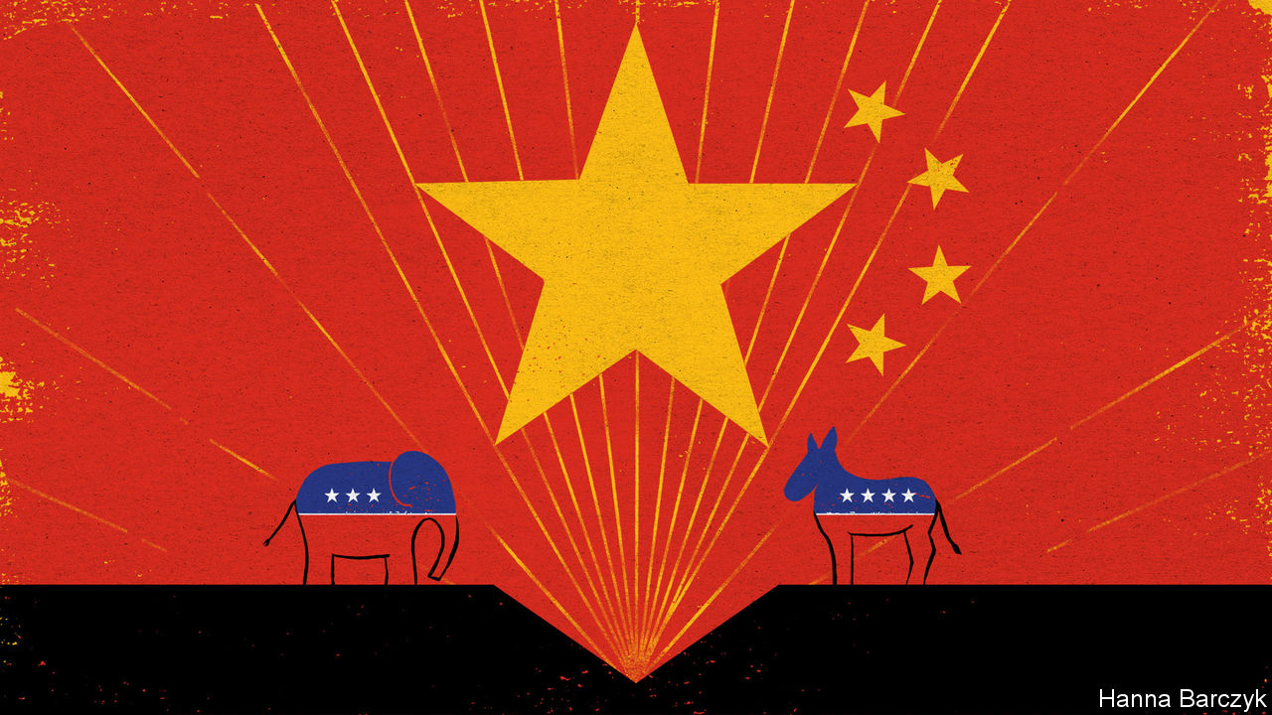

SHORTLY BEFORE election day in America, Chaguan spent an instructive morning in central Beijing listening to a senior Chinese official explain why his country does not care who sits in the White House. This was partly bravado, for China’s rulers do not care to play up the idea that mere voters might hold world leaders to account. But the official’s disdain also reflects an elite consensus that a full reset of US-China relations is difficult to imagine.

China wants smoother ties with America, said the official. But given their deep roots, present-day tensions will be hard to reverse unless America comes to a new understanding of the world. Westerners are a self-centred and judgmental lot, he charged. They never expected the Chinese—a diligent, studious people—to rival them so soon. No matter which party runs Washington, the official said, “The US has to answer this question: can the US or the Western world accept or respect the rise of China?”

To Chinese leaders, Donald Trump’s aggression in office merely accelerated some inevitable trends. To them, the Trump era shows that talk of values is a sham, that China alarms Americans because it is getting stronger—and that the solution is to become more powerful, until Western critics are shamed into silence by China’s success. They also think that American weakness is making that ex-hegemon (even more) vicious and determined to scapegoat China. Back when Xi Jinping was China’s vice-president, he spent many hours with his counterpart Joe Biden, who is seen as an establishment centrist close to business sectors that want better China ties. But struggle with America is seen as unavoidable.

Ordinary Chinese citizens never followed an American election so closely. But many watched with more scorn than envy. Instead, abetted by censors who allowed mocking jokes and memes about the race to flood social media, a common view is that the result is irrelevant. The Chinese internet is full of posts backing Mr Trump. Most reflect glee over his pugnacious style and a hunch that his incompetence, notably in handling covid-19, has usefully harmed America. Other fans include nationalists grateful for Mr Trump’s reluctance to condemn official abuses in places like Xinjiang and Hong Kong, as well as, confusingly, dissidents and Hong Kongers who think him tough on the Communist Party.

Americans may object that Chinese views of their politics are cartoonish, incoherent and self-serving. But cynicism about the democratic West—among both elites and the general public—matters. For it helps to explain how the party will approach what its Central Committee described on October 29th as a “profound adjustment in the international balance of power”.

Elite cynicism about America preoccupies Chairman Rabbit, a Harvard-educated Chinese blogger whose 1.7m followers on Weibo, a social-media platform, include business leaders and officials in government ministries. Ren Yi, the chairman’s real name, is a mainstream nationalist with princeling blood: his grandfather was a reformist party secretary of Guangdong province in the 1980s. His posts explore the nuances of American politics. But the wider public associates such nuance with naivety. Mr Trump was liked in China until 2018, says Mr Ren over coffee in a Beijing hotel. His populist nationalism resonated, as did his praise for President Xi. His slogan “Make America Great Again” mirrored talk of a great Chinese rejuvenation. Even the trade war had fans, at first. When Mr Trump’s envoys pushed China to speed up market-opening reforms, some influential Chinese were sympathetic to American arguments, recalls Mr Ren. Three events changed the mood. Canada arrested Meng Wanzhou, a boss at Huawei, a Chinese tech giant, on behalf of American prosecutors investigating alleged sanctions-busting. Then American politicians cheered on anti-government protests in Hong Kong. Finally came America’s bungling of the pandemic, even as the Chinese public complied with strict health controls that tamed the virus at home.

Mr Ren saw friends concluding that all American politicians are as bad as each other. Most Chinese “think of US politics as a huge conspiracy to keep China down”, a suspicion that they flaunt as a badge of sophistication, says the blogger. Where once the Chinese romanticised America as an advanced nation, “Now because of covid they see the US people as selfish, anti-science, anti-intellectual.” It is no accident that events that angered Chinese—Ms Meng’s arrest and the protests in Hong Kong—touched on sovereignty. Homogeneous China finds it hard to comprehend pluralistic, divided America, says Mr Ren. What Chinese really care about is China’s strength and territorial integrity. “They think that it is China’s destiny to rise, and so to come into conflict with America.”

## Too late to contain China, still time to compete

Popular opinion concerns Wang Yong, who directs the Centre for American Studies at Peking University, one of China’s most prestigious institutions. A frequent guest on state media, he made a series of short election-eve videos about America for Jinri Toutiao, an online platform, racking up over 10m visits. As he describes it, America’s China policies are guided by competing interest groups, with Mr Biden heeding the Wall Street financiers and Silicon Valley bosses who seek “more rational” ties with China, while hawks and “deep-state forces” push for a new cold war. China and America can work together on such shared interests as climate change, public health and enabling global prosperity, he insists. Yet people should be realistic, says the professor over jasmine tea near his university. America “has been accustomed to the top position in world affairs and will use all means to defend its status”.

Amid such distrust, any Chinese rapprochement with America should be understood for what it is: a bid to buy time while China races to become stronger. China’s rulers are not hiding their worldview, which is based on the idea that only the powerful are treated with respect. America can choose whether or not to compete. But it has been warned: American gridlock would be a win for China. ■

This article was downloaded by calibre from <https://www.economist.com/china/2020/11/07/no-american-election-will-change-chinas-mind>

|  |  |  |  |
| --- | --- | --- | --- |
| Previous | Articles | Sections | Next |

|  |  |  |
| --- | --- | --- |
| China | Sections | Europe |

Middle East & Africa

Conflict in Ethiopia: Abiy’s call to arms

.

Bobi Wine: Sing it loud

.

Tanzania and Ivory Coast: Setting a bad example

.

Debt in the Middle East: Not flattening the curve

.

Robert Fisk: Rage on the page

.

|  |  |  |
| --- | --- | --- |
| China | Sections | Europe |

|  |  |  |  |
| --- | --- | --- | --- |
|  | Articles | Sections | Next |

#### Abiy’s call to arms

# Ethiopia lurches towards civil war

The prime minister confronts Tigray, a restive region that will not be easy to subdue

Nov 4th 2020 | ADDIS ABABA AND MEKELLE

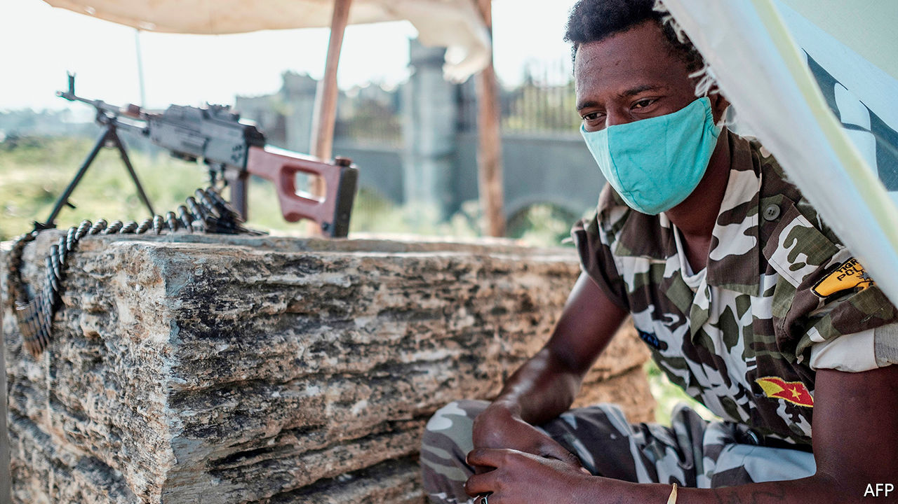

FOR SEVERAL days the warning lights had been flashing red. Early in the morning of October 29th a general in Ethiopia’s federal army had flown to the northern region of Tigray to take up his new position as deputy commander of forces in the region. He was refused entry. In Mekelle, the regional capital, rumours swirled of troop movements across the state border in the Amhara region, as well as in Eritrea, a country to its north. Throughout Tigray young men had been armed and trained. On November 2nd its president said the region was preparing for war.

War may have begun. On November 4th Ethiopia’s prime minister, Abiy Ahmed, ordered his forces to hit back in response to what he claimed was an “attack” by Tigray’s ruling party on a base housing federal troops. “The red line has been crossed,” he said. Early reports suggest there had been a heavy exchange of artillery fire around Mekelle and on the border with Amhara. The internet and phone networks in Tigray were cut off. Abiy has declared a state of emergency in the region. In a television address he said the fighting had resulted in casualties, though he did not say how many. As The Economist went to press it was unclear whether the conflict would be limited to a brief skirmish or might blow up into a full-scale war.

The latest escalation comes after months of bitter feuding between Abiy and leaders of the Tigrayan People’s Liberation Front (TPLF), an armed group that turned into a political party after leading the rebellion that ousted the Derg, a Marxist junta, in 1991. Since then, for almost three decades, the TPLF called the shots in the federal government before massive protests in 2018 among the Oromos, who make up roughly a third of Ethiopia’s population, forced it to make way for Abiy.

His administration views the TPLF as spoilers who are sabotaging Ethiopia’s fragile transition to democracy. The TPLF, by contrast, sees Abiy as a usurper determined to tear up the constitution, which guarantees self-rule for each of Ethiopia’s ten ethnically based states—and even the right to secede. When the central government postponed elections earlier this year, citing covid-19, the TPLF accused Abiy of scheming to extend his time in office.

The feud came to a head in September, when Tigray defied the federal government and went ahead to hold its own regional election. Instead of quietly accepting the result, the central government said it was illegal. The federal parliament voted to isolate Tigray’s leaders. The finance ministry in Addis Ababa stopped giving money to the regional government and set in motion plans to send funds directly to local authorities. It is also said to have blocked welfare payments to poor farmers and to have tried to prevent investors and even some tourists from travelling to Mekelle.

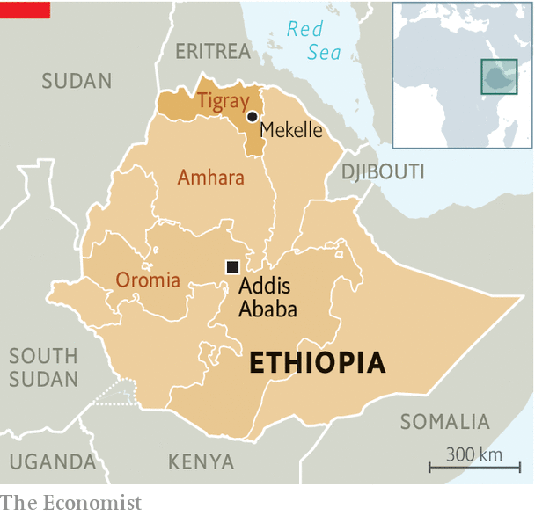

The TPLF said that slashing federal funding amounted to a “declaration of war”. It called for Abiy to step down and for a caretaker government to replace him. Although the prime minister had repeatedly ruled out armed intervention, parliament recently authorised it. Both sides had flexed their muscles with military shows of force. “If Abiy wishes to fight this out, we will pay him in his coin,” Getachew Reda, a senior TPLF official, told The Economist in late October.

It is not the only conflict tugging hard at the seams of the Ethiopian state. Abiy is also waging a war against armed separatists in his own region of Oromia, the country’s largest. He is struggling to quell popular protests against his rule there and elsewhere. In the past few weeks there have been several massacres, mostly of Amharas. On November 1st armed men killed dozens of women and children in a schoolyard in western Oromia, according to Amnesty International.

The federal government claims that the TPLF fuels these various conflicts by arming and training opposition groups, though hard evidence has yet to be shown. This, it says, justifies action. On November 2nd Abiy’s allies in Amhara called on him to finish off the TPLF “once and for all”. Parliament suggested it would declare the TPLF a “terrorist” organisation.

Abiy may be hoping to reassert control over Tigray with a quick strike. But three factors make the conflict with the TPLF especially dangerous. First, the TPLF is by far the best equipped and most powerful of Ethiopia’s opposition forces. Though Tigrayans are less than 10% of Ethiopia’s population, the region’s paramilitaries are led by veterans of both the long struggle against the Derg and of a devastating war with Eritrea fought mostly between 1998 and 2000. Tigrayan officers purged by Abiy from the federal army are said to have returned to Tigray to train and organise new recruits. Though the constitution allows each region to have its own security forces, the prime minister’s office has accused the TPLF of unconstitutionally “arming and organising irregular militias”.

Moreover, Tigray is also the home base of the Ethiopian army’s most powerful units, amounting to more than half its soldiers. Organised into its Northern Command, they bore the brunt of the fighting against Eritrea. The TPLF reckons that many of the Northern Command’s officers and soldiers would switch sides or mutiny if Abiy ordered them into battle against Tigray. On November 4th Tigray’s state broadcaster claimed that many officers and other ranks had already defected. The federal government denies it.

The third factor is Eritrea. In 2018 Abiy ended the cold war between the countries by signing a peace deal with Eritrea’s ageing dictator, Isaias Afwerki, for which Abiy was awarded the Nobel prize the year after. But Isaias, whose enmity with the TPLF stretches back decades, has shown little appetite for peace. Instead, he has stepped up his efforts to topple his old foes by cosying up to Abiy. On October 31st Eritrea’s government declared that the TPLF was “on its deathbed”. Eritrean troops are said to have been conducting provocative manoeuvres along the border. “Tigray is preparing for war on two fronts,” says Fetsum Berhane, a Tigrayan activist.

Both sides claim to have done all they can to prevent escalation. “What we want is to avoid bloodshed,” said Seyoum Mesfin, a Tigrayan who was a former foreign minister of Ethiopia, recently in Mekelle. He stressed that the TPLF wanted dialogue, but with all parties on an equal footing. Abiy’s office, for its part, claims the government has “retained a policy of extreme patience” but that war cannot be prevented by the “goodwill” of only one side. It insisted the army was acting to “save the country and the region from spiralling into instability”. As both sides edge closer to war, some hear echoes of 1998. That was when Ethiopia and Eritrea sleepwalked into a catastrophic conflict. There is still just enough time for both sides to wake up. ■

This article was downloaded by calibre from <https://www.economist.com/middle-east-and-africa/2020/11/04/ethiopia-lurches-towards-civil-war>

|  |  |  |  |
| --- | --- | --- | --- |
|  | Articles | Sections | Next |

|  |  |  |  |
| --- | --- | --- | --- |
| Previous | Articles | Sections | Next |

#### Sing it loud

# Bobi Wine, the pop star who would be president of Uganda

Arrested but undaunted, a young artist challenges an ageing autocrat

Nov 7th 2020 | KAMPALA

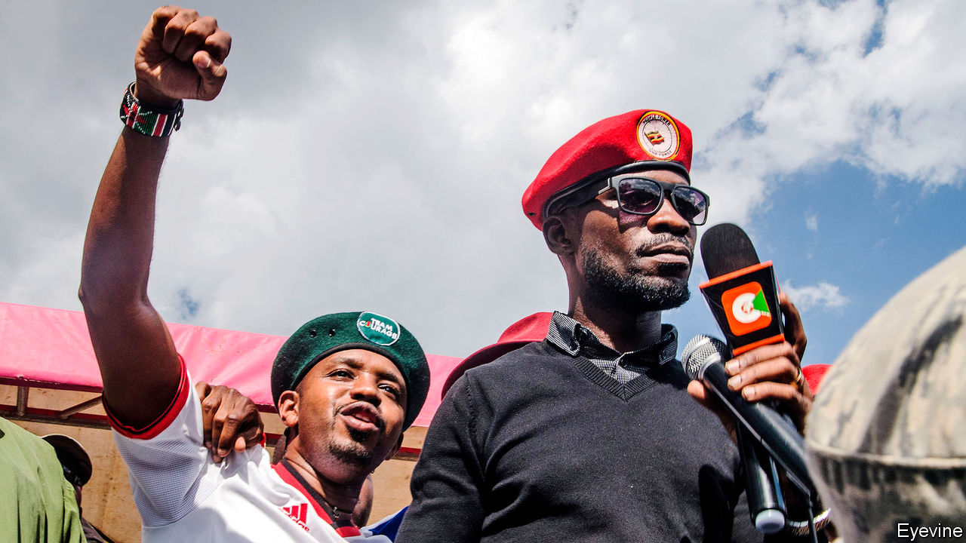

SUIT TORN, tie askew, eyes half-shut, Bobi Wine stood on his veranda and addressed a crowd. That morning, on November 3rd, the Ugandan pop star had handed in his nomination papers to run for president in elections in January. Moments later, police smashed the window of his car, arrested him and pepper-sprayed his face before driving him home. Bedraggled but defiant, he greeted his fans. “This is a revolutionary election,” he said. “If it’s a boxing fight, it has begun.”

Ugandan elections are only loosely about votes. Yoweri Museveni, the president, has ruled since fighting his way to power in 1986. He needs a contest to legitimise his regime, and uses the army, police and patronage to make sure he wins. The opposition hopes to unseat him by opening cracks in his regime. Mr Wine’s struggle is part election campaign, part call to revolution. “Running against Museveni”, he tells The Economist, “is like running against all the institutions of state.”

For Mr Wine, whose real name is Robert Kyagulanyi, it has been a meteoric rise. He found fame as the “ghetto president”, singing about social injustice. In 2017 he won a seat in parliament. Mr Museveni’s acolytes were busy abolishing a presidential age limit so the old man could stand again; Mr Wine joined opposition MPs in resisting the change. The bill passed, but Mr Wine channelled the energy of the campaign into a new movement, which he called “People Power”—a messy coalition of established politicians, frustrated graduates and the hustlers of his ghetto hinterland.

People Power speaks with many voices. In the flood-prone valleys of Kampala it sounds like a revolt against the rich. On university campuses it resembles a youth rebellion. Activists in the neglected north frame it as a fight against ethnic exclusion. “All those are just symptoms of one issue: misgovernance,” says Mr Wine. At 38, he is half the incumbent’s age.

The movement was also, at its inception, a protest against conventional politics. But in July Mr Wine announced himself the leader of an obscure party, which he renamed the National Unity Platform (NUP). A party structure gave him control over candidates, a symbol on the ballot paper and a firmer legal footing. Some considered it a wrong turn. “We are now behaving like politicians,” says Roy Ssemboga, a former student leader, once close to Mr Wine, who is running for parliament as an independent. “We wanted short-term glory and I think we lost an identity.”

Like other parties, the NUP has become caught up in Uganda’s transactional politics. The process of selecting parliamentary candidates exposed disorganisation and division. In the central region, where the party is strongest, some contenders tried to buy its endorsement. Derrick Ssonko, a mechanic in blue overalls, says he was inspired to run for local councillor, but the party ticket went to a rival who paid a bribe. He worries that the NUP is “old wine in new bottles”, even though everyone he knows will vote for it.

The NUP is contesting fewer than half of parliamentary seats. David Lewis Rubongoya, the party’s powerful secretary-general, says that scores of contenders pulled out because of a court case that challenged its legal status (the case was dismissed, but only after nominations had closed). Many others could not muster nomination fees of 3m shillings ($800), which is the average annual income in Uganda.

But the paranoid president is not the type to take chances. He warns that Mr Wine has “foreign backers who fear a strong Uganda”. Soldiers and police raid the NUP’s offices on spurious pretexts, and invoke covid-19 to block public gatherings. Activists are threatened or bought off. In 2018 Mr Wine was beaten by soldiers and charged with treason, along with 36 of his supporters (a conviction is unlikely). Voters are wary of the disorder that has always accompanied political transition. After listening to an NUP activist in a northern village, 80-year-old Rose Akello raises her hand. “Death is painful,” she says, recalling Uganda’s violent past. “When you are pursued by a knife, don’t you go and hide?”

Kizza Besigye, the main opposition leader in the past four elections, is sitting out this poll, arguing that Mr Museveni cannot be removed by voting alone. Some activists in the NUP agree, but also blame Dr Besigye for demoralising voters. Their apparent strategy is to draw a massive turnout, then “defend the vote” on the streets. “A vote must be cast before we can fight for it,” says Mr Wine.

Powerful critics, such as Andrew Mwenda, a journalist who is close to the president, argue that Mr Wine’s supporters are “radical extremists”, not liberal democrats: “They’re fighting Museveni to get power and do exactly what he’s doing, perhaps without his finesse.”

Others try to paint the NUP as a party of Buganda, an ancient kingdom within Uganda in which Kampala lies. Buganda’s kabaka (king) commands deep loyalty among the sixth of Ugandans who consider themselves his subjects, including the singer. Several leading politicians in the NUP cut their teeth on royalist struggles for land and federalism. Buganda has “legitimate and genuine concerns”, says Medard Sseggona, an NUP politician and former minister in the kingdom’s own cabinet, but those “are shared by other nationalities in this country”. Mr Wine himself has cosmopolitan instincts, nurtured in the ethnic melting pot of the city.

In general, Mr Wine’s politics are less revolutionary than his lyrics and red beret suggest. His headquarters are painted with murals of pan-African heroes like Thomas Sankara, a socialist leader of Burkina Faso. But he also collaborates with free-market think-tanks. “I don’t have a very radical programme,” he says. His most consistent pledge is to rebuild institutions after decades of personalised rule.

The singer will probably never become president. Even if he dislodged Mr Museveni, any transition would be directed by the army. But the real force is not Mr Wine—it is the hope he represents. From markets to minibuses, Ugandans repeat his slogan, “twebereremu”. What does it mean? His eyes light up. “Get involved.” ■

This article was downloaded by calibre from <https://www.economist.com/middle-east-and-africa/2020/11/07/bobi-wine-the-pop-star-who-would-be-president-of-uganda>

|  |  |  |  |
| --- | --- | --- | --- |
| Previous | Articles | Sections | Next |

|  |  |  |  |
| --- | --- | --- | --- |
| Previous | Articles | Sections | Next |

#### Setting a bad example

# Democracy is faltering in Tanzania and Ivory Coast

Their post-election crises could yet get worse

Nov 5th 2020 | DAKAR

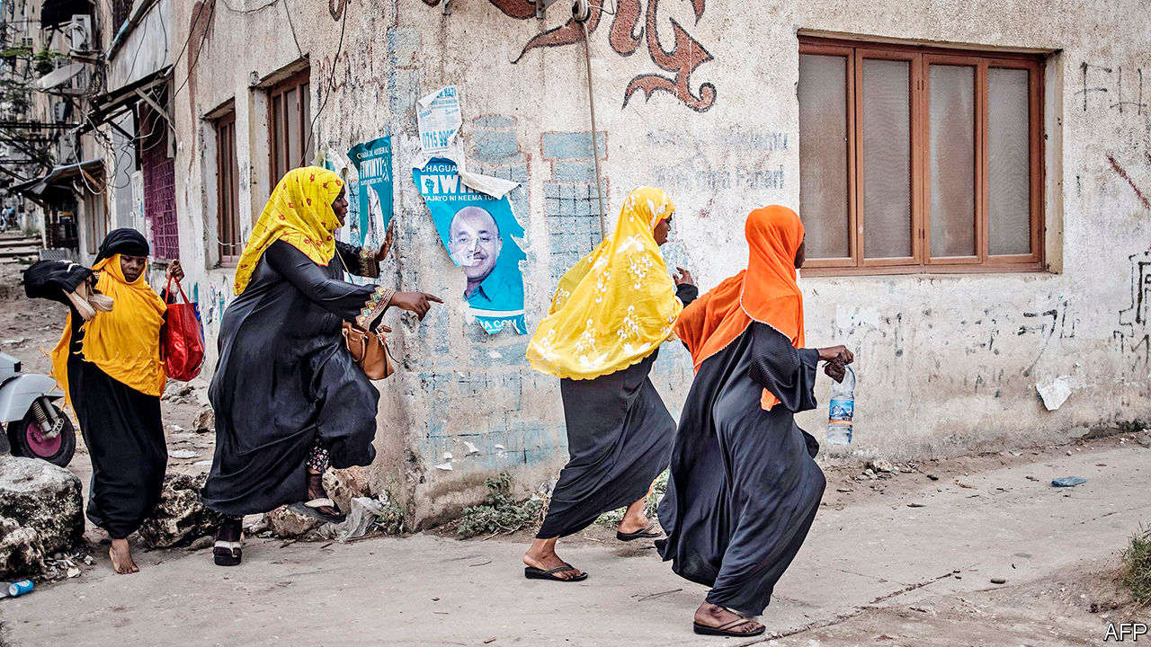

“I HAVE ESCAPED arrest twice today,” said Zitto Kabwe, a Tanzanian opposition leader, on November 2nd. But, he added, “I cannot avoid the police for ever.” The next day they picked him up, like so many of his colleagues who contested Tanzania’s election on October 28th. Some have been beaten. Tundu Lissu, a leading rival to President John Magufuli, was grabbed by police in front of European embassies, where he was seeking refuge having been turned away by the American embassy. Mr Lissu was interrogated, but not charged—perhaps because German diplomats were waiting outside the police station.

Democracy in Tanzania is broken—and is in trouble elsewhere in Africa, too. Guinea’s election on October 18th resulted in a dubious victory (and a third term) for President Alpha Condé. At least 30 people were killed protesting against the result, says the opposition. Ivory Coast is in crisis after President Alassane Ouattara won a third term on October 31st, amid a boycott by the opposition. Both leaders claimed not to be bound by term limits, illustrating a dismal recent trend (see map).

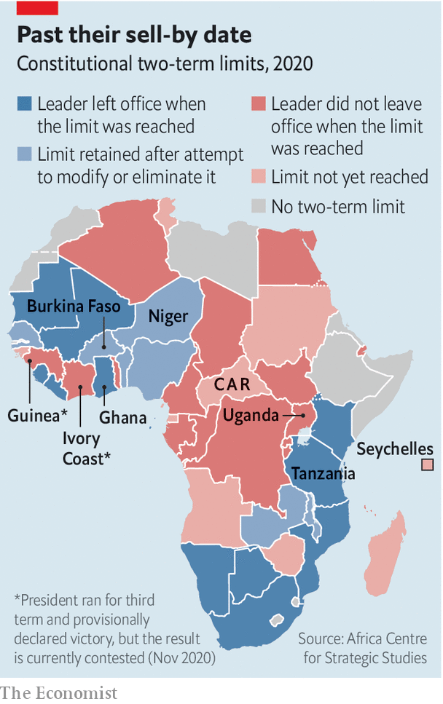

Tanzania may be the most troubling case. Not long ago it seemed on its way to becoming a relatively prosperous democracy. For more than a decade from 2000 its economy was among Africa’s best performers. But Mr Magufuli, who took over in 2015, has set things back. He has produced fishy economic numbers that seem to hide real problems, while cracking down on any opposition. In this election he won 84% of the vote, up from 58% in 2015, according to the official tally. His party won enough seats to abolish term limits, if it so chooses. The opposition is claiming fraud. “This was not an election,” says Mr Lissu. “It was just a gang of people who have decided to misuse state machinery to cling to power.”

Mr Lissu has called for protests. Mr Kabwe hopes other countries will impose sanctions on Tanzania. Britain, for one, said it was “deeply troubled” by the result. But countries in the region have been more supine. An observer mission from the East African Community, a regional bloc, said the vote had been “conducted in a credible manner”. The observer mission from the African Union (AU) has yet to express an opinion. President Cyril Ramaphosa of South Africa, who currently chairs the AU, congratulated Mr Magufuli on his win in a “peaceful election”.

Ivory Coast seemed to be moving in the right direction, too. Mr Ouattara took over in 2011, after a disputed election and much bloodshed. The economy grew faster than most in Africa. But democracy has suffered. In 2016 Mr Ouattara wangled changes to the constitution which, he claims, reset the clock on his time in office, so that its two-term limit would not apply to him until after a fourth term. In August he reneged on his decision to retire and said he would run again. The constitutional council waved through his candidacy and blocked 40 of 44 other contenders from running, including several big names. Since then there have been protests and ethnic violence. Dozens of Ivorians have been killed.

When the time came to vote, the opposition called for civil disobedience. Protesters smashed up polling stations and prevented voting in some areas. At least five people were killed in clashes. A significant chunk of the population did not vote. The electoral commission says that 21% of polling stations never opened. The AU and the Economic Community of West African States (ECOWAS), another regional bloc, nonetheless called the poll “satisfactory”. Officially Mr Ouattara took 94% of the vote.

The Ivorian opposition is not backing down. Rather, it is setting up a parallel government, led by an 86-year-old, Henri Konan Bédié, who ran against Mr Ouattara in the election. Its aim is to organise a new election. Mr Ouattara’s men call this sedition. Tensions are rising. On November 3rd riot police surrounded Mr Bédié’s house and used tear gas to disperse journalists before carting away some 20 people, including a former minister of health. The houses of other opposition figures were also surrounded. As The Economist went to press Mr Bédié had not been arrested.

With each side taking such extreme positions, dialogue looks remote, says William Assanvo of the Institute for Security Studies in Abidjan, Ivory Coast’s commercial capital. He thinks the crisis will worsen, as leaders are arrested and clashes break out between rival factions and ethnic groups. Parts of the armed forces do not view Mr Ouattara as legitimate, he adds. Guillaume Soro, a former prime minister and rebel leader exiled in France, has called on the army to act against Mr Ouattara. Over 3,000 people have fled the country.

International mediation is desperately needed, says Arsène Brice Bado of the Jesuit University in Abidjan. But regional bodies tend to favour incumbents. In 2015 the members of ECOWAS discussed a proposal to restrict presidents in the region to two terms, but it was ultimately dropped. The limp response of ECOWAS to the situations in Guinea and Ivory Coast has made opposition parties even angrier.

Guinea, Tanzania and Ivory Coast are setting a bad example just as an election season in Africa heats up. Burkina Faso, the Central African Republic, Ghana, Niger and Uganda all go to the polls in the next few months. Their leaders might do well to look instead to the Seychelles, where last month the opposition won a presidential election for the first time since independence in 1976. The loser graciously attended his opponent’s victory speech. ■

This article was downloaded by calibre from <https://www.economist.com/middle-east-and-africa/2020/11/05/democracy-is-faltering-in-tanzania-and-ivory-coast>

|  |  |  |  |
| --- | --- | --- | --- |
| Previous | Articles | Sections | Next |

|  |  |  |  |
| --- | --- | --- | --- |
| Previous | Articles | Sections | Next |

#### Not flattening the curve

# Arab states are loading up on debt

Big borrowing to cope with covid-19 has not translated into big stimulus

Nov 5th 2020 | BEIRUT

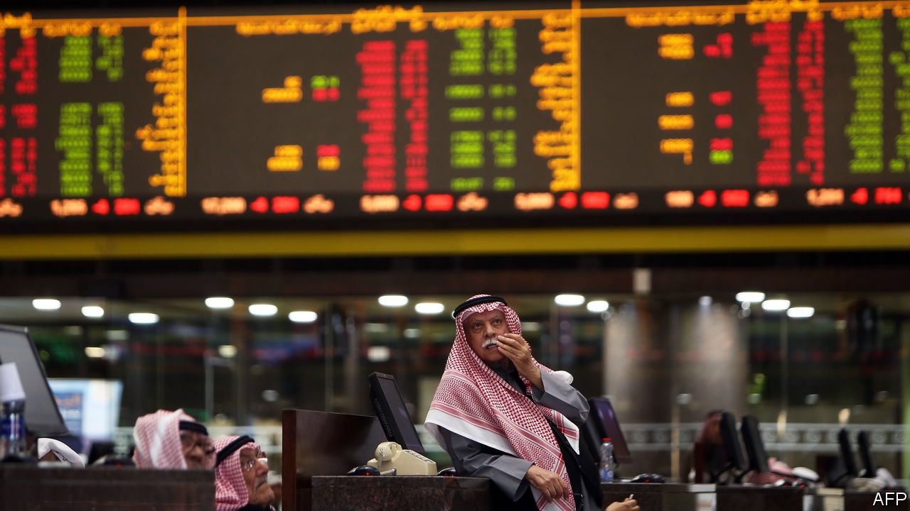

TOURISTS MAY not have returned to Egypt’s beaches and historic sites, but the portfolio investors are back. Since May foreigners have snapped up more than $10bn in local-currency debt, reversing a sell-off from the early days of the covid-19 pandemic. There is similar enthusiasm across the region. The six members of the Gulf Co-operation Council issued a record $100bn in public and corporate debt in the first ten months of the year. Treasuries are courting local investors too, though not always successfully: Tunisia’s government was rebuffed when it asked the central bank to buy treasury bonds.

Arab states are on a borrowing binge. Even before covid-19 arrived many were taking on fresh debt to cope with low oil prices and sluggish economies. The pandemic has only increased their needs. By next year public-debt ratios in many of these countries will be at their highest in two decades (see chart). The region’s 11 oil-and-gas-exporting countries owed an average of 25% of GDP from 2000 to 2016. Next year the IMF projects that ratio will hit 47%. Increases are less stark in states without energy resources—but only because they already had high debt levels.

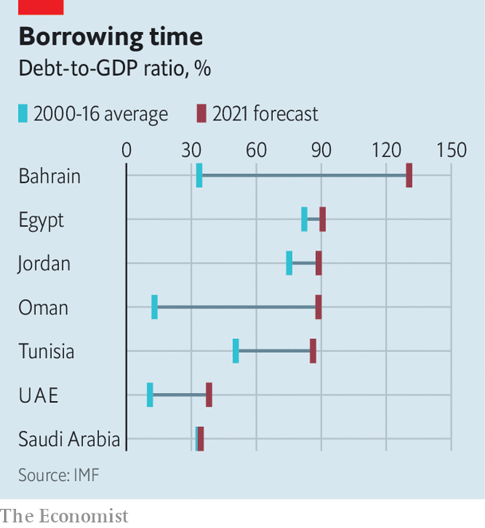

This is not always cause for concern. Saudi Arabia’s debt-to-GDP ratio will reach an estimated 34% next year, up from 17% in 2017. Debt levels in Kuwait and the United Arab Emirates will almost double as well, to 37% and 38%. These numbers are still comfortably low. All three have well-provisioned central banks or flush sovereign-wealth funds. And capital is cheap: a 35-year tranche of Saudi Eurobonds issued in January had yields below 4%.

Other oil-producing states look shakier. Bahrain’s debt-to-GDP ratio is projected to hit 131% next year, up from an average of 34% from 2000 to 2016. Oman will owe 89%. Both were largely shut out of bond markets earlier this year. Oil markets offer little hope for their budgets: renewed lockdowns in Europe and rising cases in America pushed prices lower in October.

Elsewhere in the region the pandemic has reversed years of fiscal reforms. Egypt trimmed subsidies and introduced a value-added tax after borrowing $12bn (over three years) from the IMF in 2016. It cut the deficit from 11% of GDP in 2016 to 7% last year and it was on pace to lower its debt-to-GDP ratio to 79% in 2021. The pandemic, however, sent it back to the IMF for a $5.2bn loan. Next year its debts are projected to climb back to 91% of GDP. Jordan will be close behind at 89%, and Tunisia at 86%.

For now, at least, investors are enthusiastic about Egyptian debt. Yields are high—the last batch of six-month treasury bills paid around 13.5%—and Abdel-Fattah al-Sisi’s authoritarian rule has erased concerns about political instability. But sentiment can be fickle. Between March and May $12.7bn flowed out of local markets.

All this borrowing offers limited returns for Arab states. More than 70% of Kuwait’s budget is earmarked for public-sector salaries and subsidies. It is taking on debt not to fund reforms but to sustain a bloated bureaucracy. Arab states have also been stingy with their covid-19 stimulus packages. They have allocated an average of 2% of GDP for pandemic-related help, compared with 3% for all emerging markets, in part because of limited fiscal firepower.

Borrowing has helped them cope, but it also exacerbates this problem (Egypt already spends an estimated 9% of GDP on debt service). Oil prices are projected to stay low next year, and vital industries such as tourism will be slow to recover. Heavier debt loads will limit the extent to which Arab governments can jolt their sluggish economies. ■

This article was downloaded by calibre from <https://www.economist.com/middle-east-and-africa/2020/11/05/arab-states-are-loading-up-on-debt>

|  |  |  |  |
| --- | --- | --- | --- |
| Previous | Articles | Sections | Next |

|  |  |  |  |
| --- | --- | --- | --- |
| Previous | Articles | Sections | Next |

#### Rage on the page

# Robert Fisk, a voice on the Middle East, died on October 30th

One of the best-known journalists in the region was also one of the most controversial

Nov 5th 2020 |

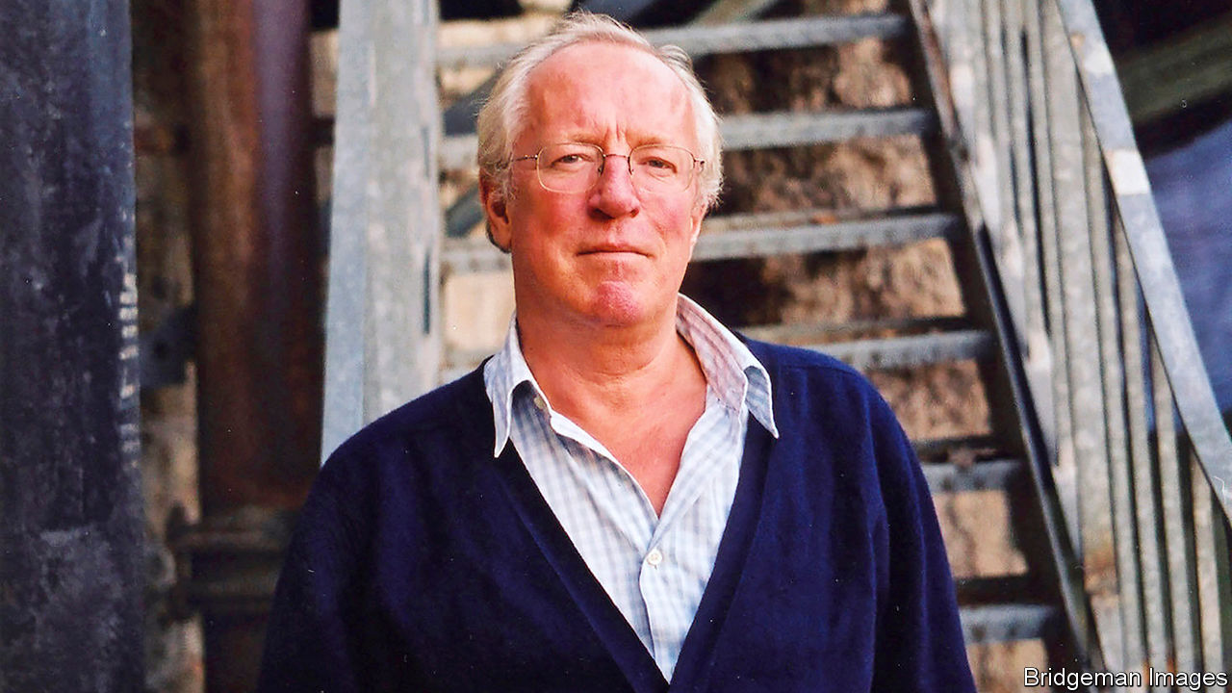

ROBERT FISK, who died in Dublin on October 30th, aged 74, was one of the most influential correspondents in the Middle East since the second world war. For the past 30-odd years he wrote mainly for the Independent, a left-of-centre British newspaper with dwindling circulation and influence at home, but his reach extended far beyond. His bitter narrative of Arab victimhood and Western wickedness (particularly American and Israeli), often brilliantly crafted, resonated across the region and was picked up in newspaper columns, by radio stations and on campuses across the world, America included. Again and again, Western correspondents in Cairo, Damascus or Baghdad would listen politely as Fisk-aficionados, from diplomats and politicians to taxi drivers and coffee-house waiters, regaled them with the wisdom of Mr Fisk’s latest diatribe.

Brought up in small-town England, Mr Fisk (pictured) made his journalistic mark for the Times, covering the Troubles in Northern Ireland, where the British authorities found his reports unduly keen on the Irish republican cause; he later took up Irish citizenship, while keeping a British passport. Leading the paeans of praise on his death was Ireland’s president.

Some of his scoops were world-beating. In 1982 he was among the first to enter the Palestinian refugee camps in Sabra and Shatila, where more than a thousand people had been massacred by Lebanese militias as Israeli forces looked the other way. In 1993 in Sudan, he became the first Western journalist to interview Osama bin Laden, penning an article headed: “Anti-Soviet warrior puts his army on the road to peace”. “I am a construction engineer and an agriculturalist,” he told Mr Fisk, who pulled off two more meetings with him before the al-Qaeda leader orchestrated the killing of some 3,000 people in New York in 2001. In one session bin Laden praised “Mr Robert” for being “neutral”.

Based most often in Beirut, Mr Fisk was a consummate operator who roved far and wide, from Algeria and Libya, through the Balkans and Turkey, to the homelands of Kurds and Afghans. He injected a vivid sense of history into his coverage, showing why so many people in the region felt angry and humiliated—and tended to blame the former colonial powers, and above all America and its protégés, especially Israel, for their unhappy predicament.

On one occasion, not long after the attacks of September 11th, he was roughed up by Afghan refugees in Pakistan. “I realised”, he wrote, that their “brutality was entirely the product of others, of us—of we who had armed their struggle against the Russians and ignored their pain and laughed at their civil war and then armed and paid them again for the ‘War for Civilisation’ just a few miles away and then bombed their homes and ripped up their families and called them ‘collateral damage’.”

His reputation among his peers was less rosy. He was a braggart. As we wrote in a review 15 years ago, “Mr Fisk tries to tell the story of the Middle East, but he does not flinch from telling the story of Mr Fisk.” He was self-righteous, though most recently had been excoriated for the leniency of his attitude to Bashar al-Assad, the blood-soaked Syrian dictator. He treated rumour as fact, if it suited his narrative: in 2004 he reported that the Americans had secretly spirited Saddam Hussein out of prison in Iraq to an American base in Qatar.

Correspondents from a range of worthy outlets and a diversity of ideologies have accused him of making stories up. In his mode of reporting, a tall tale, colourfully told in the supposed interests of the underdog, would often trump the literal truth.

This article was downloaded by calibre from <https://www.economist.com/middle-east-and-africa/2020/11/05/robert-fisk-a-voice-on-the-middle-east-died-on-october-30th>

|  |  |  |  |
| --- | --- | --- | --- |
| Previous | Articles | Sections | Next |

|  |  |  |
| --- | --- | --- |
| Middle East & Africa | Sections | Britain |

Europe

Russia: Putin’s new model army

.

Terrorism in Europe: Oh Vienna

.

Belarus: Staying put

.

Spain: Us Gallegos

.

Alcohol in Sweden: The state’s grip on grape and grain

.

Charlemagne: Baldrick’s Europe

.

|  |  |  |
| --- | --- | --- |
| Middle East & Africa | Sections | Britain |

|  |  |  |  |
| --- | --- | --- | --- |
|  | Articles | Sections | Next |

#### Putin’s new model army

# Russian military forces dazzle after a decade of reform

NATO will need to step up

Nov 2nd 2020 |

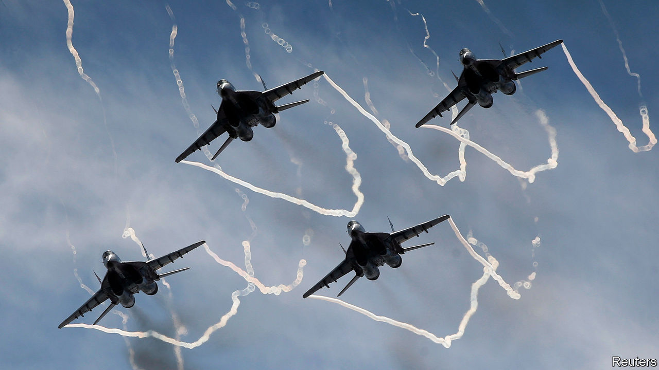

AFTER THE Soviet Union’s collapse, Russia’s once-mighty armed forces were laid low. Moscow bus drivers outearned fighter pilots. Hungry soldiers were sent to forage for berries and mushrooms. Corruption was rife—one general was charged with renting out a MiG-29 for illicit drag racing between cars and jets on a German airfield. “No army in the world is in as wretched a state as ours,” lamented a defence minister in 1994. Yet few armies have bounced back as dramatically. In 2008 Russian forces bungled a war with Georgia. In response, they were transformed from top to bottom.

That began with large sums of money. Russian military expenditure roughly doubled between 2005 and 2018, when measured in exchange rates adjusted for purchasing power. Though much of the budget is secret, Russia’s annual military spending probably stands somewhere between $150bn and $180bn, says Michael Kofman of the Centre for Naval Analyses, a think-tank in Virginia. That is around three times as much as Britain and close to 4% of GDP.

Much of that money has been spent on kit. In the past decade Russia has added around 600 new planes, 840 helicopters and 2,300 drones, estimates Julian Cooper of the University of Birmingham. Whereas 99% of Russian armour in 2007 was classified as “legacy”—ie, introduced into service more than three decades ago—today fully 27% is modern, according to a study published by the International Institute for Strategic Studies (IISS), a think-tank in London, on September 29th. Russia’s warplanes have gone from being 97% legacy to being 71% modern in that time.

The key investments were in precision missiles like the land-based Iskander, sea-launched Kalibr and air-launched Kh-101, putting in range targets across Europe (see map). A decade ago the idea that the Russian navy could accurately hit targets in Syria from warships in the Caspian Sea would have been science fiction, notes Dmitry Stefanovich of IMEMO, a research institute in Moscow. “Now it’s a reality.” In a European war, the idea would be to use such missiles to threaten civilian and military infrastructure deep behind the front lines on the ground, ensuring that a conflict over, say, Tallinn would stretch far to the west of the Rhine.

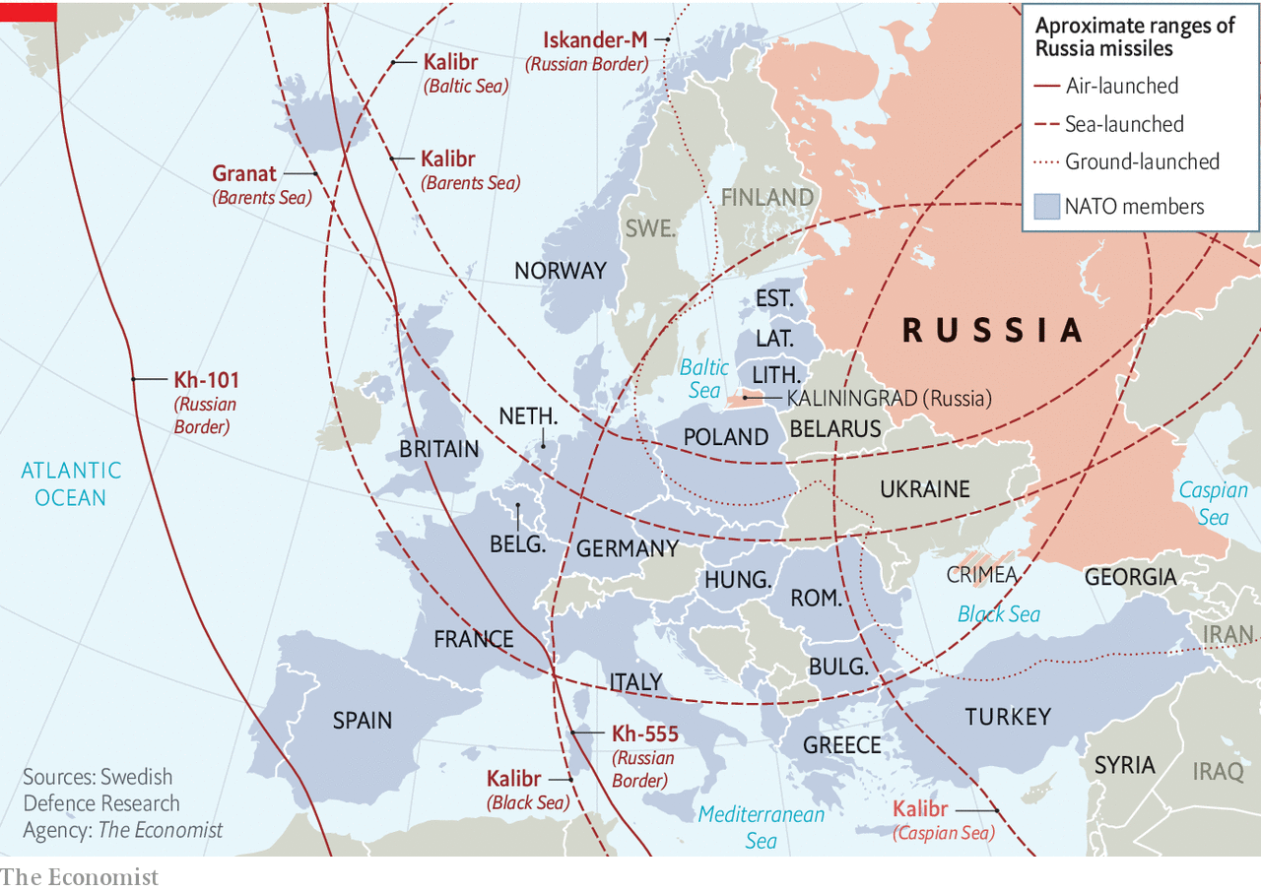

Russia’s ultimate aim is to create a “reconnaissance-strike complex”—originally a Soviet idea—in which data from vehicles on the ground, drones in the air, satellites in space and radio signals emitted by enemy units are collected, processed and fed into the weapons in real time. Any “sensor” (for instance, a drone) can feed a target to any “shooter” (like a faraway ship), with targets prioritised centrally and struck, ideally, within minutes. Though Russia is behind America and probably China in this ambitious endeavour, it has made “huge leaps”, says Dima Adamsky of IDC Herzliya, a university in Israel.

Russian forces are not just better armed, but also more fleet-footed. Thanks to improvements in readiness, Russia could probably get 100,000 troops, complete with heavy armour, to a European hotspot within 30 days. NATO might struggle to muster half the number, of lighter forces, in that time. Around 5,000 of Russia’s airborne troops are said to be on two hours’ notice. Soldiers are kept on their toes with huge exercises. The latest, Kavkaz (Caucasus) 2020, involved 80,000 personnel and concluded on September 26th. “Russia has traded mass for tempo,” concludes Lt-General Jim Hockenhull, Britain’s chief of defence intelligence.

Russia’s armed forces enjoy the additional advantage of being blooded in battle. Though Russia and China may have comparable weapons, the quality of the forces, in training and combat experience, is “night and day”, says Mr Kofman. In Ukraine, for instance, Russia has practised armoured warfare and artillery duels, experimenting with the use of cyber-attacks and drones to feed targeting information to its guns. Syria, where over 63,000 Russian personnel have served, has been a testbed for precision strikes, air defence against rebel drone swarms, and the use of unmanned vehicles.

Russian officers in Syria have even shown signs of shedding the Soviet legacy of rigid, top-down command and acting with more autonomy and creativity, a practice known as “mission command”, observes Mr Adamsky. That, he says, would be “a major departure from the Russian military tradition”. And in both countries, Russia has honed its skills in electronic warfare by jamming radios, radars and drones. Russia’s fake GPS signals in Syria were even strong enough to bamboozle civilian airliners in Israel.

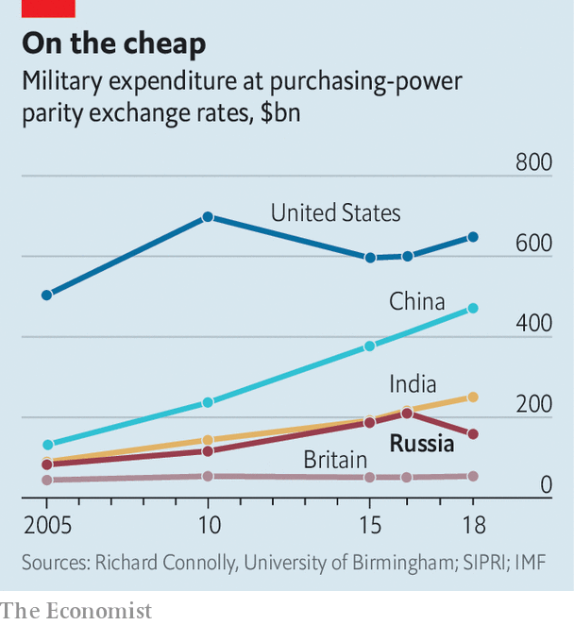

Not everything has been fixed, of course. Viktor Murakhovsky, a former officer who now edits a military journal, is positive about the reforms. But he says that shipbuilding is slow and that the country lags behind its rivals in long-range drones. The new T-14 Armata tank, the next-generation Su-57 warplane and new submarines have all been delayed. Though Russia is adept at blowing things up in space, its ageing fleet of reconnaissance satellites has shrunk over the years, with modernisation complicated by Western sanctions. The biggest problem of all, says Mr Kofman, is the limited capacity of Russia’s defence industry, including shortages of skilled personnel, machine tools and components.

The trade-off between hardware and humans is also apparent. Though troops no longer go hungry, their pay is not great. Mr Murakhovsky points out that a skilled tank commander in his 20s can expect little more than 43,000 rubles ($532) a month in peacetime, lower than the national average. “In my opinion, it’s not enough.” Morale among conscripts, who still make up 55% of ground forces, remains low, and the short duration of their service limits their usefulness in combat. Though the days of renting out warplanes may be over, last year Russian military prosecutors announced that 2,800 military officials had been charged with corruption. The amount stolen totalled around $90m.

Nor has military renaissance bought peace of mind. In a war with NATO, Russia “would have conventional superiority for a limited period”, concludes the IISS, but would be outgunned if the conflict dragged on. In recent years, Mr Putin has therefore worked to ensure that a conflict would not drag on. He has invested heavily in nuclear forces, unveiling a host of lurid weapons such as hypersonic gliders, radioactive torpedos designed to pollute coastal areas and nuclear-powered cruise missiles capable of circling the Earth indefinitely. Missiles like the Iskander, Kalibr and Kh-101 can also carry both conventional and nuclear warheads (NATO officials point out that they would have no way of knowing which until they landed). For Russian generals, the hope is that their revived strength means that the nukes are never needed.

For its part, NATO has largely focused on Russian threats to the Baltic states, and the challenges of reinforcing Europe over weeks and months. It has underestimated how Russia’s new firepower may be used in a shorter, sharper and more expansive war that would stretch far beyond the Baltics. Its planners, and the national politicians that set military budgets and priorities, need to adjust their strategies and spending in the light of these new threats. ■

This article was downloaded by calibre from <https://www.economist.com/europe/2020/11/02/russian-military-forces-dazzle-after-a-decade-of-reform>

|  |  |  |  |
| --- | --- | --- | --- |
|  | Articles | Sections | Next |

|  |  |  |  |
| --- | --- | --- | --- |
| Previous | Articles | Sections | Next |

#### Terrorism in Europe

# Despite the horrors in Vienna and Paris, jihadism has declined

But prisons are still a problem

Nov 3rd 2020 |

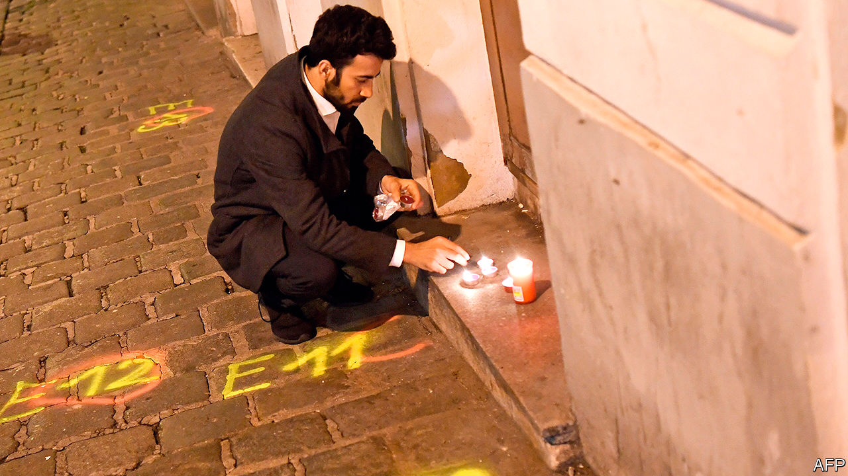

TEEMING WITH spooks and intrigue, Vienna is no stranger to political violence. “Carlos the Jackal” held OPEC’s oil ministers hostage there in 1975. Since then, assassinations in Austria’s capital have claimed the lives of Kurds and Chechens, among others. But until November 2nd Vienna had largely been spared the attacks on civilians that have menaced cities like London, Madrid or Paris. That night four people were killed and 23 injured, several of them seriously, during a gun and knife rampage in Vienna’s centre. Many were attacked as they took their last chance of a drink or a meal before Austria’s second coronavirus lockdown.

The Austrian authorities identified Kujtim Fejzulai, a 20-year-old man with dual Austrian and North Macedonian citizenship, as the sole gunman. Further arrests were made on November 3rd. Mr Fejzulai, who was shot by police, was born and raised in Vienna to Macedonian parents of Albanian extraction. Radicalised as a teenager, in 2019 he was convicted of terrorist offences and given a 22-month prison sentence after authorities thwarted his plan to join Islamic State (IS) fighters in Syria. But he was released in December under Austria’s lenient rules for young offenders.

The attack follows a spate of terrorism in Europe. On October 4th a Syrian asylum-seeker stabbed two men, killing one, in the German city of Dresden in what may have been a homophobic attack. Twelve days later, on the outskirts of Paris, a teenage Chechen refugee beheaded Samuel Paty, a teacher who had shown his class controversial cartoons of the Prophet Muhammad from Charlie Hebdo, a satirical magazine. On October 29th a Tunisian national who had arrived in France that month killed three people at a church in Nice. On the same day, French police shot dead a man claiming allegiance to a far-right anti-immigrant group near Avignon.

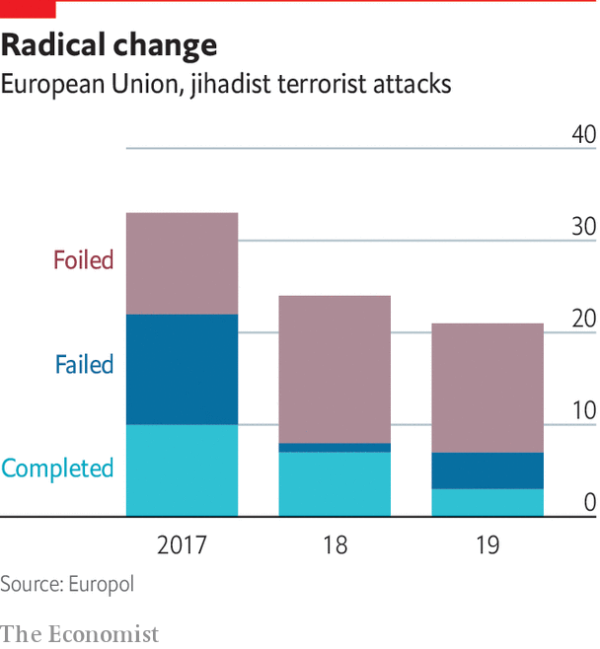

The flurry of attacks recalls the bloodshed of 2015-16, when Islamist terrorists killed 12 people at Charlie Hebdo’s offices in January 2015, 131 people at multiple sites in Paris in November and 86 people in Nice the following July. Since then, however, jihadism in Europe has declined markedly. The number of completed Islamist attacks fell every year from 2017 to 2019, while the number of foiled ones rose, according to Europol, the EU’s law-enforcement agency. Ten people were killed in 2019.

Much of the violence has been associated with IS, which swept through Iraq and Syria in 2014 with the help of 5,000 or so European recruits. The IS “caliphate” was crushed in 2019 and European security services feared that a flood of returning fighters would overwhelm their ability to monitor suspects back at home. In practice, IS veterans have not proven as numerous or violent as feared, even if the group’s ideology has remained potent.

Even so, the threat continues to dominate the work of security services. In a speech in October, Ken McCallum, director-general of MI5, Britain’s domestic-intelligence service, said that Islamist extremism remained the country’s largest threat by volume, with “tens of thousands” committed to the ideology, though he added that a growing share of plots came from right-wing extremists, like the attacker in Avignon. Mr McCallum said that tracking plots had become harder in recent years “as more terrorists have gone for basic attack methods requiring little preparation”.

None of the attackers in Dresden, Paris, Nice or Vienna is thought to have reached Iraq or Syria. Though the Dresden suspect had been convicted of recruiting on behalf of IS and downloading terrorist manuals, he is believed to have been radicalised only after arriving in Germany five years ago. Mr Paty’s killer is known to have had contact with a jihadist in Syria, but he never fought there and was not known to the French authorities. The Nice attacker, who had crossed from Tunisia to Italy in late September, had been arrested in Tunisia for using a knife but was not otherwise on the radar of Tunisian, Italian or French authorities. The problem seems to be less about hardened combat veterans than those with looser ties to the jihadist ecosystem turning to violent action.

Propaganda remains a serious issue, too. Large caches of material inciting and glorifying terrorism continue to circulate freely online, says Julian King, who served as European commissioner for security until January. The European Parliament has been sitting on proposals for Europe-wide action to remove online propaganda for almost two years, he says.

The recent attacks also highlight another worrying pattern. Mr Fejzulai was let out of prison early; the Dresden suspect had been released only five days before his attack. That reflects a wider failure of counter-terrorism policy, as does the fact that Mr Fejzulai had completed a deradicalisation programme that was evidently unsuccessful. “In many European countries the priority was to get people locked up,” says Peter Neumann of King’s College London, “and then to forget about them, with many becoming further radicalised in prison.” ■

Editor’s note: this article has been changed to reflect the police’s identification of a sole gunman, rather than several as was first suspected

This article was downloaded by calibre from <https://www.economist.com/europe/2020/11/03/despite-the-horrors-in-vienna-and-paris-jihadism-has-declined>

|  |  |  |  |
| --- | --- | --- | --- |
| Previous | Articles | Sections | Next |

|  |  |  |  |
| --- | --- | --- | --- |
| Previous | Articles | Sections | Next |

#### Staying put

# In Belarus neither dictator nor protesters are backing down

And Vladimir Putin is still waiting in the wings

Nov 5th 2020 |

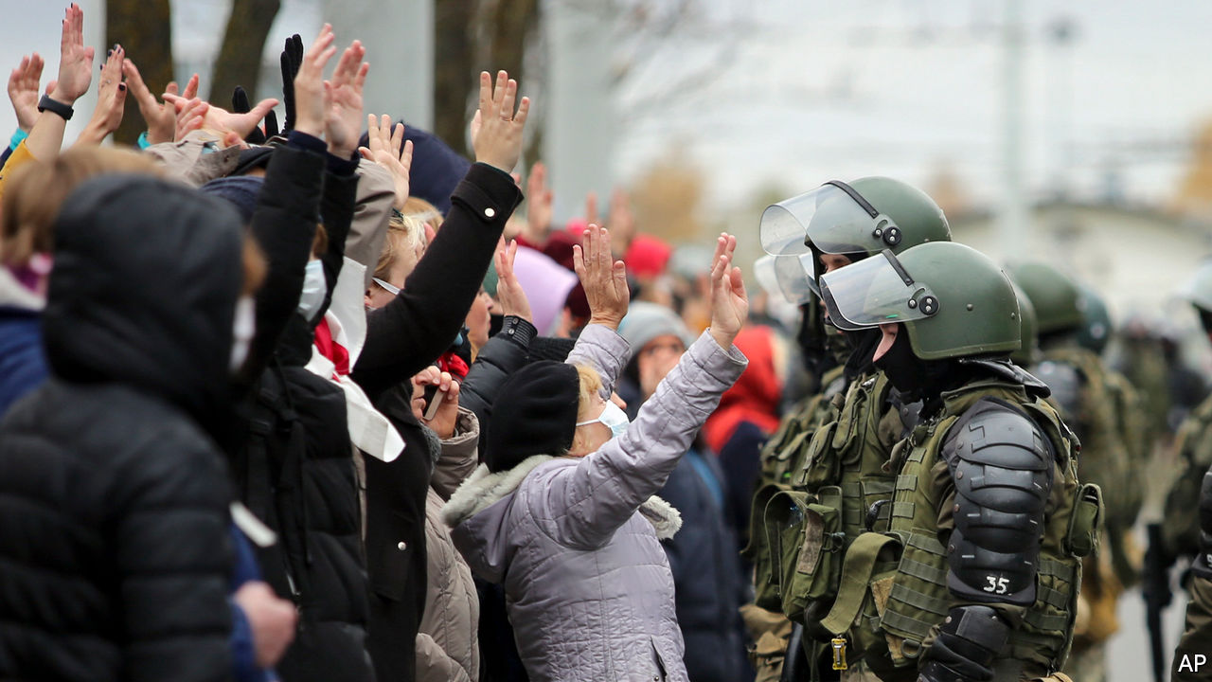

THE YOUNG man tore open his coat, threw his arms in the air, and dared the riot cop to open fire. The startled officer retreated, his assault rifle still aimed at the approaching protester. “Long live Belarus!” chanted the crowd. It was just another Sunday in Minsk, the capital of Belarus, where the opposition has staged huge rallies every weekend since August 9th, when Alexander Lukashenko, the country’s erratic dictator, rigged presidential elections to claim a sixth term.

Despite the bravery of the protesters, Mr Lukashenko, 66, shows no sign of relinquishing power. And as winter approaches, the opposition movement could be slowly running out of options. A nationwide strike called for October 26th by Svetlana Tikhanovskaya, the exiled opposition leader, has largely crumbled amid a clampdown on picketing and threats of dismissal. Dissenting students have been expelled from university. More than 230 protesters were accused this week of taking part in “mass disorder”—a charge that could see them incarcerated in a brutal Belarusian prison for up to three years.

Mr Lukashenko has urged security forces to ramp up the violence against protesters. At least five people have already been killed and dozens more have been injured. Speaking recently to security chiefs, he said protesters who confront police should have their arms torn off. “We’re not taking prisoners,” he said. Days later, security forces used live bullets at a demonstration, firing warning shots into the air. The show of strength was met by sarcastic applause from the crowd of opposition supporters.

The clampdown does not mean that the opposition is going to give up its fight to topple Mr Lukashenko. One in every five urban adults is estimated to have taken part in the protests, and around 85% of them intend to continue demonstrating until new elections are held, according to a poll by Chatham House, a British think-tank. (Independent opinion polls are banned in Belarus.) Ms Tikhanovskaya has called for more protests and fresh strikes to pile economic pressure on Mr Lukashenko. “Neither side has the strength to decisively turn the tide in its favour,” said Igor Ilyash, a political analyst in Minsk. “This is a war of attrition.”

Whatever comes next, it is hard to see how life in Belarus can go back to normal. An entire generation of Belarusians has been politicised by the protests and Mr Lukashenko’s frenzied attempts to crush them. “Where are our guys, dad?” asked a small child recently, as he gazed at a phalanx of riot police officers. “Over there, see, with the flags?” his father reassured him. The video went viral.

Waiting in the wings, should the protesters get the upper hand, is Vladimir Putin. The Russian president has said the Kremlin will intervene in Belarus, Russia’s closest ally, if the protests “get out of control”. Late last month, Russian security officials accused the West of financing the opposition. The comments came as Russian state television used images of widespread destruction from the Nagorno-Karabakh war between Armenia and Azerbaijan in a report on “aggressive” protesters in Minsk. Was it a technical error or a bid to swing Russian public opinion in favour of a military intervention in Belarus? Only the Kremlin knows the answer. ■

This article was downloaded by calibre from <https://www.economist.com/europe/2020/11/05/in-belarus-neither-dictator-nor-protesters-are-backing-down>

|  |  |  |  |
| --- | --- | --- | --- |
| Previous | Articles | Sections | Next |

|  |  |  |  |
| --- | --- | --- | --- |
| Previous | Articles | Sections | Next |

#### Us Gallegos

# Galicia shows how devolution can work

An idiosyncratic region that remains comfortable in Spain

Nov 7th 2020 | SANTIAGO DE COMPOSTELA

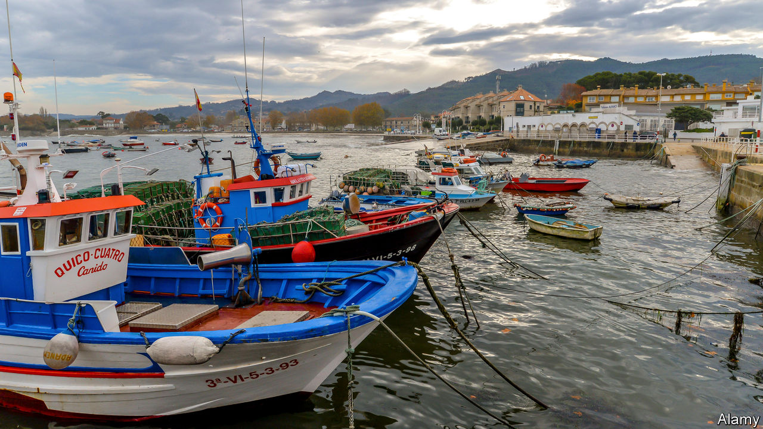

IT IS A place apart, a land of mists, forests and long Atlantic rías (inlets); of pilgrim routes to the vast medieval cathedral of Santiago de Compostela; remote from almost everywhere, its people famous for their caginess. Today Galicia stands out for two other reasons. The first is that since democracy arrived four decades ago, it has progressed from being one of the poorest regions of Spain to enjoying an income only slightly below the national average. Its second peculiarity is that like Catalonia or the Basque Country it is a cultural nation but, unlike them, it is one that is comfortable in Spain. Separatism is the pursuit of a fairly small minority.

Its economic success is broad-based. Apart from Europe’s largest fishing industry, shipbuilding, dairying and timber, Galicia has two industrial mainstays: Inditex, based near A Coruña, has grown into the world’s biggest provider of fast fashion through Zara and its other chains. A vast Citroën plant near Vigo anchors 30,000 car-industry jobs. The regional government has invested European funds in motorways: it is still six hours to Madrid, but it used to take twice as long. A high-speed railway link should be completed by 2022.

There are other factors behind Galicia’s success. A tradition of dividing farms among all children led to rural poverty (and emigration) but also to a culture that values private property, the leira (homestead) and hard work. Alberto Núñez Feijóo, the president of the regional government since 2009, highlights Galicia’s political stability. Mr Feijóo is from the conservative People’s Party, which at national level has become increasingly centralist. In Galicia it has adopted a strong regional identity that Mr Feijóo calls Galleguismo. “We have defended Galicia as a place that has its own language, culture, heritage and special characteristics,” he says. This has “halted nationalism”. At an election in July, Mr Feijóo retained his absolute majority of seats in the Galician parliament, another rarity for Spain.

Critics complain that he has failed to halt an exodus of talent, as young professionals seek opportunities abroad. In fact, Galicia has seen more immigrants than emigrants in this century. But it is an ageing society. The dynamism of the coast contrasts with a depopulated interior, prone to forest fires. The covid-19 pandemic, although mild in the region, may expose flaws in the Galician formula (with cases rising, on October 30th Mr Feijóo restricted movement into and out of the main towns). “The economic model gave priority to cement over knowledge,” says Xosé Manoel Núñez Seixas, a historian at the University of Santiago de Compostela.

Galicia suffers the vices as well as the virtues of Spanish devolution. It has three airports, where one would do; Gallegos cross the border to Porto in Portugal for many international flights. Politics features localism. Abel Caballero, the mayor of Vigo since 2007, has made a successful political career out of battling Mr Feijóo. He wants the high-speed train to go straight to his city, rather than via Santiago. That would cost €2bn to save just 15 minutes, says Mr Feijóo.

A nationalist party came second in the election. Its leader, Ana Pontón, wants Galicia “to take our own decisions” on energy, infrastructure and taxes and “the right to decide” on independence. She also wants 50% of teaching to be in Gallego. But most Gallegos seem happy enough with what Mr Feijóo calls “cordial bilingualism” rather than the language war of Catalonia. The nationalist vote seems to have a ceiling of about 25%. “The Gallego has ambitions to lead Spain,” says Miguel Conde-Lobato, an advertising man in A Coruña. “We’re more interested in captaining the ship than capsizing it.” ■

This article was downloaded by calibre from <https://www.economist.com/europe/2020/11/07/galicia-shows-how-devolution-can-work>

|  |  |  |  |
| --- | --- | --- | --- |
| Previous | Articles | Sections | Next |

|  |  |  |  |
| --- | --- | --- | --- |
| Previous | Articles | Sections | Next |

#### Sour grapes

# A proposal to water down Sweden’s state monopoly on booze

Farmers want to sell wine directly to drinkers. Temperance campaigners are horrified

Nov 7th 2020 |

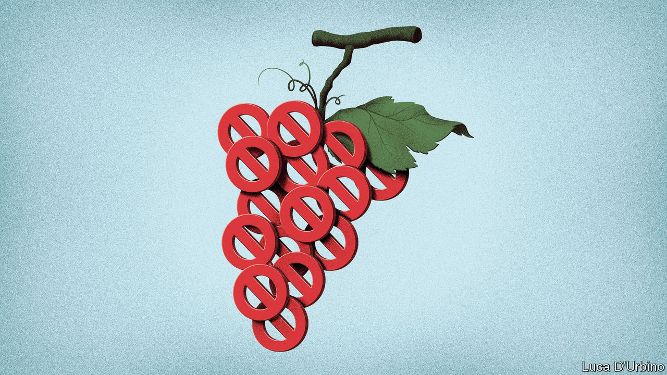

MOST NORTHERN-HEMISPHERE wine is produced at a latitude of between 30° and 50°. Any farther north and it gets too cold. Ahus vineyard, in Skane county on Sweden’s Baltic coast, is at a chilly 55.9°. But since 2005 it has been cultivating vines on a hectare of farmland. Last year it produced around 3,000 bottles, mostly from solaris grapes, a variety suited to cooler climes. It also welcomes tourists. This summer saw a rush of interest from Swedish oenophiles holidaying at home because of the pandemic. Visitors would ask, “Can we buy a bottle as a souvenir?” says Karin Birch, who helps run the vineyard. “And I would have to say no.”

In 1955 Sweden replaced a rationing system so ineffective that even the temperance movement opposed it with a state monopoly on alcohol sales. Today 446 shops called Systembolagets are the only places where Swedes can buy alcohol stronger than 3.5%, besides bars and restaurants. Similar monopolies exist in other Nordic countries, and the arrangement remains broadly popular.

The state’s grip on booze sales may be about to weaken, however. Last year, in exchange for propping up the minority government, the moderate Centre Party negotiated a consultation on the introduction of “farm sales”. The policy would allow producers such as Ahus to sell directly to customers. But the idea is controversial.

The IOGT-NTO, a Swedish temperance movement, claims that farm sales are a Trojan horse that will end up letting big producers flog their wares on the open market, noting that the Swedish farmers’ association has argued against putting a size limit on sales. Opponents also argue that farm sales could be illegal under European Union law, though this has yet to be tested. In 1997, two years after Sweden joined the bloc, the European Court of Justice ruled that the monopoly complied with the EU’s rules on the free movement of goods, since it did not discriminate against any producers. But farm sales would by their nature exclude alcohol from abroad.

According to Sofia Nilsson, a Centre Party MP for Skane, farm sales are not a way to abolish the state’s monopoly by the back door, but could boost tourism and jobs in the countryside. The government consultation will take time, but Ms Nilsson is optimistic: “I really hope that in a couple of years we can cycle around Skane, stop at a vineyard and buy a bottle of wine for dinner.”

This article was downloaded by calibre from <https://www.economist.com/europe/2020/11/07/a-proposal-to-water-down-swedens-state-monopoly-on-booze>

|  |  |  |  |
| --- | --- | --- | --- |
| Previous | Articles | Sections | Next |

|  |  |  |  |
| --- | --- | --- | --- |
| Previous | Articles | Sections | Next |

#### Charlemagne

# What Blackadder’s Baldrick says about Europe

Europe should stop defining itself as what it is not

Nov 7th 2020 |

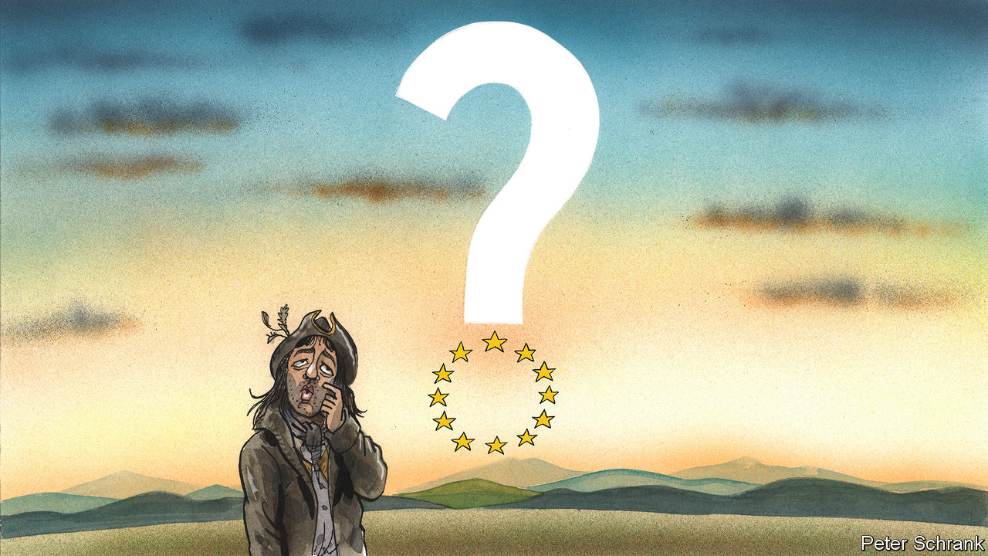

IN AN EPISODE of “Blackadder”, a British historical sitcom, Edmund Blackadder finds himself having to rewrite Samuel Johnson’s first-ever English dictionary after his idiot manservant, Baldrick, throws the sole copy on a fire. Time is short, and he has been threatened with gruesome murder if he fails. In desperation, he asks Baldrick for help. Baldrick’s definition of “dog” is certainly original: “Not a cat”. When it comes to defining Europe, leaders end up unintentionally channelling their inner Baldrick. Europe is defined by what it is not, rather than what it is.

For some, Europe is—in Baldrickian terms—Not America. Under Donald Trump, the gaps between America and the EU have widened, with the EU seen as a rival on trade and a freeloader on defence. Leaders including Emmanuel Macron, the French president, now think in terms of a specifically European rather than Western civilisation. Both America and the EU may be capitalist democracies, but Europe is greener, more equal and more humane, argued Mr Macron in a speech last year. But not everyone agrees that America is the best example of what Europe is not. Americophiles still lurk in the EU, particularly in eastern Europe, where America has remained hugely popular under Mr Trump.

Typically, these Americophiles prefer a different, but still Baldrickian definition: Europe is Not Russia. Joining the EU was a way for eastern European countries to assert independence from Moscow. During the 1990s and 2000s, Europe was an evangelistic project, open to anyone willing to sign up. Now it is an exclusive one. Expansion is viewed as a burden, rather than an opportunity. The bloc’s frontiers must be strictly defined, with those stuck between Europe and Russia having to pick a side, sharpish. Sometimes others decide for them. When discussing the EU’s response to Belarus’s slide into despotism, Thierry Breton, the French commissioner, said the quiet part out loud when he announced: “Belarus is not Europe.”

Where there is more agreement is on the definition of Europe as Not Africa. Europeans once expanded into Africa; now they fear the reverse. Migration has been a neuralgic issue, but there is an ugly consensus when it comes to Africa: tightly limited legal migration and brutal treatment for anyone who arrives illegally. “The Scramble for Europe” by Stephen Smith, which spells out the prospect of mass migration from Africa into Europe, received effusive praise from Mr Macron, for instance. Sometimes this attitude bleeds into outright racism. During one meeting, a southern diplomat summed up the EU’s debates over asylum with a startling ultimatum: Europe needs to decide whether it wants to be black. For all that Europeans argued that Mr Trump was an affront to liberal values, they are not always so different. When it comes to the bloc’s policy towards Africa, there are similarities. The only reason “Build the Wall” never caught on in the EU is because the bloc uses the Mediterranean as a moat—one in which nearly 20,000 people have died since 2014.

Not being Africa has been a long-term pursuit. After all, the EU began as a club of five failed and fading empires (plus Luxembourg) working out how to survive. Defining Europe as Not China is a more recent development. China’s entry into the World Trade Organisation was supposed to herald an era of westernisation. Instead, Chinese companies snatched intellectual property from Western rivals, while the Chinese government kept its market largely closed even as the EU opened its own. Now leaders such as Angela Merkel, the German chancellor, worry that a non-democratic power will for the first time have the lead when it comes to technology. Other systemic rivals were more easily disregarded. After the Soviet Union collapsed, it was dismissed as good for beating Nazis in land wars, but bad at producing the good life. To Europeans, American superiority was ultimately fine, since it too was a capitalist democracy. Decadent Europe had the option of matching American wealth and power, but preferred a life of puny armies, long holidays and fat welfare states. China offers no such comfort. The prospect of a technologically superior power coping with problems such as covid-19 better via an abhorrent political system looms in the minds of EU leaders. If Europe struggles to match the results of rival systems then why should people support it?

Perhaps faith would do it. The EU’s founding fathers may have been devout Catholics, yet God is absent from its structures. “Perhaps it was considered better for Europe to be Christian not in letter but in spirit,” writes Olivier Roy, a French author, in “Is Europe Christian?” “Or maybe this pillar of European identity was so obvious that there was no need to carve it in stone.” Whether Europe is part of Christendom or a secular endeavour is an emerging fault line in the bloc. It cuts across everything from gay rights to abortion, with governments in a liberal west—and the EU institutions themselves—now set against their illiberal peers in the east. Rather than grapple with this question, a caucus of European politicians have reached an uneasy compromise whereby Europe is simply “Not Muslim”. It is an easy definition to sell. According to Pew, a pollster, the majority of people in Italy, Poland, Greece, Slovakia, Czech Republic, Lithuania and Hungary have an “unfavourable” view of Muslims.

## Whatever People Say I’m Not, That’s What I Am

A reliance on Baldrick’s idiosyncratic method of definition stems from Europe’s relative weakness. Where European powers once expected others to bend to its norms—dressed up as universal values, naturally—it now worries about the process happening in reverse. Or, as Ivan Krastev, a writer, puts it: “Lack of power means universalism becomes exceptionalism. You stress the differences.” EU politicians do not want to be a colony of America or China, while some fear Islam or an unpredictable Russia. They end up explaining all the ways Europe does not fit with any system other than its own. Baldrick would be proud, but the EU should not be. ■

This article was downloaded by calibre from <https://www.economist.com/europe/2020/11/07/what-blackadders-baldrick-says-about-europe>

|  |  |  |  |
| --- | --- | --- | --- |
| Previous | Articles | Sections | Next |

|  |  |  |
| --- | --- | --- |
| Europe | Sections | International |

Britain

Populism: Look who’s back

.

Remembrance Day: Over the top

.

Scotland and defence: Should auld acquaintance be forgot

.

The economy: The fright before Christmas

.

Education: New tricks

.

Bagehot: Captain Foresight

.

|  |  |  |
| --- | --- | --- |
| Europe | Sections | International |

|  |  |  |  |
| --- | --- | --- | --- |
|  | Articles | Sections | Next |

#### Look who’s back

# Nigel Farage returns to torment the Conservative Party

The godfather of Brexit sees an opportunity in covid-19

Nov 5th 2020 |

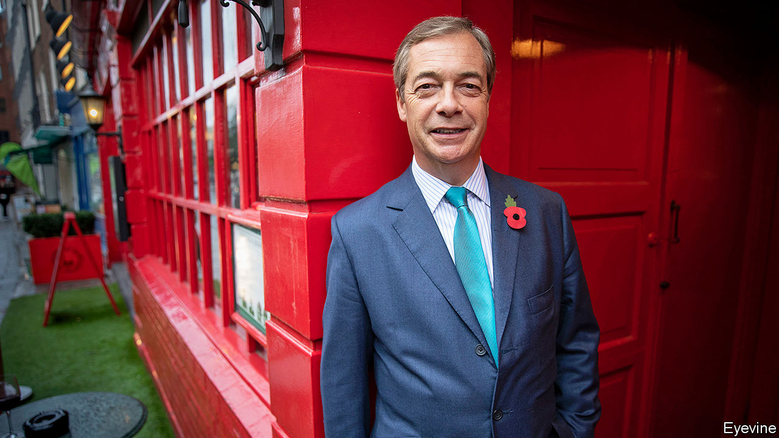

“FRANKLY, I’VE had enough of lockdown,” declared Nigel Farage in a video shot on November 1st in the bar of Donald Trump’s Washington, DC, hotel. The man responsible for Brexit, who was visiting America to support his friend’s campaign, has announced that he will be launching a new political party, Reform UK, to contest local elections next spring. It will advocate letting covid-19 circulate freely among the young and healthy, while the old and vulnerable shield themselves.

The Tory party once dismissed Mr Farage’s followers as a gaggle of golf-club bores and pub cranks. The problem for Boris Johnson is that, once again, Britain’s club houses and bars are closed, and a growing slice of their Conservative-voting patrons are unhappy about it. On November 5th, the government instigated a second national lockdown, which will be in place until at least December 2nd.

Mr Johnson had vowed to avoid that at all costs, and had wanted to pursue a series of tiered regional restrictions. He changed course on October 31st, after the government’s scientists warned that on its current trajectory the disease would kill up to 4,000 people a day in the week before Christmas. That, Mr Johnson said, would be a “moral and medical disaster”, which would see hospitals filled and doctors choosing whom to save.

Ministers scoff at Mr Farage’s many comebacks. He is “like Frank Sinatra”, says one. But he is hard to ignore, for he has traumatised and transformed the Conservative Party in the past decade. First, as leader of the UK Independence Party, he turbocharged the question of EU membership by fusing it to immigration, and compelled David Cameron to hold the 2016 referendum. Then, as Theresa May’s exit treaty became stuck in Parliament, he launched the Brexit Party, which swiftly overtook the Tories in the polls, prompting them to dump her and her deal. His method is to harass the party through local and European elections, thus panicking the leadership into adopting his policies.

Mr Johnson was chosen to replace Mrs May because Tories believed that only he could suppress Mr Farage and unite the party under the Brexit banner. The Tory village has been rebuilt as a citadel against future assaults. Europhiles and fiscal disciplinarians were given the boot. Its mission is to deliver Brexit, and to hold together the coalition that Mr Johnson built. Yet Mr Farage can spy cracks in the fortress walls.

On November 4th, 34 Tories voted against the new restrictions. They abhor the lockdown as a violation of civil liberties, a destroyer of jobs and a humiliating reversal. Ministers fear that in future they will need Labour support to pass covid-19 rules—a sign of impotence that last year’s election victory was meant to banish.

The splits on covid-19 are shallower and less treacherous than on Europe, which afflicted the party for three decades. But they run along similar lines. The lockdown critics include Iain Duncan Smith and Steve Baker, leading Brexiteers. Mr Farage will get enthusiastic support from the Daily Telegraph, a Brexity newspaper, and the right-wing commentariat. Each side has its favoured scientists. The polarisation makes it increasingly hard to forge a national consensus on epidemiology, just as it was on European trade policy.

Lockdown scepticism is a minority pursuit, but growing: support has fallen from 93% of voters in March to 72% now. The low-trust, anti-immigration voters who flitted between Mr Farage and Mr Johnson are the “shakiest wing” of the Tory coalition, says Rob Ford, a political scientist and co-author with Maria Sobolewska of “Brexitland”, a new book. “It doesn’t take much for them to be out the door.” The government’s net approval rating among Leave voters stands at -3%, compared with 67% in March. A growing share of Leavers say the prime minister is weak rather than strong, according to YouGov, a pollster. Most significantly, Mr Johnson’s vote is spongy at the edges. The proportion of people who voted Tory in 2019 who are now either undecided or wouldn’t vote at all is up from 8% in January to 18% now. For Labour voters the figure has fallen one point to 12%.

This is fertile terrain for Mr Farage, who undermines Mr Johnson’s raison d’être. The prime minister’s appeal to his party lay in his ability to match Mr Farage’s beery charm. He is now mirthless, and deeply reliant on the Whitehall expertocracy he once mocked. “Boris and his people want us all to hide behind the sofa,” says Richard Tice, chairman of Reform UK. The damage may last even if a vaccine curbs the pandemic soon, for rebellion is habit-forming.

Mr Farage’s return will sharpen the Conservatives’ instinct to prioritise holding its Brexit coalition together over pursuing new voters. But the task will get harder. Since 2015, the Tories have told Mr Farage’s followers that while they might like the cut of his jib, only they can deliver a referendum on Europe, or an exit deal. A Labour Party with a hard-left leader was a useful bogey. But Brexit is nearly done, and Sir Keir Starmer does not frighten the horses.

How is Mr Johnson to bind his coalition? One answer is money. The government will launch an infrastructure spree in its new northern constituencies. Another is the threat of a Scottish independence referendum, which Mr Johnson will oppose. It will also double down on cultural issues; ministers think a row over the singing of patriotic songs at the Proms music festival resonated with their base. Many Conservatives will conclude from Mr Trump’s better-than-expected performance that a disastrous response to covid-19 can be overcome by whipping up angry identity politics, says Mr Ford.

Yet that approach is fraught with risks. It may push the liberal wing of the Tory coalition towards the soothing Sir Keir. Continental Europe’s experience suggests that aping the rhetoric of the radical right fans its flames rather than dousing them, reckons Tim Bale, a political scientist. Mr Johnson may eventually succeed in managing the pandemic. But a prime minister can never match Mr Farage as a crusading outsider, nor as the toast of the golf club. ■

This article was downloaded by calibre from <https://www.economist.com/britain/2020/11/05/nigel-farage-returns-to-torment-the-conservative-party>

|  |  |  |  |
| --- | --- | --- | --- |
|  | Articles | Sections | Next |

|  |  |  |  |
| --- | --- | --- | --- |
| Previous | Articles | Sections | Next |

#### Over the top

# Competitive Remembrance Day celebrations

Commemoration is getting more ostentatious

Nov 5th 2020 | MELKSHAM

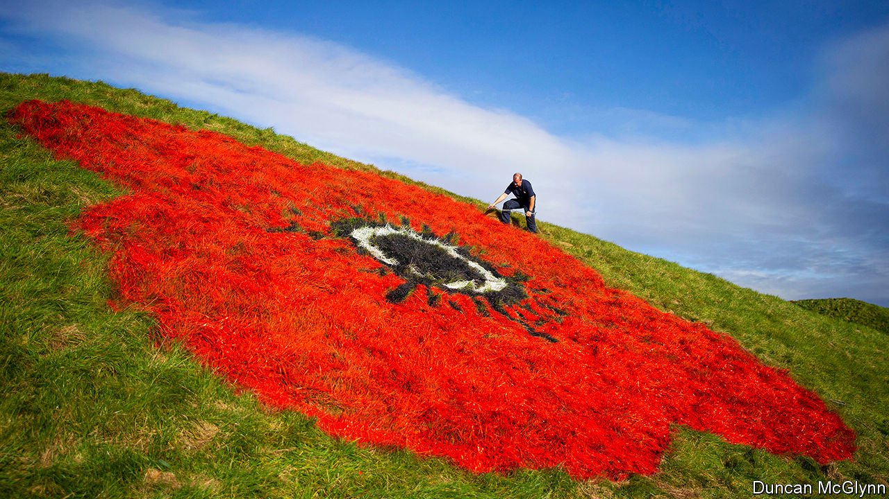

IN PELSALL, A Spitfire fighter plane is suspended in flight above the memorial clock. The wooden replica is part of Remembrance Day celebrations in the West Midlands village. The event has been a hotly anticipated annual spectacle since 2015, when an ambitious display featuring 1,500 knitted poppies hit the headlines. “We are becoming a Poppy Village,” says Garry Perry, a councillor. Preparations for November 11th take up much of his year.

Remembrance Day was not always as extravagant as this. In the years after the first world war, Britons were split on how best to remember the fallen. Some wanted solemn parades; others alcohol-fuelled parties. Restraint won the day. Poppies—a reference to those that grew on the battlefields—were worn, a two-minute silence was observed and veterans marched. It seemed likely that, once all the survivors of the Great War were dead, the ceremonies would wither away.

The opposite has happened. Inspired by the Tower of London’s 2014 installation of 888,246 ceramic poppies marking the war’s centenary—each bloom representing a casualty from Britain and its colonies—towns are now creating ever more ostentatious displays. Giant roadside poppies painted on grass verges are popular, as are road markings. In Bolton, Greater Manchester, 12 poppies have been painted onto strategic thoroughfares.

Poppy cascades are also in vogue. In Callington, Cornwall, 9,000 knitted poppies float down a church wall. After dark in Melksham, Wiltshire, an animation of a poppy fading into love hearts plays continually on the town hall’s facade. Not even covid-19 is allowed to interrupt remembrance ceremonies: the government has let socially distanced parades go ahead.

This iconography helps fill the void left by veterans, whose stoic marching in regimental ties once provided a meditative imagery on its own. “Creativity comes forward in the space of living advocates of the events, to try to find other ways to prompt people into thinking and reflecting,” says Alexander Ehmann, a councillor in Richmond, London, who turned a zebra crossing into a multi-colour poppy design.

The boom in remembrance artistry has coincided with a resurgence of patriotism. “There was a period in this country where you were afraid to show your nationalism,” says Mr Perry. “Villages like mine…want to be able to keep the traditions that they’re proud of.” Andy Morgan, a Bolton councillor and veteran, thinks enthusiasm for the armed forces has grown, too. “It’s much more respectful, almost like it is in America now.” He believes that the Iraq and Afghanistan wars, which provided a fresh supply of veterans for Bolton’s parades, burnished that admiration.

Councils now vie to have the biggest and boldest remembrance artworks, some of which stay up for months. “It’s way more pressure every year,” says Mr Perry. “We’re sitting here thinking, ‘how are we going to beat this?’” Pelsall has an edge: a committee entitled the Preservation of Pelsall Remembrance Service, or POPRS for short. Pronounced “poppers”, the abbreviation’s narcotic overtones caused a little frisson when people noticed. “I’m thinking, ‘Crikey, they’re going to think we’re all going round the village high as a kite’,” says Mr Perry.■

This article was downloaded by calibre from <https://www.economist.com/britain/2020/11/05/competitive-remembrance-day-celebrations>

|  |  |  |  |
| --- | --- | --- | --- |
| Previous | Articles | Sections | Next |

|  |  |  |  |
| --- | --- | --- | --- |
| Previous | Articles | Sections | Next |

#### Defence policy

# How Scottish independence would threaten Britain’s defence

As support for independence grows, so does Scotland’s military importance

Nov 5th 2020 | GARELOCHHEAD, SCOTLAND

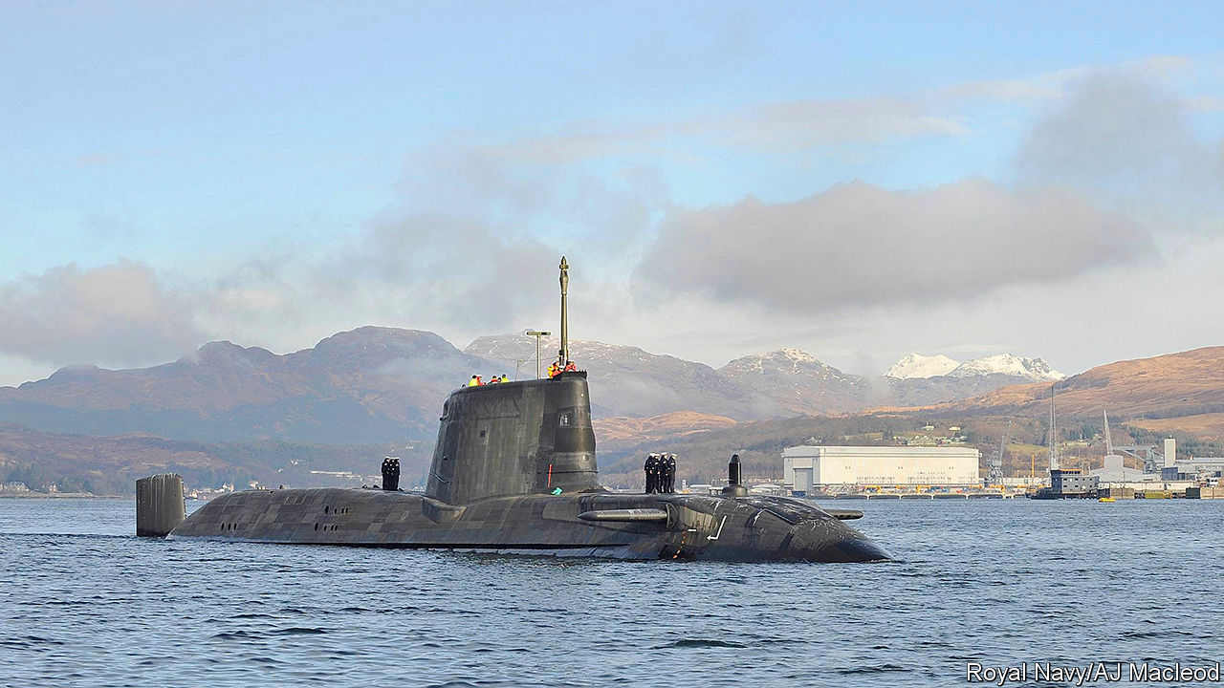

THE GARELOCH seems a tranquil place. At its northern tip there is a tiny village with a pub, a café and a welding shop. But the ramshackle camp on the loch’s eastern shore, whose signage exhorts that there be “nae bombs, anywhere!”, hints at its unusual nature. An exploration of the surrounding countryside reveals another—a density and attentiveness of police jeeps that is somewhat higher than average. A pair of squad cars arrives to check on your correspondent within half an hour of his arrival in the area.

Their scrutiny is warranted, for the Gareloch is home to Britain’s nuclear weapons. A rotating fleet of submarines is stationed at Her Majesty’s Naval Base, Clyde, a streak of buildings that runs along the loch’s eastern shore. The policemen, who work for the Ministry of Defence (MoD), explain that the base, also known as Faslane, is just one component of the infrastructure in the area, a network of roads, bunkers and jetties all focused on a singular mission: keeping several megatonnes of atomic weaponry in the Atlantic at all times.

“Faslane will be ideal for a headquarters of the Scottish armed forces,” says Stewart McDonald, the defence spokesman of the Scottish National Party (SNP), which favours independence. For now, that is aspirational. In a referendum held in 2014, 55% of voters in Scotland opted to stay in the United Kingdom. But Britain’s constitutional settlement has frayed since then, at the same time as Scotland’s military importance has grown.

In a general election held the year after that referendum, the SNP won 56 out of 59 Scottish seats in Parliament (it currently holds 47). When a majority of Britons voted to leave the European Union in 2016, 62% of voters in Scotland voted to remain. If Britain and the EU fail to agree a trade deal before the end of this year, when a transition period ends, many Scots would opt to leave the union and rejoin the EU. In Scotland, support for independence has accordingly grown. A poll in October put it at 58%, excluding undecided voters—the highest ever recorded. Nicola Sturgeon, the leader of both the SNP and Scotland’s devolved government, wants a fresh mandate for a second referendum from Scottish parliamentary elections in May 2021. That would require British consent, something that Boris Johnson has ruled out.

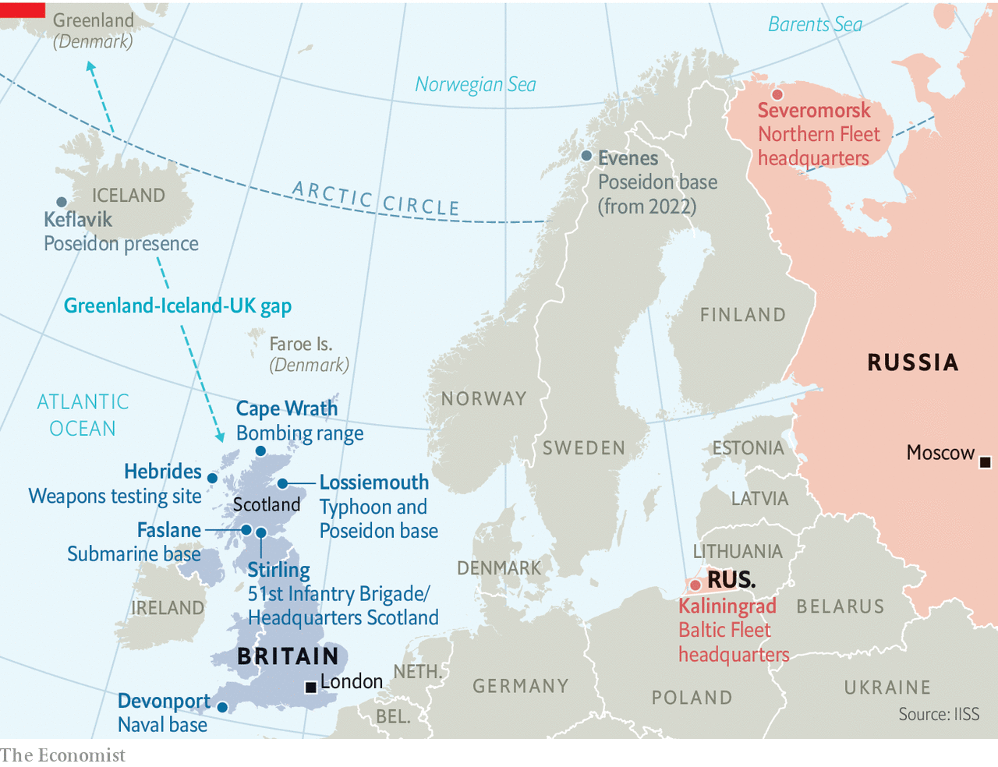

If there is another referendum, it will not happen for years. But the consequences of a yes vote could be profound. That is not because of Scotland’s economic weight—last year it accounted for less than 8% of British GDP—but because over the centuries Scotland has played an outsized role in projecting British force around the world. Out of proportion to their numbers, Scots ran the empire and, until recently, manned the army. “The British armed forces are the most Unionist of all the main public services,” says Malcolm Chalmers of the Royal United Services Institute.

As the threat from Russia has grown since the invasion of Ukraine in 2014 (see article), so has Scotland’s military importance. Its northerly latitude is ideal for projecting air and naval power into key Atlantic sea lanes and bastions of Russian power in the High North. RAF Lossiemouth in Moray, north-east Scotland, now houses four squadrons of Eurofighter Typhoon fighter jets and Britain’s entire fleet of new Poseidon submarine-hunting planes. Scotland’s geography is vital to both.

The Typhoons intercept Russian bombers from Murmansk that approach British airspace. If the planes had to be scrambled from southern bases, explains Group Captain Chris Layden, station commander at Lossiemouth, a Russian bomber would “already be over Aberdeen by the time you get anywhere near it”. Similarly, the Poseidons must quickly get to Russian subs passing from their Arctic bases through the “GIUK gap”—a choke point created by Greenland, Iceland and Britain—to the North Atlantic. “If they get into the North Atlantic, it is bloody hard to find them,” he says.

Scotland’s jagged west coast is also the simplest and safest way for Britain’s own submarines to slip quietly into the deep northern waters of the Atlantic, which in turn affords the quickest route for nuclear missiles to travel over the Arctic to Russia. Britain’s entire submarine fleet, including the four nuclear-armed boats colloquially known as Trident, is therefore based at Faslane. Nuclear warheads are stored and loaded onto the subs at nearby Coulport on Loch Long. At both Lossiemouth and Faslane, assets that were once split between England and Scotland are now concentrated in the latter.

Scottish real estate is vital in other ways, too. The MoD uses 115,000 square kilometres of airspace over the remote Hebrides archipelago as a range for honing its missile defence systems and other weapons. Cape Wrath in the Highlands is the only naval gunfire range in the country. Over 10,000 Scots are also employed in Britain’s defence industry, particularly in shipbuilding. Boeing, an American company, designed and built a facility to house the Poseidons at Lossiemouth. Raytheon is planning to open a second high-tech Scottish facility, in Livingston. Leonardo, an Italian firm, operates a tech “incubator” in Edinburgh.

The degree to which Scottish independence would up-end these arrangements depends in part on political choices in Edinburgh. The SNP has had an anti-Western-alliance streak—its former leader, Alex Salmond, hosts his own show on RT, a Russian propaganda outlet—and some fear that Scotland would become a chink in NATO’s armour. However, the party’s leadership has moved in a more pragmatic direction over the years. “I don’t think there’s much appetite in the SNP leadership for Scotland to go off in a neutralist direction,” says Mr Chalmers. “I think the model for them is Norway or Denmark.”

In 2012 the SNP reversed its traditional antipathy to NATO and said it would seek membership, subject to an agreement that it would not have to host nuclear weapons. That is not a formality. NATO is a self-proclaimed “nuclear alliance” and America, which routinely uses Faslane, does not tell allies when nuclear-armed planes or ships are passing through allied territory. This issue could probably be overcome, says Mariot Leslie, a former British diplomat who retired in 2014 as envoy to NATO, and supports independence. If so, Scotland would be “snapped up very quickly”, she says.

Faslane would be a serious bone of contention, though. The SNP says that it expects Britain to remove its nuclear weapons in the event of independence “on the fastest possible timetable”. A study by Mr Chalmers in 2014 estimated that transplanting Faslane and Coulport to England would cost £3bn-4bn and take years. Few sites in England are suitably remote and close to deep water. Devonport in Plymouth, which previously housed attack submarines, is the likeliest candidate, though 30 times as many people live within 5km of Devonport as Faslane. Stuart Crawford, a former British army officer and one-time SNP parliamentary candidate, suggests a compromise by which Scotland would lease out Faslane, Lossiemouth and other sites to Britain for around £1.2bn a year, for up to two decades. That, he estimates, could fund Scottish armed forces comprising 8,500 soldiers and sailors, 20 ships and 50 planes and drones—comparable to Ireland or New Zealand.

Mr McDonald suggests renting Lossiemouth back to the RAF is “perfectly sensible”, but leasing out Faslane “is not something we’ve even thought about”. Even if a transition period could be agreed, Trident would probably need to move, eventually. “If independence comes,” says Mr Chalmers, “we’re faced with a situation in which most of our submariners will bring up their families in Scotland. They will be Scottish voters and Scottish citizens.” The prospect of eviction would hang over the base, he adds. “The risk is that in 15 to 20 years, just when you need it the most, you get turfed out, as happened in 1938 when the Royal Navy was turfed out of Ireland.” In theory, Britain or America could veto Scottish membership of NATO unless the issue was resolved—with a decades-long lease, for instance.

Conventional forces could stick around for longer, or indefinitely, assuming that negotiations over partition were not too acrimonious. A former British civil servant points out that some Scottish forces could operate as an independent part of a joint force, just as many European countries have merged elements of their armed forces. There are Dutch tanks in German divisions, for instance. But despite Scotland’s martial history, its leaders would almost certainly be less willing than British ones to deploy and exercise military forces abroad, as Britain does everywhere from Iraq to the South China Sea. “We’re not going to be projecting power around the world”, says Mr McDonald. “We agree with countries such as Finland, for example, who see the North Atlantic as a key strategic region that needs attention.”

Secession would undoubtedly dilute British military power—even if an amicable outcome were in reach, the mechanics of “Skexit” would make Brexit look like light entertainment. The question is whether it would also occasion an existential crisis. “There would be a tendency to carry on as if it hadn’t happened,” says a former senior British defence official who served at the MoD during the 2014 referendum. “Just as Russia took on the mantle of the Soviet Union, the argument will be that England is the successor state which takes over the permanent seat at the UN Security Council—nothing to see here, move on.”

Yet a former defence chief suggests that if relocating Faslane proved too costly, Britain might even reconsider whether it could afford nuclear weapons at all. Moreover, the dynamics driving support for Scottish independence—the rise of English nationalism and the prospect of a harder Brexit—are also stirring a debate in Northern Ireland over unification with the next-door republic. The loss of either Scotland or Northern Ireland, and certainly both, would force Britain to consider whether the time had come to give up on trying to project the global clout of a big power, and accept a position in the world somewhat more in keeping with its declining economic and political status.■

This article was downloaded by calibre from <https://www.economist.com/britain/2020/11/05/how-scottish-independence-would-threaten-britains-defence>

|  |  |  |  |
| --- | --- | --- | --- |
| Previous | Articles | Sections | Next |

|  |  |  |  |
| --- | --- | --- | --- |
| Previous | Articles | Sections | Next |

#### Covid-19 and the economy

# Britain’s awful economic performance

The fright before Christmas

Nov 5th 2020 |

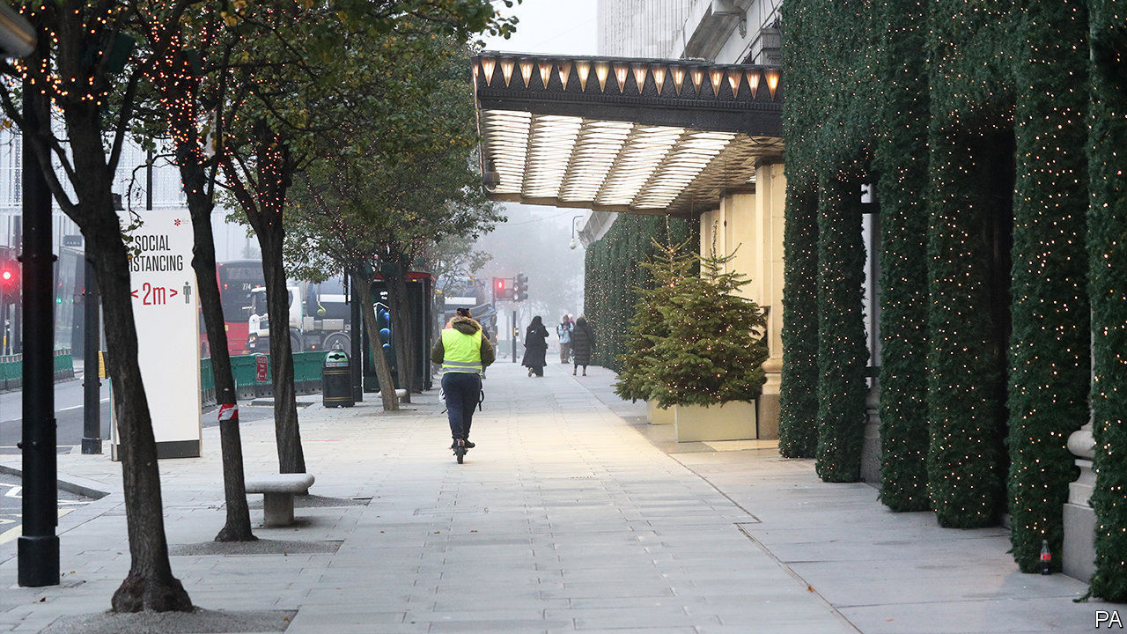

WHACK-A-MOLE is what Boris Johnson called the approach to eliminating the coronavirus through local lockdowns, which he has now abandoned. Business must be tempted to describe the new approach, a national lockdown imposed on November 5th, as “whack-a-firm”. Pubs, restaurants and all but essential shops are forced to close in the run-up to Christmas, the most profitable time of the year. The restrictions will ensure that 2020 is one of the worst years ever for the economy. Carolyn Fairbairn, the director general of the Confederation of British Industry (CBI), called it “the start of a bleak midwinter”.

After the spring lockdown, overall output had steadily recovered as people trickled back to work in the summer, and the government encouraged consumers to spend with a cut in value-added tax on hospitality and the “eat out to help out” subsidy for restaurants. Even so, before the second lockdown was announced, the IMF estimated that British output would drop by 10.4% this year, compared with an expected 8.3% decline in the euro zone. The duration and severity of Britain’s spring lockdown, longer and stricter than those in continental Europe, largely explains the disparity.

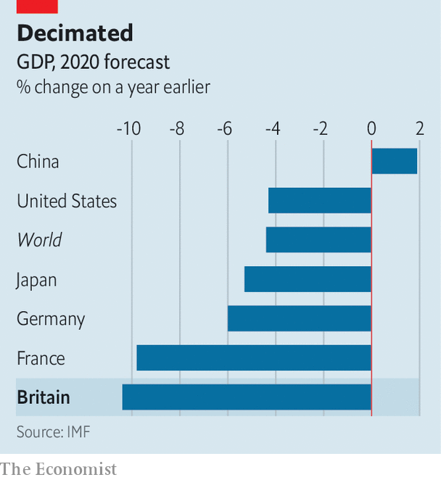

The hit this time round is unlikely to be as bad. Still, on the basis of the new restrictions, Credit Suisse, a bank, thinks that the British economy will shrink by 5% this quarter, and by 11.8% over 2020 as a whole.

Normally, such big declines in GDP would translate into a jump in unemployment. But Rishi Sunak, the chancellor, fended off such an increase with a furlough scheme that paid workers 80% of their normal pay. The scheme was due to stop at the end of October but Mr Sunak changed course and extended it at the last moment, a relief to the estimated 2m workers who were benefiting. But the cost of government support measures, along with the decline in tax revenues caused by the slowdown, has already pushed up the budget deficit to £246bn in the first six months of the financial year and taken government debt up to 103.5% of GDP.

On November 5th, the Bank of England stepped in to give the economy a boost through its quantitative-easing programme, buying an extra £150bn of government bonds. This was a response, it said, to signs that “consumer spending has softened across a range of high-frequency indicators, while investment intentions have remained weak.” The Bank’s actions have helped keep down the cost of government borrowing; even with the massive deficit, ten-year gilts offer an annual return of a mere 0.2%.

As if business did not already have enough to worry about, the British government has still not agreed a trade deal with the EU, even though the Brexit transition period comes to an end on December 31st. Failure to reach a deal could lead to substantial disruption to international trade and supply chains. Companies may feel even more battered in early 2021.■

This article was downloaded by calibre from <https://www.economist.com/britain/2020/11/05/britains-awful-economic-performance>

|  |  |  |  |
| --- | --- | --- | --- |
| Previous | Articles | Sections | Next |

|  |  |  |  |
| --- | --- | --- | --- |
| Previous | Articles | Sections | Next |

#### Education

# England’s catch-up tutoring programme has bold ambitions

With covid-19 spreading and schooling disrupted, pupils are likely to need even more help

Nov 7th 2020 |

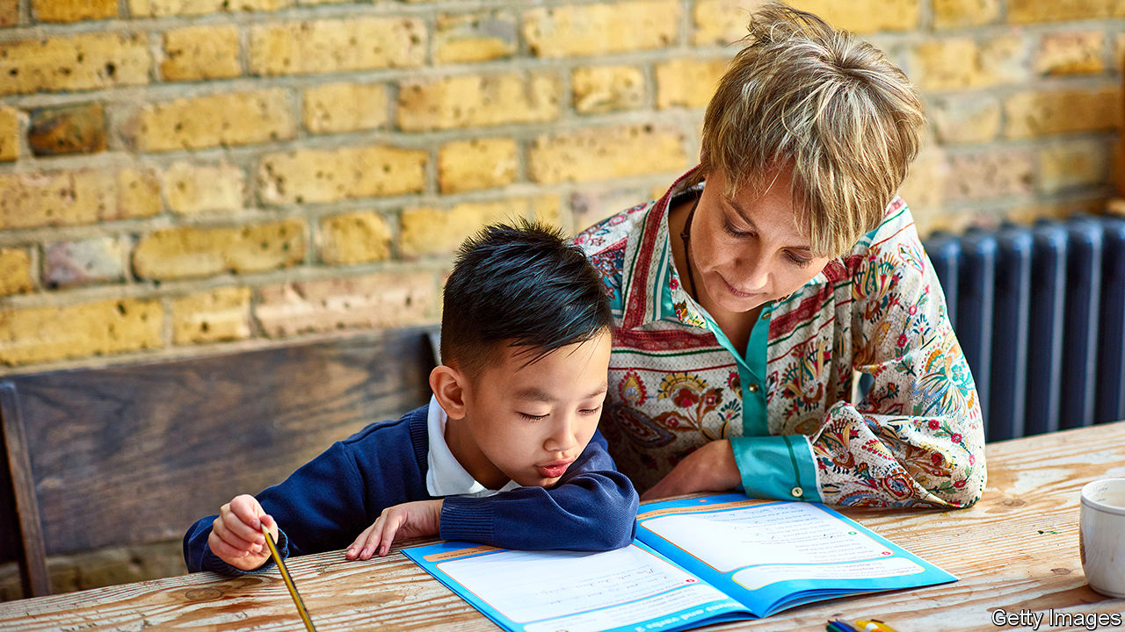

IT IS A straightforward process. Go to the National Tutoring Programme website, type in your location and pick a provider. A school in Tyneside can, for instance, choose from 19 options, including TLC Live (a firm offering online tutoring from qualified teachers), the Brilliant Club (a charity providing lessons from PhD students) and White Rose Maths (just maths teaching, from a chain of schools in Yorkshire).

In June, Boris Johnson announced a £1bn ($1.3bn) pupil catch-up fund, with a portion set aside for tutoring. On November 2nd the National Tutoring Programme launched—and not a minute too soon. Children spent the end of the last academic year at home. They have now returned to school, but things are not going entirely to plan. Before the start of half-term, the spread of covid-19 meant that one in eight secondary-school pupils was absent.

English schools have an unusually high degree of autonomy, so the government can’t simply order head teachers to hire tutors. Schools have thus been given £650m to aid their efforts to bring children up to speed. Another £76m has been spent establishing the National Tutoring Programme, which is run by a group of charities, and which will subsidise 75% of the cost of tuition, to encourage schools to spend on extra pairs of hands. The government had planned to spend more: the limit is the availability of top-notch providers.

According to research by the Sutton Trust, one of the charities running the scheme, 10% of pupils received tutoring last year, up from 5% in 2009, mostly paid for by parents. The market is something of a Wild West, making it hard to identify high-quality providers. The National Tutoring Programme hopes to impose some order. Only 32 out of the 393 outfits that applied made it through the approval process, which required proof of safety standards and an idea of how to work with schools.

There is plenty of evidence that tutoring is effective, with trials finding that 12-week programmes can lead to the progress that would be expected from three to five months of normal schooling. As Robbie Coleman of the National Tutoring Programme notes, tuition tends to work best when it happens regularly over a longish period, which is why it is offered in 15-hour blocks. The programme will also add to the evidence base. By measuring the outcomes of pupils involved in the programme, and comparing them with similar ones who are not involved, officials will be able to measure which approaches do the most good.

That will help determine the relative effectiveness of, say, online versus in-person tutoring. It could also come in useful if the programme is extended, allowing resources to be directed to better outfits (and thus may help convince the Treasury to stump up the cash). Even before the results are in, the programme has a powerful cheerleader. Speaking at prime minister’s questions on November 4th, Mr Johnson hailed the tutoring programme as one of the most innovative ideas to have come out of the crisis, adding that he wanted to see it continue in the post-pandemic era. As more evidence emerges of the distance pupils have fallen behind, support for such interventions is likely to grow. ■

Editor’s note: Some of our covid-19 coverage is free for readers of The Economist Today, our daily [newsletter](https://my.economist.com/user#newsletter). For more stories and our pandemic tracker, see our [hub](https://www.economist.com/news/2020/03/11/the-economists-coverage-of-the-coronavirus)

This article was downloaded by calibre from <https://www.economist.com/britain/2020/11/07/englands-catch-up-tutoring-programme-has-bold-ambitions>

|  |  |  |  |
| --- | --- | --- | --- |
| Previous | Articles | Sections | Next |

|  |  |  |  |
| --- | --- | --- | --- |
| Previous | Articles | Sections | Next |

#### Bagehot

# Sir Keir Starmer: foresight without vision

Prescience and competence will take the Labour leader far, but not far enough

Nov 7th 2020 |

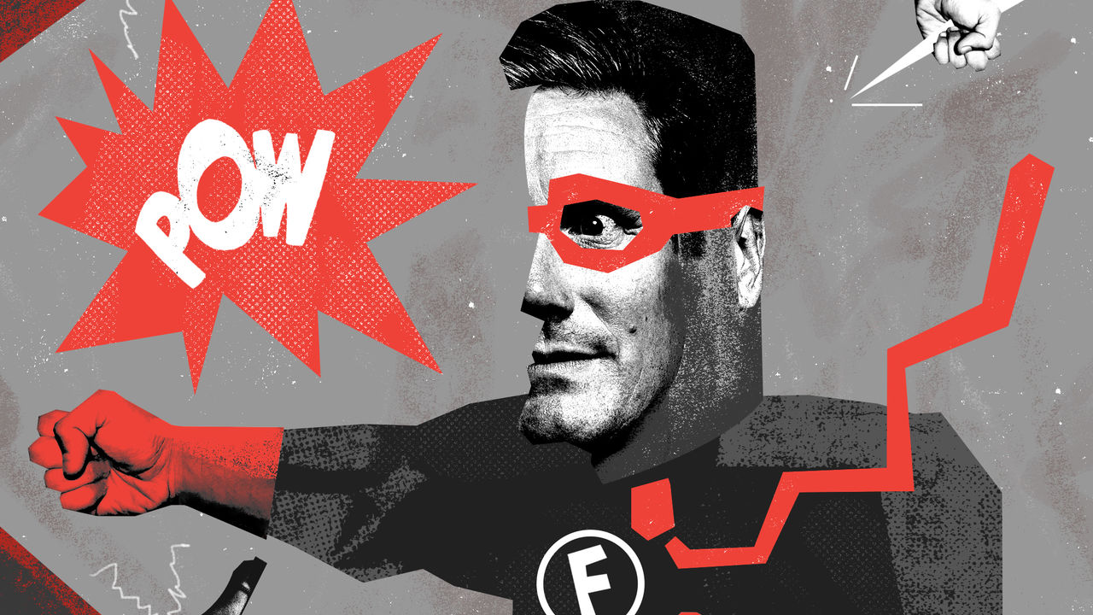

SIR KEIR STARMER’S leadership of the Labour Party has taken place entirely in the age of covid-19—he was elected on April 4th—but the politics of the disease have changed completely in that short time. Last time Britain went into lockdown the leader of the opposition was walking on eggshells. Criticism of the government’s strategy would have come across as opportunistic or unpatriotic. This time he is riding the surf. Serial incompetence has rendered the government fair game. The sense of national unity, which started to unravel when the prime minister’s chief adviser broke lockdown rules, has gone entirely. With the Tories at each other’s throats, nobody can object to tough criticism from Labour.

Sir Keir’s latest success is the lockdown itself. On October 13th, he started arguing for a two-to-three-week “circuit break” to coincide with half term. His position echoed that of SAGE, the government’s team of scientific advisers. Boris Johnson vigorously rejected his advice on the grounds that a full lockdown would be a “national disaster”. The prime minister then spent three weeks scrambling to make his tiered system work, only to reverse himself and introduce a national lockdown.

This feeds nicely into Labour’s main line of attack: that the prime minister’s handling of the virus has been slow and clumsy from the beginning. Mr Johnson’s volte face makes him look weak and dithering and Sir Keir prescient and decisive. It also gives the Labour leader a licence to be simultaneously for and against the lockdown: whenever anyone mentions the costs of closing the country down he can argue that they would have been lower if only the prime minister had acted sooner. The Conservative Party has devoted a lot of energy to labelling Sir Keir “Captain Hindsight”. Mr Johnson has transformed him at a stroke into Captain Foresight.

Sir Keir’s good call on lockdown coincides with a piece of good fortune: the Equality and Human Rights Commission’s strongly worded report on anti-Semitism in the party under the leadership of his predecessor, and Jeremy Corbyn’s dismissive reaction to it. Mr Corbyn was swiftly suspended from the party. Chucking out a former leader is a dangerous manoeuvre, particularly when that leader is a hero not just to leathery old leftists but also to young idealists who flooded into the party when he took over in 2015. Moreover, hard leftists are dangerous enemies to have, given their long memories and habit of lurking in the dark corridors of the party machinery, ice picks in hand. But so far the move has paid off, making Sir Keir look tough without sparking a rebellion in the parliamentary party. Mr Corbyn’s most vocal supporters consist mostly of has-beens and misfits—indeed, Chris Williamson, one of the most vocal of the lot, was expelled from the party over anti-Semitism. This looks more like the death-rattle of a dying regime than a live threat in the future.

Luck isn’t randomly distributed in politics: it goes to the well-prepared and gutsy. Sir Keir has done patient work taking over the party. Rather than drafting old Blairites like Hilary Benn into the shadow cabinet, he has appointed a new generation of MPs, and brought enthusiastic young advisers into his office. The parliamentary party is more disciplined than it has been for years. John McTernan, a former political adviser to Tony Blair, points out that the difference between first-rate barristers and also-rans lies in their sense of timing: they know not only which is the most damaging weakness in their opponent’s case, but also exactly when to expose it. On everything from the sacking of his leftist rival for the leadership, Rebecca Long-Bailey, from the shadow cabinet—one of his first moves as leader—to the call for a second lockdown, Sir Keir has used the skills he has honed in his career.

Perhaps, given the shambles of Mr Johnson’s government, Sir Keir’s professionalism, competence and normality will be enough to win him the next election. But thanks to Labour’s collapse in Scotland, the electoral mountain he has to climb is far higher than the one that Tony Blair faced in 1997. And the Conservative Party has a distinguished record of getting rid of failing leaders: it is notable that the Labour Party is now shifting its fire from Mr Johnson, who is beginning to have the air of yesterday’s man, to Rishi Sunak, his chancellor, who is every bit as normal, professional and competent as Sir Keir.

Labour leaders who have broken long periods of Conservative rule have offered something more than competence: a galvanising vision of the future. Clement Attlee offered to replace the old devil-take-the-hindmost patchwork of benefits with a modern welfare state, and a class-ridden society with a meritocracy. Harold Wilson talked about the “white heat of the technological revolution”. Tony Blair peddled a third way between socialism and capitalism.

Sir Keir’s main initiatives are party-focused and backward-looking: winning back traditional Labour voters in the Midlands and the north, ridding the party of its unpatriotic image, kicking out anti-Semites. He has said nothing about the great issues that will define the future: how Britain should try to define itself after Brexit, how to head off Scottish independence or even—this is the Labour Party after all—what work will look like when the pandemic is over. “Technocratic, nasal and boring” is how a Labour veteran summarises his style.

These are still early days in the Keir era, and the middle of a pandemic might not be the right time to be unveiling shiny new visions of the future. But Sir Keir has given no sign that he is capable of either providing what George Bush senior called “the vision thing” or promoting others who can do it for him. Attlee, Wilson and Blair all surrounded themselves with big political beasts who had a keen sense not only of how to gain power, but also of what they wanted to do with it. Labour’s top table today is heavy on technocrats but light on gurus. Sir Keir may have cast off the Captain Hindsight label when it comes to the pandemic, but if he is to inspire voters, he will need to persuade his countrymen that he can look beyond the next lockdown.■

This article was downloaded by calibre from <https://www.economist.com/britain/2020/11/07/sir-keir-starmer-foresight-without-vision>

|  |  |  |  |
| --- | --- | --- | --- |
| Previous | Articles | Sections | Next |

|  |  |  |
| --- | --- | --- |
| Britain | Sections | Business |

International

Global hipsters: Flat-white world

.

|  |  |  |
| --- | --- | --- |
| Britain | Sections | Business |

|  |  |  |  |
| --- | --- | --- | --- |
|  | Articles | Sections | Next |

#### Flat white world

# Even as traditional globalisation has slowed, a new kind has sped up

Global hipster culture is spreading to even the world’s poorest countries

Nov 7th 2020 | KABUL

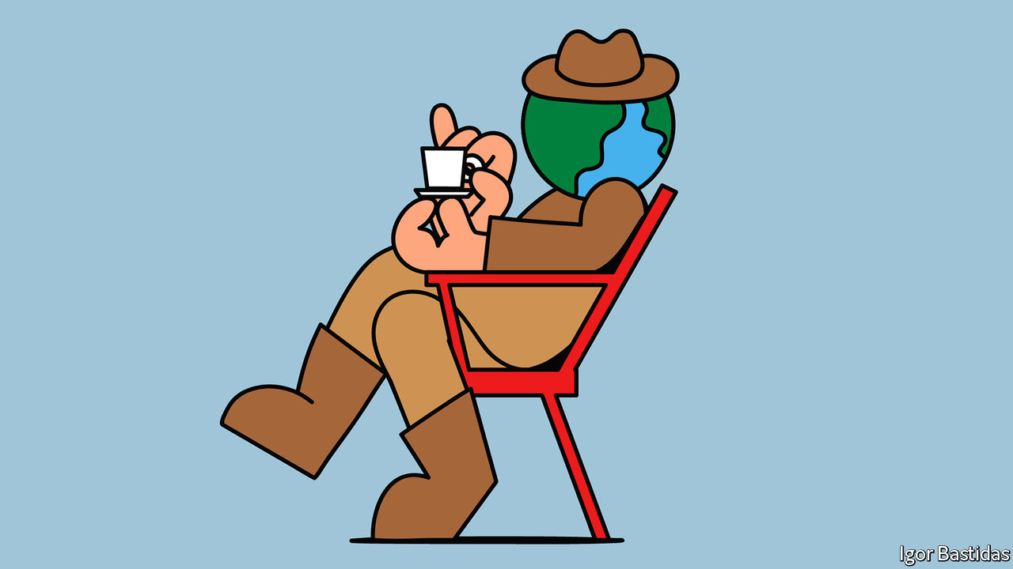

HAIRPORT, A BARBER SHOP, could be anywhere in the world. A smart logo on its doors shows a pirate in a tricorn, flanked by crossbone-style scissors. Giant photos of tattooed and bearded hipsters cover its walls. Two stylists trim the beards of jeans-clad customers. The owner, Ahmed Zia, a 31-year-old who founded the place in 2018, explains the logo, which he designed himself. “I was a fan of ‘Pirates of the Caribbean’,” he says, “I like the idea of a team of pirates.” Hence the crossbones-style theme. He settled on the name because it sounds like “airport”—a portal to the rest of the world.

What makes Hairport striking is its location: in Kabul, the embattled capital of Afghanistan. The city is no stranger to beards. A couple of decades ago, sporting them was compulsory, a rule enforced with beatings by the Taliban. But in the past few were so well maintained, nor were they accompanied by tattoos or earrings.

Today, however, Hairport is one of many such barber shops to have opened in Kabul. Walk around Shahr-e-Naw, a neighbourhood in the city’s centre, and you stumble across half a dozen, with names like “New York barber” or “West Style barber”. Some offer tattoos, too. “The market has completely changed,” says Mr Zia, who sports carefully clipped facial topiary. “The youth now are very interested in new styles.” They get their ideas from Instagram and Pinterest, he says, and happily pay 200 Afghanis ($2.60) for a trim. As for skin ink? “It is prohibited in our religion,” he says, “but the youngsters, they do not care.”

Globalisation in the traditional sense has slowed in the past couple of decades. Even before covid-19 smashed it, global trade had stagnated for a decade. By last year, foreign direct investment (FDI) as a share of GDP had fallen by two-thirds compared with its peak in 2007. The globalisation of brands, which once seemed unstoppable, has slowed. From the 1970s to the early 2000s, the number of countries in which you could get a McDonald’s soared, from just two to over 100. But no new country has welcomed the firm in over four years. Indeed a few places, such as Bolivia and Iceland, have demolished their golden arches. Big expansions of other brands have failed. In January Walmart, an American retailer, began laying off people in India and wrapping up its business there.

And yet in recent years a different type of globalisation has accelerated. A new design aesthetic is taking over the world, spread not via brands or FDI, but through social media and the internet. Even as formal trade slows, the globalisation of taste is rampant. Starbucks may not have reached large chunks of the world, but there are very few large cities in the world now in which a visitor cannot order a latte surrounded by exposed wood and vintage light bulbs. Kabul boasts no McDonald’s, but you can get a decent burger and fries at Burger House, a restaurant that would not be out of place in San Francisco.

A global “hipster index” drawn up by MoveHub, an international shipping company, in February, did not include Kabul in its calculations of the world’s 446 most latte-soaked metropolises. The firm ranked cities by the number of coffee shops, record stores, tattoo parlours, vegan restaurants and vintage boutiques. At the top were predictable spots such as Brighton, in England, and Portland, Oregon, on the west coast of America. But the hipsters have spread much farther afield.

At the Lion Café in West Kabul, young trendies slurp coffee beneath paintings by local artists. “Sometimes you need a break from your own culture,” says Karim Karimi, a 22-year-old law student, who takes his laptop there to work. “It is joyful when you can find that in your own country,” he says. Even Goma, a city in conflict-ridden eastern Congo, boasts Le Petit Chalet, which serves quinoa protein bowls as well as “latte macchiatos”. In Bangui, the capital of the Central African Republic, a place at least as war-torn as eastern Congo, Le Grand Café features exposed brickwork (the café does still rely on freeze-dried Nescafé; global gentrification has its limits).

## How did the hipster burn his tongue?

The style, all “raw wood tables, exposed brick, and hanging Edison bulbs”, has been termed “AirSpace” by Kyle Chayka, an American writer. Sajith Pai, a venture capitalist in Delhi, describes it as “the bastard child of IKEA, Starbucks and Apple”. Its purpose is to communicate to potential customers that there will be a certain level of quality; that the coffee or haircut will meet some global standard. “You can call it reassurance design,” he says.

Wealthier Indians decorate their own homes with “slightly old furniture, hand looms, that sort of thing”, not spartan brick and stripped-down wood, says Mr Pai. But they seek out hipster design in the bars and cafés of places such as Delhi and Mumbai because it signals their membership of a global elite. Mr Pai reckons the biggest consumers of this style are not the super-rich but the class just beneath them—the upper-middle class, who cannot stretch to Bentleys or private jets, but can afford plane tickets and posh coffees.

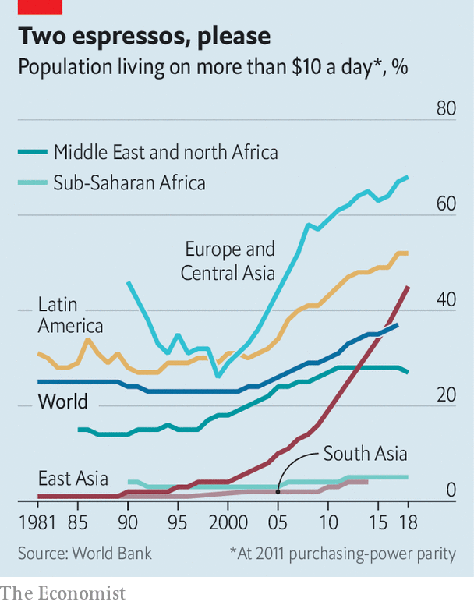

Both the rich and middle class are growing in numbers. According to the World Bank, the share of the world’s population living on more than $10 per day (at 2011 purchasing-power parity)—enough money to buy things other than food and shelter—has swelled from less than a quarter two decades ago to almost two-fifths in 2017. The bulk of the growth has been in East Asia, but the figure increased in every region (see chart). The Brookings Institution, a think-tank, estimated in 2018 that the number of rich people (those living on more than $110 a day) will grow by 50%, or 100m people, by 2030. The global middle class (which it also defines as those on more than $10 a day) will increase to almost two-thirds of the world’s population.

Such people are more likely than they were to be urbanites. Over half the world’s population now live in cities, according to the World Bank. Not everyone in poor-world cities (or even those in rich ones) will be able to afford regular flat whites or visits to craft-beer bars. But cities create high-paying specialist jobs, so some will. That allows specialist tastes to flourish. In Kenya, Eoin Flinn, the Irish CEO of 254 Brewing, a craft-beer company (named after Kenya’s dialling code), says that his firm has experimented with beers from a “Mexican pineapple sour” to a “Nitro Stout”. The buyers are middle-class Kenyans bored with of the bog-standard lagers that were until recently the only option.

This class of people is more global literally, too. There are 272m migrants worldwide, according to the International Organisation for Migration (IOM), a UN body. That figure represents just 3.5% of the world’s population. But it is at an all-time high. And it is already higher than the IOM’s predictions for 2050 made in 2003. Some are refugees. Many more—nearly two-thirds—are economic migrants.

Both groups contribute to the globalisation of hipsterism. While abroad they acquire new tastes and money which they then bring home. In Afghanistan many of the hottest new businesses, such as the Lion Café, are founded by Afghans who previously fled their country. The same is true in Somalia—a country with a population of 15m, but a diaspora of 2m. Mogadishu is not an easy place to get a posh coffee—but it is now possible, thanks to Somali returnees.

With travel comes education and thus exposure to a global culture of trendiness. Between 1975 and 2017 the number of students studying outside their home country increased from 800,000 to almost 5m. Their ranks have swelled even faster this millennium—the figure increased by a fifth between 2012 and 2016 alone.

But it is not just travelling abroad for education that has increased. Global education options at home have, too. The American University of Afghanistan, inspired by the American University of Beirut, was established in Kabul in 2004. Its professors include foreigners and Afghans educated abroad. Courses are taught in English, not Dari or Pushtu, Afghanistan’s two predominant languages.

Yet the biggest driver of late has surely been the internet. It enables would-be trendsetters to access information about the latest fashions free of charge, at least those who can read English and afford mobile-phone data. Worldwide, the proportion of people with a broadband subscription has nearly doubled since 2010. In only a few countries, such as Eritrea and North Korea, is fast mobile internet not widely available in big cities. Restaurant designers and hair stylists from Kabul to Bangui can take inspiration from Instagram; so can their consumers. In Afghanistan a fast-growing sector is e-commerce, mostly of Chinese “drop-shipped” goods, which retailers order straight from the factory and sell via Facebook. Where commerce spreads, so does culture.

What does the rise of this class mean? A class of people who buy into a common cult of mid-century furniture and banal contemporary art do not always endear themselves to their fellow citizens. Even in rich countries, they cluster in cities which tend to vote for left or liberal-leaning parties. And even in those places—where they are accused of “gentrification” or worse—they are not always welcome. The rise of such a style hints at an urban-rural divide that is growing all over the world.

## He drank his cortado before it was cool

Yet in rich countries these days being a hipster is hardly a rebellion—the culture has spread so relentlessly in big cities it is practically conformist. A somewhat tongue-in-cheek mathematics study published last year by Brandeis University found that even “pure anti-conformist[s] systematically taking their decisions with a tendency to oppose the majority” can end up making the same decisions as everybody else. These days it would be far braver for an entrepreneur in New York or Copenhagen to start a business with plastic tables and staff sporting chinos and polo-shirts.

That is not true in many poor countries, and especially not in Kabul, where universities and schools are frequent targets of attack, most recently on November 2nd. At Hairport, the barber shop in Kabul, Mr Zia says that the Taliban returning to power is his greatest fear. Before getting into his own business, he studied English in Pakistan and then worked with the American army. He likes the idea of the rest of the world. But he says, “I love my country,” and does not want to leave. Afghanistan’s future is uncertain. If the Taliban come back, “I am planning to run away.” Not everyone with a beard is a good omen. ■

This article was downloaded by calibre from <https://www.economist.com/international/2020/11/07/even-as-traditional-globalisation-has-slowed-a-new-kind-has-sped-up>

|  |  |  |  |
| --- | --- | --- | --- |
|  | Articles | Sections | Next |

|  |  |  |
| --- | --- | --- |
| International | Sections | Finance & economics |

Business

The outlook for corporate America: Still ailing

.

Xiaomi: Mi time

.

The turkey glut: Gobble, gobble?

.

Video games: The games are only just beginning

.

Bartleby: Questionable behaviour

.

Schumpeter: Mickey v Masa

.

|  |  |  |
| --- | --- | --- |
| International | Sections | Finance & economics |

|  |  |  |  |
| --- | --- | --- | --- |
|  | Articles | Sections | Next |

#### Still ailing

# USA Inc’s ponderous recovery

USA Inc’s uncertain recovery

Nov 7th 2020 | NEW YORK



ON THE HUSTINGS, both Donald Trump and Joe Biden promised to revive America’s economy from its pandemic-induced funk. Doing so will require a turnaround for corporate America, which has suffered a savage downturn. When the occupant of the White House starts his four year term in January, in what state will American business be?

Some recent vital signs may look promising. America’s economy expanded at a record pace of 33%, on an annualised basis, in the third quarter. Total profits for the big firms of the S&P 500 index have surpassed analysts’ expectations by roughly a fifth, with 85% beating forecasts for the quarter. Michael Wilson of Morgan Stanley, a bank, calculates that revenues for the median S&P 500 firm rose by 1% year on year. Small wonder that the Conference Board, a research organisation, published a survey on October 20th finding that its measure of confidence of bosses at big companies has jumped to 64 from 45 in the previous quarter—a figure above 50 indicates more positive than negative responses.

Yet anyone tuning into big firms’ quarterly update calls with Wall Street investors could not help but pick up the tentative tone and frequent dour notes of executives. Visa, a payments company, for example, called the recovery “uneven”. Caterpillar, a maker of industrial machinery, admitted it is “holding more inventory than we normally would” because of the uncertainties resulting from the pandemic. And a close analysis of the figures suggests that the corporate recovery is very patchy, with some industries and smaller firms still in big trouble. Meanwhile, corporate balance-sheets are under strain, which could hold back investment and lead to an eventual rise in defaults.

America’s economic boom in the latest quarter would be impressive had it not come on the heels of a comparable decline in GDP in the previous three-month period. The economy remains 3.5% smaller than it was at the end of 2019, reckons the Conference Board, and it is not likely to return to its pre-pandemic level until the tail end of 2021 or possibly later (see chart). As for the large proportion of companies where profits exceeded expectations this quarter, Tobias Levkovich of Citi, a bank, is unimpressed: “Beating lowered earnings expectations is not that great a feat.” It is now clear that analysts were too pessimistic when they pencilled in their forecasts earlier in the year. He adds that many firms managed to improve profits not by boosting sales but by slashing their expenses. The business outlook remains “squishy”, he reckons, as “you can’t cost-cut your way to prosperity.”

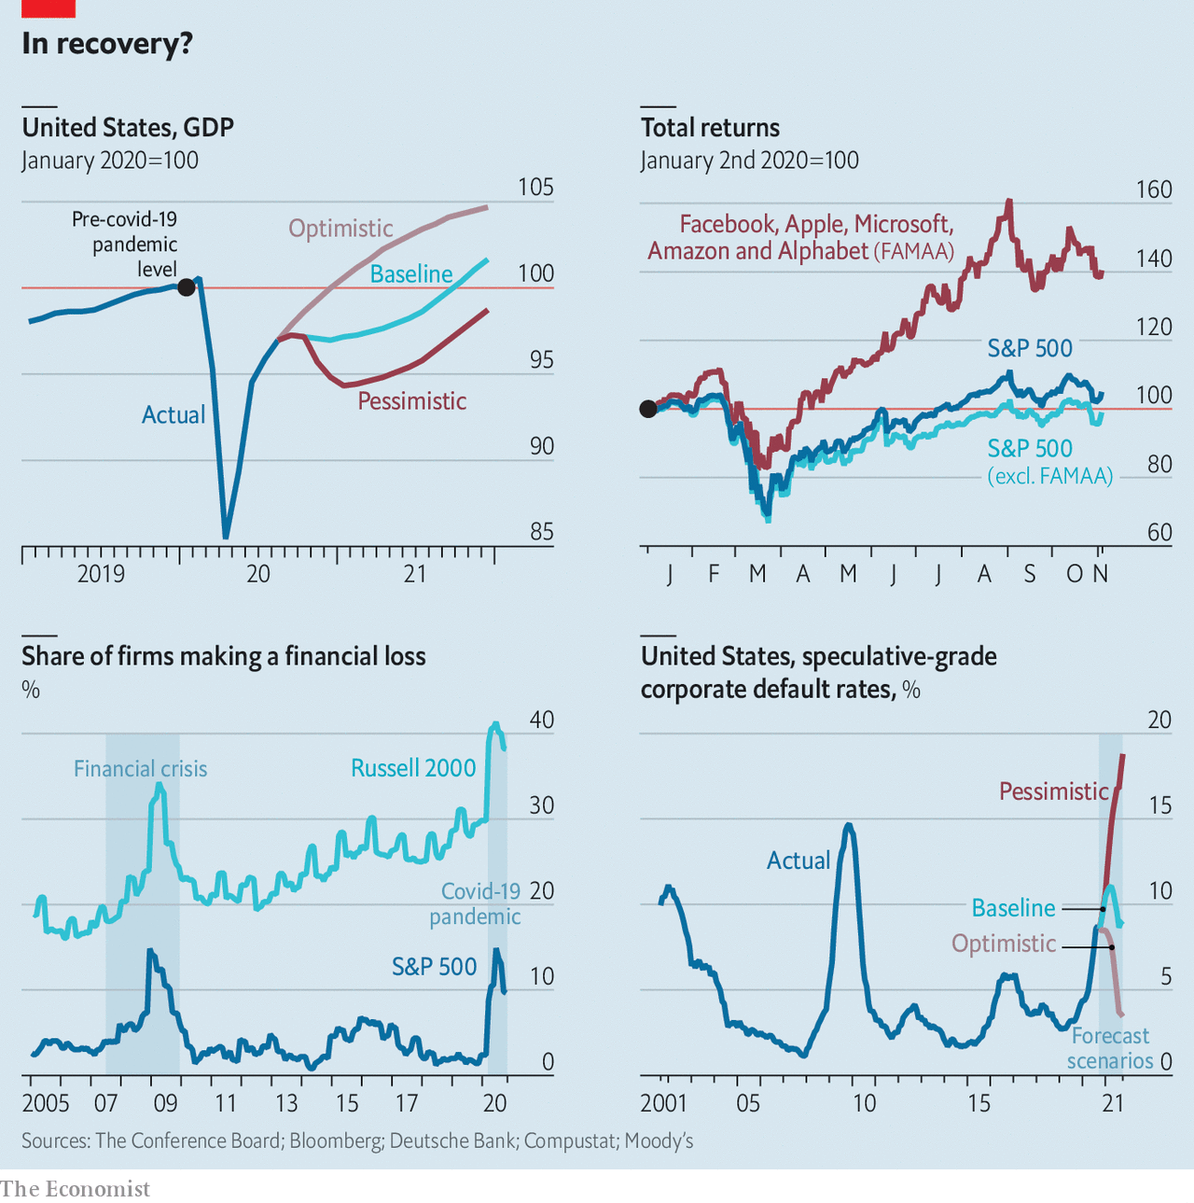

The more you peer into the numbers, the more inconsistent the recovery looks. One source of differentiation is where a company’s customers are based. Jonathan Golub of Credit Suisse, another bank, estimates that the companies in the S&P 500 reported an aggregate revenue decline of 2.8% and a fall of 10.2% in profits in the third quarter compared with a year earlier. But he estimates that at American firms focused on exports profits plunged by over 14%, whereas those companies more reliant on the domestic market suffered a drop of less than 9%.

Size is another lens which reveals the uneven recovery. Binky Chadha of Deutsche Bank argues that it is “a tale of two stockmarkets”. The market capitalisation of the five biggest tech giants (Facebook, Amazon, Apple, Microsoft and Alphabet) has fallen in recent weeks from its peak of roughly a quarter of the entire value of the S&P 500 index. Even so, they have generated returns of 39% for shareholders this year and without them the 495 others have produced a return of -1%.

Small and medium-sized firms (SMEs) have been crushed. The proportion of them that are making losses—based on the Russell 2000, an index of SMEs—has declined a bit from its peak of above 40%, but it remains well above 30%. SMEs are nearly four times as likely to be losing money as big firms, a far worse situation than during the recession of 2001 or the global financial crisis a decade ago.

The mood in the board rooms of small companies is foul. The latest survey of executives at SMEs, published by the Wall Street Journal and Vistage, an executive-coaching organisation, found sentiment “stalled in October 2020 due to increased concerns about an economic slowdown amid a resurgence in covid-19 infections.” The gloomy outlook, the most pessimistic in six years, may be explained by the fact that 42% of small firms believe they will run out of cash in under six months.

If the inconsistency of the recovery is one worry, the other is the state of firms’ balance-sheets. Corporate debt was rising before the pandemic, and many firms have piled on more borrowings in order to cover the shortfall in revenue they have experienced this year. Edward Altman of NYU Stern School of Business is worried about what he calls “the enormous build-up of non-financial corporate debt.” By his estimation, firms have issued more than $360bn in high-yield debt (ie, junk bonds) so far this year, surpassing the previous record of $345bn in all of 2012. With debt-earnings ratios reaching critical levels, and a resurgence in corporate defaults, Mr Altman reckons that 6.5% to 7% of junk bonds, by dollar value, will default in 2020.

His fears are echoed by S&P Global, a credit-rating agency. It calculates that the “distress ratio” (distressed credits are junk bonds with spreads of more than ten percentage points relative to US Treasuries) for American companies had come down to 9.5% in September from its peak of 36% in March but that it remains above pre-pandemic levels. Corporate America already leads the world in the tally of corporate defaults this year, with 127 by the end of October. Nicole Serino of S&P Global notes that corporate credit quality is deteriorating, with the number of firms rated a lowly CCC+ or below now 50% higher than at the end of 2019. For such firms, she worries that “excess liquidity and low interest rates are only postponing the inevitable.”

With a large share of firms still making losses and given the weakening of balance-sheets it is far from clear that American business is in the clear. What happens next depends on three unknowns. One is the fallout from this week’s presidential vote. A prolonged period of post-election uncertainty would weigh on the mood, notes Mr Levkovich. He points to the 11% fall in the S&P 500 index after the election in 2000 while legal wrangling decided the outcome of the contest for the presidency between George W. Bush and Al Gore.

Another unknown is the timing and size of the next package of fiscal stimulus from Congress, which at the moment is frozen by partisan gridlock in Washington, DC, and which could be limited if the Republicans keep firm control of the Senate. This matters to companies because, as Mr Golub puts it, “the government has effectively said, ‘We do not want market forces to drive firms out of business right now and so we are going to backstop a large part of the economy.’” Mr Wilson believes that the number of companies going bankrupt so far this year has been much lower than otherwise feared because of generous stimulus measures.

The biggest unknown, though, is the pandemic. Moody’s, a credit-rating agency, predicts that corporate-debt defaults will continue to rise until March 2021. The reason it gives is “economic recovery remains fragile amid risks of another pandemic resurgence leading to another round of countrywide lockdowns”. That should serve as a sober reminder to the next president and corporate bosses alike that, despite a rebound, there may yet be difficult days ahead for USA Inc.■

This article was downloaded by calibre from <https://www.economist.com/business/2020/11/07/usa-incs-ponderous-recovery>

|  |  |  |  |
| --- | --- | --- | --- |
|  | Articles | Sections | Next |

|  |  |  |  |
| --- | --- | --- | --- |
| Previous | Articles | Sections | Next |

#### Mi time

# Xiaomi takes advantage of Huawei’s woes

A Chinese smartphone-maker shrugs off feelings of inferiority

Nov 5th 2020 |

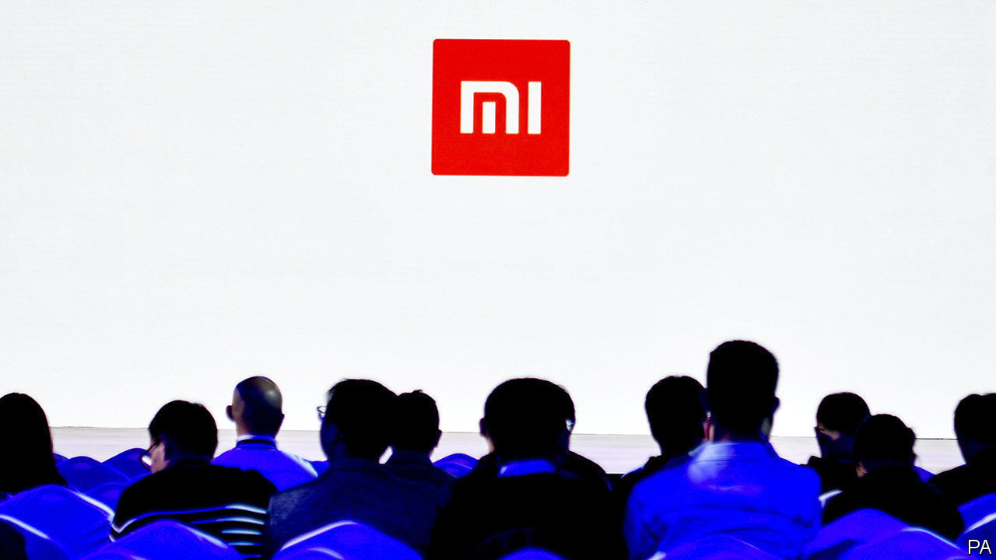

LEI JUN, THE founder and boss of Xiaomi, a Chinese smartphone-maker, has long had something of an inferiority complex. For a decade Xiaomi has played second fiddle to Huawei, a rival Chinese producer of handsets. In a recent live-streamed address watched more than 30m times, Mr Lei admitted that his firm is not yet “in the same league” as Huawei. The audience, comprising mainly “Mi fans” (as devotees of Xiaomi products are known), booed the dispiriting assessment. That prompted Mr Lei to change tack, quickly adding that “you will find lots of things we do well”.

Investors are not complaining. Xiaomi’s share price has doubled since June. Its value surged to $80bn on November 5th. The main explanation is the flagging performance of none other than Huawei, which has been cut off from a critical resource—mobile chips—after export restrictions imposed by America came into effect on September 15th. The regulations prohibit chip manufacturers whose products contain American technology, including suppliers outside America, from selling to Huawei, which is accused of acting on behalf of the Communist Party. The chokehold is likely to depress Huawei’s sales for the foreseeable future.

Xiaomi is better insulated from the geopolitical storm. Unlike Huawei, which sells telecoms gear to foreign network operators, Xiaomi runs only a consumer operation. It is thus less likely to stoke foreign ire. Big chipmakers like Taiwan Semiconductor Manufacturing Company, for instance, continue to supply Xiaomi even as they are forced to cut ties with Huawei.

New data from Canalys, a research firm, suggest that Xiaomi is cashing in on Huawei’s troubles. In the third quarter Xiaomi shipped 47m smartphones worldwide, up by 45% year on year. Huawei hawked more handsets, 52m units, but that is down by 23% from a year ago and the next quarter will almost certainly be even weaker. Xiaomi could soon overtake Huawei to become the world’s second-biggest smartphone vendor—behind only Samsung, which shifted 80m units in the quarter. Xiaomi is the undisputed winner from Huawei’s woes. Compared with the same period last year, third-quarter shipments from Samsung and Apple, which dispatched 43m handsets, barely budged. This suggests that consumers regard Xiaomi smartphones as a suitable substitute for Huawei’s products.

Like its Chinese rival, Xiaomi tries to cater to every customer. Wealthier folk favour the flagship “Mi” phones. “Redmi” phones are aimed at the mass market (similar to Huawei’s “Honor” series). This explains Xiaomi’s popularity in both developed and developing countries. It is the leading smartphone supplier in markets as diverse as India and Spain. Apple’s pricey products have less appeal in poorer countries.

The question is how long Xiaomi can sustain its fortuitous ascent. A new administration in America may lift restrictions against Huawei, enabling it to buy chips from global suppliers once again. If that happens, Xiaomi could be squeezed. To avoid this fate it talks of building on an “ecosystem” designed to keep customers interested. In addition to smartphones, which account for three-fifths of revenues, the company sells a range of smart devices, from light bulbs to electric scooters. It also offers fintech services like micro-lending. Xiaomi’s sense of inferiority could be a thing of the past. ■

This article was downloaded by calibre from <https://www.economist.com/business/2020/11/05/xiaomi-takes-advantage-of-huaweis-woes>

|  |  |  |  |
| --- | --- | --- | --- |
| Previous | Articles | Sections | Next |

|  |  |  |  |
| --- | --- | --- | --- |
| Previous | Articles | Sections | Next |

#### Gobble, gobble?

# Socially distanced Thanksgiving weakens appetite for big turkeys

Smaller gatherings raise demand for smaller birds

Nov 5th 2020 |

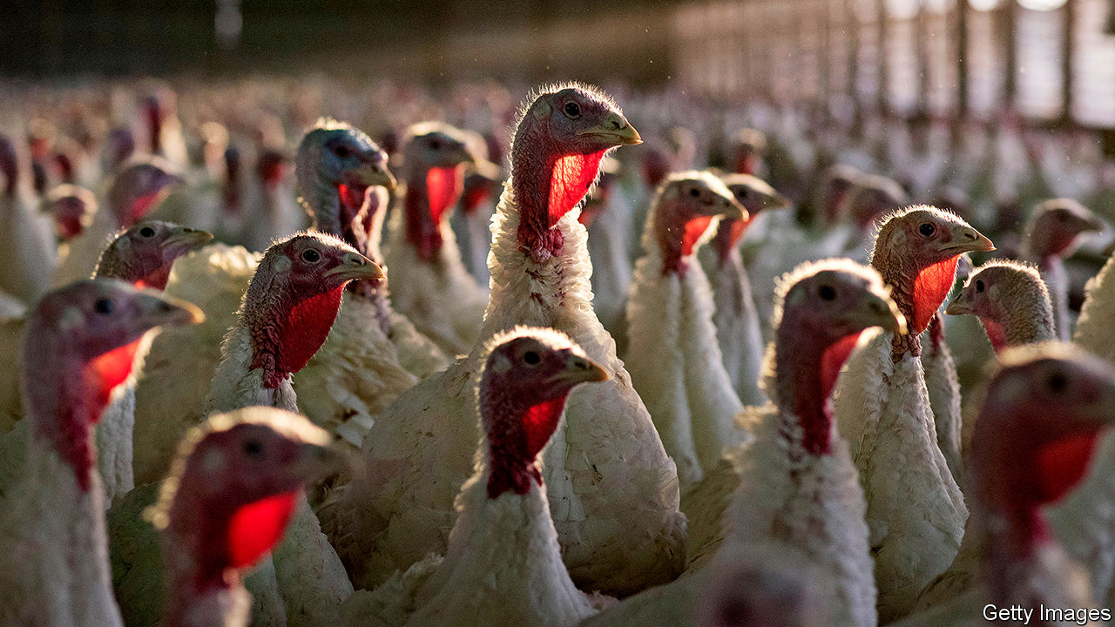

IN BARNS OR pens, or already in freezers, 40m American turkeys await their fate. More than half of the whole turkeys sold in America each year are eaten over Thanksgiving, which this year falls on November 26th. Most of the rest are polished off the following month, at Christmas. Social-distancing rules and travel restrictions mean that celebrations will look rather different in 2020—and so will the market for meat.

Some 30% of Americans say they will spend Thanksgiving with their immediate family only, up from 18% last year, according to Butterball, a North Carolina firm which rules the roost of turkey producers, supplying one in three Thanksgiving birds. Flight bookings for November are a third lower than last year, reports Skyscanner, a search platform, suggesting fewer people are going home for the holidays. In Britain, where 9m turkeys are usually eaten over Christmas, 61% of people say they are less likely than usual to have guests on Christmas Day, according to Kantar, a data firm.

Birds bred to feed large gatherings are therefore out of favour. Walmart and Kroger, large American food retailers, both plan to offer more small turkeys. However, “a lot of supply for the holidays is locked in well before the fall,” says Beth Breeding of America’s National Turkey Federation, an industry group. It is too late for producers to switch to daintier varieties, since a hen takes 14-16 weeks to mature from hatchling to main course. Changing a bird’s diet or the temperature of its surroundings can reduce its size, and it can be slaughtered earlier. But many Thanksgiving turkeys have already been dispatched and frozen, to fatten up inventory for the “Super Bowl” of the turkey calendar, as a Butterball spokesman describes it.

Some consumers may therefore end up buying spare parts cut from big birds. Walmart plans to increase by 20-30% its stock of breast meat, for families who can’t manage a whole turkey. Such cuts command a premium but may mean that the leftover dark meat goes unsold. “Whole birds are easier to produce and with no waste, so producers like them,” says Richard Griffiths of the British Poultry Council. Some farmers are in a flap at the prospect that turkey could lose out to more petite meats. Kroger is buying in more ham, beef, pork-roast and seafood, as well as vegetarian “meatless roasts”.

Yet the signs are that most consumers want to stick to tradition. Although millions of people accustomed to their mother’s cooking will have to fend for themselves this year, convenience products will mostly stay on the shelf, believes Scott McKenzie of Nielsen, another data company. Lockdowns have encouraged homely hobbies: Americans are buying 81% more yeast than last year and 41% more seaweed for wrapping home-made sushi, Nielsen reckons. Mr McKenzie expects increased demand for “made-from-scratch” products over the holidays, and beyond: “Homebody habits are here to stay,” he believes. If that is true, the glut of large turkeys may have a happy outcome: more leftovers. ■

Editor’s note: Some of our covid-19 coverage is free for readers of The Economist Today, our daily [newsletter](https://my.economist.com/user#newsletter). For more stories and our pandemic tracker, see our [hub](https://www.economist.com/news/2020/03/11/the-economists-coverage-of-the-coronavirus)

This article was downloaded by calibre from <https://www.economist.com/business/2020/11/05/socially-distanced-thanksgiving-weakens-appetite-for-big-turkeys>

|  |  |  |  |
| --- | --- | --- | --- |
| Previous | Articles | Sections | Next |

|  |  |  |  |
| --- | --- | --- | --- |
| Previous | Articles | Sections | Next |

#### Video games

# PlayStation 5 v Xbox Series X

New consoles and cloud gaming will shake up an industry turbocharged by the pandemic

Nov 5th 2020 |

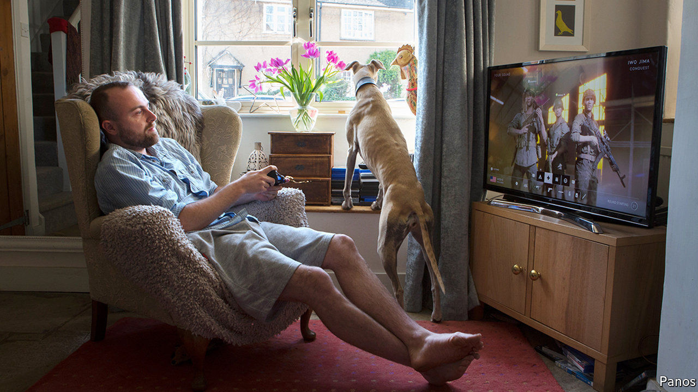

THERE IS NOTHING quite like a captive audience. When Sony, a Japanese electronics giant, reported its latest set of quarterly results on October 28th, the star performer was the firm’s video-gaming division, which makes the PlayStation line of consoles. Had it been a normal year, revenues would probably have been down, because Sony’s current model—the PlayStation 4—is coming to the end of its life.

But in a year marked by lockdowns and working from home, gaming revenue instead grew by 11.5% year-on-year (and operating profits by 61%) as housebound consumers reached for their controllers. Sony is not alone. Microsoft, its gaming arch-rival, released its own results the day before. Its Xbox One console is similarly superannuated, yet revenues jumped by 30%. The good times have been repeated across the industry (see chart).

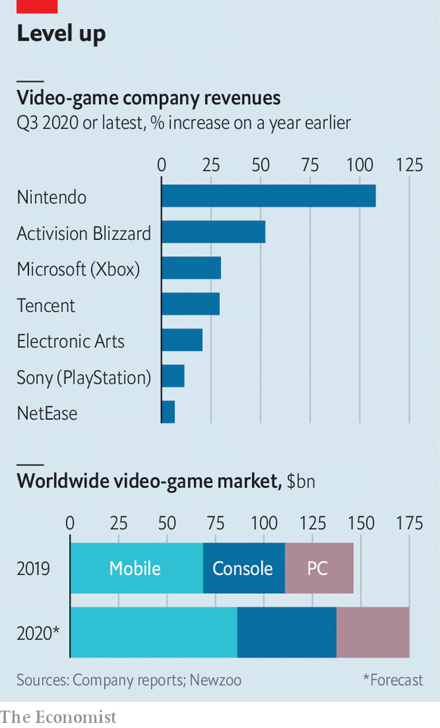

Most forecasters expected covid-19 to boost the video-gaming business. The pandemic has given a filip to other forms of indoor entertainment, from board games to video-streaming to books. But the scale of the surge has caught industry-watchers by surprise. Tony Habschmidt, head of consulting at Newzoo, a games-industry analytics firm, says that when the pandemic began, his company predicted a boost of around $2bn to industry revenues on top of its existing forecasts. The latest figures, he says, suggest the real figure has been nearer $17bn. Newzoo now reckons industry revenues will reach $175bn this year, a rise of 20%. Even for an industry that had been growing by 9% annually, 2020 has been a barnstorming year.

It is not over yet. Amid a blitz of adverts, trailers and PR, Sony and Microsoft are gearing up to replace their existing consoles with new, more powerful machines. On November 10th Microsoft will release the Xbox Series X. Sony will respond two days later with the PlayStation 5. With a locked-down Christmas looming in many parts of the world, demand for both will be high. If industry rumours about pre-orders are correct, some consumers may have to go without.

At the same time, both firms will be keeping their eyes on several big new competitors. Amazon, Facebook and Google all think the time is right to try their luck in the gaming business. Over the past decade streaming has revolutionised music, television and films. The tech giants think cloud computing, fast broadband and 5G mobile networks mean the time is right to try the same thing with video games.

Start with the consoles themselves. Sony won the previous round of the console wars, selling over 100m PlayStation 4s and more than 1bn games. Microsoft does not provide official figures, but most analysts reckon that sales of the Xbox One (confusingly, the Xbox’s third iteration) were only half as high. Most expect Sony to outsell its rival this time, too. Piers Harding-Rolls at Ampere Analysis, a media-analysis firm, thinks 5m new PlayStations will be sold in the run-up to Christmas, compared with 3.9m Xboxes.

One reason is brand loyalty. “There’s very much a cult following when it comes to consoles,” says Michael Pachter, an analyst at Wedbush Securities. “PlayStation owners will mostly buy another PlayStation, and Xbox owners will get a new Xbox.” Another is Sony’s strategy, which focuses on existing gamers. Analysts think the firm is selling the machines at a loss—a common tactic for console-makers. Sony’s marketing has emphasised exclusive, big-budget games that are aimed at committed gamers and are not available elsewhere.

Sony’s executives will be hoping the analysts’ projections are right, because the PlayStation 5 is vital to its future. The firm’s gaming division is now its largest. Its recent success has cushioned the impact of problems elsewhere, such as in its imaging division, which has suffered from the troubles of Huawei, a Chinese tech giant that is one of its big customers (see [Schumpeter](https://www.economist.com/node/21795190)).

Microsoft, for its part, professes itself unworried about precisely how many new Xboxes it sells. It is just as focused on expanding the market as on trying to win over existing gamers. More than 3bn people own smartphones, and mobile games—smaller and more casual than console titles—are the most popular sort of app. Phil Spencer, who runs Microsoft’s Xbox division, estimates that only around 200m households worldwide are willing—or able—to splash out on an expensive piece of gaming hardware like a console.

Microsoft is therefore trying to lower the barriers to adoption. It will offer hire-purchase deals for its new Xbox. It is heavily promoting “Game Pass”, a subscription service that offers access to an online library of hundreds of games for up to $15 per month (a quarter of the upfront cost of a typical high-end console game).

## Cloud strife

The centrepiece of this strategy is a service called xCloud, which aims to remove the need to own a dedicated console at all, by running games in distant data-centres and streaming the results to smartphones, internet-connected TVs, or any screen that can be hooked up to the internet and a game controller.

In rich countries, streaming could let gamers play anywhere, not just at home—doing for games what Spotify and Netflix have done for music and films. In poorer countries, where smartphones are common and data plans are cheap, it could bring console gaming within the reach of millions of new players. “There are 1.2bn people in Africa and the average age is 20,” says Mr Spencer. “Many of them follow our games—they know the characters, the stories, even the release dates. They just lack devices on which to play them”.

Game-streaming is not a new idea. Previous attempts have been plagued by technical problems (streaming a game, which must react instantly to a player’s actions, is far harder than streaming a film or song to a passive viewer). And Microsoft is not the only firm that thinks the time is now ripe. Sony offers its own version, called “PSNow” (though it is limited to older games), as does Nvidia, a gaming-focused chipmaker, and several other firms. Other tech giants with little experience of video-gaming are also piling in. Google launched “Stadia” in 2019. Amazon announced its “Luna” service in September. On October 26th Facebook threw its hat into the ring with its own “Facebook Gaming” service.

Game-streaming sounds attractive on paper, but few expect it to transform the industry overnight. “I would describe the market as embryonic,” says Mr Harding-Rolls. Still, there is huge interest: Ampere tracks 60 firms whose offerings are either in public testing or available for use. And if streaming does take off, it is likely to prove just as disruptive as it has been in other media. “If you can make streaming work, you could grow the gaming market tenfold,” reckons Mr Pachter. The video-streaming wars have seen deep-pocketed tech giants and media companies spend billions on content. Similar jockeying may be under way in games. On September 21st Microsoft bought ZeniMax Media, which makes the best-selling “Fallout” and “Elder Scrolls” series of games, for $7.5bn.

It is too early to pick out winners and losers, but most analysts think Microsoft is well positioned. Its Azure cloud business is the world’s second-biggest, giving it a reach that many competitors lack. Last year Sony, which lacks cloud infrastructure of its own, said it was exploring the option of using Azure to power its own gaming services. And unlike Google or Amazon, its only real cloud rivals, Microsoft has decades of experience in the games business.

But its competitors have strong points, too. Amazon has 150m subscribers to its Prime service, which already includes streamed video and music. Google could leverage YouTube, where gaming videos are popular. Facebook plans to pitch its service at people who already play simpler, browser-based games on its existing platform, which boasts over 2bn users a month. And Sony’s success with the PlayStation has proved that size is not everything. There is all to play for. ■

This article was downloaded by calibre from <https://www.economist.com/business/2020/11/05/playstation-5-v-xbox-series-x>

|  |  |  |  |
| --- | --- | --- | --- |
| Previous | Articles | Sections | Next |

|  |  |  |  |
| --- | --- | --- | --- |
| Previous | Articles | Sections | Next |

#### Bartleby

# Questionable behaviour

Companies are relying more and more on psychometric tests

Nov 5th 2020 |

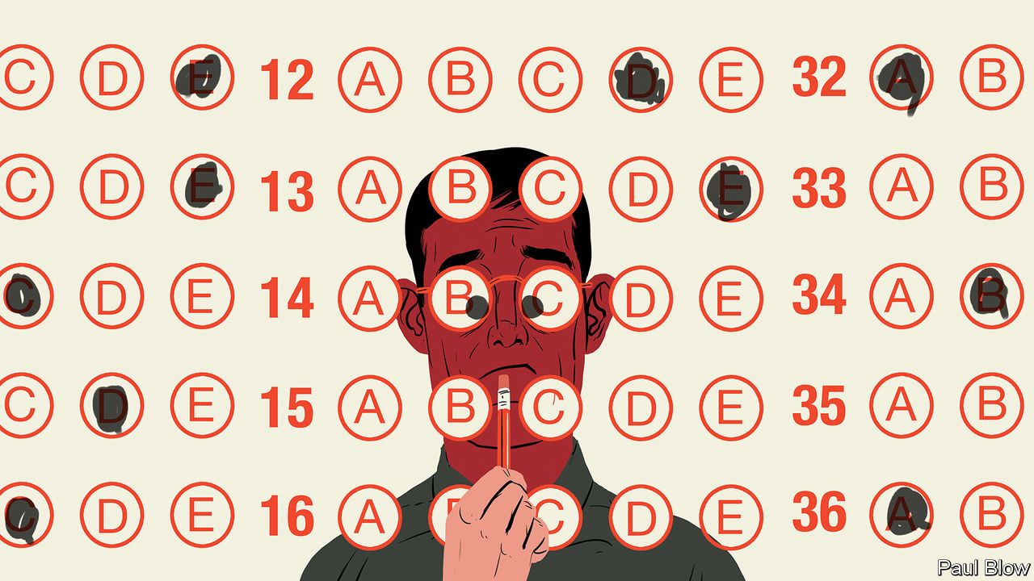

HERE IS A test. Assign a score of 1 to 5, where 1 is “strongly agree” and 5 is “strongly disagree”, to the following statement: “I really care about my work.” If you have answered that kind of question before, you have probably applied for a job at a large company. Psychometric tests, as they are called, have become increasingly popular.

Eager job-seekers may think the answers to these questions are glaringly obvious. For any statement, give a response that creates a portrait of a diligent, collaborative worker. Of course, applicants care about their work, love collaborating with other people and pay careful attention to detail. But the people who set the tests know that candidates will respond this way. So questions are rephrased in many different ways to check that applicants are consistent and make it difficult for them to remember what they have already said.

Aptitude tests are not a new idea. Intelligence tests have been around for a century and were popular with government departments. Charles Johnson, who has been involved in psychometric testing for 40 years and was responsible for constructing the tests used to recruit British civil servants, says the second world war had a big impact. The British were impressed with the efficiency of German army officers and learned they had been selected with the help of intelligence tests. This led the British to create the War Office Selection Board. Alongside verbal and non-verbal reasoning, it challenged candidates with word-association exercises and being made to lead group discussions.

For high-skilled jobs, these tests are useful. However, Mr Johnson says there is a risk with using such tests to recruit workers for low-skilled jobs. If you select people who pass sophisticated cognitive tests, they will learn the job quickly but will then get bored and leave.

Psychometric tests became more popular from the 1970s onwards and are now seen as a useful way of sorting through the many candidates who apply for the jobs offered by big companies. “It is a laborious task to sort through thousands of written applications,” says Julia Knight, another occupational psychologist. “As well as being time consuming, it is not very effective and subject to bias.”

Questions in such tests may ask a candidate to describe their behaviour in hypothetical situations: dealing with an angry customer, for example. The suggested answers may all be plausible (apologise profusely, fetch a manager and so on), so there is no obviously “right” answer. Nevertheless the aim is to build a profile of the candidate to see if they have the right character traits for the job.

People are generally judged on the basis of five characteristics with the acronym OCEAN for openness, conscientiousness, extroversion (or introversion), agreeableness and neuroticism. The ideal characteristics can be surprising: it turns out that introverts are the best train-drivers as they seem to pay more attention to details such as safety procedures and can cope with spending long periods of their time on their own.

Extroverts do not make the best call-centre employees because they can spend so much time chatting to customers that they don’t get much done. The most useful trait among such workers, according to Steve Fletcher, an occupational psychologist, is assertiveness; this enables them to deal with more calls.

These tests are used to assess senior managers, as well as new hires. Along with OCEAN characteristics, testers are also looking for what is known as the “dark triad”—psychopathy, narcissism and Machiavellianism. Factors that can make people successful as junior managers may limit their ascent. Candidates who are good with detail turn out to be obsessive micromanagers; people who flourish in sales may have an excessive need to be the centre of attention.

A large majority of big companies use these tests but they are hardly perfect. Paul Flowers, the former head of Co-op Bank, a British lender, passed his psychometric tests with flying colours, according to testimony at a parliamentary inquiry. But he was later ousted in a sex-and-drugs scandal that led him to be dubbed “the crystal Methodist”. Mr Johnson says the tests can be useful, but only in conjunction with aptitude tests and structured interviews.

That probably won’t save job candidates from having to take these tests in future, because they winnow down the list. But at least they beat the old-fashioned method: drop half the applications in the bin and pick from the other half.

This article was downloaded by calibre from <https://www.economist.com/business/2020/11/05/questionable-behaviour>

|  |  |  |  |
| --- | --- | --- | --- |
| Previous | Articles | Sections | Next |

|  |  |  |  |
| --- | --- | --- | --- |
| Previous | Articles | Sections | Next |

#### Schumpeter

# Which Japanese mogul will leave the biggest legacy

Is it Mickey or Masa

Nov 5th 2020 |

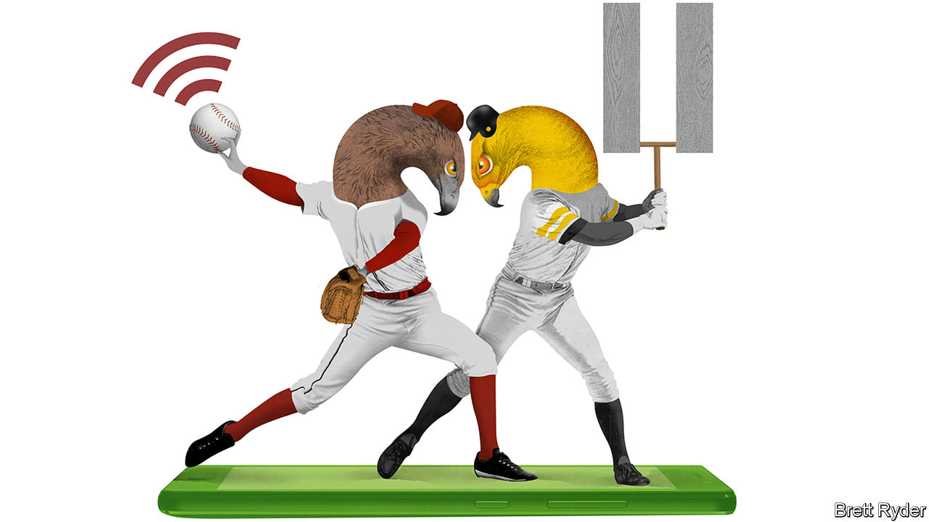

IN THE 1990S, when a youthful Son Masayoshi, a Japanese entrepreneur, was pursuing acquisitions in his home country, he sought advice from a banker eight years his junior called Mikitani Hiroshi. They shared a lot in common: both had studied in America (Mr Son at the University of California, Berkeley, Mr Mikitani at Harvard Business School); they had a common interest in the internet; and they were both baseball mad.

In the decades since, both men have blazed past a stifling corporate hierarchy to become two of Japan’s leading tech billionaires. Mr Mikitani, who says in an interview that he did not even know the word “entrepreneur” when he enrolled at Harvard, pioneered e-commerce in Japan via Rakuten, which is now a sprawling tech conglomerate worth $14bn. Mr Son’s SoftBank, after spectacular investments in early internet stocks, muscled into Japan’s telecoms industry. They have both invested heavily in Silicon Valley. They also each own baseball teams named after birds of prey; the SoftBank Hawks and the Rakuten Golden Eagles.

Now it is rivalry, not a shared past, that better defines their relationship. In Japan SoftBank and Rakuten are elbowing their way onto each other’s turf. Their respective investments overseas in Uber and Lyft, two ride-hailing firms, put them at odds. Even the Hawks and the Eagles are bitter enemies. Until recently Masa, as Mr Son is known, appeared to have the advantage. He has bigger money bags than Mr Mikitani, and a higher profile thanks to the audacity of his $100bn Vision Fund, which backed blitzscaling tech startups globally. Yet Mickey, as Mr Mikitani is known, has made a quieter bet on mobile communications that is almost as bold—though in a different way. If it pays off, it could start a revolution not just in Japan, but across the world, too.

Discussing it by Zoom from his home in Tokyo, a hoodie-wearing Mr Mikitani is keen to emphasise both the audacity of the bet and the difficulty of bringing it to fruition. Since 2018 he has committed $8bn to build a fourth- and fifth-generation (5G) mobile network from scratch in Japan, a country where a triumvirate of industry heavyweights, including SoftBank, dominate. Instead of replicating the huge investments they have made in hardware, he used low-cost base stations, cloud-based architecture and software to create what Rakuten calls the world’s first fully commercial virtualised network, adaptable for a new modular technology called OpenRAN. In essence, what Mr Mikitani has sought to show is that an internet firm like his, with a geeky software-engineering culture, can provide a high-quality, low-cost alternative to the hardware-obsessed telecoms giants, using OpenRAN at the core of its 5G architecture. It’s a work in progress but it has been blessed with geopolitical tailwinds. Concerns about the influence of the Chinese government over Huawei, the world’s biggest 5G equipment supplier, have caused telephone companies, as well as governments, to embark on a frantic hunt for alternatives. OpenRAN is attracting a lot of attention. All eyes are on Rakuten to see whether its network functions.

Mr Mikitani and his lieutenants are upbeat. Though he has faced naysayers all the way—“Good luck, Mickey, you’re going to fail,” he says his CEO friends all told him—the company has brought forward to 2021 the year when it expects to have coverage over almost all of Japan. It had been 2026. Low costs have lured more than 1m customers, even though coverage remains patchy. Globally, Tareq Amin, Rakuten’s mobile-technology guru, has become one of the most prominent OpenRAN evangelists. In September he struck a deal with Madrid-based Telefónica, a big telecoms group, to develop the technology further. Mr Mikitani says one of the blessings of the OpenRAN model is that, rather than replacing antiquated kit with each new generation of mobile technology, it can be updated with software. He likens it to Tesla’s ability to use software to upgrade its electric cars.

For all that, Mr Son is hovering menacingly in the background. Well before Mr Mikitani started to encroach on his telecoms territory, he used SoftBank’s big stake in Yahoo Japan to challenge Rakuten in e-commerce. Last year SoftBank upped the stakes by orchestrating a merger between Yahoo Japan (now known as Z Holdings) and Line, a messaging app, to create Japan’s largest online services company. Kirk Boodry of Redex Research, an Asian equity-research firm, says Rakuten’s e-commerce operating margins have fallen by half recently as it spends money to defend itself against both Yahoo and Amazon in e-commerce. That may eventually constrain Rakuten’s telecoms ambitions. As he puts it: “They don’t have enough money to be as disruptive as they’d like to be.”

Mr Mikitani is gracious about his former client. He credits Mr Son with having a great eye for investments and tactfully does not mention the Vision Fund’s debacle with WeWork, an office-rental firm that faced near-collapse last year. He insists SoftBank and Yahoo “are my rivals, not my enemies”. He goes on to express the irony that whereas once he was Mr Son’s investment banker, now, of the two, he is more of the operator.

## Home RAN?

That raises the question of both men’s legacy. Mr Son may have broken the mould for investing in snazzy startups in a way that put him on the cover of global magazines (including this one). Although he has a strong claim to be one of Japan’s great entrepreneurs he has never pioneered a new technology. Mr Mikitani has never achieved such global stature. He is arguably more famous outside Japan for making English the lingua franca in his company than for Rakuten itself. Yet if his 5G dreams come true, Mr Mikitani will have helped engineer a solution not only to a global technological problem but a pressing geopolitical one, too. As far as the tech world is concerned, that would be a more far-reaching achievement. And if Masa resents that, he can always get his talons out on the baseball field. ■

This article was downloaded by calibre from <https://www.economist.com/business/2020/11/05/which-japanese-mogul-will-leave-the-biggest-legacy>

|  |  |  |  |
| --- | --- | --- | --- |
| Previous | Articles | Sections | Next |

|  |  |  |
| --- | --- | --- |
| Business | Sections | Science & ... |

Finance & economics

Treasuries: The bonds that bind

.

Buttonwood: Our currency, your problem

.

Regulators v Ant Group: Ant agonises

.

The world economy: Winter is here

.

Lebanon’s financial mess: The final unravelling

.

Free exchange: Turning inward

.

|  |  |  |
| --- | --- | --- |
| Business | Sections | Science & ... |

|  |  |  |  |
| --- | --- | --- | --- |
|  | Articles | Sections | Next |

#### The bonds that bind

# Why the bond market might keep America’s next president awake at night

Over the past year or so, the world’s most important asset market has malfunctioned twice

Nov 4th 2020 | NEW YORK

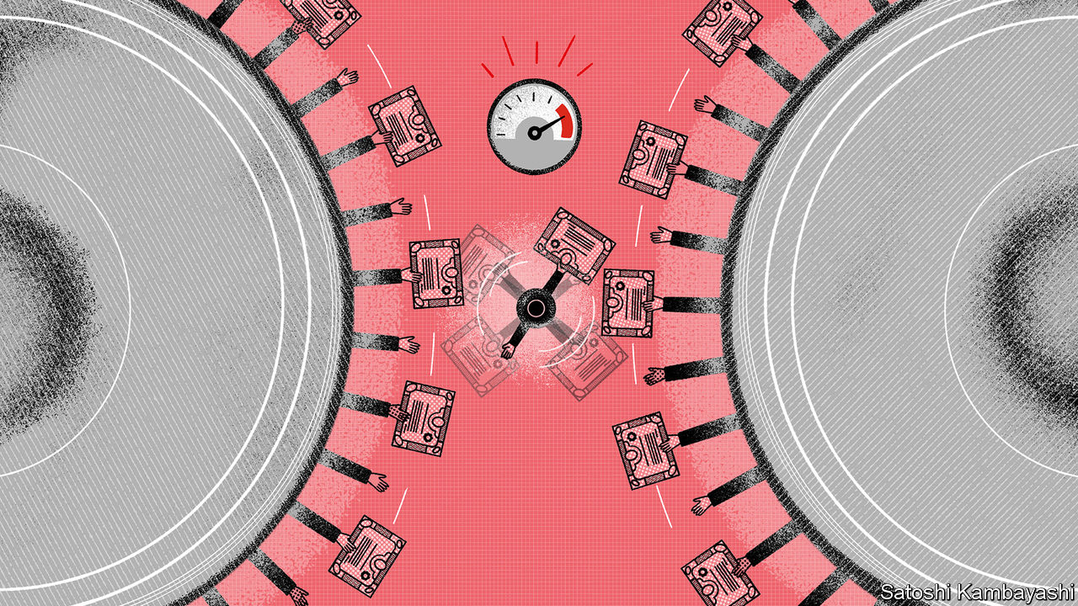

THE TREASURY market has long been able to strike fear into the hearts of the powerful. Frustrated by worries in the 1990s that bond yields would spike if Bill Clinton, then America’s president, pushed through economic stimulus, James Carville, his adviser, joked that he wanted to be reincarnated as the bond market, because “you can intimidate everybody”.

In the quarter-century since then, Treasuries have only become more pivotal to the world’s financial system. The stock of tradable bonds amounts to $20.5trn, and is expected to approach 100% of America’s GDP this year, roughly double the share in the 1990s (see chart). The dollar’s dominance means that everyone holds them, from American banks and European pension schemes to Arab sovereign-wealth funds and Asian exporters. The yield on Treasuries is known as the “risk-free” interest rate, and underpins the value of every other asset, from stocks to mortgages. In times of stress investors sell racier assets and pile into Treasuries.

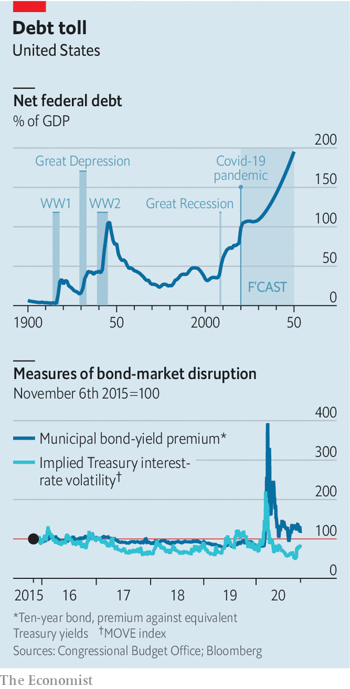

As The Economist went to press the outcome of America’s presidential election was still unknown, but the likelihood of a Biden presidency and a Republican-controlled Senate was rising. The yield on ten-year Treasuries fell by 0.12 percentage points to 0.78% on November 4th, perhaps on expectations that government spending will be stingier than if a blue Democratic wave had swept over Congress. Still, the next president may find himself worrying about the bond market—not because of the vigilantes that annoyed Mr Carville, but because of the risk of a snarl-up in the bond market’s plumbing, just as the scale of government borrowing rises sharply.

On October 14th Randal Quarles, the Federal Reserve’s regulatory boss, said that the Treasury market’s expansion over the past decade “may have outpaced the ability of the private-market infrastructure to kind of support stress of any sort”. His comments were prompted by the fear of a repeat of the extreme stresses in March and April, as the economic threat of covid-19 became clear. Usually a haven, the Treasury market convulsed. The bid-ask spread—the gap between the price at which you can buy a bond and that at which you can sell—was 12 times its typical level. The spread between “on-the-run” bonds, which are recently issued and tend to be most liquid, and older “off-the-run” Treasuries widened. Investors rushed to dump their holdings. Municipal-bond yields, which tend to trade at 60-90% of Treasury yields, spiked above 350%. The chaos spread to corporate-debt markets and panicked equity investors, forcing the Fed to act.

To understand why the Treasury market broke down, consider how the burdens on the system have grown. The debt stock has risen from $5trn in 2007, owing to stimulus after the financial crisis, deficits under Donald Trump, and stimulus this year. At the same time, “the provision of credit to households and businesses has become much more market-based and less bank-based,” Nellie Liang of the Brookings Institution, a think-tank, said at an event held by the New York Fed in September. Non-bank firms facing redemptions in a crisis rely on selling Treasuries to meet demand, placing further strain on the system.

As the demands upon them grew, though, the pipes through which Treasury trades are intermediated began to shrink. Trading depends on so-called “primary dealers”—a handful of firms allowed to buy bonds directly from the American government. Access to issuance lets these dealers—largely housed inside big banks, like JPMorgan Chase or Goldman Sachs—also dominate the intermediation of most Treasury trading. But their ability to make markets has been curtailed by tighter regulations after the financial crisis, such as the introduction of the supplemental leverage ratio, which measures the total size of bank assets relative to the amount of capital they hold. The rule is “not very friendly to low-risk activities, which include buying Treasuries,” says Pat Parkinson of the Bank Policy Institute, a lobby group.

In the spring the Fed eased pressures by buying Treasuries from market participants struggling to sell them to intermediaries. To encourage dealer activity it also allowed banks to exclude reserves held with the Fed and Treasuries from their leverage ratios. That marked the Fed’s second intervention in a year. In September 2019 it eased the pressure on dealers after repo rates—the price paid to swap a Treasury overnight for cash, a key funding market for Treasuries—spiked to over 10%.

Such strains may become more apparent over time. Whatever the scale of stimulus enacted next year, the bond market will swell further. The Congressional Budget Office expects federal debt to be worth over $120trn in 2050, or 195% of GDP. The result is that “in ten or 15 years only half as big a shock as covid-19...would cause the same degree of Treasury-market dysfunction,” noted Darrell Duffie of Stanford University, at the Fed’s conference. “And after that, yet smaller and smaller shocks would be enough to choke dealer balance-sheets with demands for liquidity.”

To ward off such a scenario, academics and market participants are considering how to revamp the system. The main principle involves expanding intermediation capacity. That could be done in many ways. Restrictions that curtail intermediation could be loosened; or the roster of primary dealers could be expanded, to include more banks and non-bank institutions.

Other solutions are more radical. Instead of trading through brokers, as they do today, market participants could trade directly with each other. At present counterparty risk deters direct trades; a central clearing-house—a solution proposed by Mr Duffie—could change that. With such a set-up in place, the market might not have seized up earlier in the year. “We were actually in a position to be a liquidity provider,” Sarah Devereux of Vanguard, a giant asset manager, said in September. “It was hard to sell bonds, but it was also difficult to buy bonds, for example, off-the-run Treasuries, when they got to very attractive levels.”

The Fed could also make some of its interventions permanent. William Dudley, a former Fed official, favours a “standing repo” facility, which would allow holders of Treasuries to swap them for cash at any time, reducing the likelihood of a panic. Whatever the solution, the bond market’s importance is such that it would be welcomed not only by America’s lawmakers, but by the world’s investors too. ■

This article was downloaded by calibre from <https://www.economist.com/finance-and-economics/2020/11/04/why-the-bond-market-might-keep-americas-next-president-awake-at-night>

|  |  |  |  |
| --- | --- | --- | --- |
|  | Articles | Sections | Next |

|  |  |  |  |
| --- | --- | --- | --- |
| Previous | Articles | Sections | Next |

#### Buttonwood

# Why dollar assets are still riding high after America’s election

And why that matters for everywhere else

Nov 7th 2020 |

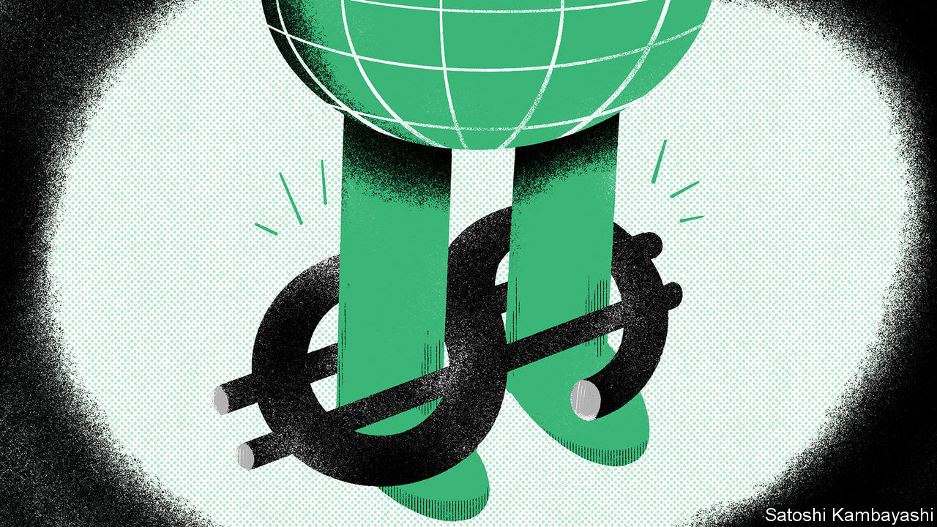

CAN YOU identify what or whom the following describes: is widely disliked around the world; might have been ditched by some supporters earlier had convincing alternatives existed; has had a difficult six months; and refuses to go quietly? Here’s another clue: this is not a column about politics. The answer is the dollar. It is the most unloved of major currencies, apart from all the others. And, oddly, it has been given a fillip by a messy election result at home.

Or perhaps that is not so odd. The dollar’s resilience has been one of the more monotonous motifs in financial markets in recent years. Dollar strength is twinned with another hardy theme—the growing heft of America’s companies, notably its tech giants, in global equity markets. The dollar matters for America, but it matters for everywhere else, too. A weaker dollar would trigger a period of catch-up by the rest of the world’s economies and asset markets. Such a prospect is seemingly delayed.

A reason for dollar resilience is growing doubts over fiscal stimulus in America. The election was supposed to be the start of a new era of fiscal largesse. Agreeing on any kind of policy now looks hard. If Joe Biden enters the Oval Office in January he is likely to face a divided Congress. But dollar strength is not solely down to politics. It is as much about the economic consequences of a resurgent coronavirus as it is about dashed hopes of a blue-wave election.

Begin with the blue wave that didn’t crest. Before the election, an idea had taken hold, fuelled by pollsters and election forecasters, that a clean sweep of the White House and both houses of Congress by the Democratic Party was highly likely. The upshot would be a weaker dollar.

In 2016 a similar prospect of fiscal easing drove the dollar up, not down. This needs some explaining. The difference is that four years ago, the Federal Reserve was expected to offset the stimulative effect of tax cuts by raising interest rates in order to contain inflation—thus supporting the dollar. But with the economy now weak, the Fed has committed itself to easy money. A fiscal-stimulus package would be an unimpeded spur to aggregate demand, leading to more imports, a wider trade deficit and a weaker dollar. And a weaker dollar would in turn help the rest of the world, partly because of its role as a borrowing currency beyond America’s shores. A lot of emerging-market companies and governments have dollar debts, so a weaker greenback acts as an indirect stimulus to global growth.

Instead, the dollar has perked up a bit. That is because the dollar is special in another way. Dollar assets, notably shares, are more prized when the outlook seems less certain. Holders of dollars cling on to them for longer, rather than swap them for other currencies. This goes for wealthy savers in emerging economies, or Chinese or South Korean exporters, say, who have earned dollars on sales.

It also goes for institutional investors at home who might have thought of cashing in some of their expensive-looking American tech stocks for a wager on cheap-looking cyclical stocks in Europe or Asia. The diminished prospect of fiscal stimulus is one reason why this “reflation trade” is less alluring. The resurgence of coronavirus infections is another. Much of Europe is now in soft lockdown. Its economy is losing steam. The appeal of cyclical stocks is similarly ebbing. Investors have instead piled back into tech firms, which benefit from the stay-at-home economy.

If there is one thing as hardy as the dollar itself, it is forecasts that its resilience cannot last. What might hasten the dollar’s fall now? Even without a friendly Senate to back his plans for increased federal spending, a President Biden would probably have a less bellicose and arbitrary trade policy than a re-elected President Trump. Good news on a vaccine might rekindle American investors’ appetite for buying cheap assets abroad.

Further out, the dollar still seems likely to weaken. Whatever the configuration of American politics, fiscal stimulus will not stay off the agenda for ever. Populism is hardly in retreat. Bond yields are incredibly low. In the circumstances it would be unwise to think that politicians will forgo the temptations of deficit-financed spending or tax cuts for too long. And for the past half-decade the greenback has drawn strength from the fact that short-term interest rates in America were higher than in western Europe and Japan. One of the few things that everyone can agree on is that this advantage is largely gone.

This article was downloaded by calibre from <https://www.economist.com/finance-and-economics/2020/11/07/why-dollar-assets-are-still-riding-high-after-americas-election>

|  |  |  |  |
| --- | --- | --- | --- |
| Previous | Articles | Sections | Next |

|  |  |  |  |
| --- | --- | --- | --- |
| Previous | Articles | Sections | Next |

#### Ant agonistes

# Regulators spoil Ant’s party less than 48 hours before it starts trading

The world’s biggest IPO is now the world’s biggest suspended IPO

Nov 3rd 2020 | HONG KONG AND SHANGHAI



JACK MA WAS in a triumphant mood shortly after Ant Group, his Chinese fintech firm, priced its initial public offering—set to be the world’s biggest ever, with almost $40bn worth of shares sold. Speaking at a summit in Shanghai on October 24th, he chided regulators for being too focused on preventing financial risks. Red tape, he said, only held up innovation. Ten days later his words came back to haunt him. Less than 48 hours before its stock was to begin trading in Hong Kong and Shanghai, Ant was forced by Chinese regulators to halt the flotation.

The group said in a regulatory notice to the Hong Kong exchange that the IPO, scheduled for November 5th, had been suspended because the company “may not meet listing qualifications or disclosure requirements”, after the regulator conducted an interview with Mr Ma and other executives. The filings also mentioned “recent changes in the fintech regulatory environment”, hinting that newly published rules may have got in the way. The sudden suspension also suggests that some powerful officials may be displeased with Mr Ma, a self-made man who, by the conservative standards of big business in China, has an outspoken streak.

Yet the turn of events is not just painful for Ant. It reflects poorly on China’s regulators. IPOs are rarely stopped at such a late stage. The deal was more than 800 times oversubscribed in Shanghai, and in Hong Kong last week the firm closed its book a day early. It was set to float in Shanghai on the STAR market, China’s answer to Nasdaq, designed to lure home Chinese tech groups that have listed abroad. Instead, the last-minute halt of Ant’s listing highlights the opacity of the Chinese political system and the risks that can trip up even its most successful companies.

It is also easily the most public, and most disruptive, of Ant’s run-ins with regulators. The company has consistently adjusted its business as the rules around it have shifted. The IPO debacle appears to be partly related to one such case. Back in 2018 officials placed caps on asset-backed securitisation, upending Ant’s model of selling its loans on to banks. So it pioneered a new approach: consumers and merchants borrowed through Alipay, its payments service, on their smartphones, but the money came from banks. Ant was simply the conduit, collecting a “technology-service fee”. This conduit business boomed, with credit growing to outstrip payments as Ant’s biggest source of revenue.

On November 2nd the Chinese central bank and banking regulator published new draft rules for online micro-lending, which looked almost perfectly tailored to undercut Ant. Online lenders will need to fund at least 30% of any loan they supply jointly with banks. That could force Ant to keep much more of the credit that it originates on its books; currently, 98% is held as assets by other firms, off Ant’s balance-sheet. Additional disclosure requirements could also make it much more cumbersome for banks to partner with the group. Officials at China’s banking regulator have already pressed commercial lenders to adhere to the new rules, according to Bloomberg, in effect making many of Ant’s transactions non-compliant.

Depending on how the rules are implemented—they will not be finalised until December—Ant’s capital-light model could end up looking much less sleek. “It will be valued more like a financial firm than a tech firm,” said a strategist with an Asian sovereign-wealth fund. Given Ant’s track record, it seems a fair bet that it will quickly adapt to the new rules, but its credit operations are likely to face much slower growth and lower profitability.

Investors had previously given Ant a forward price-to-earnings multiple of 40, in line with big global payments companies. Most Chinese banks, in contrast, trade on multiples of less than ten. Ant had been on track for a market capitalisation north of $300bn, higher than any bank in the world. Now it is likely to fall well short of that. Shares in Alibaba, a Chinese e-commerce giant that owns a third of Ant, tumbled by 8% after the suspension of the listing was announced.

Some investors may at least be grateful to regulators for introducing the new rules before the IPO, however late in the process, allowing them to reprice Ant before they buy its shares. But it is not as if the IPO came as a surprise or the company was an unknown entity; regulators could have acted far earlier. The possibility that they were motivated by a grudge against Mr Ma, and perhaps irritated by his recent speech, cannot be ruled out.

Ant had gone to great lengths to brand itself as a tech firm, not a bank. It describes its business as “techfin”—ie, putting technology first—not fintech. In the lead-up to its listing, it asked brokerages to assign tech analysts, not just banking analysts, to cover it. Ultimately, though, its focus has always been on China’s financial sector. That is the industry ripe for disruption, and where the money is. But as Ant and legions of investors have been reminded, that is also where the regulators lurk. ■

This article was downloaded by calibre from <https://www.economist.com/finance-and-economics/2020/11/03/regulators-spoil-ants-party-less-than-48-hours-before-it-starts-trading>

|  |  |  |  |
| --- | --- | --- | --- |
| Previous | Articles | Sections | Next |

|  |  |  |  |
| --- | --- | --- | --- |
| Previous | Articles | Sections | Next |

#### Winter is here

# How economically damaging will new lockdowns be?

Less severe than last time—but still very painful

Nov 7th 2020 |

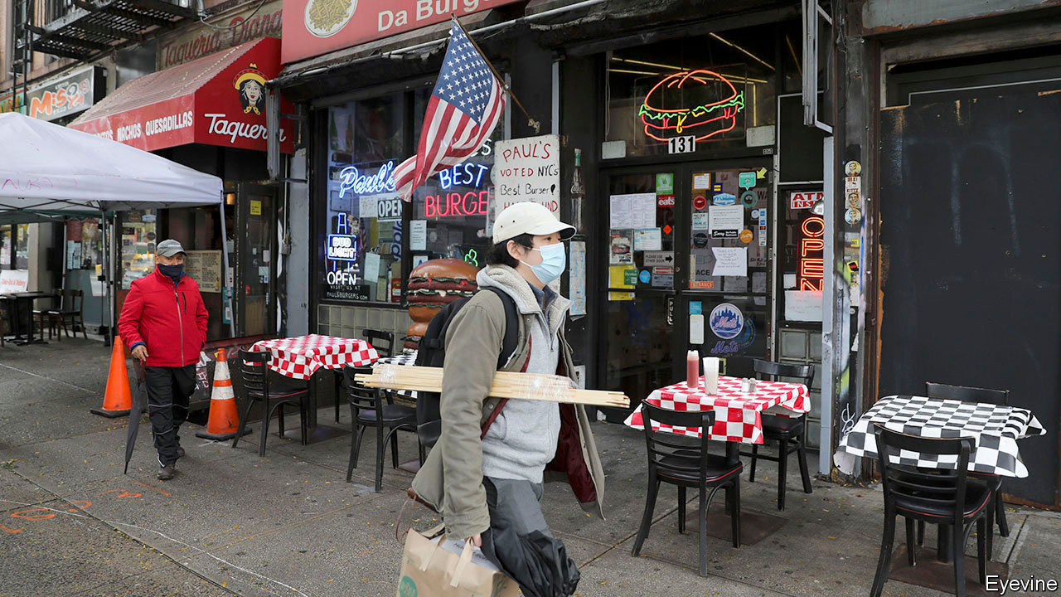

COUNTRIES NOTCHED up absurdly high growth rates in the third quarter. America’s GDP rose by 7.4%, compared with the second (an annualised rate of 33%). Output in the euro area grew by 12.7%. But there is little reason for cheer. The resurgence of covid-19, and lockdowns to contain the virus, seem likely to stop the economic recovery in its tracks. Such fears drove oil prices to a five-month low on November 2nd.

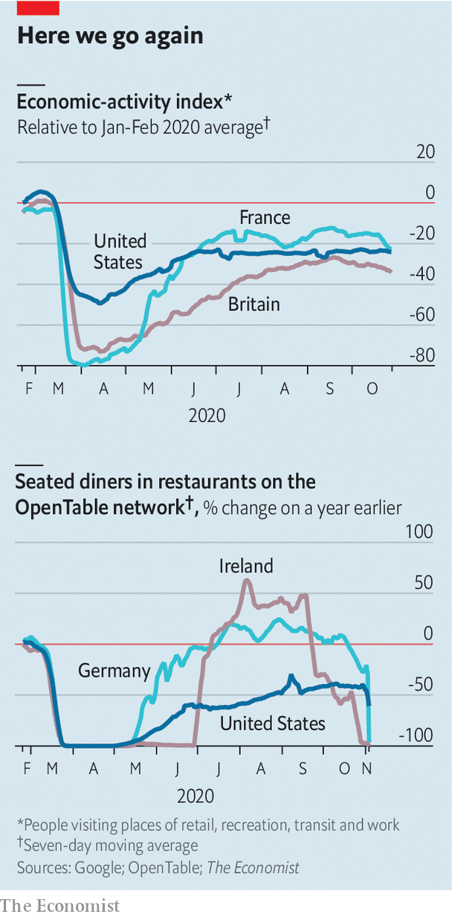

Using mobility data from Google, The Economist has constructed an index of real-time economic activity. This suggests that America’s recovery has come to a halt as recorded covid-19 cases have risen again. Europe, with a higher number of infections, is faring worse. Activity in Britain and France seems to have peaked in September and performance is set to slip given that Britain, France and Germany returned to varying degrees of lockdown in the past week or so.

It is too soon to see the full impact of these new lockdowns in our index. They should at least be less damaging than those earlier in the year: more manufacturing and construction firms, for instance, will stay open this time. Still, the experience of places that have already locked down suggests they will be painful. Ireland’s restaurants have more or less been closed since it locked down on October 21st. Wales locked down two days later; our index suggests activity in Cardiff, its capital city, has fallen by 20 percentage points. Based on past relationships, a similar decline in European countries would cause GDP to be 5% lower in the fourth quarter.

Editor’s note: Some of our covid-19 coverage is free for readers of The Economist Today, our daily [newsletter](https://my.economist.com/user#newsletter). For more stories and our pandemic tracker, see our [hub](https://www.economist.com/news/2020/03/11/the-economists-coverage-of-the-coronavirus)

This article was downloaded by calibre from <https://www.economist.com/finance-and-economics/2020/11/07/how-economically-damaging-will-new-lockdowns-be>

|  |  |  |  |
| --- | --- | --- | --- |
| Previous | Articles | Sections | Next |

|  |  |  |  |
| --- | --- | --- | --- |
| Previous | Articles | Sections | Next |

#### The final unravelling

# Deconstructing the Lebanese central bank’s Ponzi scheme

A web of mutual liabilities binds the central bank to the government and the banks

Nov 5th 2020 | BEIRUT

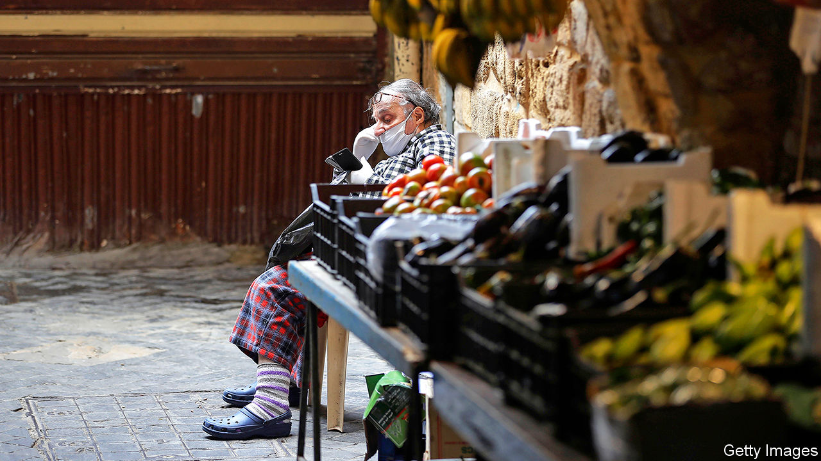

GEORGE AZZI no longer allows customers inside his pharmacy. Too many shops have been robbed. Instead he takes orders through a plexiglass window. But now, he jokes, there is not much left to steal. A currency crisis has left his shelves half-empty. A nearby petrol station has rationed supplies, limiting drivers to 20 litres. The supermarket around the corner has not stocked fresh chicken for weeks because poultry farmers will not sell at the government-mandated price.

Lebanon has spent the past year lurching from one crisis to the next: protests, covid-19, the catastrophic explosion at Beirut’s port on August 4th. In the background all along has been a grinding economic collapse. Pegged for decades at 1,500 to the dollar, the Lebanese pound recently traded on the black market as low as 9,000. Annual inflation hit 120% in August. GDP may shrink by a quarter this year.

Subsidies have kept a few essentials affordable: medicine, fuel, a morning manoucheh (flatbread). But the central bank, the Banque du Liban (BdL), has less than $2bn in usable foreign-currency reserves remaining. By the year’s end it will be unable to maintain its subsidy scheme, through which it grants importers of essential goods access to dollars at preferential rates. Some Lebanese have begun hoarding food and medicine in anticipation of far higher prices.

It will be the end of a monetary regime that once seemed inviolable. The peg helped restore confidence after a 15-year civil war, during which inflation peaked at 487% and the pound lost 80% of its value. But it was built on an unproductive economy and a complex series of transactions that, in recent years, came to resemble a Ponzi scheme. It has now collapsed. Yet Lebanon’s political and financial elites—sometimes one and the same—are unwilling to bear the costs of fixing it. Instead they have forced the economy into a brutal self-correction, with the heaviest consequences piled on ordinary citizens.

Most Arab states with fixed currencies defend their pegs with revenue from oil and gas exports. Lebanon has none. It has few goods exports at all: at their peak in 2012 they came to $4.4bn, against $21.1bn in imports. Other sources of hard currency, such as tourism and property, were insufficient to sustain a peg, with current-account deficits exceeding 25%, and fiscal deficits of over 10%, of GDP.

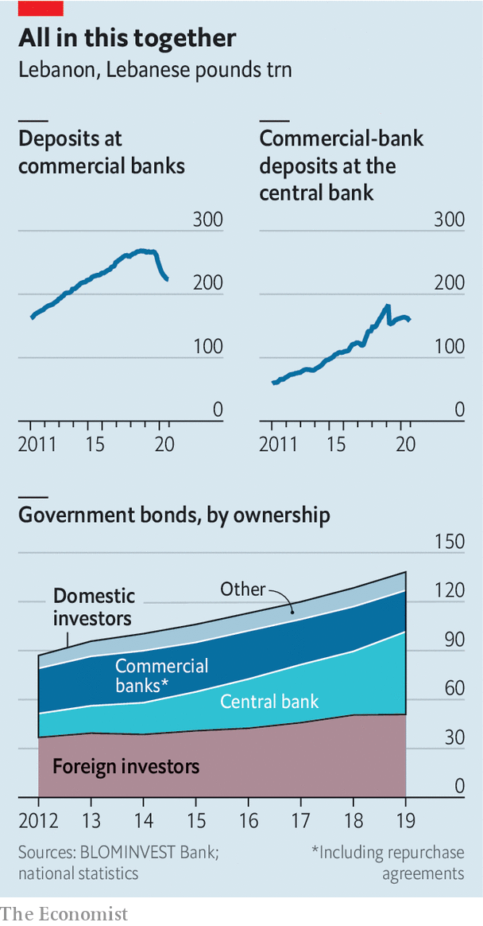

It did have one reliable source of dollars: a vibrant financial sector that, at its peak in 2018, held 269trn pounds of deposits, then worth $179bn—more than three times the country’s GDP. About two-thirds of deposits were in dollars. To funnel some of that into its coffers the BdL crafted a scheme it called “financial engineering”. Starting in 2016 it exchanged local-currency debt with the finance ministry for dollar-denominated bonds, which it sold to commercial banks with high rates of return. Banks could also borrow pounds against their dollar deposits at the BdL, then lend them back to it, with a spread of 11 percentage points on the transaction.

The longtime central-bank governor, Riad Salamé, defends the scheme as a short-term fix. In his telling the BdL did not create Lebanon’s deficits: those were the work of politicians who failed even to pass a budget between 2005 and 2017. True enough—but the scheme made those debts possible and tied everyone in a web of mutual liabilities. By 2018 the BdL was financing most of the fiscal deficit, and by 2019 most of Lebanon’s public debt (more than 80% of local-currency debt and 60% of foreign-currency bonds) was owned by banks and the BdL. The banks, in turn, deposited more than half their liquidity with the BdL. In its annual assessment of the Lebanese economy, the IMF reckoned that banks’ combined exposure to the BdL and the government amounted to 69% of their total assets in May 2019, more than eight times their Tier 1 capital, largely due to the rise in their deposits with the central bank.

Sustaining this house of cards required an ever larger supply of fresh dollars, which necessitated ever higher yields to lure depositors. Average interest rates on dollar deposits climbed from 3% in 2016 to almost 7% three years later. But after a decade of growth, bank deposits flattened off in late 2018, in part because low oil prices hurt the Gulf economies where many Lebanese work. Last year they began to decline. Short of cash, banks severely curtailed dollar withdrawals. Credit cards that once financed trips to Europe now carry spending limits of $50. In March the state defaulted when it failed to make a payment of $1.2bn on a hard-currency bond. The prime minister at the time, Hassan Diab, estimated an $83bn loss in the banking sector.

Most customers can withdraw their dollar savings only in local currency (Dan Azzi, a former executive at Standard Chartered, a bank, dubbed these “lollars”). Since April the BdL has allowed withdrawals at an above-market exchange rate, currently 3,900 pounds to the dollar. That is still up to 55% below the black-market rate—“a massive haircut on the Lebanese,” says Alain Bifani, who resigned in June after 20 years as the director-general of the finance ministry. Despite the haircut, people have rushed to withdraw deposits. Cash in circulation was up 274% in the year to August.

Mr Diab proposed shifting more of the losses on to banks, rather than entirely on their depositors. His cabinet approved a plan in April calling for a bail-in, wiping out shareholders and imposing a haircut on wealthy depositors. He also began talks with the IMF about a financial agreement worth up to $10bn. The fund was broadly supportive of his plan, but it was doomed by lobbying from banks. They have strong allies in parliament: most of Lebanon’s big banks are at least partly owned by politicians or their families. In meetings with the IMF, bankers would not even agree on the scale of Lebanon’s losses, insisting that Mr Diab’s numbers were exaggerated.

Mr Diab has since resigned as prime minister, though he remains caretaker. His designated successor, Saad Hariri, who is still struggling to cobble together a government, is unlikely to take up his ideas. He had been prime minister before, when the financial-engineering scheme was in full swing, and his family has a stake in BankMed, one of the country’s largest banks (his stepmother serves as vice-chair). Instead the association of banks has suggested selling $40bn in state assets to help clean up the mess. Critics argue this wildly overstates the value of Lebanon’s assets, among them an electric company that cannot provide 24-hour electricity and a telecoms monopoly that offers some of the world’s slowest internet speeds. Neither is likely to prompt a bidding war when a bankrupt state dumps them in a fire sale.

The BdL, once again, is left to pursue its policies, some of which seem to be attempts to keep the Ponzi scheme going. In August it told banks to boost their capital by 20% or “exit the market” in February next year. Depositors who have transferred at least $500,000 abroad since 2017 would be encouraged to repatriate 15% of that sum, and 30% for politically exposed persons. Banks may offer “incentives” to grease the wheels. What would incentivise customers to send money to an insolvent banking system was left unclear. Efforts to audit the central bank, meanwhile, have met with months of obstruction.

Even the good news is bad. The trade deficit fell by 51% in the first quarter, but mainly because few Lebanese can afford imported goods. Banks have fewer liabilities—customer deposits were down by 16% in August, compared with the previous year—but partly because depositors who need cash are taking haircuts to withdraw devalued pounds. Politicians and bankers still hope to avoid a reckoning, even as the economy crumbles around them. But they have nowhere left to turn. ■

This article was downloaded by calibre from <https://www.economist.com/finance-and-economics/2020/11/05/deconstructing-the-lebanese-central-banks-ponzi-scheme>

|  |  |  |  |
| --- | --- | --- | --- |
| Previous | Articles | Sections | Next |

|  |  |  |  |
| --- | --- | --- | --- |
| Previous | Articles | Sections | Next |

#### Free exchange

# Why is the idea of import substitution being revived?

Past experience suggests its revival is unlikely to meet with success

Nov 7th 2020 |

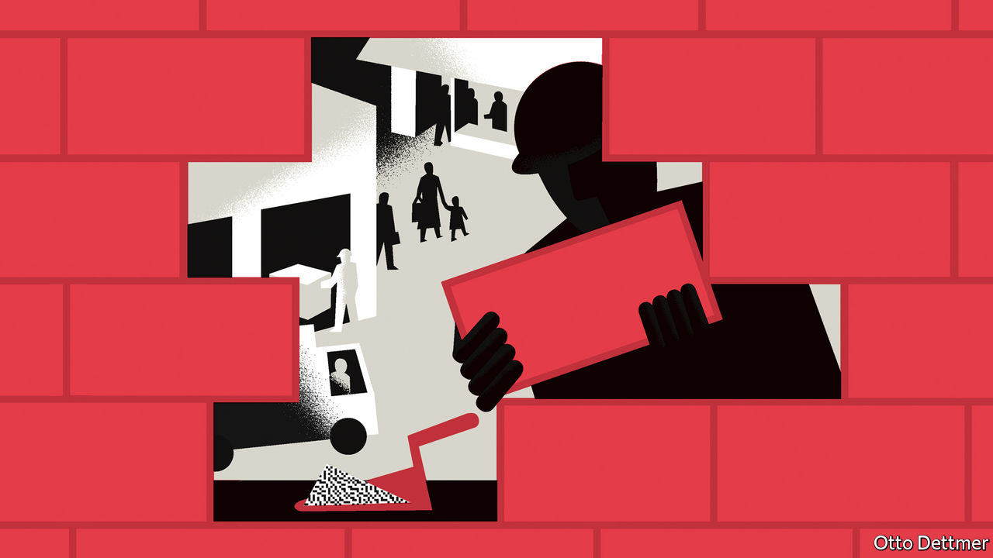

FOR THE past quarter-century, growth came so easily to the developing world that it can be hard to remember it was ever otherwise. Fuelled by globalisation, real GDP per person in emerging economies more than doubled from 1995 to 2019, in purchasing-power-parity terms. In advanced countries, by contrast, it grew by only 44%. The burst of growth consigned to the scrapheap decades’ worth of arguments about whether and how poor countries could catch up with rich ones. But explosive trade growth has ended, and the industrialised world is turning inward. Some governments are therefore dusting off old ideas. Among them is “import-substituting industrialisation” (ISI), a strategy that seeks to develop industrial capacity by shielding domestic producers from foreign competition. Many countries may feel they have little choice but to give the idea a try, but as the conditions that might allow it to succeed are generally absent in the poorest of economies, the revival seems doomed to fail.

Between 1990 and 2008, global trade as a share of GDP rose from 39% to 61%. This “hyperglobalisation”, as Martin Kessler and Arvind Subramanian of the Peterson Institute for International Economics dubbed it, facilitated rapid, broad-based economic expansion. After the late 1990s growth in incomes per head in nearly three-quarters of developing countries outpaced that in America, by an average of more than three percentage points a year. Global supply chains proliferated. Countries with a small industrial base, or none at all, could export manufactured goods by finding niches in production chains, following a shortcut to industrialisation.

The era of openness, however, is drawing to a close. The share of trade in world GDP fell after the global financial crisis; last year it was still below its 2008 peak. The level of world trade is forecast to fall by more than 9% this year. In America and Europe shortages of medical supplies and a souring relationship with China have rekindled interest in protecting domestic producers. But it is the biggest winners of hyperglobalisation, such as China and India, that are leading the way back to ISI. The share of foreign value-added in China’s exports fell by almost ten percentage points from 2005 to 2016; its government’s “Made in China 2025” campaign aims to make it self-sufficient in the production of many key goods. In India, Narendra Modi, the prime minister, unveiled a campaign for self-reliance as part of his pandemic-recovery package in May.

As poor-country politicians often point out when pressed by rich-world leaders to liberalise, many of today’s advanced economies practised elements of an ISI strategy as they industrialised. Alexander Hamilton, America’s first treasury secretary, used tariffs to protect domestic manufactures and reduce its dependence on Britain. In the 19th century European rivals worried that abundant British manufactures would stunt industrial development and leave them at a permanent military disadvantage. Governments erected tariff barriers and mobilised domestic capital, often squeezed out of the agricultural sector, towards state-supported industry. Russia and Japan followed western Europe in promoting domestic industry as a matter of national security.

Still, past experience also shows why the renewed interest in ISI may be misguided. Its intellectual heyday was in the 1950s, when economists like Raúl Prebisch and Gunnar Myrdal (the latter a Nobel prizewinner) argued against a laissez-faire approach to trade in developing economies. Their views were informed by the constraints of their era. Poor countries were desperately short of hard currency with which to obtain imports after the second world war. The replacement of some imports with domestic production was seen as a way to ration foreign exchange. More generally, advocates for ISI rejected the idea that specialisation and trade would leave every economy better off. Poor countries that stuck to their comparative advantage would remain exporters of primary products for ever, it was thought, never making the leap to industrialisation and the higher incomes it would bring.

The flaws of ISI rather quickly became apparent, though. Many governments used it to bestow favours upon domestic industries based on political self-interest rather than rational economic calculation. The enthusiasts among economists lost interest. Tariff barriers left some countries nearly closed off to trade. Meanwhile, import-substituting economies in Latin America and South Asia fell behind a handful of others that opted instead to promote exports made with abundant cheap labour. Export-orientation was not a sure route to development; success stories like South Korea and Taiwan were rare before the emerging-market acceleration of the 1990s. Nor was it a laissez-faire endeavour; the governments of the Asian Tigers meddled extensively in their economies, subsidising favoured industries and firms. But global competition placed relentless pressure on exporters, forcing them to become more efficient and encouraging the acquisition of technical know-how. Those in ISI economies, sheltered behind high tariffs, tended instead to be small, inefficient and complacent.

## A matter of great imports

What does all this mean for the revival in ISI today? In economies with large domestic markets and capable states, import substitution may well allow governments to achieve strategic goals without nudging firms into growth-sapping complacency. China probably fits the bill. In India, with its poorer and less integrated domestic market, the strategy is riskier.

In smaller economies with weak institutions, however, ISI-related policies are doomed to fail. The consumers, competition and technologies that developing economies can only find on global markets are a crucial prerequisite for their industrialisation. If the world’s biggest economies focus on their own strategic interests alone, they will deprive others of access to these precious resources—and the golden age of emerging-market growth will become an ever more faded memory. ■

This article was downloaded by calibre from <https://www.economist.com/finance-and-economics/2020/11/07/why-is-the-idea-of-import-substitution-being-revived>

|  |  |  |  |
| --- | --- | --- | --- |
| Previous | Articles | Sections | Next |

|  |  |  |
| --- | --- | --- |
| Finance & economics | Sections | Books & arts |

Science & technology

Superbatteries: What do you get when you cross a hare with a tortoise?

.

Covid-19: Teed up

.

Manipulating magnetism: Out of left field

.

Think again: Female stone-age hunters

.

|  |  |  |
| --- | --- | --- |
| Finance & economics | Sections | Books & arts |

|  |  |  |  |
| --- | --- | --- | --- |
|  | Articles | Sections | Next |

#### The tortoise and the hare

# How to hybridise batteries and supercapacitors

The offspring will give electric cars more range and power

Nov 7th 2020 |

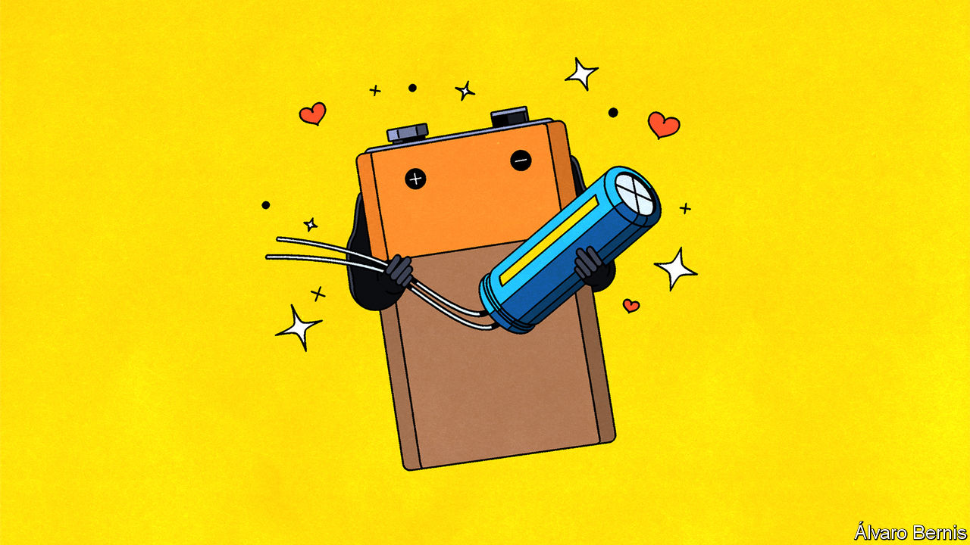

For more coverage of climate change, register for The Climate Issue, our fortnightly [newsletter](https://www.economist.com/theclimateissue/), or visit our [climate-change hub](https://www.economist.com/news/2020/04/24/the-economists-coverage-of-climate-change)

WHEN IT COMES to putting on pace, some electric vehicles rely not only on a battery to deliver the necessary wattage, but also on a second source of power called a supercapacitor. The battery serves as a marathon runner, providing a steady discharge over a long distance. The supercapacitor is a sprinter, unleashing a large amount of energy rapidly.

Speedy discharge is not the only advantage supercapacitors bring. They can be recharged more quickly, too. That makes them particularly useful in regenerative-braking systems, since they are able to absorb more of the electricity that is produced as a vehicle slows down. They can, though, store only a fraction of the amount of energy which a battery stuffs away. They therefore soon run out of puff. Because of this, engineers have been trying for a while to hybridise the best bits of a supercapacitor with the most useful features of a battery, to make a storage device with both speed and endurance. They are now having some success. Indeed, NAWATechnologies, near Aix-en-Provence, France, claims its supercapacitor-like battery could more than double the range of an electric car, allowing it to be driven for 1,000km on a single charge. This new device could also, NAWA says, be recharged to 80% of its capacity in as little as five minutes.

## The science bit

Capacitors and batteries work in different ways, so combining them is tricky. A capacitor stores energy physically, in the form of static electricity. This is easily and rapidly discharged, so capacitors have good power density (the rate at which they transfer energy, per unit of weight). A decent modern supercapacitor has a power density of several kilowatts per kilogram.

Batteries store their energy chemically, in the form of reactive substances in their two electrodes. These electrodes are held physically apart, but are connected by a material called an electrolyte through which charged atoms, known as ions, can pass from one to the other, in order to permit a reaction to proceed. That, though, happens only when the ion flow is balanced by a flow of electrons through an external circuit between the electrodes. This electron flow is the electric current which is the reason for the battery’s existence.

Controlled in this way, chemical reactions take time, so batteries have low power density. A lithium-ion (Li-ion) battery of the sort used in electric cars might thus muster only a tenth of a kilowatt per kilogram. But chemicals can hold a lot of energy, so batteries have high energy density (the amount of energy they can contain, again per unit weight). A Li-ion battery can store 200-300 watt-hours per kilogram (Wh/kg). Supercapacitors generally manage less than 10Wh/kg.

Capacitors, by contrast—whether basic or “super”—consist of a pair of electrically conductive plates placed either side of a separator material. When a voltage is applied to these plates, a positive charge builds up on the surface of one and a corresponding negative charge on the other. Connect the plates through an external circuit and, as with a battery, a current will then flow.

Making the leap from a basic capacitor to the super variety involves two things. One is to coat the plates with a porous material such as activated carbon, to increase the surface area available for energy storage. The other is to soak them in an electrolyte. This creates yet more storage area in the form of the electrolyte’s boundary with the plates. But adding an electrolyte to the mix also brings the possibility of adding a bit of battery-like electrochemistry at the same time. And Skeleton Technologies, an Estonian supercapacitor firm, plans to do just that.

## Plate tectonics

Skeleton has already developed plates composed of what it calls “curved” graphene, for a new range of straightforward supercapacitors. Ordinary graphene is a single layer of carbon atoms arranged in a hexagonal grid. It is highly conductive. Skeleton’s curved variety consists of crumpled sheets of the stuff. The consequent increase in surface area will, the firm hopes, push the energy density of its new products to 10-15Wh/kg—a good fraction of the theoretical maximum for a supercapacitor of 20-30Wh/kg.

That, though, is just the start of Skeleton’s plan. The firm’s engineers are now working with the Karlsruhe Institute of Technology, in Germany, to use curved graphene in what it calls its “SuperBattery”. Though this remains basically a supercapacitor, storing most of its charge electrostatically, the electrolyte will, says Sebastian Pohlmann, Skeleton’s head of innovation, also provide some chemical-energy storage. The company is keeping mum about the electrolyte it uses and the chemistry involved. “It is not comparable to the classic lithium-ion chemistry,” is all that Dr Pohlmann will say. But the overall consequence, he claims, will be something that is rechargeable within 15 seconds and has the ability to store 60Wh/kg. Skeleton aims to start producing this commercially by 2023.

Other groups, too, are working on ways to add chemical-energy storage to a supercapacitor. Researchers at Graz University of Technology in Austria, for example, have developed a version that has its electrical contacts coated with carbon which is pierced by tiny pores. One contact operates like a capacitor plate, the other like a battery electrode. Unlike Skeleton, the Graz group are open about their approach to electrolyte chemistry. They are using aqueous sodium iodide (ie, a solution of sodium ions and iodine ions). At the electrode, the iodide turn into elemental iodine, which crystallises within the pores during discharge. This process then reverses itself when the device is charging. The pores in the plate serve to accommodate sodium ions similarly.

According to a paper its inventors published recently in Nature Communications, the Graz cell’s performance exceeds that of a Li-ion battery. It is able, for example, to cope with up to 1m charge and discharge cycles, says Qamar Abbas, a member of the team. A Li-ion equivalent might be expected to manage a couple of thousand cycles.

Both Skeleton and the Graz group, then, are taking modified supercapacitor architecture and adding some bespoke electrochemistry. By contrast, although the offering from NAWATechnologies does indeed also employ modified supercapacitor plates as its electrodes, it uses tried and trusted Li-ion ingredients for the chemical donkey work.

Like Skeleton, NAWA already manufactures supercapacitors. The plates for these are created using a process which the firm calls VACNT (vertically aligned carbon nanotubes). This arranges those tubes in an array that resembles, in miniature, the bristles on a brush. Extreme miniature. A square centimetre contains about 100bn of them, all standing to attention. That greatly increases the surface area available to hold an electric charge.

To adapt VACNT plates to operate also as battery-like electrodes, NAWA’s engineers have thinned the nanotube forest to make room for coatings of the chemicals which batteries employ for their reactions, and also for the movement of lithium ions into and out of the spaces between the tubes. This freedom of movement, the company reckons, will boost the arrangement’s power density by a factor of ten.

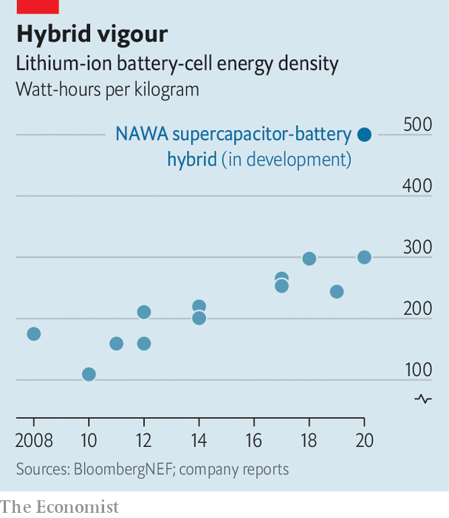

To start with, the nanotubes of the invention’s cathode (the positive electrode in a battery) will be coated with nickel, manganese and cobalt, a mixture already widely used to make such cathodes. Conventional anodes (the negative electrodes) are already carbon based, so using that element in the form of nanotubes is not a big departure. Other, less commercially developed battery chemistries should, though, also work with VACNT electrodes. These include lithium-sulphur and lithium-silicon, both of which have the potential to increase energy densities.

Silicon is particularly promising, but it swells as it absorbs ions, and that can rupture a battery. The thicket of nanotubes in a VACNT electrode should operate like a cage to keep the silicon in check, says Pascal Boulanger, a physicist who helped found NAWA in 2013. The new electrode material could also be used with solid rather than liquid electrolytes, to make “solid-state” batteries. These are powerful and robust, but are proving tricky to commercialise.

## Bristling to work

In tests with a number of unnamed battery companies, Dr Boulanger says VACNT electrodes achieved an energy density of 500Wh/kg in one battery and up to 1,400 watt-hours per litre in another. This is roughly double what a typical Li-ion battery can manage in terms of weight and volume respectively. “We have done that very easily,” he adds, “so we believe there is more room for improvement.”

One firm that NAWA does admit to working with is Saft, a large batterymaker owned by Total, a French oil giant keen to diversify from fossil fuels. Among Saft’s customers are several Formula 1 teams which use some electric power in their racing cars. Saft has also teamed up with PSA group, a big European carmaker, to manufacture batteries for electric vehicles.

Naturally, the new device’s success will depend on the cost of manufacturing it. NAWA is already constructing a mass-production line to make VACNT plates for its latest supercapacitors. The process used, which grows nanotubes on both sides of a roll of aluminium foil, would, says Ulrik Grape, NAWA’s chief executive, transfer easily to an existing battery-production line and might even reduce battery-making costs. He expects the first versions of the supercapacitor-battery hybrids to be in production by 2023.

Whether such hybrid storage will be able to compete with conventional Li-ions remains to be seen. Li-ion batteries have the advantage of incumbency, and batterymakers have invested billions of dollars in huge “gigafactories” to turn them out in droves. Yet, for all the hype surrounding electric cars, doubts about Li-ions linger in many customers’ minds. Range-anxiety, recharge rate and cost all combine to induce a hesitation to reach for the credit card. Mixing the spice of a supercapacitor with the stamina of a battery might overcome at least the first two of these objections, and thus, at last, truly launch an era of carefree electric motoring.■

This article was downloaded by calibre from <https://www.economist.com/science-and-technology/2020/11/07/how-to-hybridise-batteries-and-supercapacitors>

|  |  |  |  |
| --- | --- | --- | --- |
|  | Articles | Sections | Next |

|  |  |  |  |
| --- | --- | --- | --- |
| Previous | Articles | Sections | Next |

#### Teed up

# The T-cell immune response to covid lasts at least six months

That is good news

Nov 7th 2020 |

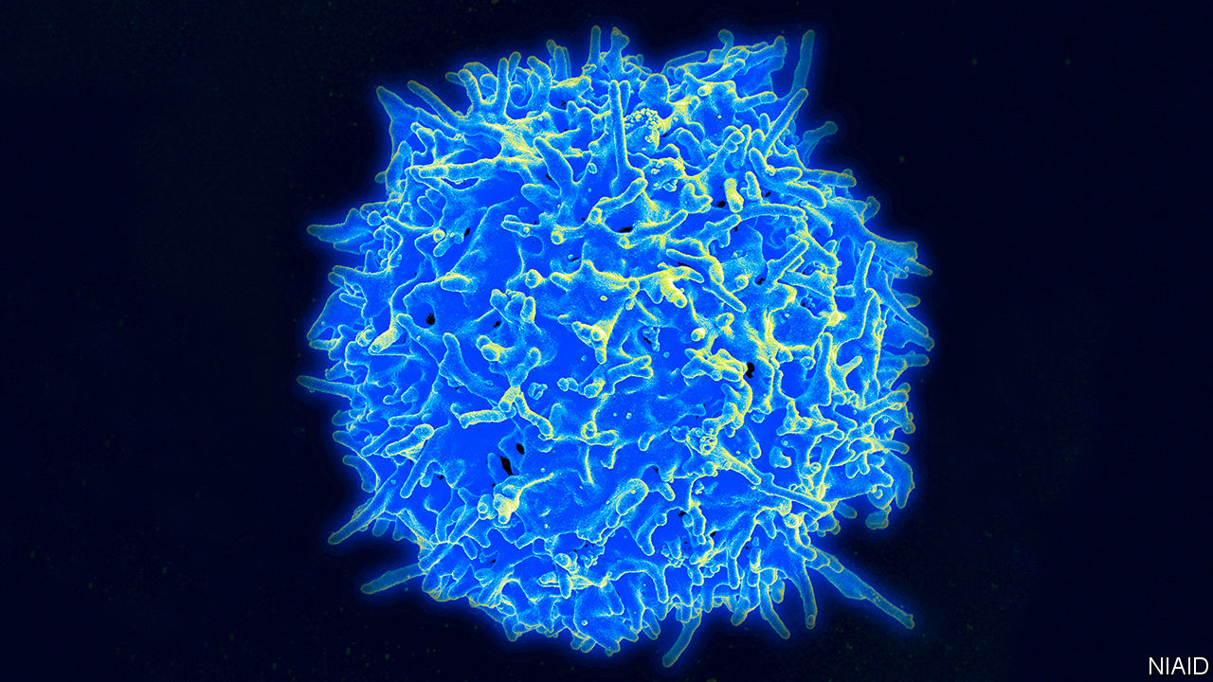

SINCE THE beginning of 2020 medical researchers have been in hot pursuit of covid-19. One of their most important goals is to understand the immune response to SARS-CoV-2, the virus that causes it. Finding out what a good response looks like, and how long it lasts, is crucial. The answers will reveal whether people who have recovered from the illness are protected from a second infection, and also indicate how difficult it will be to develop a vaccine.

There is much to worry about. Over the past year, many reports have shown rapidly waning levels of covid-specific antibodies after the initial burst caused by an infection. Antibodies are parts of the immune system that attack the virus directly. They are expected to be involved in any long-term protection against reinfection. If they disappear quickly, that looks, on the face of things, like bad news. Worriers also highlight the facts that immunity to types of coronavirus which cause the symptoms described as “a cold” is short-lived, and that there are already a number of proven cases of reinfection with SARS-CoV-2.

Yet antibodies tell only part of the story. Another important actor is the T-cell (pictured above). Rather than attacking viruses directly, T-cells attack infected cells, to stop the virus reproducing. The balance of importance of the antibody and T-cell arms of the immune system varies with the illness in question. And, as far as this particular infection is concerned, although almost all patients who catch SARS-CoV-2 are thought to create T-cells in response, an understanding of their significance has been elusive.

This is largely because T-cells are harder to measure than antibodies, and so are less often studied. Shamez Ladhani, a consultant epidemiologist with Public Health England, a government health-protection agency, who has worked on a new, long-term investigation of these cells, says it took nearly three weeks to count them in the 100 patients his study looked at. The effort was worthwhile, though, because it has shed new light on how long-lasting this form of immunity to SARS-CoV-2 might be.

## To a T?

Dr Ladhani’s project is part of a wider effort focused on health-care workers that Public Health England began in March. Over 2,000 people have donated blood samples every month since then. The 100 he and his colleagues have studied are a subset of these. In a paper just published as a preprint, but not yet peer reviewed, they say that six months after infection all of these patients, even those who had had only mild symptoms, or none at all, still had detectable levels of T-cells directed against the virus. Though their antibodies might have vanished, T-cells remained on the scene.

These findings bode well for the idea that T-cells offer long-term protection against reinfection, says Eleanor Riley, a professor of immunology at the University of Edinburgh. And Paul Moss, a haematologist at the University of Birmingham, says that his experience with other viruses leads him to expect the T-cell response Dr Ladhani has observed will last many more months than the six it has persisted for so far. In SARS-CoV-1, the name now given to the virus that caused the original SARS outbreak, in 2002-03, this form of cellular immunity was found to last in some people for over a decade. The long-lived nature of such T-cell responses fits in with the observation that, so far, reinfections seem rare.

Dr Moss says the implication of the new study is that those searching for vaccines against covid-19 should give priority to the production of T-cells. There is more good news here. Two of the leading candidates—one from a collaboration between Pfizer, an American drug company, and BioNTech, a German biotech firm, and the other from a second joint effort, between AstraZeneca, a British-Swedish drug company, and the Jenner Institute of Oxford University—do exactly this, while also stimulating the production of antibodies. Speaking in July, when the first results from the AstraZeneca-Oxford vaccine were published, Adrian Hill, the Jenner Institute’s boss, was keen to highlight the “excellent” T-cell response their vaccine created. “That is what this vaccine type does,” he explained. “That is what it is designed for.”

The significance of T-cells was obvious to Pfizer and BioNTech as well. In July they switched the focus of their efforts in response to data suggesting that an experimental vaccine they had hitherto regarded as secondary was eliciting strong T-cell responses. The coming weeks are likely to produce results concerning whether one or more of these putative vaccines actually provides protection against covid-19. That the two leading candidates provoke strong T-cell responses is grounds for optimism that vaccinology is on the right track.

As for the vanishing antibodies, there may be grounds for optimism here, too. The fact that levels of these proteins wane rapidly after infection, when they are no longer needed, should not be so surprising. It might not matter, either. The immune system could well be primed to make them in large numbers again, if and when it re-encounters SARS-CoV-2. It is also worth remembering that, even if researchers cannot detect antibodies, that does not mean they are not there at all.

As winter approaches in the northern hemisphere, the scientific fight against covid-19 feels more urgent than ever. But, while it is true that science has not yet jammed the pandemic exit doors open, there are now at least a few shafts of light emerging around the doorway. ■

Editor’s note: Some of our covid-19 coverage is free for readers of The Economist Today, our daily [newsletter](https://my.economist.com/user#newsletter). For more stories and our pandemic tracker, see our [hub](https://www.economist.com/news/2020/03/11/the-economists-coverage-of-the-coronavirus)

This article was downloaded by calibre from <https://www.economist.com/science-and-technology/2020/11/07/the-t-cell-immune-response-to-covid-lasts-at-least-six-months>

|  |  |  |  |
| --- | --- | --- | --- |
| Previous | Articles | Sections | Next |

|  |  |  |  |
| --- | --- | --- | --- |
| Previous | Articles | Sections | Next |

#### Manipulating magnetism

# Can you generate a magnetic field remotely?

You can. Which is good news for medical scanning and quantum computers

Nov 7th 2020 |

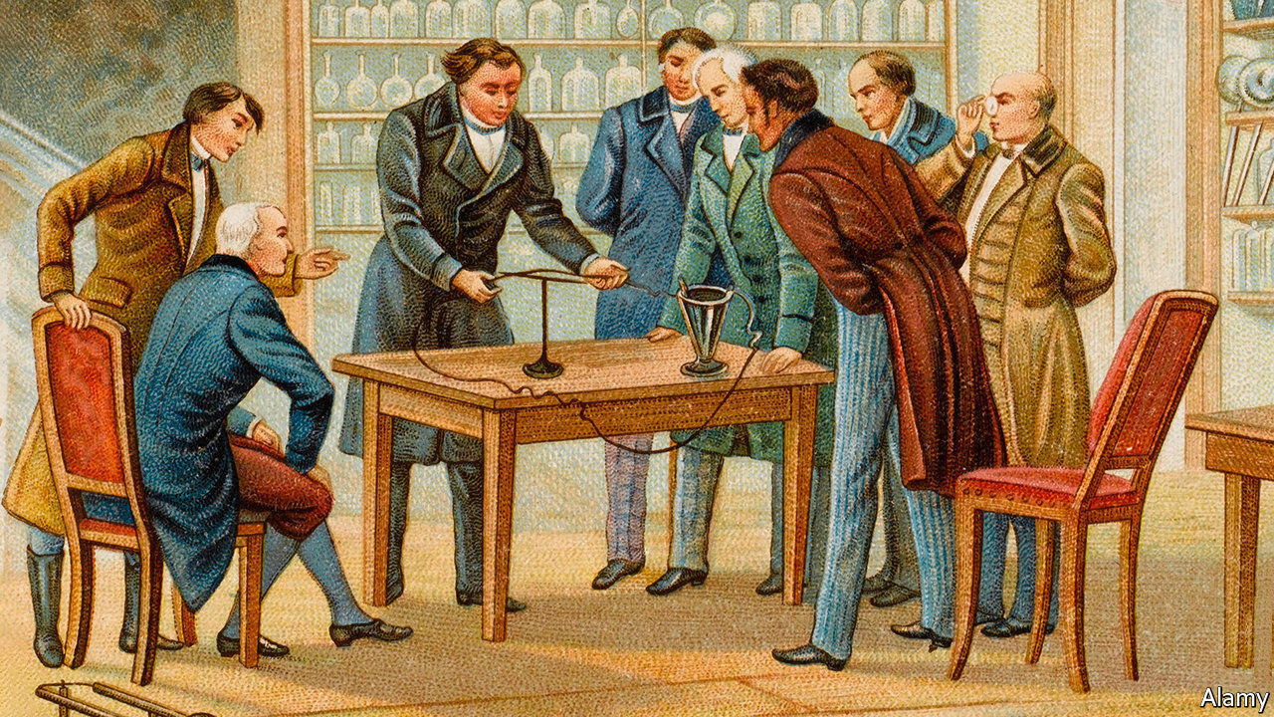

TWO CENTURIES ago Hans Christian Oersted, a Danish physicist, demonstrated that the motion of an electric charge produces magnetism. This was the first observation of a wide-ranging phenomenon. The charged clouds of particles which float through the cosmos generate vast interstellar magnetic fields as they go. The sloshing of molten metal in Earth’s core produces the planet’s north and south magnetic poles. Even the firing of nerve cells in a human brain creates a minuscule amount of magnetism.

The ubiquity of such electrically generated magnetic fields does, though, bring problems ranging from the pragmatic to the esoteric. Doctors looking at MRI scans, for example, have to compensate for background magnetism. Meanwhile, experimentalists conducting precision tests may have to build complex shields to obscure the magnetic effect of something as simple as an electric wire running through the wall of their laboratory.

It would be useful, then, to be able to control, limit or shape magnetic fields from a distance. Useful, but apparently impossible. For, in 1842, Samuel Earnshaw, a British physicist, demonstrated mathematically that the maximum strength of a magnetic field cannot lie outside its source. Every such field must, in other words, surround and radiate from the object which generates it. And there matters stood until Rosa Mach-Batlle of the Autonomous University of Barcelona spotted a way around Earnshaw’s conclusions. She has not actually proved him wrong. But she has shown that multiple magnetic fields, each obeying Earnshaw’s theorem individually, can collectively appear to bypass it.

As they describe in Physical Review Letters, Dr Mach-Batlle and her colleagues pulled off their trick in a surprisingly simple way, by arranging 20 straight wires next to one another in the form of a cylinder 40cm tall and 8cm in diameter, with a 21st running through the cylinder’s centre. When they passed electric currents through all 21 wires a complex pattern of magnetic field lines blossomed in the surrounding area, forming shapes which varied with the strength and direction of the individual currents.

By choosing the right combination of currents the researchers found they were able to create a field pattern which emanated from a virtual version of the 21st wire that ran not through the middle of the cylinder but, rather, 2cm outside it. In other words, if the apparatus doing the generating were to be shielded from an observer, Wizard of Oz-style, by a curtain, it would look to that observer as if this field was appearing from nowhere.

Going from Dr Mach-Batlle’s demonstration to something which could be used in practice to manipulate distant magnetic fields will be a long journey. But if that journey can be made, potential applications go way beyond cleaning up fuzzy MRI scans. Remotely cast fields of this sort might be used to steer medical nanobots through someone’s bloodstream to deliver drugs to a particular tissue, or else to guide them towards a malignant tumour and remotely raise their temperature once they have arrived, in order to cook it to death. There are also likely to be applications in quantum computing. Many designs for quantum computers rely on trapping atoms at precise locations in space—a difficult feat which this sleight of hand could simplify.

The trick still requires refining. To achieve such desired applications the team need to be able to sculpt intricate magnetic fields in three dimensions. At present, limited as they are to emulating the field generated by a single electric wire, they cannot do this. But it is worth remembering that Oersted’s original experiment, from which the whole of electrical engineering ultimately descends, was even simpler. It involved only a battery, a magnetic compass and a single wire. Great oaks from little acorns grow.■

This article was downloaded by calibre from <https://www.economist.com/science-and-technology/2020/11/07/can-you-generate-a-magnetic-field-remotely>

|  |  |  |  |
| --- | --- | --- | --- |
| Previous | Articles | Sections | Next |

|  |  |  |  |
| --- | --- | --- | --- |
| Previous | Articles | Sections | Next |

#### Human evolution

# Female stone-age hunters

If you thought men hunted and women gathered, think again

Nov 5th 2020 |

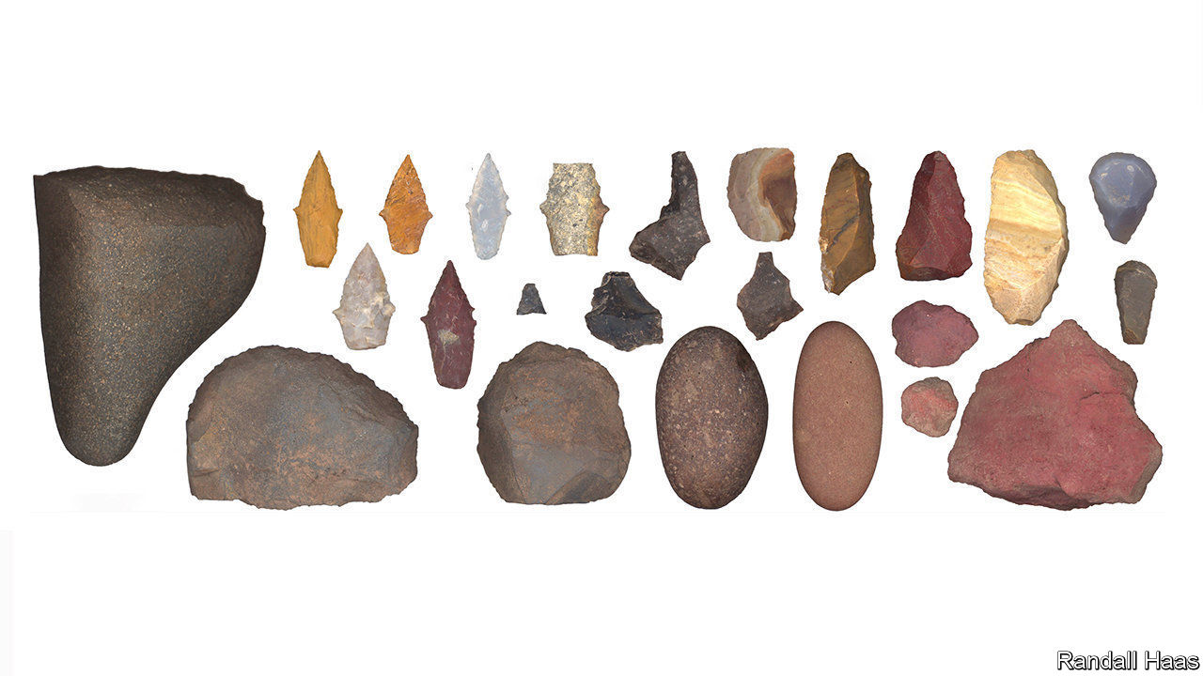

THIS COLLECTION of stone tools from Peru upsets the idea that, in the ancient world of hunter-gatherers, it was men who hunted and women who gathered. It comes from the 9,000-year-old grave of a woman in her late teens and includes seven spear tips, and a knife and a set of scrapers for butchering large animals. In light of its discovery, reported this week in Science Advances, Randall Haas of the University of California, Davis, and his colleagues, who found it, searched the literature on early burials in North and South America. There were 27 where the sex of the inhumed was known and hunting tools had been discovered alongside. Of these 11 were of females. Two, admittedly, were of infant girls. But the idea that only men did the hunting does now look, well, a bit old fashioned.■

This article was downloaded by calibre from <https://www.economist.com/science-and-technology/2020/11/05/female-stone-age-hunters>

|  |  |  |  |
| --- | --- | --- | --- |
| Previous | Articles | Sections | Next |

|  |  |  |
| --- | --- | --- |
| Science & ... | Sections | Economic & ... |

Books & arts

Colour in art: Paint it black

.

Renaissance art: Take me to church

.

China and the second world war: Lest they forget

.

The Western mind: Value judgments

.

Martin Amis’s new book: In my life

.

|  |  |  |
| --- | --- | --- |
| Science & ... | Sections | Economic & ... |

|  |  |  |  |
| --- | --- | --- | --- |
|  | Articles | Sections | Next |

#### Shades of black

# For centuries, the colour black has tested artists’ ingenuity

Anish Kapoor, a British-Indian artist, uses the blackest black ever created to question notions of perception

Nov 7th 2020 |

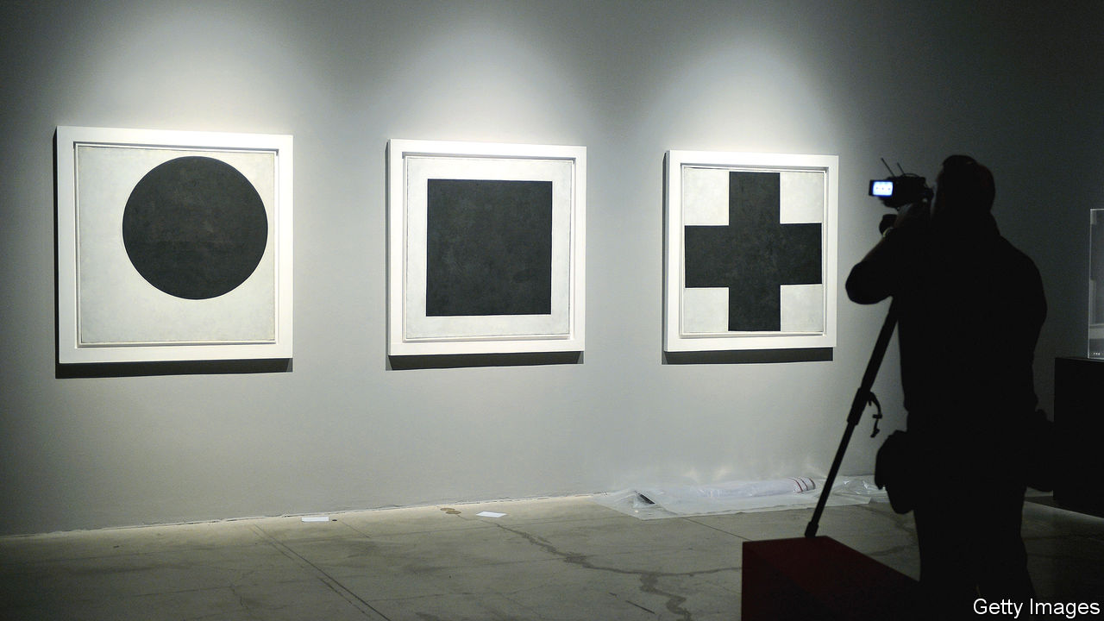

CLAUDE MONET died in darkest December in 1926 surrounded by the garden he had created at Giverny. When Georges Clémenceau, the former French prime minister, arrived three days later for the artist’s funeral and caught sight of the black-draped coffin, he exclaimed: “No! No black for Monet.” An old piece of cretonne was brought down from the house to replace the dark pall with the palette that the artist had made his own: nature’s many greens, lavender, water lilies and forget-me-nots.

Most colours represent different things for different people. The hue of death in India and in some Slavic cultures is white, yet white also means spiritual rebirth for Muslims participating in the haj. Green was for bankers in early modern Europe; in the Kenyan flag it represents the land. Red is the badge of loyalty and success in China and of power and devotion in Russia. In Nathaniel Hawthorne’s New England it was the sign of adultery. Black, however, has associations that are universal. It is bound up with witchcraft, the underworld, night-time and the far side of the Moon.

Physicists say it is not really a colour at all. Because black is the result of the absence of light, Sir Isaac Newton did not see it on the spectrum of colours in his experiments with prisms in the late 1660s. Many artists take a different view. For them black represents an intellectual and technical challenge; it is the high-jump of colour, a test of their skill, ingenuity and imagination. (Black skin has its own, entwined but distinct, artistic history, with vexed connotations of power, prejudice and eroticism.)

The latest attempt to plumb these depths comes from Anish Kapoor, a British-Indian artist whose work questions notions of perception. He has co-opted a revolutionary black material which, he hopes, will break completely new ground. “I’m really invested in the process of what is real and what is not real,” Mr Kapoor says. “What is an appearance? What’s a trick? What’s an illusion?”

The discovery in ancient Egypt, China and Rome that writing (and, later, printing) worked best when black was used on a white background gives black a special place in the pantheon of colours. But before the concoction in Europe of black ink from gall nuts (tumours that grow on trees where insects have laid eggs), real black was hard to conjure up. The early artists in France’s Lascaux caves drew crude animals and human figures with charcoal, which sometimes washed away. Most confected blacks, especially fabric dyes, produced a muddy purply-grey or brown at best.

## No colours any more

It was only when black pigments—made from coal, lampblack or even burned ivory—were successfully mixed with gum arabic or linseed oil that it became possible to create the black gloss that many European artists came to love. Caravaggio revolutionised Baroque painting with his studies of darkness; yet it was the Spaniards of a generation later, when black was the colour of high fashion, who made black painting all their own, starting with the power portraits of Diego Velázquez and the brooding figures that haunt the tall works of Francisco de Zurbarán. “Black became the colour of distinction,” Philip Ball, the author of “Bright Earth: Art and the Invention of Colour”, has said. It wasn’t only a hue in its own right, artists realised, but an enlivener of other colours.

The myth of Orpheus, who descends into the blackness of the underworld to bring his dead wife, Eurydice, back to the land of the living, has inspired musicians, poets and painters. None more so, perhaps, than Samuel Palmer. Retreating from the problems associated with the Industrial Revolution, in the 1820s Palmer went with a band of like-minded spirits to live in the Kent countryside where he witnessed nights that were blacker than anything he had ever seen. The series of works inspired by his nocturnal ramblings represented something of an epiphany for Palmer. He called them “my blacks” or “little moonshines”, for the intensity they project is due almost entirely to the blackness of his night sky, as can be seen, for example, in a tiny picture called “Cornfield by Moonlight, with the Evening Star”.

Unlike Palmer and other Romantics, Monet and some of his fellow Impressionists banished black entirely. Édouard Manet, however, took it on. When he painted his disciple and future sister-in-law, Berthe Morisot, in 1872, he dressed her all in black with a matching hat. With one side of her face lit up gloriously and the other darkly shaded, it is her eyes that capture the viewer’s attention; in life they were green, but Manet made them profound by painting them black. “Manet was the strongest of us all,” his friend, Camille Pissarro, once said. “He turned black into light.”

## Until my darkness goes

In the 20th century, Pablo Picasso used black to ask how God could possibly exist amid so much suffering. “Guernica”, his visual poem in black-and-white about the Spanish civil war, recalls the use of black in Francisco Goya’s prints, “The Disasters of War”. Perhaps the shade’s most ambitious devotee was Kazimir Malevich, a Russian artist who enlisted black to invent a whole new painterly language that elevated feelings over representation. He called this movement “suprematism”.

“Trying desperately to free art from the dead weight of the real world,” he later wrote, “I took refuge in the form of the square.” Malevich painted many squares of different colours, but “Black Square” (see picture) is the one people remember. Unveiled against the backdrop of the first world war and turmoil in Russia, Malevich’s “Black Square” marked a turning-point in modern art.

Malevich was a huge influence on his successors, especially the American abstract expressionists, but time has not been kind to “Black Square”, at least not physically. These days it is shrunken, cracked and slightly miscoloured. All the same, the challenge that it represented to artists is as powerful as ever.

It was exactly a century after “Black Square”, in 2015, that Mr Kapoor secured the rights to make art using Vantablack, the blackest black ever created. It is not a paint so much as a dense coating of tiny “nanotubes”—“Vanta” stands for “vertically aligned nanotube array”—which, instead of reflecting light, traps it almost completely. (It was developed as a material that might be useful in hiding satellites.) In a recent display in his studio, Mr Kapoor’s artworks seemed to have no shape or contours. A circle of Vantablack on the floor could be a rug-like coating or a bottomless hole; a bowl shape could be convex or concave. There was no way of telling.

During the Renaissance, artists saw that paint could be used to portray objects in three dimensions. Vantablack seems to remove the object altogether. Speaking to Artforum, a magazine, Mr Kapoor once said: “Imagine walking into a room where you literally have no sense of the walls—where the walls are or that there are any walls at all. It’s not an empty dark room, but a space full of darkness.” For the viewer, as for the artist, these works are another step in the quest for the meaning of black. ■

This article was downloaded by calibre from <https://www.economist.com/books-and-arts/2020/11/07/for-centuries-the-colour-black-has-tested-artists-ingenuity>

|  |  |  |  |
| --- | --- | --- | --- |
|  | Articles | Sections | Next |

|  |  |  |  |
| --- | --- | --- | --- |
| Previous | Articles | Sections | Next |

#### Take me to church

# A lavish set of books brings readers closer to the Sistine frescoes

For $22,000 you can pore over every detail in the comfort of your own home

Nov 4th 2020 |

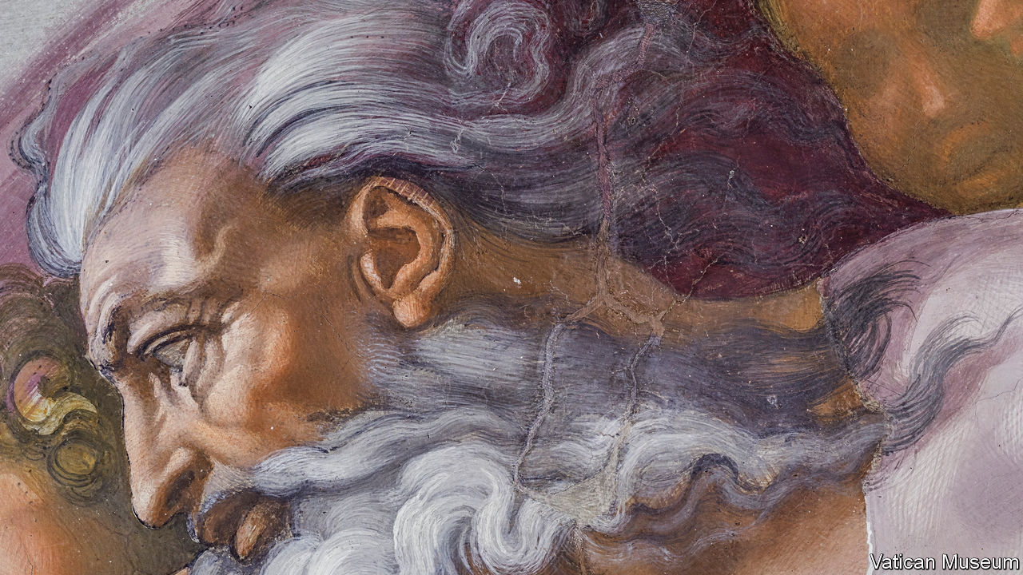

The Sistine Chapel. Callaway Arts & Entertainment; 822 pages; $22,000

IT TOOK MICHELANGELO four years to paint the ceiling of the Sistine Chapel, but most visitors spend less than 30 minutes gawking at it, often while pressed against umpteen strangers. These are hardly ideal conditions for beholding artistic genius, and the pandemic has curbed most discretionary travel, anyway. Now, for a mere $22,000, it is possible to commune with these Renaissance frescoes in the comfort of your own home.

This month the Vatican, together with Scripta Maneant, an Italian art publisher, and Callaway Arts & Entertainment, a publisher in New York, have released “The Sistine Chapel”, a three-volume set that documents every painted inch of this vaulted room. Each page stitches together hundreds of tiny high-resolution photos, taken over months by photographers perched on 33-foot-tall scaffoldings. The results reveal every daub of paint and every hairline crack in plaster. The one-to-one visuals capture the arm’s-length perspective Michelangelo had while painting it.

But $22,000? Some of the proceeds will go towards the Vatican Museums’ conservation efforts, says Nicholas Callaway of Callaway Arts & Entertainment. Much of the fee covers the costs of producing these books. The 600 English-language editions are all bound in silk and white calf leather, and apparently only one bookbinder in the world—in Novara, Italy—can hand-sew something this size. The sets are rare, too, as the Vatican has allowed only 1,999 copies to be made (in a decree both strict and mysterious, true to form). The 1,000 in Italian have already sold out.

Eager for a glimpse, your correspondent arranged to borrow a set for several days. Each volume weighs 11 kilograms, so it took two people to haul the set in its protective case up the stairs. Simply removing a book from its foam nest is an undertaking. But they are, indeed, remarkable.

Without the overwhelming drama of the chapel, it is easier to notice the gracefully bent legs of a man on his back, his nostrils facing the viewer, in the pendentive “The Brazen Serpent”. In “The Creation of Adam”, you can appreciate the fleshy curve of Adam’s lower stomach. Every page also reveals the web of cracks cast by time, making the value of this archive plain.

But for all the pleasures of doting on individual panels from this extraordinary room, the effect can be disorienting. Paging through these immersive reproductions, the reader gets little sense for how they fit together. It is easy to imagine a more user-friendly digital experience that allows viewers to zoom in and out without worrying about the cleanliness of their hands. Depending on demand, Mr Callaway anticipates other editions, interactive and print-based, at more affordable prices.

In the meantime, the coronavirus may boost sales of the luxury sets, reckons James Daunt, head of Barnes & Noble and Waterstones, whose stores are selling these books online. Most rich people, he explains, have not got poorer during the pandemic, and many want something nice to look at during their hours at home. ■

This article was downloaded by calibre from <https://www.economist.com/books-and-arts/2020/11/04/a-lavish-set-of-books-brings-readers-closer-to-the-sistine-frescoes>

|  |  |  |  |
| --- | --- | --- | --- |
| Previous | Articles | Sections | Next |

|  |  |  |  |
| --- | --- | --- | --- |
| Previous | Articles | Sections | Next |

#### Lest they forget

# The changing legacy of the second world war in China

Under Mao Zedong the subject of the war was avoided. Now it is used to illustrate the country’s rise to power

Nov 7th 2020 |



China’s Good War. By Rana Mitter. Belknap Press; 336 pages; $27.95 and £22.95

THE WAY the second world war is remembered—and used—is always changing. In Britain, the Blitz is invoked in every new crisis. In America, the attack on Pearl Harbour resonated anew after 9/11. Yet, as Rana Mitter of Oxford University shows in “China’s Good War”, nowhere have successive generations thought more differently about the conflict than in China, where it is seen through the prism of the Japanese invasion that began in 1931.

In his previous book Mr Mitter chronicled the bloody struggle between Japan and China that erupted into full-scale war in 1937. Now he focuses on the afterlife of those events in films, monuments, parades and propaganda. The Communist Party, he writes, has been striving to convince domestic and global audiences that Japanese atrocities, especially the Nanjing massacre, should rank among the era’s worst abominations. Gallingly for many Chinese, the bombing of Hiroshima and Nagasaki often seems to command more sympathy than the suffering inflicted on them.

This push, Mr Mitter notes, represents a break from the rule of Mao Zedong, when “official China spoke in a minor key about the war years”, stressing their role in bringing the party to power. In the past, Nationalist officials and spies, or American soldiers in Korea, were often the villains in Chinese films, as Nazis were in Hollywood productions. Heroic Chinese Communists repelling Japanese marauders always featured as well, but recently the balance has altered. China has been saturated with images of Japanese aggression; the lengths to which movies go to demonise Japanese invaders and heroise Chinese fighters are as striking as their volume. In “Designation Forever” (2011-), a television series, a Chinese soldier brings down a Japanese plane by throwing a grenade at it.

These observations are not new, though the range of evidence that Mr Mitter marshals is impressive. The argument he makes about war, memory and the international order is more original. The post-Mao changes, he writes, are part of a broader move from an emphasis on revolutionary ideals and class struggle to one on foreign mistreatment of China during a “century of humiliation” that began with the Opium wars and peaked in Japanese imperialism. Recent portrayals of the war complement a softening of official hostility towards the Nationalists, whose soldiers and even leader, Chiang Kai-shek, are now given some credit for helping defeat Japan. They fit, too, with a shift from Mao’s dream of prying Tokyo away from Washington’s embrace toward a more combative approach to Japan as a regional rival.

Finally, and most intriguingly, all this fits with a switch from rejecting the post-war global system, as Mao sometimes did, to using the country’s status among the wartime Allies to forge a “morally weighted narrative about China’s role in the global order”. President Xi Jinping’s tightening of controls over peripheral territories, and Beijing’s expansion into the South China Sea, can seem imperialistic. But China’s rulers want all that to be interpreted in a radically different light. According to Mr Mitter, China wishes to be seen as incorporating itself into the “existing, largely liberal order”, while striving to “revise that order to match its own preferences”.

Joining the World Trade Organisation, hosting the Olympics and becoming more involved in the United Nations all further this aim. So does telling war stories that show Chinese forces contributing to the defeat of the Axis powers—thereby earning China a place at the table at which the post-war order was created. ■

This article was downloaded by calibre from <https://www.economist.com/books-and-arts/2020/11/07/the-changing-legacy-of-the-second-world-war-in-china>

|  |  |  |  |
| --- | --- | --- | --- |
| Previous | Articles | Sections | Next |

|  |  |  |  |
| --- | --- | --- | --- |
| Previous | Articles | Sections | Next |

#### Value judgments

# Joseph Henrich’s study of WEIRD societies

That is, Western, educated, industrialised, rich and democratic

Nov 7th 2020 |

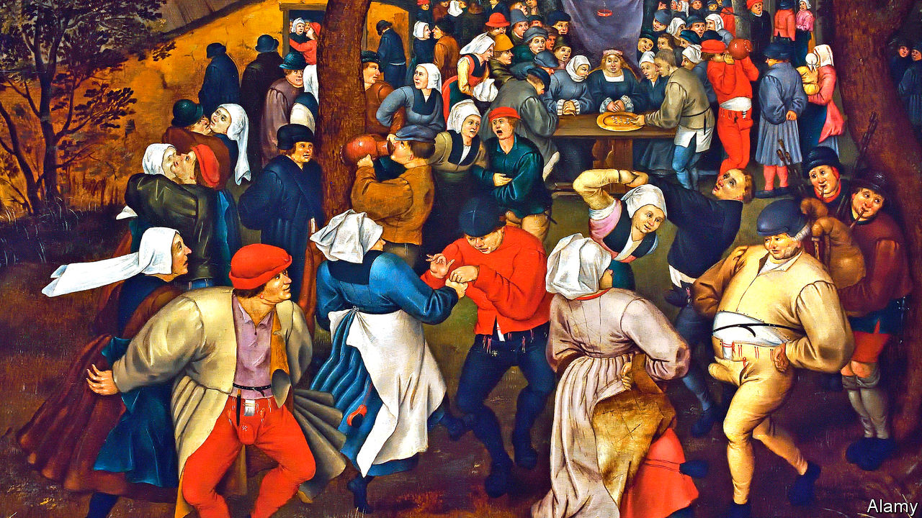

The Weirdest People in the World: How the West Became Psychologically Peculiar and Particularly Prosperous. By Joseph Henrich. Farrar, Straus and Giroux; 704 pages; $35. Allen Lane; £30

IT TAKES MORE than a decent constitution to build a democracy, as anyone who has tried to steer a country out of anarchy or tyranny can attest. And it takes more than well-turned commercial laws to make a healthy market economy. For either to happen, certain values must be widely accepted—yet defining them can be tricky.

Joseph Henrich, a professor of human evolutionary biology at Harvard, has devised a teasing term to describe societies where rules and values have come together with benign results: Western, educated, industrialised, rich and democratic. The acronym, WEIRD, neatly makes his point that these attributes, and the mindset that goes with them, are the exception not the rule in human history.

The values that underpin WEIRDness, he writes, include a tough-minded belief in the rule of the law, even at the risk of personal disadvantage; an openness to experimentation in matters of scientific knowledge or social arrangements; and a willingness to trust strangers, from politicians offering new policies to potential business partners. These may not seem original insights, but Mr Henrich’s work is distinguished by the weight he places on the extended family as an obstacle to healthy individualism, and on religious norms as the determinant of family obligations. He reinforces this theme with a welter of polling data and sweeping historical arguments, mostly about medieval Europe.

As an example of kin loyalty at odds with modern thinking, Mr Henrich records the experience of democracy-builders in Afghanistan: rural folk could not grasp the idea that they might vote for somebody who was not part of their family. Just as foreign to such outlooks, he says, is the idea that crimes are treated equally regardless of the relationships involved. In medieval China, killing within the family was treated differently from killing a stranger; killing your father was a worse crime than killing a child.

In many accounts of modern history, it was Europe’s Protestant Reformation that catalysed a more individualist, law-based mentality. Mr Henrich’s own emphasis is on the Catholic world from about 1000 onwards. He thinks that, by banning kin-marriage, the Roman church ushered in a more fluid society where people had to look farther afield for spouses.

Here he is not quite convincing, despite the extensive studies he adduces to argue that modern mentalities, even now, are correlated with regions of historic Catholic influence. It seems more likely that the medieval church was negotiating with, rather than moulding, a social reality which was evolving fast as cities emerged. Nor does a ban on marrying cousins imply free marital choice. It can be part of an elaborate system of communally arranged unions.

Mr Henrich’s broad point about the values that underpin liberal democracy is stronger, with one big qualification. Hundreds of millions of people live neither in atomistic WEIRD-land nor in kin-obsessed pre-modern societies, but in an interesting limbo, sometimes dynamically and sometimes tragically. Think, say, of a family from a poor, remote part of south-eastern Europe, whose younger members are working and raising children in assorted European cities, while their elders keep the home fires burning in the village. An extraordinary range of roles and attitudes co-exist in three generations.

Or take the South Asian communities in some northern English towns, where the mores of rural Kashmir can persist even in the fourth generation of diaspora life. Tradition-bound as they are, such communities are not untouched by modern British culture. Younger generations grow up somewhere between Mr Henrich’s WEIRDness and the harsh security of a regulated rural clan. Some have fun negotiating this terrain, some swing sharply towards either individualism or conformity; a handful react to the confusion by embracing extremism. In any case, WEIRDness need not be an either-or category, whether in medieval Europe or the 21st century. ■

This article was downloaded by calibre from <https://www.economist.com/books-and-arts/2020/11/07/joseph-henrichs-study-of-weird-societies>

|  |  |  |  |
| --- | --- | --- | --- |
| Previous | Articles | Sections | Next |

|  |  |  |  |
| --- | --- | --- | --- |
| Previous | Articles | Sections | Next |

#### Songs of innocence and experience

# Martin Amis’s new book mixes autofiction and writing advice

“Inside Story” is a reflection on past loves, friendships and a 50-year career

Nov 7th 2020 |



Inside Story: How to Write. By Martin Amis. Knopf; 560 pages; $28.95. Jonathan Cape; £20

ALREADY THE author of four darkly satirical and precociously stylish novels, Martin Amis secured his status as one of Britain’s greatest living writers with “Money” (published in 1984), which followed a depraved narcissist called John Self around the streets of London and New York. In “Experience” (2000), Mr Amis turned to memoir, recounting the extraordinary childhood he spent in the care of a father and stepmother who were both eccentric authors. His latest book, “Inside Story: How to Write”, combines the two forms.

It is a novel, but its main character is called Martin Amis, and the events that make up the story recapitulate those of Mr Amis’s own life, from a devastating house fire to his long friendship with the late journalist Christopher Hitchens. He even incorporates his five children (though their names are changed). Messy as they are, Mr Amis quips, lives are far more difficult to write than fiction, and in narrating his own he skips freely between decades, telling the “inside story” of his rise and 50-year career.

The account of a youthful love affair in the 1970s harks back to his debut, “The Rachel Papers” (1973), albeit now the episode has much darker undertones. Later Mr Amis reflects on the deaths of his father, Kingsley Amis, his mentor, Saul Bellow, and, most crushingly, Hitchens, whose final months with cancer are revisited in excruciating detail. Death looms over “Inside Story”: now 71, Mr Amis observes that it “is almost certainly my last long novel”. The elegiac passages are often moving—where other writers might flounder in a mire of sentimentality, Mr Amis writes about illness with gravity and grace.

These narrative sections are broken up by short intermissions in which he takes on his subtitle, “How to Write”, reflecting on his craft and offering advice. Some of his points are peevish—“‘myself’ is just a crap word”—but most, such as a warning against repeating affixes, will prove useful for regular writers of English, from office workers to novelists. And though Mr Amis, set in his ways after dozens of books, can seem a little curmudgeonly, he ends his lessons on a heartening note. Good writing, he says, “is achievable by anyone willing to put in the time”.

With each sumptuous sentence he proves his credentials as both an instructor and a worthwhile subject for the kind of autobiographical fiction that is now in vogue. For fans of his work, “Inside Story” is a victory lap; newcomers will be steered towards his rich back catalogue. ■

Listen to our interview with Martin Amis at [economist.com/Amispod](https://economist.com/Amispod)

This article was downloaded by calibre from <https://www.economist.com/books-and-arts/2020/11/07/martin-amiss-new-book-mixes-autofiction-and-writing-advice>

|  |  |  |  |
| --- | --- | --- | --- |
| Previous | Articles | Sections | Next |

|  |  |  |
| --- | --- | --- |
| Books & arts | Sections | Graphic detail |

Economic & financial indicators

Economic data, commodities and markets

.

|  |  |  |
| --- | --- | --- |
| Books & arts | Sections | Graphic detail |

|  |  |  |  |
| --- | --- | --- | --- |
|  | Articles | Sections | Next |

# Economic data, commodities and markets

Nov 5th 2020 |

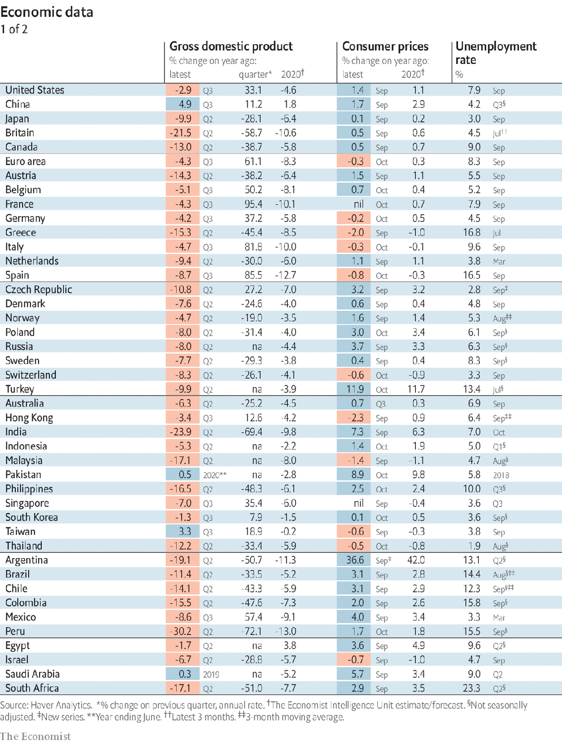

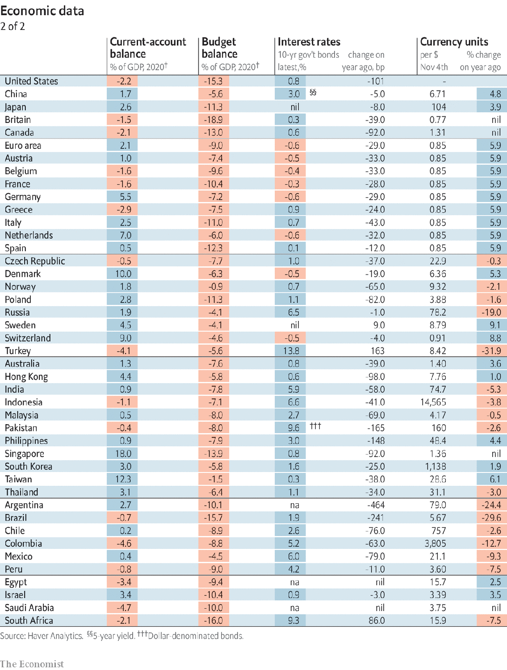

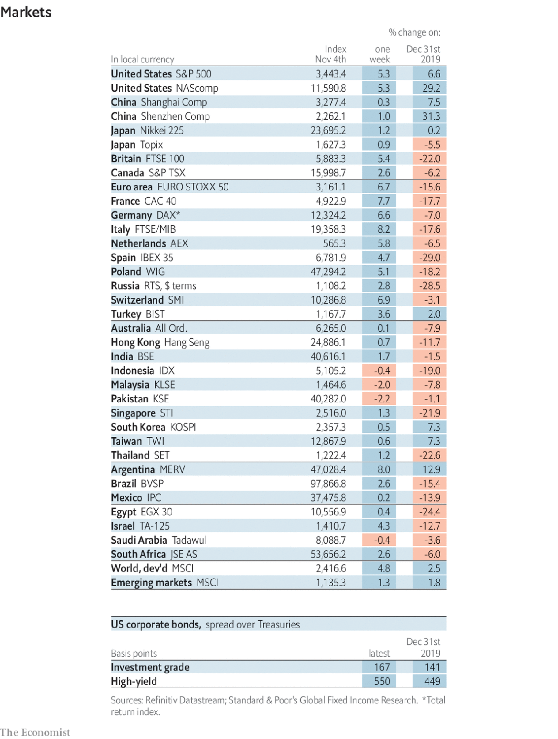

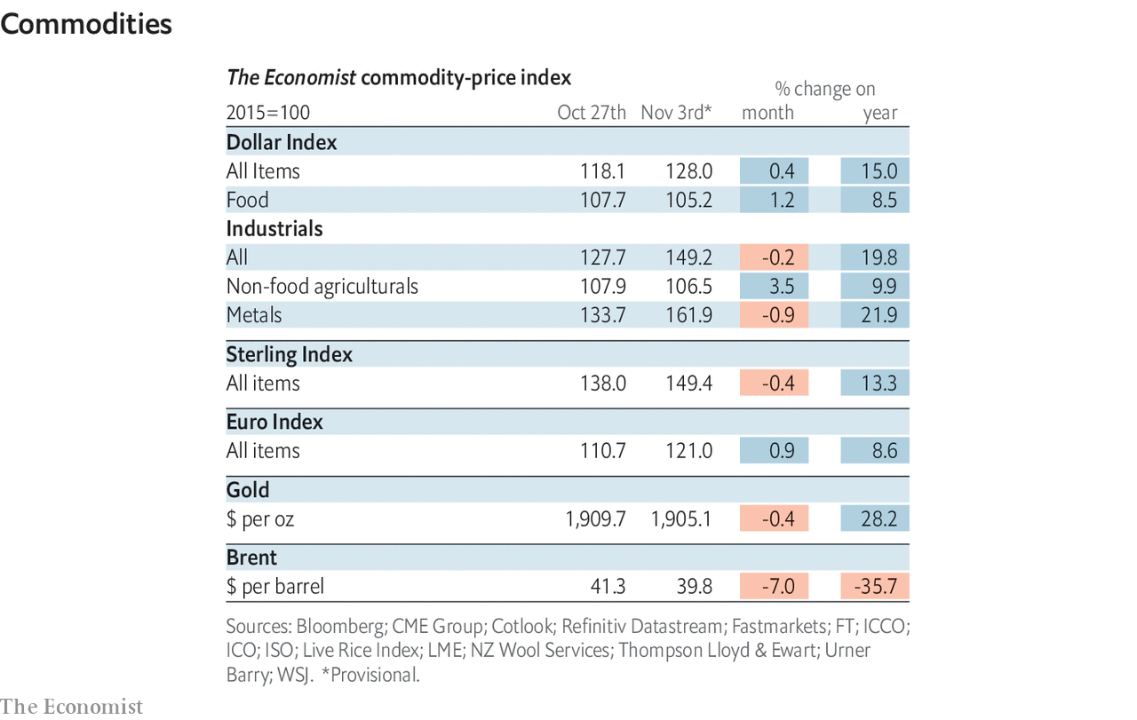

This article was downloaded by calibre from <https://www.economist.com/economic-and-financial-indicators/2020/11/05/economic-data-commodities-and-markets>

|  |  |  |  |
| --- | --- | --- | --- |
|  | Articles | Sections | Next |

|  |  |  |
| --- | --- | --- |
| Economic & ... | Sections | Obituary |

Graphic detail

Covid-19 super-spreading: Power of inequality

.

|  |  |  |
| --- | --- | --- |
| Economic & ... | Sections | Obituary |

|  |  |  |  |
| --- | --- | --- | --- |
|  | Articles | Sections | Next |

#### Bulk of transmission

# A minority of people with covid-19 account for the bulk of transmission

In two Indian states 10% of people caused 60% of subsequent infections

Nov 7th 2020 |

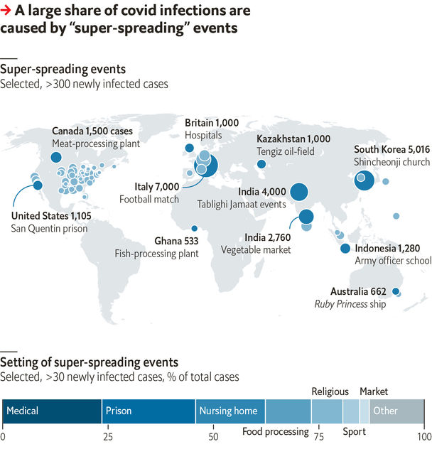

VILFREDO PARETO, a 19th-century economist, famously observed in 1896 that 20% of the people in Italy held 80% of the wealth. Pareto’s law has been found to apply to countless social and natural phenomena. Covid-19 is no exception. Just as economists use the Gini coefficient to measure income inequality, epidemiologists use a dispersion parameter, K, to measure the spread of infections caused by infectious individuals. When K is zero one individual causes all subsequent infections; as it rises so do the number of infectors.

While many people worry about the reproduction number, R0—the average number of infections caused by an infectious individual—experts think the dispersion figure matters, too. Research published recently in Science attempts to estimate it more accurately. The paper, by Ramanan Laxminarayan of Princeton University and eight co-authors, gleaned information from test and tracing in two Indian states. The academics used data from 84,965 infected individuals and 575,071 of their known contacts—all of whom were subsequently tested for covid-19.

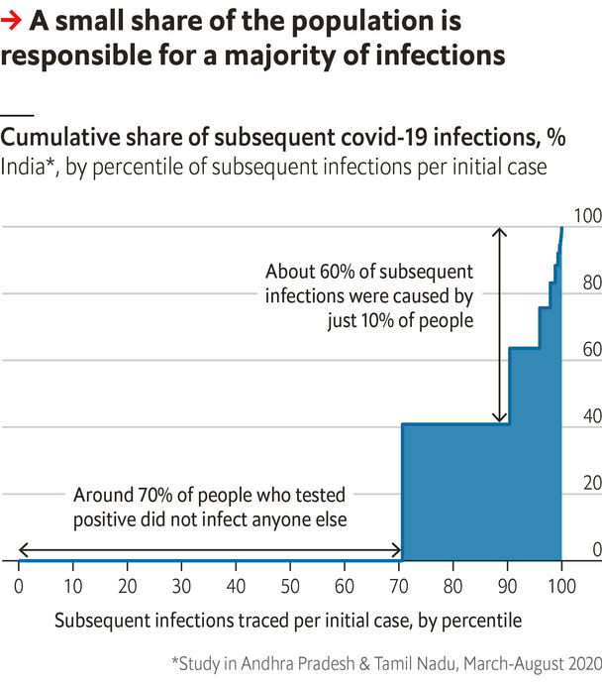

The study finds that covid-19 transmission is highly concentrated. Of all the contacts traced, 7.5% subsequently tested positive for covid-19 (assumed to be caused by exposure to the infected person identified). Yet the academics find that these infections stem from a minority of originally infectious individuals. Fully 71% of infected people did not transmit the virus on. Most new transmissions were from a few “super-spreaders": about 10% of the people caused 60% of new infections, giving covid to three other people, on average.

The K-factor does however depend on how people interact. Early on, studies found a K close to zero, as a few highly contagious individuals had ample opportunity to spread the disease. As social distancing is enacted to curb outbreaks, the dispersion parameter tends to increase. This new study, in line with others from Hong Kong and China, finds that K among all 85,000 infectors is around 0.5.

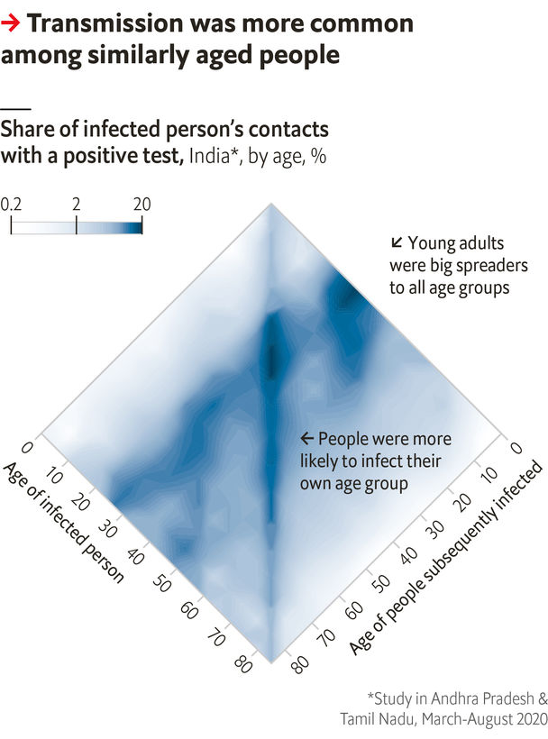

The authors’ treasure trove of data gives clues to how those infections happen. Risk of infection is greatest in private homes and among similarly aged people. That is corroborated by evidence from 1,600 covid-19 “super-spreading" events. Such transmission occurs most often in large buildings, while just three documented events have taken place outdoors. ■

Sources: “Epidemiology and transmission dynamics of covid-19 in two Indian states”, by R. Laxminarayan et al., Science, 2020; Koen Swinkels

This article was downloaded by calibre from <https://www.economist.com/graphic-detail/2020/11/07/a-minority-of-people-with-covid-19-account-for-the-bulk-of-transmission>

|  |  |  |  |
| --- | --- | --- | --- |
|  | Articles | Sections | Next |

|  |  |  |
| --- | --- | --- |
| Graphic detail | Sections |  |

Obituary

Sean Connery: Screen Scot

.

|  |  |  |
| --- | --- | --- |
| Graphic detail | Sections |  |

|  |  |  |  |
| --- | --- | --- | --- |
|  | Articles | Sections | Next |

#### Great Scot

# Sean Connery died on October 31st

The actor and Scots nationalist was 90

Nov 7th 2020 |

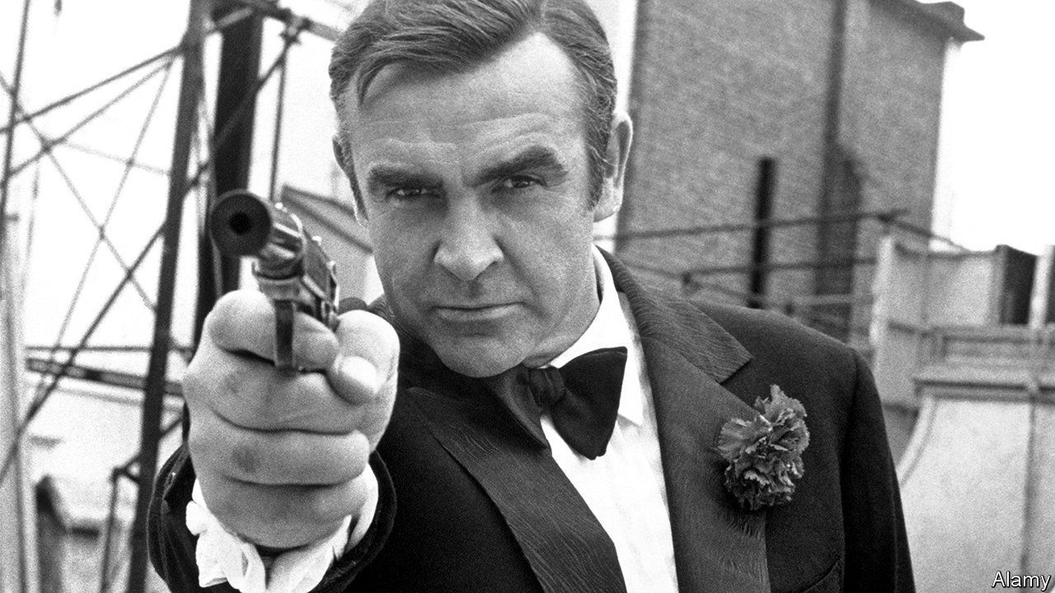

IN OCTOBER 1962, just as the world watched America’s handsome young president go head to head with the Soviets over their missiles on Cuba, another 20th-century hero made his first on-screen appearance. James Bond’s creator, Ian Fleming, described him as English, with a slim build, blue-grey eyes, a cruel mouth and short black hair, a comma of which rested on his forehead. The man the world came to know as Bond when “Dr No” was released that month was a hulking Scot with dark eyes and so little hair he had to wear a toupée. But the two men had more in common than one might think, and it was their differences as much as their similarities that combined to make him the Bondest of Bonds.

The first glimpse of him is from behind. The camera pans around the gaming table at Les Ambassadeurs in London, pausing briefly to take in Sylvia Trench’s red-chiffonned bosom before turning at last to the saturnine face with its feline eyebrow, its sultry lips. He is sitting down, so you don’t see the way the manly tailoring emphasises how he dresses to the left or how, when clothed in nothing but a towel, his pelty chest fills a doorway. But the message is clear. Sean Connery as James Bond simply is British manhood: good-mannered, patriotic, entitled.

Both went to Fettes College in Edinburgh, Mr Bond after he was reputedly expelled from Eton, Mr Connery to deliver milk from a barrow. He grew up in Fountainbridge, which used to be known as Foulbridge for the open sewer that ran through it. Although the sewer was eventually culverted, a stench remained, thanks to the toffee factory, the brewery and the rubber mill where his father worked 12 hours a day. By 1930, when he was born, it was one of the worst tenement slums in Edinburgh, with outside toilets and no hot water. The only bath in the street belonged to the brewery. Half a century later, whenever he stayed in a posh hotel he liked to luxuriate every day in a long hot soak.

He didn’t think of it as a tough childhood, but it left its mark in several ways. His mother may have taken command of his father’s wages every week, but that did not make her his equal. Even as attitudes were changing in the 1960s, Mr Connery expected women to understand that, and if they refused—if a woman was “a bitch, or hysterical, or bloody-minded continually”, he famously told Playboy in 1965—then he was entitled to slap them. His first wife, Diane Cilento, said he abused her physically and psychologically for all of their decade-long marriage, which ended in 1973.

Delivering milk was only the first job he tried. By the time he was 13, he couldn’t see the point of staying on at school. There was a war on and he wanted to earn money and play football. So he signed up, first as a bricklayer and then as a lifeguard before he learned French polishing from a coffin-maker. He hoped, for a while, that he might become a professional footballer, but plumped for acting when a friend pointed out that, as a career, it had a longer shelf life.

Not long after he finished touring provincial theatres as part of the chorus for “South Pacific”, during which he did bodybuilding to keep in shape, a friend suggested he try out for a low-budget film whose producers were looking to sign up a cheap unknown rather than an established name. Fleming was unsure about the heavy Scots burr and the lumber jacket he wore to the interview, emphasising that what was needed was Commander Bond and not an overgrown stuntman. But the producer’s wife liked his barely concealed menace. He played Bond in six more films.

With his second wife, Micheline Roquebrune, he settled in the Bahamas. He liked the low tax rate. He played golf and made up for his lack of schooling by reading—literature, politics and history, especially about how the English oppressed the Scots. Even after decades of the classless, moneyed world of international cinema, he retained much of what his childhood had taught him about being born on the wrong side of the tracks.

Perhaps because he was away from it for so long, his devotion to Scotland was intense. In 1967 he released “The Bowler and the Bunnet”, the only film he ever directed, about turbulent industrial relations in a shipyard on the Clyde in which the managers wore bowler hats and the workmen “bunnets” or cloth caps. A staunch nationalist, he campaigned for the Scottish parliament in Edinburgh and spoke up for Scottish independence—literally, in a party political broadcast for the Scottish National Party. Not for nothing did he have “Scotland Forever” tattooed on his arm.

## Untouchable

There were other film roles, some of which made far better use of his acting talents than Bond—Daniel Dravot in John Huston’s “The Man Who Would Be King” and Jimmy Malone in “The Untouchables”, a caper about Al Capone, which won him his only Oscar—but it was Bond that defined him. It made him rich, world famous, a real star. Five other Bonds would follow, but none was as good as him. And if at times, the association seemed to weigh on him so much that some referred to it as bondage, in his gut he understood that owning Bond the way he did amounted to a sort of Scottish co-opting of an English hero, and that was sweet revenge.

Most of the time he responded to questions about it with that eyebrow. Just occasionally, he would open fire. “In playing Bond, I had to start from scratch,” he pointed out to an interviewer just after “Dr No” opened. “Nobody knows anything about him, after all. Not even Fleming.” Bond made Connery. But, more than anyone else, Connery also made Bond.■

This article was downloaded by calibre from <https://www.economist.com/obituary/2020/11/07/sean-connery-died-on-october-31st>

|  |  |  |  |
| --- | --- | --- | --- |
|  | Articles | Sections | Next |